Chapter 1. Unsupervised Machine Learning

In this chapter, you will learn how to apply unsupervised learning techniques to identify patterns and structure within datasets.

Unsupervised learning techniques are a valuable set of tools for exploratory analysis. They bring out patterns and structure within datasets, which yield information that may be informative in itself or serve as a guide to further analysis. It's critical to have a solid set of unsupervised learning tools that you can apply to help break up unfamiliar or complex datasets into actionable information.

We'll begin by reviewing **Principal Component Analysis** (**PCA**), a fundamental data manipulation technique with a range of dimensionality reduction applications. Next, we will discuss **k-means clustering**, a widely-used and approachable unsupervised learning technique. Then, we will discuss Kohenen's **Self-Organizing Map** (**SOM**), a method of topological clustering that enables the projection of complex datasets into two dimensions.

Throughout the chapter, we will spend some time discussing how to effectively apply these techniques to make high-dimensional datasets readily accessible. We will use the **UCI Handwritten Digits** dataset to demonstrate technical applications of each algorithm. In the course of discussing and applying each technique, we will review practical applications and methodological questions, particularly regarding how to calibrate and validate each technique as well as which performance measures are valid. To recap, then, we will be covering the following topics in order:

* Principal component analysis
* k-means clustering
* Self-organizing maps

Principal component analysis

In order to work effectively with high-dimensional datasets, it is important to have a set of techniques that can reduce this dimensionality down to manageable levels. The advantages of this dimensionality reduction include the ability to plot multivariate data in two dimensions, capture the majority of a dataset's informational content within a minimal number of features, and, in some contexts, identify collinear model components.

**NOTE**

For those in need of a refresher, collinearity in a machine learning context refers to model features that share an approximately linear relationship. For reasons that will likely be obvious, these features tend to be unhelpful as the related features are unlikely to add information mutually that either one provides independently. Moreover, collinear features may emphasize local minima or other false leads.

Probably the most widely-used dimensionality reduction technique today is PCA. As we'll be applying PCA in multiple contexts throughout this book, it's appropriate for us to review the technique, understand the theory behind it, and write Python code to effectively apply it.

**PCA – a primer**

PCA is a powerful decomposition technique; it allows one to break down a highly multivariate dataset into a set of orthogonal components. When taken together in sufficient number, these components can explain almost all of the dataset's variance. In essence, these components deliver an abbreviated description of the dataset. PCA has a broad set of applications and its extensive utility makes it well worth our time to cover.

**NOTE**

Note the slightly cautious phrasing here—a given set of components of length less than the number of variables in the original dataset will almost always lose some amount of the information content within the source dataset. This lossiness is typically minimal, given enough components, but in cases where small numbers of principal components are composed from very high-dimensional datasets, there may be substantial lossiness. As such, when performing PCA, it is always appropriate to consider how many components will be necessary to effectively model the dataset in question.

PCA works by successively identifying the axis of greatest variance in a dataset (the principal components). It does this as follows:

1. Identifying the center point of the dataset.
2. Calculating the covariance matrix of the data.
3. Calculating the eigenvectors of the covariance matrix.
4. Orthonormalizing the eigenvectors.
5. Calculating the proportion of variance represented by each eigenvector.

Let's unpack these concepts briefly:

* **Covariance** is effectively variance applied to multiple dimensions; it is the variance between two or more variables. While a single value can capture the variance in one dimension or variable, it is necessary to use a *2 x 2* matrix to capture the covariance between two variables, a *3 x 3* matrix to capture the covariance between three variables, and so on. So the first step in PCA is to calculate this covariance matrix.
* An **Eigenvector** is a vector that is specific to a dataset and linear transformation. Specifically, it is the vector that does not change in direction before and after the transformation is performed. To get a better feeling for how this works, imagine that you're holding a rubber band, straight, between both hands. Let's say you stretch the band out until it is taut between your hands. The eigenvector is the vector that did not change direction between before the stretch and during it; in this case, it's the vector running directly through the center of the band from one hand to the other.
* **Orthogonalization** is the process of finding two vectors that are orthogonal (at right angles) to one another. In an n-dimensional data space, the process of orthogonalization takes a set of vectors and yields a set of orthogonal vectors.
* **Orthonormalization** is an orthogonalization process that also normalizes the product.
* **Eigenvalue** (roughly corresponding to the length of the eigenvector) is used to calculate the proportion of variance represented by each eigenvector. This is done by dividing the eigenvalue for each eigenvector by the sum of eigenvalues for all eigenvectors.

In summary, the covariance matrix is used to calculate Eigenvectors. An orthonormalization process is undertaken that produces orthogonal, normalized vectors from the Eigenvectors. The eigenvector with the greatest eigenvalue is the first principal component with successive components having smaller eigenvalues. In this way, the PCA algorithm has the effect of taking a dataset and transforming it into a new, lower-dimensional coordinate system.

**Employing PCA**

Now that we've reviewed the PCA algorithm at a high level, we're going to jump straight in and apply PCA to a key Python dataset—the UCI handwritten digits dataset, distributed as part of **scikit-learn**.

This dataset is composed of *1,797* instances of handwritten digits gathered from 44 different writers. The input (pressure and location) from these authors' writing is resampled twice across an *8 x 8* grid so as to yield maps of the kind shown in the following image:

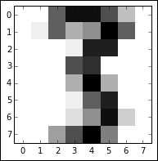

These maps can be transformed into feature vectors of length 64, which are then readily usable as analysis input. With an input dataset of 64 features, there is an immediate appeal to using a technique like PCA to reduce the set of variables to a manageable amount. As it currently stands, we cannot effectively explore the dataset with exploratory visualization!

We will begin applying PCA to the handwritten digits dataset with the following code:

import numpy as np

from sklearn.datasets import load_digits

import matplotlib.pyplot as plt

from sklearn.decomposition import PCA

from sklearn.preprocessing import scale

from sklearn.lda import LDA

import matplotlib.cm as cm

digits = load_digits()

data = digits.data

n_samples, n_features = data.shape

n_digits = len(np.unique(digits.target))

labels = digits.target

This code does several things for us:

1. First, it loads up a set of necessary libraries, including numpy, a set of components from scikit-learn, including the digits dataset itself, PCA and data scaling functions, and the plotting capability of matplotlib.
2. The code then begins preparing the digits dataset. It does several things in order:
   * First, it loads the dataset before creating helpful variables
   * The data variable is created for subsequent use, and the number of distinct digits in the target vector (*0* through to *9*, so n_digits = 10) is saved as a variable that we can easily access for subsequent analysis
   * The target vector is also saved as labels for later use
   * All of this variable creation is intended to simplify subsequent analysis
3. With the dataset ready, we can initialize our PCA algorithm and apply it to the dataset:
4. pca = PCA(n_components=10)
5. data_r = pca.fit(data).transform(data)
6. print('explained variance ratio (first two components): %s' % str(pca.explained_variance_ratio_))

print('sum of explained variance (first two components): %s' % str(sum(pca.explained_variance_ratio_)))

1. This code outputs the variance explained by each of the first ten principal components ordered by explanatory power.

In the case of this set of 10 principal components, they collectively explain *0.589* of the overall dataset variance. This isn't actually too bad, considering that it's a reduction from *64* variables to 10 components. It does, however, illustrate the potential lossiness of PCA. The key question, though, is whether this reduced set of components makes subsequent analysis or classification easier to achieve; that is, whether many of the remaining components contained variance that disrupts classification attempts.

Having created a data_r object containing the output of pca performed over the digits dataset, let's visualize the output. To do so, we'll first create a vector of colors for class coloration. We then simply create a scatterplot with colorized classes:

X = np.arange(10)

ys = [i+x+(i*x)**2 for i in range(10)]

plt.figure()

colors = cm.rainbow(np.linspace(0, 1, len(ys)))

for c, i target_name in zip(colors, [1,2,3,4,5,6,7,8,9,10], labels):

plt.scatter(data_r[labels == I, 0], data_r[labels == I, 1],

c=c, alpha = 0.4)

plt.legend()

plt.title('Scatterplot of Points plotted in first \n'

'10 Principal Components')

plt.show()

The resulting scatterplot looks as follows:

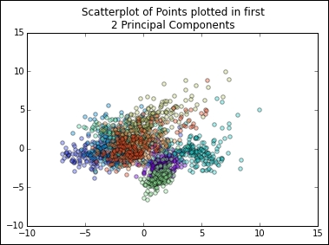

This plot shows us that, while there is some separation between classes in the first two principal components, it may be tricky to classify highly accurately with this dataset. However, classes do appear to be clustered and we may be able to get reasonably good results by employing a clustering analysis. In this way, PCA has given us some insight into how the dataset is structured and has informed our subsequent analysis.

At this point, let's take this insight and move on to examine clustering by the application of the k-means clustering algorithm.

3. Supervised Learning for Classification Problems

Vaibhav Verdhan[**1**](https://learning.oreilly.com/library/view/supervised-learning-with/9781484261569/html/499122_1_En_3_Chapter.xhtml#Aff2)

(1)

Limerick, Ireland

*“Prediction is very difficult, especially if it’s about the future.”*

*— Niels Bohr*

We live in a world where the predictions for an event help us modify our plans. If we know that it is going to rain today, we will not go camping. If we know that the share market will crash, we will hold on our investments for some time. If we know that a customer will churn out from our business, we will take some steps to lure them back. All such predictions are really insightful and hold strategic importance for our business.

It will also help if we know the factors which make our sales go up/down or make an email work or result in a product failure. We can work on our shortcomings and continue the positives. The entire customer-targeting strategy can be modified using such knowledge. We can revamp the online interactions or change the product testing: the implementations are many. Such ML models are referred to as *classification* algorithms, the focus of this chapter.

In Chapter [2](https://learning.oreilly.com/library/view/supervised-learning-with/9781484261569/html/499122_1_En_2_Chapter.xhtml), we studied the regression problems which are used to predict a continuous variable. In this third chapter we will examine the concepts to predict a categorical variable. We will study how confident we are for an event to happen or not. We will study logistic regression, decision tree, k-nearest neighbor, naïve Bayes, and random forest in this chapter. All the algorithms will be studied; we will also develop Python code using the actual dataset. We will deal with missing values, duplicates, and outliers, do an EDA, measure the accuracy of the algorithm, and choose the best algorithm. Finally, we will solve a case study to complete the understanding.

**Technical Toolkit Required**

We are using Python 3.5+ in this book. You are advised to get Python installed on your machine. We are using Jupyter notebook; installing Anaconda-Navigator is required for executing the codes.

The major libraries used are numpy, pandas, matplotlib, seaborn, scikitlearn, and so on. You are advised to install these libraries in your Python environment. All the codes and datasets have been uploaded at the Github repository at the following link: [https://github.com/Apress/supervised-learning-w-python/tree/master/Chapter%203](https://github.com/Apress/supervised-learning-w-python/tree/master/Chapter%25203)

Before starting with classification “machine learning,” it is imperative to examine the statistical concept of critical region and p-value, which we are studying now. They are useful to judge the significance for a variable out of all the independent variables. A very strong and critical concept indeed!

**Hypothesis Testing and p-Value**

Imagine a new drug X is launched in the market, which claims to cure diabetes in 90% of patients in 5 weeks. The company tested on 100 patients and 90 of them got cured within 5 weeks. How can we ensure that the drug is indeed effective or if the company is making false claims or the sampling technique is biased?

Hypothesis testing is precisely helpful in answering the questions asked.

In hypothesis testing, we decide on a hypothesis first. In the preceding example of a new drug, our hypothesis is that drug X cures diabetes in 90% of patients in 5 weeks. That is called the *null hypothesis* and is represented by H**0**. In this case, H**0** is 0.9. If the null hypothesis is rejected based on evidence, an *alternate hypothesis* H**1** needs to be accepted. In this case, H**1** < 0.9. We always start with assuming that the null hypothesis is true.

Then we define our significance level, ɑ. It is a measure for how unlikely we want the results of the sample to be, before we reject the null hypothesis H**0**. Refer to Figure [3-1(i)](https://learning.oreilly.com/library/view/supervised-learning-with/9781484261569/html/499122_1_En_3_Chapter.xhtml#Fig1) and you will be able to relate to the understanding.

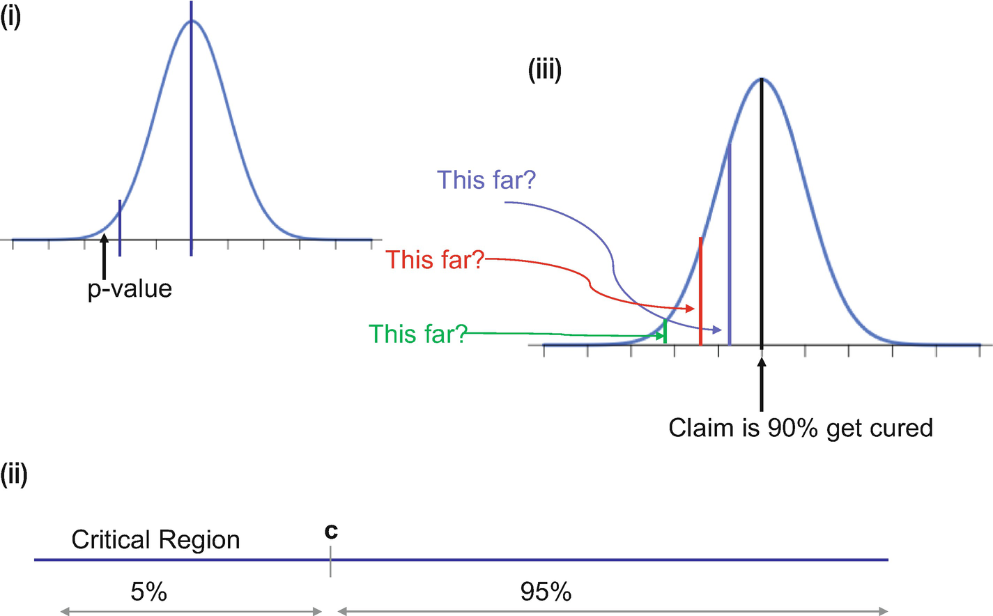

***Figure 3-1***

(i) The significance level has to be specified, that is, until what point we will accept the results and not reject the null hypothesis. (ii) The critical region is the 5% region shown in the middle image. (iii) The right side image is showing the p-value and how it falls in the critical region in this case.

We then define the critical region as “c” as shown in Figure [3-1(ii)](https://learning.oreilly.com/library/view/supervised-learning-with/9781484261569/html/499122_1_En_3_Chapter.xhtml#Fig1).

If X represents the number of diabetic patients cured, the critical region is defined as P(X<c) < α where α = 5%. In a 95% confidence interval, there is a 5% chance that the sample will not have the population mean. It is interpreted as, if a sample we are interested in falls in a critical region then we can safely reject the null hypothesis.

This is precisely the reason for 5% or 0.05 being referred to as the *significance level.* If we want a confidence interval of 99%, then 0.01 is the significance level.

Then the next step is to get the p-value. Refer to Figure [3-1(iii)](https://learning.oreilly.com/library/view/supervised-learning-with/9781484261569/html/499122_1_En_3_Chapter.xhtml#Fig1) for better understanding.

Formally out, *p-value* is the probability of getting a value up to and including the one in the sample in the direction of the critical region. It is a method to check if the results of a sample fall in the critical region of the hypothesis test. So, based on the p-value we take a call to reject or accept the null hypothesis.

Once the p-value is calculated, we analyze if the value falls in the critical region. If the answer we get is yes, we can reject the null hypothesis.

This knowledge of hypothesis testing and p-value is critical as it paves the way for identifying the *significant variables*. Whenever we train our ML algorithms, along with other results we get a p-value for each of the variables. As a rule of thumb, if the p-value is less than or equal to 0.05, the variable is considered as significant.

In this case, the null hypothesis is that the independent variable is not significant and does not impact the target variable. If the p-value is less than or equal to 0.05, we can reject the null hypothesis and hence can conclude that the variable is indeed significant. In the language of statistics, if the p-value for an independent variable x is less than or equal to 0.05, it suggests strong evidence against the null hypothesis as there is less than a 5% chance of the null hypothesis being correct. Or in other words, the variable x is a significant variable to make a prediction for the target variable y. But it does not mean there is 95% probability for the alternate hypothesis to be correct. To be noted is that p-value is a condition upon the null hypothesis and is unrelated to the alternate hypothesis.

We use the p-value to shortlist the significant variables and compare their respective importance. It is a universally accepted metric to choose significant variables.

We will now proceed to the concepts of classification algorithms in the next section.

**Classification Algorithms**

In our day-to-day business, we make decisions to either invest in stock or not, send a communication to a customer or not, accept a product or reject it, accept an application or ignore it. The basis of these decisions is some sort of insight we have about our business, our processes, our goals, and the factors which enter into our decision making. At the same time, we do expect a favorable output from this decision of ours.

*Supervised classified* algorithms are used to generate such insights and help us take that decision. They predict the probability for an event to happen or not. At the same time, depending on the choice of supervised learning algorithm, we get to know the factors which impact the occurrences of such an event.

Formally put, *classification* algorithms are a branch of supervised ML algorithms which are used to model the probability for a certain class. For example, if we want to perform binary classification, we will be modeling for two classes like pass or fail, healthy or sick, fraudulent or genuine, yes or no, and so on. It can be extended to multiclass classification problems—for example, good/bad/neutral, red/yellow/blue/green, cat/dog/horse/car, and so on.

Like a regression model, there is a target variable and independent variables. The only difference is that the target variable is categorical in nature. The independent variables used to make the predictions can be continuous or categorical, and it depends on the algorithm used for modeling.

The following use cases will make the usage of classification algorithms clear:

1. 1.

A retailer is losing its repeat customers, that is, customers who used to make purchases are not coming back. The supervised learning algorithm will help identify the customers who are more prone to churn and not come back. The retailer can then target those customers selectively and can offer discounts to bring them back to the business.

1. 2.

A manufacturing plant has to maintain the best quality of their products. And for that the technical team would like to ascertain if a particular combination of tools, raw materials, and physical conditions will lead to the best quality and yield. Supervised algorithms can help in that selection.

1. 3.

An insurance provider wants to model which customers should be given the policy or not. Depending on the customers’ previous history, employment details, transaction patterns, and so on, the decision has to be made. Here the classification ML model can help to predict acceptance score for the customers, which can be used to accept or reject the application.

1. 4.

A bank offering credit cards to its customers has to identify which incoming transactions are fraudulent and which are genuine. Based on the transaction details like origin, amount, time of transaction, mode, and other customer parameters, a decision has to be made. Supervised classification algorithms will be helpful to making that decision.

1. 5.

A telecom operator wishes to launch a new data product in the market. For it, the need is to target a few subscribers who have a higher probability of being interested in the product and recharging with it. Supervised classification algorithms will be able to generate a score for each subscriber and subsequently an offer can be made.

The preceding use cases are some of the pragmatic implementations in the industry. A classification algorithm generates a probability score for an event and accordingly the sales/marketing/operations/quality/risk teams can take a business call. Quite a powerful usage and very handy too!

There are quite a few algorithms which serve the purpose and we will be discussing a few in this chapter and rest in Chapter [4](https://learning.oreilly.com/library/view/supervised-learning-with/9781484261569/html/499122_1_En_4_Chapter.xhtml).

The algorithms which can be used are

* Logistic regression
* k-nearest neighbor
* Decision tree
* Random forest
* Naïve Bayes
* SVM
* Gradient boosting
* Neural networks

We are discussing the first five algorithms in this chapter and rest in the next chapter. Let us start the discussion with the logistic regression algorithm in the next section.

**Logistic Regression for Classification**

In Chapter [2](https://learning.oreilly.com/library/view/supervised-learning-with/9781484261569/html/499122_1_En_2_Chapter.xhtml) we learned how to predict the value for a continuous variable like number of customers, sales, rainfall, and so on using linear regression. Now we have to predict whether a customer will visit or not, whether the sale will go up or not, and so on. Using logistic regression, we can model and solve the preceding problems.

Formally put, logistic regression is a statistical model that utilizes logit function to model classification problems, that is, a categorical dependent variable. In the basic form, we model a *binary* classification problem and refer to it as binary logistic regression. In complex problems, where more than one categories have to be modeled, we use *multinomial* logistic regression.

Let us understand logistic regression by means of an example.

Consider we have to make a decision whether a credit card transaction is fraudulent or not. The response is binary (Yes or No); if the transaction seems promising it will be accepted, otherwise not. We will have incoming transaction attributes like amount, time of transaction, payment mode, and so on, and we have to make a decision based on them.

For such a problem, logistic regression models the probability of fraud. In the preceding case, the probability of fraud can be

Probability (fraud = Yes | amount)

The value for this probability will lie between 0 and 1. It can be interpreted as follows: given a value of “fraud amount” we can make a prediction for the genuineness of a credit card transaction.

The question arises of how we model such a relationship. If we use a *linear* equation, we can simply write it as

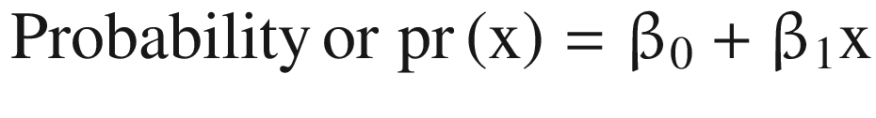

(Equation 3-1)

If we want to predict for “success” using “amount” by fitting the preceding formula, it can be represented in the form of the following graph. For the smaller values of the fraud amount, we can see that probability is less than zero while for the large values, fraud probability is greater than one. And both of these situations are not possible.

Hence, logistic regression is used to tackle this problem. Logistic regression uses the *sigmoid* function, which takes input as any real value and gives an output between 0 and 1. The standard *logistic regression* equation can be represented as in Equation 3-2 and shown in Figure [3-2](https://learning.oreilly.com/library/view/supervised-learning-with/9781484261569/html/499122_1_En_3_Chapter.xhtml#Fig2).

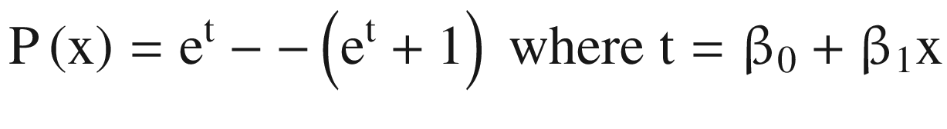

(Equation 3-2)

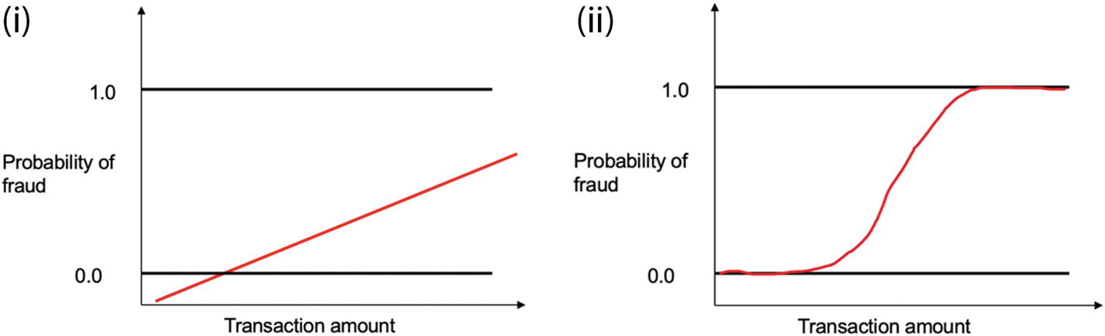

***Figure 3-2***

(i) Linear regression function will not be able to do justice to the task of predicting fraud. (ii) Logistic regression having an “S”-shaped curve will be more suitable as it will give scores between 0 and 1.

which can be rewritten as

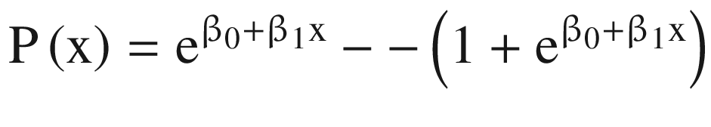

(Equation 3-3)

The next question that comes to mind is how to fit this equation. Recall in the case of linear regression, we want to make a prediction of the target variable as close to the actual values. A similar approach is followed here too. The fitting of the logistic regression is done using the *maximum likelihood* function. The likelihood function measures the goodness of fit of a statistical model and for logistic regression sometimes referred to as log-likelihood function. The mathematical proof is beyond the scope of the book.

If we manipulate Equation 3-3 we will get

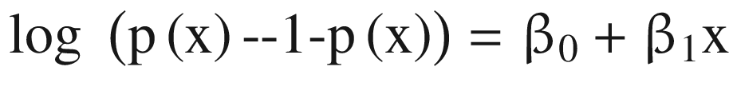

(Equation 3-4)

If we take a natural log of both the sides,

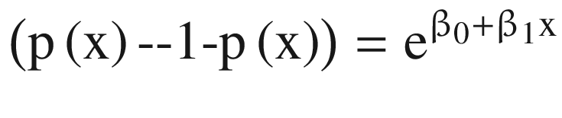

(Equation 3-5)

In Equation 3-5, the quantity 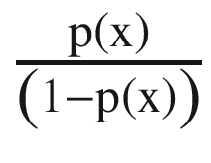 is referred to as *odds*. It iscalled odds because it is more intuitive as compared to probability, as odds are a common jargon in betting.

The term log 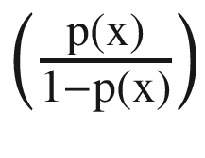 is called *logit*. If we compare with a linear regression equation, we can easily make out that with each unit increase in x, the logit (or sometimes called log-odds) changes by β**1**. This value can take any value between 0 and infinity. We can visualize the function in Figure [3-2(ii)](https://learning.oreilly.com/library/view/supervised-learning-with/9781484261569/html/499122_1_En_3_Chapter.xhtml#Fig2).

In most of the business problems, we have more than one independent variable and hence we use multinomial logistic regression to solve it. Mathematically, it can be represented as follows:

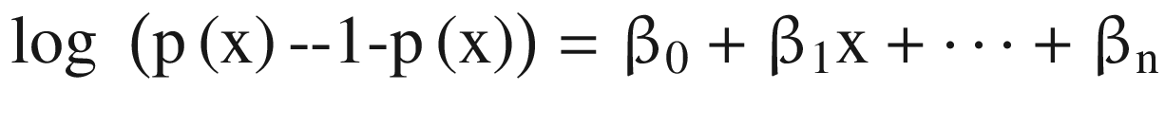

(Equation 3-6)

But there is a question which still remains unanswered: why do we need logistic regression when we have linear regression with us?

Let’s say a bank is making an assessment of its service quality, based on the customer’s historical transactions and service details. In such a case, the predicted response is going to be positive, negative, or neutral. We code these responses as

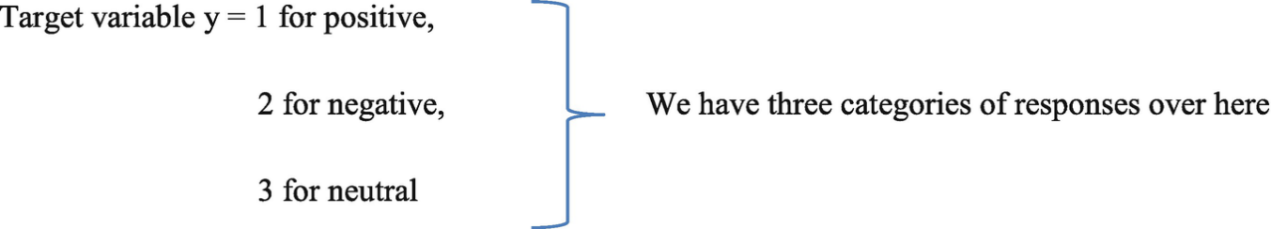

If we treat the target variable as a continuous variable, it means we have to predict the actual value of y. But this implies that positive is one less than negative and negative is one less than neutral. And the difference between positive and negative is the same as the difference between negative and neutral. This argument is intrinsically wrong and does not make any practical sense.

Moreover, even if we reduce the number of responses from three to two, let’s say positive and negative only, then too the linear regression might give us some probability score beyond 1 or less than 0, which is mathematically not possible. If we fit the best-found regression line, it still won’t be enough to decide any point by which we can differentiate between the two classes. It will classify some positive as negative and vice versa. Moreover, if we get a score of 0.5 from linear regression, should it be classified as positive or negative? And an outlier can completely mess the outputs for us. Hence it is practically more sensible to use a classification algorithm like logistic regression instead of a linear regression model to solve the problem.

Like linear regression, logistic regression has a few assumptions:

1. 1)

Being a classification algorithm, the outcome of the logistic regression model is a binary or dichotomous variable like success/fail, yes/no, or zero/one.

1. 2)

There exists a linear relationship between the logit of the outcome and each of the independent variables.

1. 3)

Outliers do not exist or at least there are no significant outliers for continuous variables.

1. 4)

There exists no correlation between the independent variables.

An important point to be noted is that the accuracy of the algorithm depends on the training data which has been used to train the algorithm. If the training data is not representative, then the resultant model will not be a robust one. The training data should conform to the data quality standards we discussed in Chapter [1](https://learning.oreilly.com/library/view/supervised-learning-with/9781484261569/html/499122_1_En_1_Chapter.xhtml). We will be revisiting this concept in detail in Chapter [5](https://learning.oreilly.com/library/view/supervised-learning-with/9781484261569/html/499122_1_En_5_Chapter.xhtml).

**Tip**

To be able to have a representative dataset, it is advisable to have a minimum of 10 data points for each of the independent variables with reference to their least frequent value. For example, for 20 independent variables and a least frequent outcome of 0.2, we should have (20*10)/0.2 = 1000 data points.

Key points to note about logistic regression:

1. 1)

The output of a logistic classification model generally is a probability score for an event. It can be used for both binary classification and multi classification problems.

1. 2)

Since the output is probability, it cannot go beyond 1 and cannot be less than 1. And hence the shape of the logistic curve is “S”.

1. 3)

It can handle any number of classes as the target variable as well as both categorical and continuous independent variables.

1. 4)

The maximum likelihood algorithm helps to determine the respective coefficients for the equation. It is not required for the independent variables to be normally distributed or have an equal variance in each group.

1. 5)

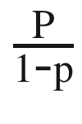 is the odds ratio and whenever this value is positive, the chances of success are above 50%.

1. 6)

The interpretation of coefficients is difficult in logistic regression as the relation is not straightforward as in the case of linear regression.

Before moving further, it is imperative to carefully examine the accuracy measurement methods. You are advised to be thorough with each of them. A vital component in supervised learning, indeed!

**Assessing the Accuracy of the Solution**

The objective to create an ML solution is to predict for future events. But before deploying the model to a production environment, it is imperative we measure the performance of the model. Moreover, we generally train multiple algorithms with multiple iterations. We have to choose the best algorithm based on the variously accurate KPIs. In this section, we are studying the most important accuracy assessment criteria.

The most important measures to measure the efficacy of a classification problem are as follows:

1. 1.

**Confusion matrix** : One of the most popular methods is *confusion matrix.* It can be used for both binary and multiclass problems. In its simplest form it is represented as a 2×2 matrix in Figure [3-3](https://learning.oreilly.com/library/view/supervised-learning-with/9781484261569/html/499122_1_En_3_Chapter.xhtml#Fig3).

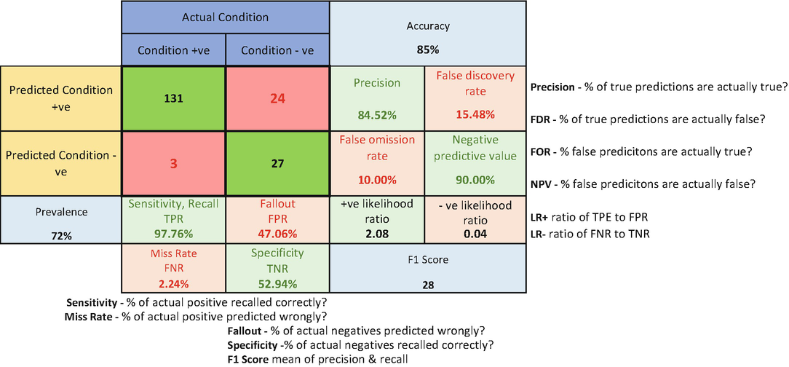

***Figure 3-3***

Confusion matrix is a great way to measure the efficacy of an ML model. Using it, we can calculate precision, recall, accuracy, and F1 score to get the model’s performance.

We will now learn about each of the parameters separately:

1. a.

**Accuracy**: Accuracy is how many predictions were made correctly. In the preceding example, the accuracy is (131+27)/ (131+27+3+24) = 85%

1. b.

**Precision**: Precision represents out of positive predictions; how many were actually positive. In the preceding example, precision is 131/ (131+24) = 84%

1. c.

**Recall or sensitivity**: Recall is how of all the actual positive events; how many we were able to capture. In this example, 131/ (131+3) = 97%

1. d.

**Specificity or true negative rate**: Specificity is out of actual negatives; how many were predicted correctly. In this example: 27/ (27+24) = 92%

1. 2.

**ROC curve and AUC value**: ROC or receiver operating characteristics is used to compare different models. It is a plot between TPR (true positive rate) and FPR (false positive rate). The area under the ROC curve (AUC) is a measure of how good a model is. The higher the AUC values, the better the model, as depicted in Figure [3-4](https://learning.oreilly.com/library/view/supervised-learning-with/9781484261569/html/499122_1_En_3_Chapter.xhtml#Fig4). The straight line at the angle of 45° represents 50% accuracy. A good model is having an area above 0.5 and hugging to the top left corner of the graph as shown in Figure [3-4](https://learning.oreilly.com/library/view/supervised-learning-with/9781484261569/html/499122_1_En_3_Chapter.xhtml#Fig4). The one in the green seems to be the best model here.

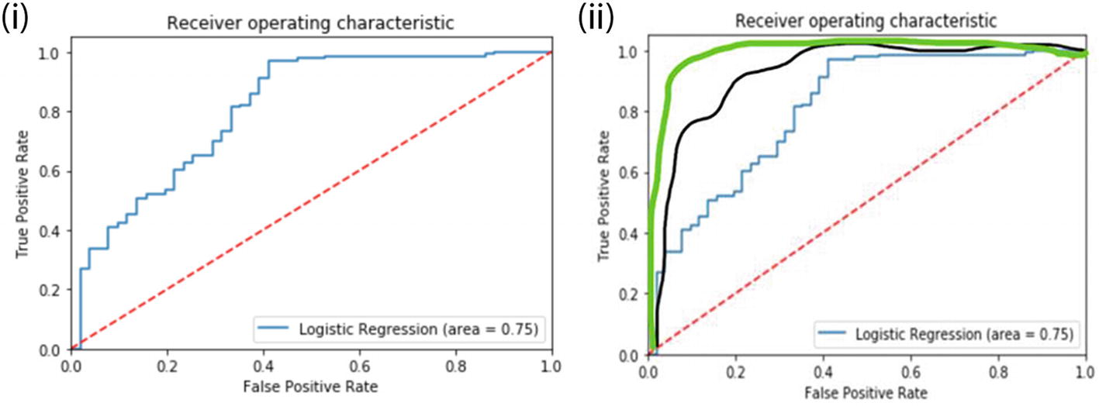

***Figure 3-4***

(i) ROC curve is shown on the left side. (ii) Different ROC curves are shown on the right. The green ROC curve is the best; it hugs to the top left corner and has the maximum AUC value.

1. 3.

**Gini coefficient**: We also use Gini coefficient to measure the goodness of a fit of our model. Formally put, it is the ratio of areas in a ROC curve and is a scaled version of the AUC.

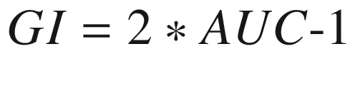

(Equation 3-7)

Similar to AUC values, a higher-value Gini coefficient is preferred.

1. 4.

**F1 score**: Many times, we face the problem of which KPI to choose (i.e., higher precision or higher recall) when we are comparing the models. F1 score solves this dilemma for us.



(Equation 3-8)

F1 score is the harmonic mean of precision and recall. The higher the F1 score, the better.

1. 5.

**AIC and BIC**: Akaike information criteria (AIC) and Bayesian information criteria (BIC) are used to choose the best model. AIC is derived from most frequent probability, while BIC is derived from Bayesian probability.



(Equation 3-9)

while

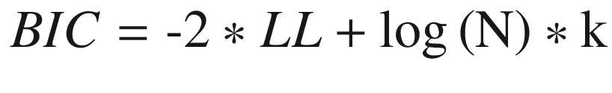

(Equation 3-10)

In both formulas, N is number of examples in training set, LL is log-likelihood of the model on training dataset, and k is the number of variables in the model. The log in BIC is natural log to the base e and is called natural algorithm.

We prefer lower values of AIC and BIC. AIC penalizes the model for its complexity, but BIC penalizes the model more than AIC. If we have a choice between the two, AIC will choose a more complex model as compared to BIC.

**Tip**

Given a choice between a very complex model and a simple model with comparable accuracy, choose the simpler one. Remember, nature always prefers simplicity!

1. 6.

**Concordance and discordance**: Concordance is one of the measures to gauge your model. Let us first understand the meaning of concordance and discordance.

Consider if you are building a model to predict if a customer will churn from the business or not. The output is the probability of churn. The data is shown in Table [3-1](https://learning.oreilly.com/library/view/supervised-learning-with/9781484261569/html/499122_1_En_3_Chapter.xhtml#Tab1).

***Table 3-1***

Respective Probability Scores for a Customer to Churn or Not

| Cust ID | Probability | Churn |
| --- | --- | --- |
| 1001 | 1 | 0.75 |
| 2001 | 0 | 0.24 |
| 3001 | 1 | 0.34 |
| 4001 | 0 | 0.62 |

Group 1: (churn = 1): Customer 1001 and 3001

Group 2: (churn = 0): Customer 2001 and 4001

Now we create the pairs by taking a single data point from Group 1 and one for Group 2 and then compare them. Hence, they will look like this:

Pair 1: 1001 and 2001

Pair 2: 1001 and 4001

Pair 3: 3001 and 2001

Pair 4: 3001 and 4001

By analyzing the pairs, we can easily make out that in the first three pairs the model is classifying the higher probability as churners. Here the model is correct in the classification. These pairs are called concordant pairs. Pair 4 is where the model is classifying the lower probability as churner, which does not make sense. This pair is called discordant. If the two pairs have comparable probabilities, this is referred to as tied pairs.

We can measure the quality using Somers D, which is given by

Somers D = (percentage concordant pair – percentage discordant pair). The higher the Somers D, the better the model.

Concordance alone cannot be a parameter to make a model selection. It should be used as one of the measures and other measures should also be checked.

1. 7.

**KS stats**: KS statistics or Kolmogorov-Smirnov statistics is one of the measures to gauge the efficacy of the model. It is the maximum difference between the cumulative true positive and cumulative false positive. The higher the KS, the better the model.

1. 8.

It is also a recommended practice to test the performance of the model on the following datasets and compare the KPIs:

* 1. a.

Training dataset: the dataset used for training the algorithm

* 1. b.

Testing dataset: the dataset used for testing the algorithm

* 1. c.

Validation dataset: this dataset is used only once and in the final validation stage

* 1. d.

Out-of-time validation: It is a good practice to have out-of-time testing. For example, if the training/testing/validation datasets are from Jan 2015 to Dec 2017, we can use Jan 2018–Dec 2018 as the out-of-time sample. The objective is to test a model’s performance on an unseen dataset.

These are the various measures which are used to check the model’s accuracy. We generally create more than one model using multiple algorithms. And for each algorithm, there are multiple iterations done. Hence, these measures are also used to compare the models and pick and choose the best one.

There is one more point we should be cognizant of. We would always want our systems to be accurate. We want to predict better if the share prices are going to increase or decrease or whether it will rain tomorrow or not. But sometimes, accuracy can be dubious. We will understand it with an example.

For example, while developing a credit card fraud transaction system our business goal is to detect transactions which are fraudulent. Now generally most (more than 99%) of the transactions are not fraudulent. This means that if a model predicts each incoming transaction as genuine, still the model will be 99% accurate! But the model is not meeting its business objective of spotting fraud transactions. In such a business case, recall is the important parameter we should target.

With this, we conclude our discussion of accuracy assessment. Generally, for a classification problem, logistic regression is the very first algorithm we use to baseline. Let us now solve an example of a logistic regression problem.

**Case Study: Credit Risk**

**Business Context**: Credit risk is nothing but the default in payment of any loan by the borrower. In the banking sector, this is an important factor to be considered before approving the loan of an applicant. Dream Housing Finance company deals in all home loans. They have presence across all urban, semiurban, and rural areas. Customers first apply for a home loan; after that company validates the customers’ eligibility for the loan.

**Business Objective** : The company wants to automate the loan eligibility process (real time) based on customer detail provided while filling out the online application form. These details are gender, marital status, education, number of dependents, income, loan amount, credit history, and others. To automate this process, they have given a problem to identify the customer segments that are eligible for loan amounts so that they can specifically target these customers. Here they have provided a partial dataset.

**Dataset**: The dataset and the code is available at the Github link for the book shared at the start of the chapter. A description of the variables is given in the following:

Variable Description

1. a.

Loan_ID: Unique Loan ID

1. b.

Gender: Male/Female

1. c.

Married: Applicant married (Y/N)

1. d.

Dependents: Number of dependents

1. e.

Education: Applicant Education (Graduate/Undergraduate)

1. f.

Self_Employed: Self-employed (Y/N)

1. g.

ApplicantIncome: Applicant income

1. h.

CoapplicantIncome: Coapplicant income

1. i.

LoanAmount: Loan amount in thousands

1. j.

Loan_Amount_Term: Term of loan in months

1. k.

Credit_History: credit history meets guidelines

1. l.

Property_Area: Urban/ Semi Urban/ Rural

1. m.

Loan_Status: Loan approved (Y/N)

Let’s start the coding part using logistic regression. We will explore the dataset, clean and transform it, fit a model, and then measure the accuracy of the solution.

**Step 1**: Import all the requisite libraries first. Importing seaborn for statistical plots, to split data frames into training set and test set, we will use sklearn package's data-splitting function, which is based on random function. To calculate accuracy measures and confusion matrices, we have imported metrics from sklearn.

import pandas as pd

from sklearn.linear_model import LogisticRegression

import matplotlib.pyplot as plt

import seaborn as sns

from sklearn.model_selection import train_test_split

import numpy as np

import os,sys

from scipy import stats

from sklearn import metrics

import seaborn as sn

%matplotlib inline

**Step 2**: Load the dataset using read_csv command. The output is shown in the following.

loan_df = pd.read_csv('CreditRisk.csv')

loan_df.head()

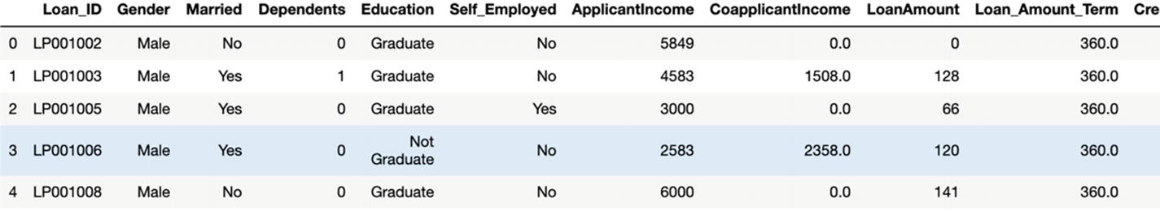

**Step 3**: Examine the shape of the data:

loan_df.shape

**Step 4**: credit_df = loan_df.drop('Loan_ID', axis =1 ) # dropping this column as it will be 1-1 mapping anyways:

credit_df.head()

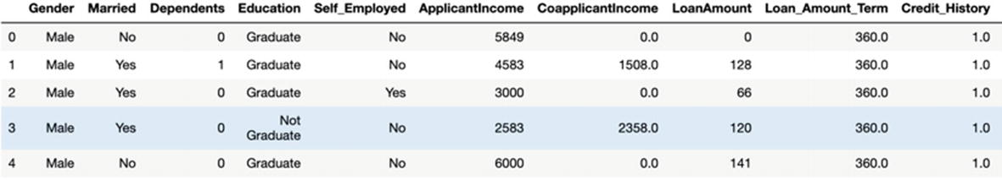

**Step 5**: Next normalize the values of the Loan Value and visualize it too.

credit_df['Loan_Amount_Term'].value_counts(normalize=True)

plt.hist(credit_df['Loan_Amount_Term'], 50)

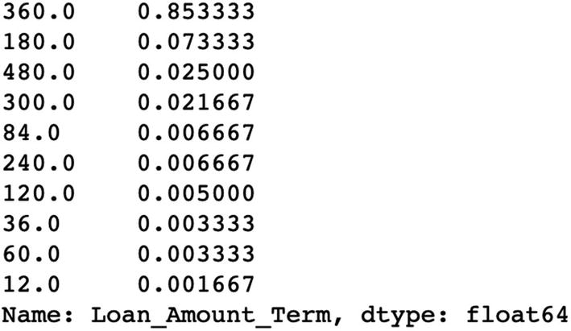

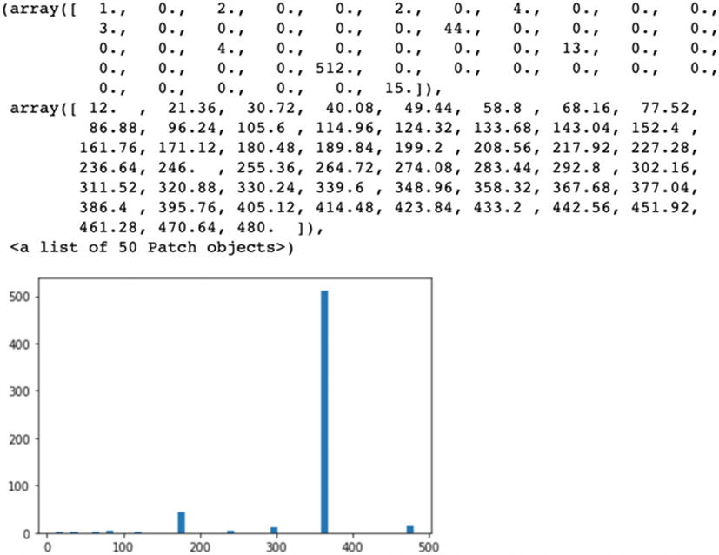

**Step 6**: Visualize the data next like a line chart.

plt.plot(credit_df.LoanAmount)

plt.xlabel('Loan Amount')

plt.ylabel('Frequency')

plt.title("Plot of the Loan Amount")

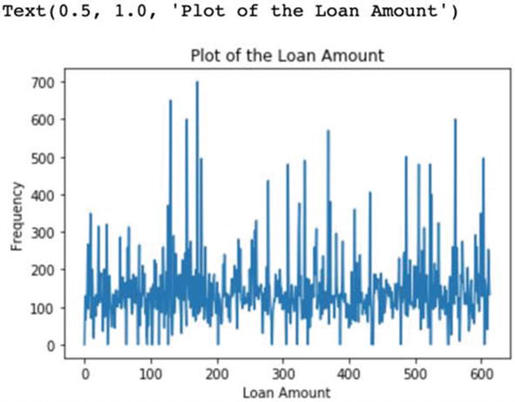

**Tip**

We have shown only one visualization. You are advised to generate more graphs and plots. Remember, plots are a fantastic way to represent data intuitively!

**Step 7**: The Loan_Amount_Term is highly skewed and hence we are deleting this variable.

credit_df.drop(['Loan_Amount_Term'], axis=1, inplace=True)

**Step 8**: Missing value treatment is done next and each variable’s missing value is replaced with 0. Compare the results after replacing the missing values with median.

credit_df = credit_df.fillna('0')

##credit_df = credit_df.replace({'NaN':credit_df.median()})

credit_df

**Step 9**: Next we will analyze how our variables are distributed.

credit_df.describe().transpose()

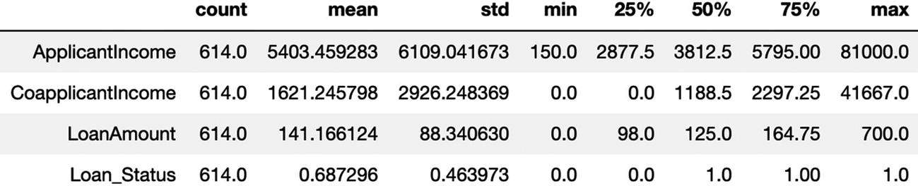

You are advised to create box-plot diagrams as we have discussed in Chapter [2](https://learning.oreilly.com/library/view/supervised-learning-with/9781484261569/html/499122_1_En_2_Chapter.xhtml).

**Step 10**: Let us look at the target column, ‘Loan_Status’, to understand how the data is distributed among the various values.

credit_df.groupby(["Loan_Status"]).mean()

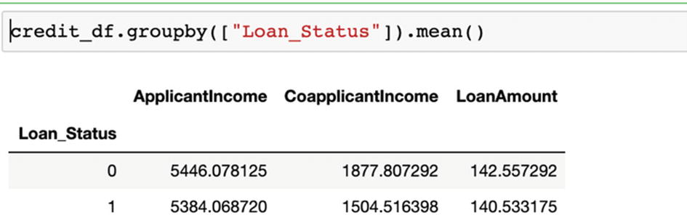

**Step 11**: Now we will convert X & Y variable to a categorical variable.

credit_df['Loan_Status'] = credit_df['Loan_Status'].astype('category')

credit_df['Credit_History'] = credit_df['Credit_History'].astype('category')

**Step 12**: Check the data types present in the data we have now as shown in the output:

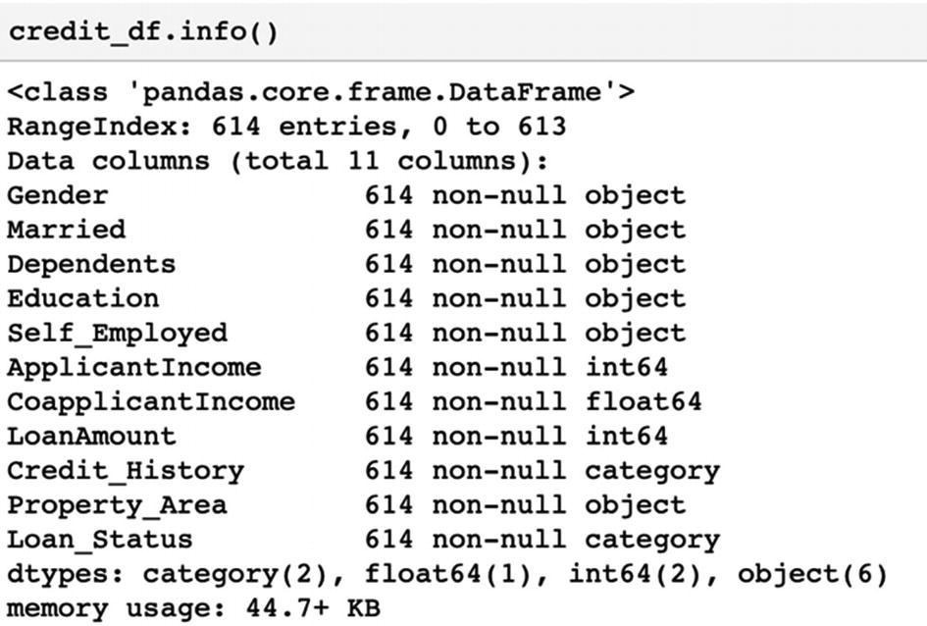

**Step 13**: Check how the data is balanced. We will get the following output.

prop_Y = credit_df['Loan_Status'].value_counts(normalize=True)

print(prop_Y)

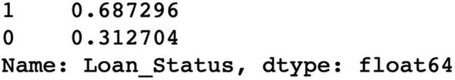

There seems to be a slight imbalance in the dataset as one class is 31.28% and the other is 68.72%.

**Note**

While the dataset is not heavily imbalanced, we will also examine how to deal with data imbalance in Chapter [5](https://learning.oreilly.com/library/view/supervised-learning-with/9781484261569/html/499122_1_En_5_Chapter.xhtml).

**Step 14**: We will define the X and Y variables now.

X = credit_df.drop('Loan_Status', axis=1)

Y = credit_df[['Loan_Status']]

**Step 15**: Using one-hot encoding we will convert the categorical variables to numeric variables:

X = pd.get_dummies(X, drop_first=True)

**Step 16**: Now split into training and test sets. We are splitting into a ratio of 70:30

from sklearn.model_selection import train_test_split

X_train, X_test, y_train, y_test = train_test_split(X, Y, test_size=0.30)

**Step 17**: Build the actual logistic regression model now:

import statsmodels.api as sm

logit = sm.Logit(y_train, sm.add_constant(X_train))

lg = logit.fit()

**Step 18**: We will now check the summary of the model. The results are as follows:

from scipy import stats

stats.chisqprob = lambda chisq, df: stats.chi2.sf(chisq, df)

print(lg.summary())

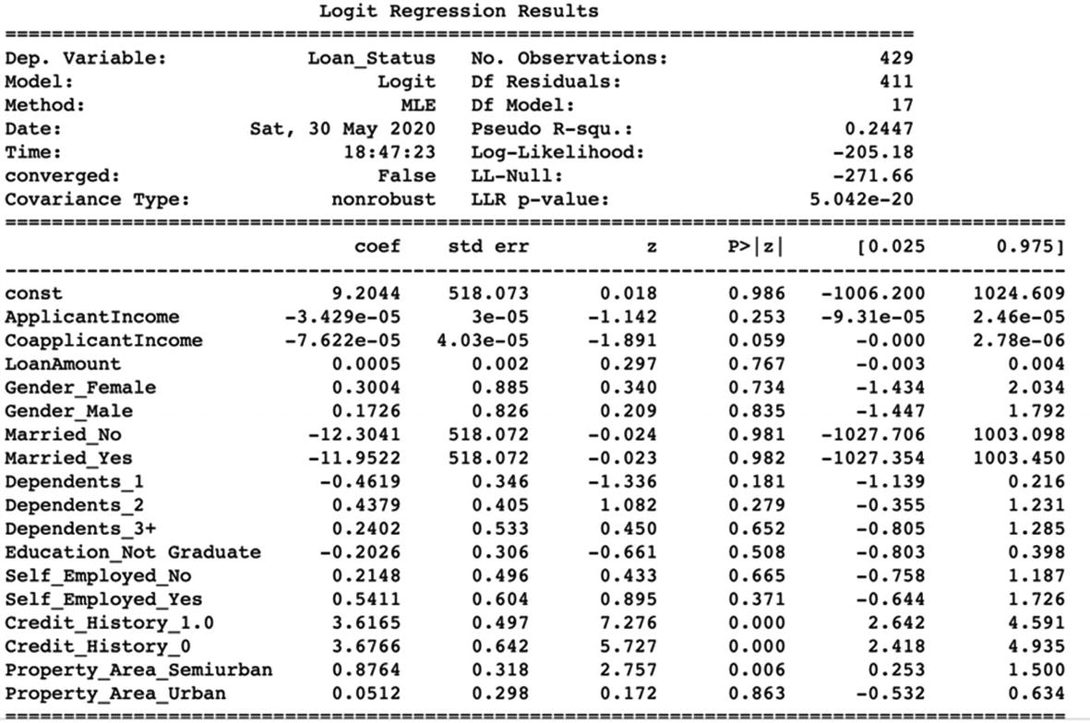

Let us interpret the results. The pseudo r-square shows that only 24% of the entire variation in the data is explained by the model. It is really not a good model!

**Step 19**: Next we will calculate the odds ratio from the coefficients using the formula odds ratio=exp(coef). Next we will calculate the probability from the odds ratio using the formula probability = odds / (1+odds).

log_coef = pd.DataFrame(lg.params, columns=['coef'])

log_coef.loc[:, "Odds_ratio"] = np.exp(log_coef.coef)

log_coef['probability'] = log_coef['Odds_ratio']/(1+log_coef['Odds_ratio'])

log_coef['pval']=lg.pvalues

pd.options.display.float_format = '{:.2f}'.format

**Step 20**: We will now filter all the independent variables by significant p-value (p value <0.1) and sort descending by odds ratio. We will get the following output:

log_coef = log_coef.sort_values(by="Odds_ratio", ascending=False)

pval_filter = log_coef['pval']<=0.1

log_coef[pval_filter]

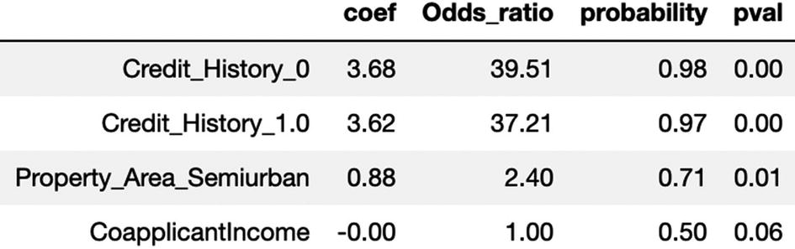

If we analyze the data, we can see that the customers who have credit history 1 have a 97% probability of defaulting the loan while the ones having history of 0 have 98% probability of defaulting.

Similarly, the customers in semiurban areas have odds of 2.50 times to default as compared to others.

**Step 21**: We are now fitting the model using the training data. The .fit is the function used for it.

from sklearn import metrics

from sklearn.linear_model import LogisticRegression

log_reg = LogisticRegression()

log_reg.fit(X_train, y_train)

**Step 22**: Once the model is ready and fit, we can use it to make a prediction. But first we have to check the accuracy of the model on the training data using confusion matrix; the output is as follows.

pred_train = log_reg.predict(X_train)

from sklearn.metrics import classification_report,confusion_matrix

mat_train = confusion_matrix(y_train,pred_train)

print("confusion matrix = \n",mat_train)

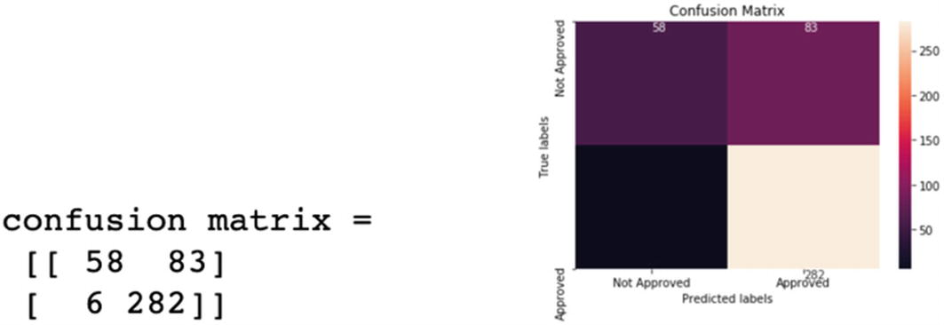

**Step 23**: Next we will make the prediction for test set and visualize it, and we will get the following output.

pred_test = log_reg.predict(X_test)

mat_test = confusion_matrix(y_test,pred_test)

print("confusion matrix = \n",mat_test)

ax= plt.subplot()

ax.set_ylim(2.0, 0)

annot_kws = {"ha": 'left',"va": 'top'}

sns.heatmap(mat_test, annot=True, ax = ax, fmt= 'g',annot_kws=annot_kws); #annot=True to annotate cells

ax.set_xlabel('Predicted labels');

ax.set_ylabel('True labels');

ax.set_title('Confusion Matrix');

ax.xaxis.set_ticklabels(['Not Approved', 'Approved']);

ax.yaxis.set_ticklabels(['Not Approved', 'Approved']);

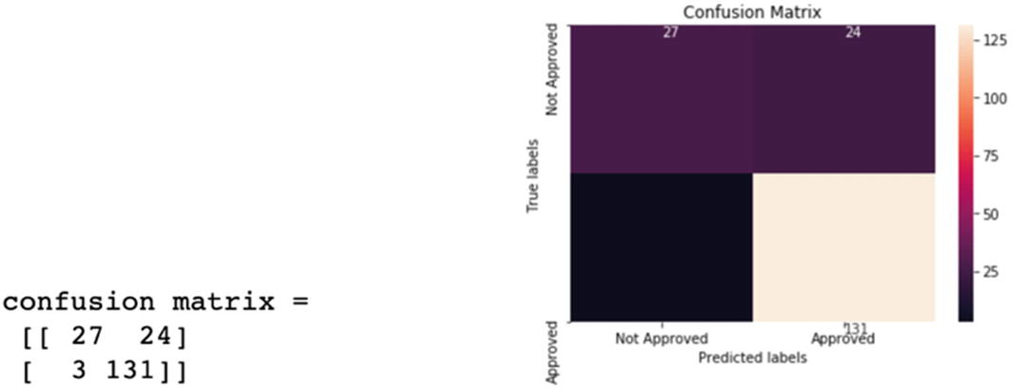

**Step 24**: Let us now create the AUC ROC curve and get the AUC score. We will get the following output.

from sklearn.metrics import roc_auc_score

from sklearn.metrics import roc_curve

logit_roc_auc = roc_auc_score(y_test, log_reg.predict(X_test))

fpr, tpr, thresholds = roc_curve(y_test, log_reg.predict_proba(X_test)[:,1])

plt.figure()

plt.plot(fpr, tpr, label='Logistic Regression (area = %0.2f)' % logit_roc_auc)

plt.plot([0, 1], [0, 1],'r--')

plt.xlim([0.0, 1.0])

plt.ylim([0.0, 1.05])

plt.xlabel('False Positive Rate')

plt.ylabel('True Positive Rate')

plt.title('Receiver operating characteristic')

plt.legend(loc="lower right")

plt.savefig('Log_ROC')

plt.show()

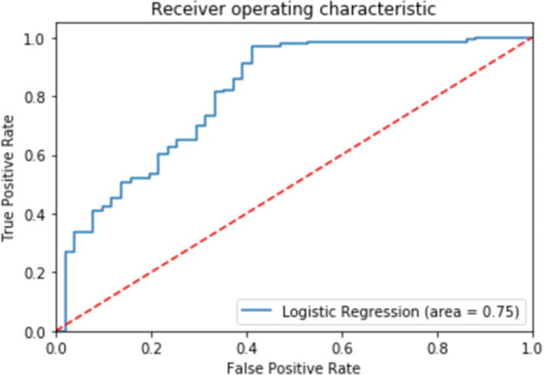

auc_score = metrics.roc_auc_score(y_test, log_reg.predict_proba(X_test)[:,1])

round( float( auc_score ), 2 )

The output is 0.81.

**Interpretations of the Results:** By comparing the training confusion matrix and testing confusion matrix, we can determine the efficacy of the solution as shown in the confusion matrix.

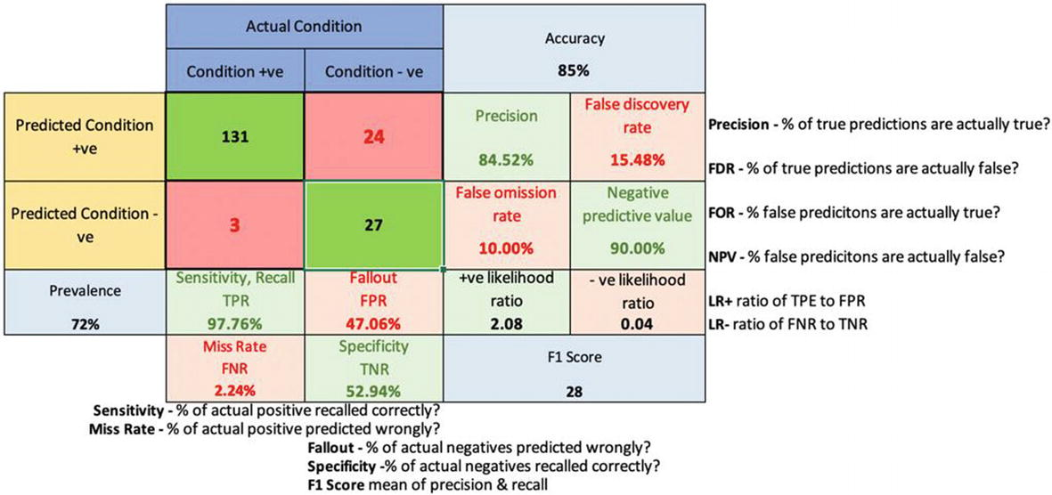

On testing data, the model’s overall accuracy is 85%. Sensitivity or recall is 97% and precision is 84%. The model has a good overall accuracy. However, the model can be improved as we can see that 24 applications were predicted as approved while they were actually not approved.

**Additional Notes**

You can do a quick visualization for all the variables in using only one command using the following code and as shown in the following graph. It depicts the relationship of loan status with all the variables.

import seaborn as sns

sns.pairplot(credit_df, hue="Loan_Status", palette="husl")

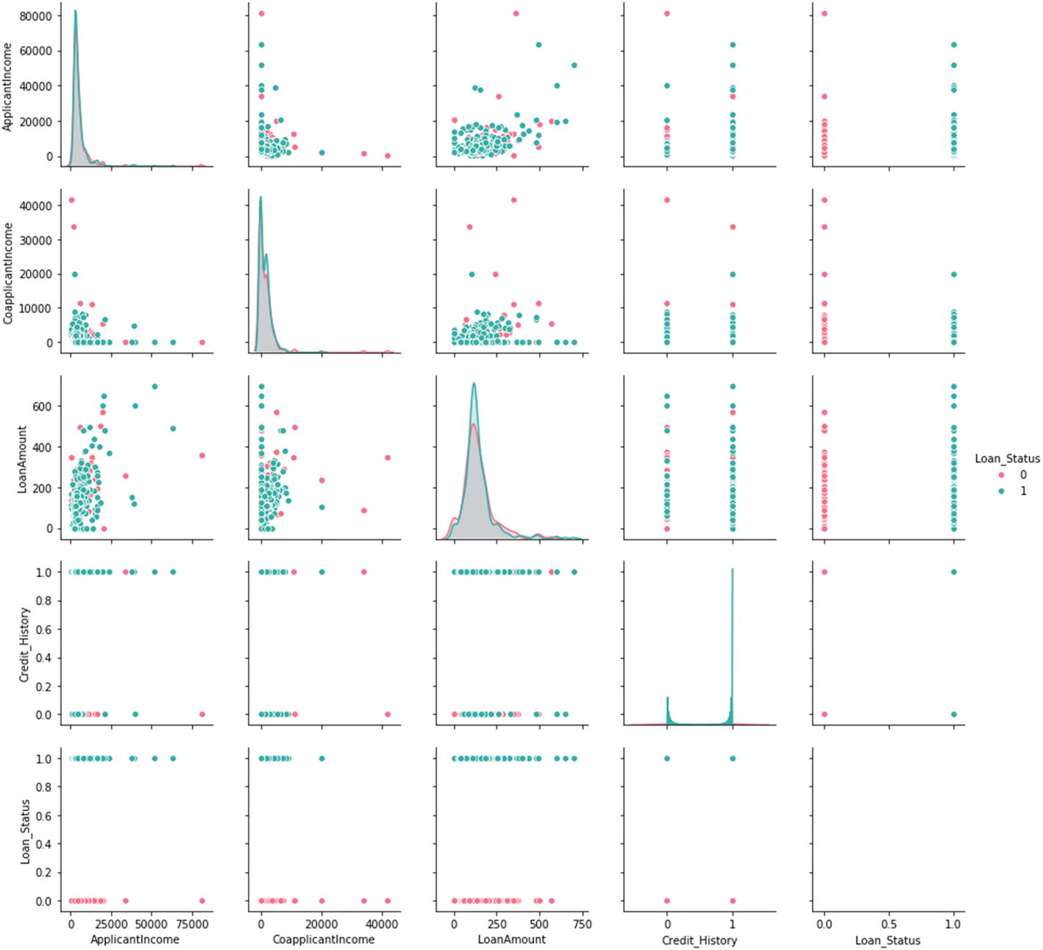

**Note**

If the testing accuracy is not similar to training accuracy and is significantly lower, it means the model is overfitting. We will study how to tackle this problem in Chapter [5](https://learning.oreilly.com/library/view/supervised-learning-with/9781484261569/html/499122_1_En_5_Chapter.xhtml).

Logistic regression is generally the first few algorithms which are used whenever we approach a classification problem. It is fast, easy to comprehend, and compact to handle categorical and continuous data points alike. Hence, it is quite popular. It can also be used to get the significant variables for a problem.

Now that we have examined logistic regression in detail, let us move to the second very important classifier used: naïve Bayes. Don’t go by the word “naïve”; this algorithm is quite robust in making classifications!

**Naïve Bayes for Classification**

Consider this: you are planning for camping. This trip will depend on a few factors like how the weather is, are there any predictions of rain, did you get a day off from the office, are your friends coming, and so on. You have the data from the history to make a prediction if you are going to camping or not which is shown in Table [3-2](https://learning.oreilly.com/library/view/supervised-learning-with/9781484261569/html/499122_1_En_3_Chapter.xhtml#Tab2).

***Table 3-2***

Factors to Consider When Planning a Camping Trip

| Day off | Weather | Friends coming | Humidity | Going camping |
| --- | --- | --- | --- | --- |
| Yes | Rainy | No | High | Yes |
| No | Sunny | Yes | Low | Yes |
| Yes | Overcast | No | Low | No |
| Yes | Rainy | No | High | Yes |
| Yes | Sunny | Yes | Low | Yes |
| Yes | Rainy | Yes | High | Yes |
| No | Sunny | No | High | No |
| No | Overcast | Yes | Low | Yes |

As shown in the table, the final decision to go camping or not is dependent on the outcome from other events. This brings us to the concepts of *conditional probability.* We will first discuss a few key points related to probability to help understand better:

1. 1)

If A is any event, then the complement of A, denoted by Â, is the event that A does not occur.

1. 2)

The probability of A is represented by P(A), and the probability of its complement P() = 1 – P(A).

1. 3)

Let A and B be any events with probabilities P(A) and P(B). If you are told that when B has occurred, then the probability of A might change. As in the previous case if the weather is rainy then the probability of camping changes. This new probability of A is called the *conditional probability* of A given B, which can be written as P(A|B).

1. 4)

Mathematically, 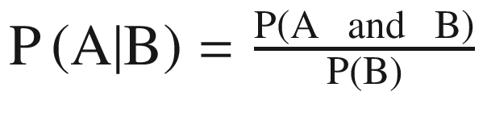 where P(A|B) means that probability of A given B which means the probability of A if B was known to have occurred.

1. 5)

This relationship can be viewed as *probabilistic* dependency and is called *conditional* probability. It means that knowledge of one event is of importance when assessing the probability of the other.

1. 6)

If the two events are mutually independent, then the multiplication rule simplifies to P (A and B) = P(A)P(B). For example, there will be no impact on your camping plans based on the price of milk.

There are many events which are mutually dependent on each other and hence it becomes imperative to understand the relationship: P(A|B) and P(B|A). This is true in the case of business activities too where the sales are dependent on the number of customers visiting the store, a customer will come back for shopping or not will depend on the previous experiences, and so on. Bayes’ theorem helps to model for such factors and make a prediction.

As per *Bayes’s rule*, if we have two events A and B. Then the conditional probability of A given B can be represented as

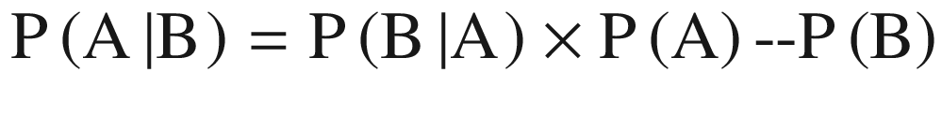

(Equation 3-11)

where P(A) and P(B): probability of A and B respectively, P(A|B): probability of A given B and P(B|A): probability of B given A.

For example, if we want to know in finding out a patient’s probability to have a heart disease if they have diabetes. The data we have is as follows: 10% of patients entering the clinic have heart disease while 5% of the patients have diabetes. Among the patients diagnosed with heart disease, 8% are diabetic. Then P(A) = 0.10, P(B) = 0.05, and P(B|A) = 0.08. And using Bayes’ rule, P(A|B) = (0.08×0.1)/0.05 = 0.16.

If we generalize the rule, let A**1** through A**n** be a set of mutually exclusive outcomes. The probabilities of the events A are P(A**1**) through P(A**n**). These are called *prior* probabilities. Because an information outcome might influence our thinking about the probabilities of any A**i**, we need to find the conditional probability P(A**i**|B) for each outcome A**i**. This is called the *posterior* probability of A**i**.

Using Bayes’ rule, we can say that



(Equation 3-12)

Bayes’ rule says that the posterior is the likelihood times the prior, divided by a sum of likelihood times priors. The denominator in Bayes’ rule is the probability P(B).



(Equation 3-13)

Bayes’ theorem is used for making classification (binary or multiclass), and it is referred to as *naïve Bayes.* It is called naïve due to a very strong assumption that the variables and features are independent of each other which is generally not true in the real world. Often this assumption is violated and still naïve Bayes tends to perform well. The idea is to factor all available evidence in the form of predictors into the naïve Bayes rule to obtain more accurate probability for class prediction.

As per Bayes’ rule, the naïve Bayes estimates conditional probability (i.e., the probability that something will happen, given that something else has already occurred). For example, if we want to design an email spam filter and find a given mail is spam if there is an appearance of the word “discount.” It is easy to implement, fast, robust, and quite accurate. Because of its ease of use, it is quite a popular technique.

Advantages of naïve Bayes algorithm:

1. 1.

It is a simple, easy, fast, and very robust method.

1. 2.

It does well with both clean and noisy data.

1. 3.

It requires few examples for training, but the underlying assumption is that the training dataset is a true representative of the population.

1. 4.

It is easy to get the probability for a prediction.

Disadvantages of naïve Bayes algorithm:

1. 1.

It relies on a very big assumption that independent variables are not related.

1. 2.

It is generally not suitable for datasets with large numbers of numerical attributes.

1. 3.

The predicted probabilities by the naïve Bayes algorithm is considered as less reliable in practice than predicted classes.

1. 4.

In some cases, it has been observed that if a rare event is not in training data but present in the test, then the estimated probability will be wrong.

But when some of our independent variables are continuous, we cannot calculate conditional probabilities! And hence in real-life variables, naïve Bayes is extended to Gaussian naïve Bayes.

In Gaussian naïve Bayes, continuous values associated with each attribute or independent variable are assumed to be following a Gaussian distribution. They are also easier to work with, as for the training we would only have to estimate the mean and standard deviation of the continuous variable.

Let us move to the case study to develop the naïve Bayes solution.

**Case Study: Income Prediction on Census Data**

**Business Objective**: We have census data and the objective is to predict whether income exceeds 50K/yr for an individual based on the value of other attributes.

**Dataset**: The dataset and code is available at the Github link shared at the start of this chapter.

Variable description:

* Age: continuous
* Workclass: Private, Self-emp-not-inc, Self-emp-inc, Federal-gov, Local-gov, State-gov, Without-pay, Never-worked.
* fnlwgt: continuous.
* Education: Bachelors, Some-college, 11th, HS-grad, Prof-school, Assoc-acdm, Assoc-voc, 9th, 7th-8th, 12th, Masters, 1st-4th, 10th, Doctorate, 5th-6th, Preschool.
* Education-num: continuous.
* Marital-status: Married-civ-spouse, Divorced, Never-married, Separated, Widowed, Married-spouse-absent, Married-AF-spouse.
* Occupation: Tech-support, Craft-repair, Other-service, Sales, Exec-managerial, Prof-specialty, Handlers-cleaners, Machine-op-inspct, Adm-clerical, Farming-fishing, Transport-moving, Priv-house-serv, Protective-serv, Armed-Forces.
* Relationship: Wife, Own-child, Husband, Not-in-family, Other-relative, Unmarried.
* Race: White, Asian-Pac-Islander, Amer-Indian-Eskimo, Other, Black.
* Sex: Female, Male.
* Capital-gain: continuous.
* Capital-loss: continuous.
* Hours-per-week: continuous.
* Native-country: United States, Cambodia, England, Puerto Rico, Canada, Germany, Outlying-US (Guam-USVI-etc), India, Japan, Greece, South, China, Cuba, Iran, Honduras, Philippines, Italy, Poland, Jamaica, Vietnam, Mexico, Portugal, Ireland, France, Dominican Republic, Laos, Ecuador, Taiwan, Haiti, Colombia, Hungary, Guatemala, Nicaragua, Scotland, Thailand, Yugoslavia, El Salvador, Trinadad&Tobago, Peru, Hong, Holland-Netherlands.
* Class: >50K, <=50K

**Step 1**: Import the necessary libraries here.

import pandas as pd

import numpy as np

from sklearn import preprocessing

from sklearn.model_selection import train_test_split# used to split the dataset into train and test datasets

from sklearn.naive_bayes import GaussianNB # To model the Gaussian Naive Bayes classifier

from sklearn.metrics import accuracy_score # To calculate the accuracy score of the model

**Step 2**: We now import the data. Please note that this file has a .data extension. Now for importing the census data, we are passing four parameters. The ‘adult.data’ parameter is the file name. The header parameter suggests whether the first row of data consists of headers of the file or not. For our dataset there are no headers and hence we can pass ‘None’. The delimiter parameter indicates the delimiter that is separating the data. Here, we are using the ‘ , ’ delimiter. This delimiter allows the method to delete the spaces before and after the data values. This is very helpful when there is inconsistency in spaces used with data values.

census_df = pd.read_csv('adult.data', header = None, delimiter=' *, *', engine="python")

**Step 3**: We are now adding the headers to the dataframe. It is required so that we are able to access the columns later and better:

census_df.columns = ['age', 'workclass', 'fnlwgt', 'education', 'education_num', 'marital_status', 'occupation', 'relationship', 'race', 'sex', 'capital_gain', 'capital_loss', 'hours_per_week', 'native_country', 'income']

**Step 4**: Let us print the total number of records (rows) in the dataframe:

len(census_df)

The output is 32561

**Step 5**: Check the presence of null values in our dataset, as follows:

census_df.isnull().sum()

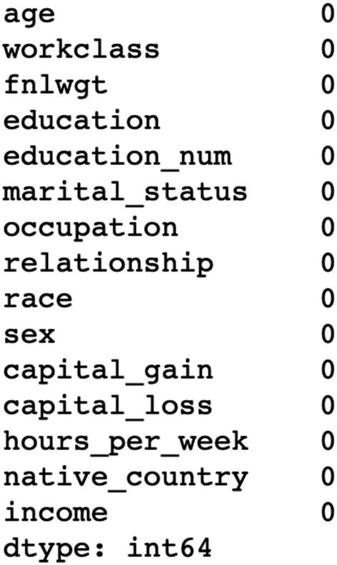

The preceding output shows that there is no “null” value in our dataset.

There can be some categorical variables having missing values. We will check that, sometimes they have “?” in place of missing values.

for value in ['workclass','education','marital_status','occupation','relationship','race','sex','native_country','income']:

    print(value,":", sum(census_df[value] == '?'))

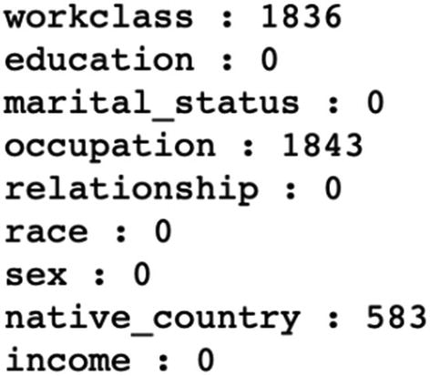

The output of the preceding code snippet shows that there are 1836 missing values in the workclass attribute, 1843 missing values in the occupation attribute, and 583 values in the native_country attribute.

**Step 6**: We will now proceed to data preprocessing. First, we will create a deep copy of our data frame:

census_df_rev = census_df.copy(deep=True)

**Step 7**: Before doing missing value handling tasks, we need some summary statistics of our data frame. For this, we can use the describe() method. It can be used to generate various summary statistics, excluding NaN values.

census_df_rev.describe(), as follows:

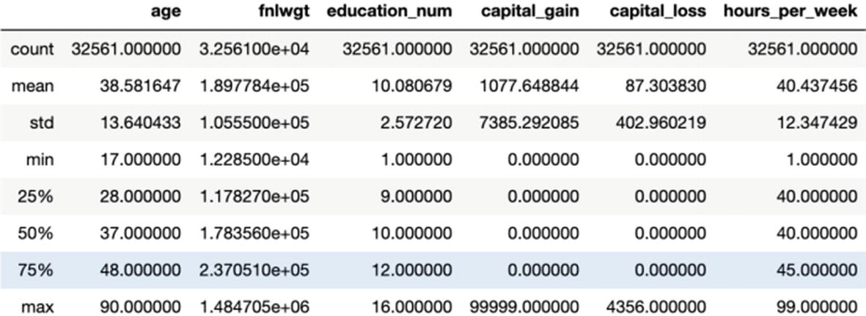

census_df_rev.describe(include= 'all')

If all is passed, it means we want to check the summary of all the attributes as follows:

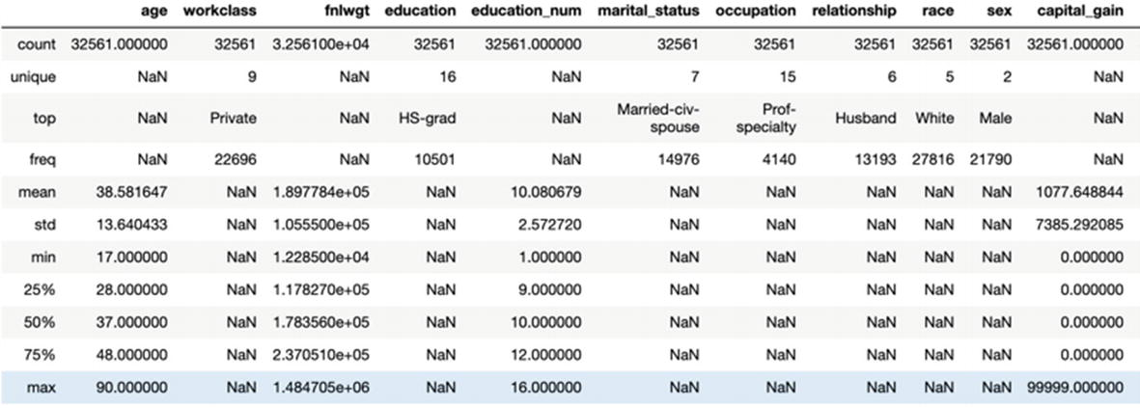

**Step 8**: We will now impute the missing categorical values:

for value in ['workclass','education','marital_status','occupation','relationship','race','sex','native_country','income']:

    replaceValue = census_df_rev.describe(include='all')[value][2]

    census_df_rev[value][census_df_rev[value]=='?'] = replaceValue

**Step 9**: One-hot encoding to convert all the categorical variables to numeric

le = preprocessing.LabelEncoder()

workclass_category = le.fit_transform(census_df.workclass)

education_category = le.fit_transform(census_df.education)

marital_category   = le.fit_transform(census_df.marital_status)

occupation_category = le.fit_transform(census_df.occupation)

relationship_category = le.fit_transform(census_df.relationship)

race_category = le.fit_transform(census_df.race)

sex_category = le.fit_transform(census_df.sex)

native_country_category = le.fit_transform(census_df.native_country)

**Step 10**: We will now initialize the encoded categorical columns:

census_df_rev['workclass_category'] = workclass_category

census_df_rev['education_category'] = education_category

census_df_rev['marital_category'] = marital_category

census_df_rev['occupation_category'] = occupation_category

census_df_rev['relationship_category'] = relationship_category

census_df_rev['race_category'] = race_category

census_df_rev['sex_category'] = sex_category

census_df_rev['native_country_category'] = native_country_category

**Step 11**: Look at the first few lines of our data:

census_df_rev.head()

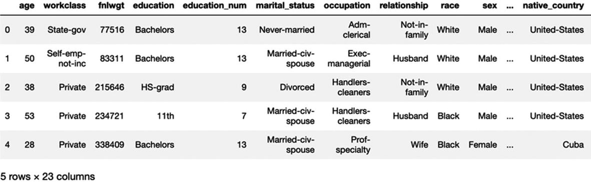

**Step 12**: There is no need of old categorical columns and we can drop them safely:

dummy_fields = ['workclass','education','marital_status','occupation','relationship','race', 'sex', 'native_country']

census_df_rev = census_df_rev.drop(dummy_fields, axis = 1)

**Step 13**: We will have to reindex all the columns and for that we will use the reindex_axis method.

census_df_rev = census_df_rev.reindex_axis(['age', 'workclass_category', 'fnlwgt', 'education_category', 'education_num', 'marital_category', 'occupation_category', 'relationship_category', 'race_category', 'sex_category', 'capital_gain', 'capital_loss', 'hours_per_week', 'native_country_category', 'income'], axis= 1) census_df_rev.head(5)

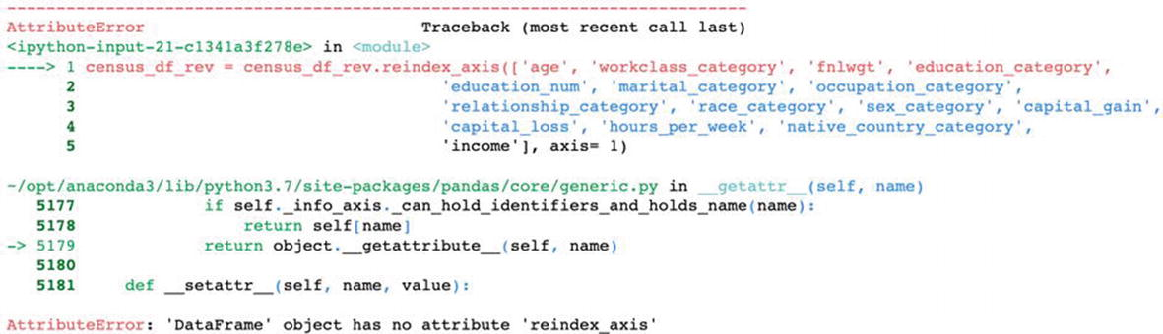

The method has deprecated and hence we will receive this error, as shown in the preceding illustration. Hence, let’s use a newer method and we will not get the error shown.

census_df_rev = census_df_rev.reindex(['age', 'workclass_category', 'fnlwgt', 'education_category', 'education_num', 'marital_category', 'occupation_category',  'relationship_category', 'race_category', 'sex_category', 'capital_gain',  'capital_loss', 'hours_per_week', 'native_country_category', 'income'], axis= 1)

census_df_rev.head(5)

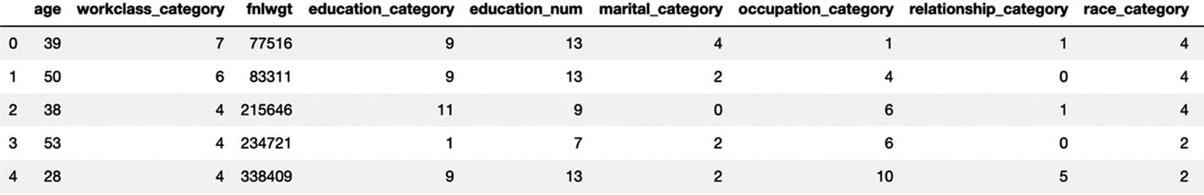

**Step 14**: We will now get our data arranged into dependent variables and target variable:

X = census_df_rev.values[:,:14]  ## These are the input variables

Y = census_df_rev.values[:,14]  ## This is the Target variable

**Step 15**: Now split the data into train and test in the ratio of 75:25.

X_train, X_test, Y_train, Y_test = train_test_split(X, Y, test_size = 0.25, random_state = 5)

**Step 16**: We will fit the naïve Bayes model now.

clf = GaussianNB()

clf.fit(X_train, Y_train)

**Step 17**: The model classifier is now trained using training data and is ready to make predictions. We can use the predict() method with test set features as its parameters.

Y_pred = clf.predict(X_test)

**Step 18**: Check the accuracy of the model now.

accuracy_score(Y_test, Y_pred, normalize = True)

The accuracy we are getting is 0.79032.

With it we have implemented naïve Bayes using a live dataset. You are advised to understand each of the steps and practice the solution by replicating it.

Naïve Bayes is a fantastic algorithm to practice and use. Bayesian statistics is gathering a lot of attention and its power is being harnessed in research areas a lot. You might have heard the term *Bayesian optimization* . The beauty of the Bayes’ theorem lies in its simplicity, which is very much visible in our day-to-day life. A straightforward method indeed!

We have covered logistic regression and naïve Bayes so far. Now we will examine one more very widely used classifier called *k-nearest neighbor*. One of the popular methods, easy to understand and implement—let’s study knn next.

**k-Nearest Neighbors for Classification**

“Birds of the same feather flock together .” This old adage is perfect for k-nearest neighbors. It is one of the most popular ML techniques where the learning is based on the similarity of data points with each other. knn is a *nonparametric* model; it does not construct a “model” and the classification is based on a simple majority vote from the neighbors. It can be used for classification where the relationship between attributes and target classes is complex and difficult to understand, and yet items in a class tend to be fairly homogenous on the values of attributes. But it might not be the best choice for an unclean dataset or where the target classes are not distinctively clear. If the target classes are not clearly demarcated, then it leads to an obvious confusion while taking the majority vote. knn can also be used for regression problems to make a prediction for a continuous variable. In the case of regression, the final output will be the average of the values of the neighbors and that average will be assigned to the target variable. Let us examine this visually:

For example, we have some data points represented by circles and plus signs in a vector space diagram as shown in Figure [3-5](https://learning.oreilly.com/library/view/supervised-learning-with/9781484261569/html/499122_1_En_3_Chapter.xhtml#Fig5). There are clearly two classes in this case. The objective is to classify a new data point (marked in yellow) shown in Figure [3-5](https://learning.oreilly.com/library/view/supervised-learning-with/9781484261569/html/499122_1_En_3_Chapter.xhtml#Fig5)(ii) and identify which class it belongs to.

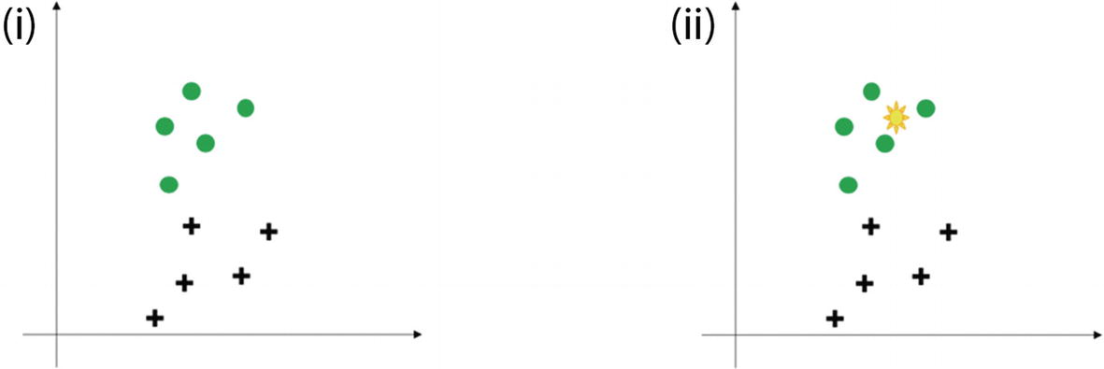

***Figure 3-5***

(i) The distribution of two classes in green circle and black plus sign. (ii) The right side shows the new data point which has to be classified (shown in yellow sign). The k-nearest neighbor algorithm has to be used to make the classification.

This yellow point can be a circle or a plus sign and nothing else. knn will help in this classification by taking a vote of majority from the other data points in the vicinity. And the value of “k” will guide us on how many data points to be considered for voting. Let’s assume we took k = 4. Hence, we will now make a circle with a yellow point as the center. And the circle should be just as big as to enclose only four data points. It is represented in Figure [3-6](https://learning.oreilly.com/library/view/supervised-learning-with/9781484261569/html/499122_1_En_3_Chapter.xhtml#Fig6)(i).

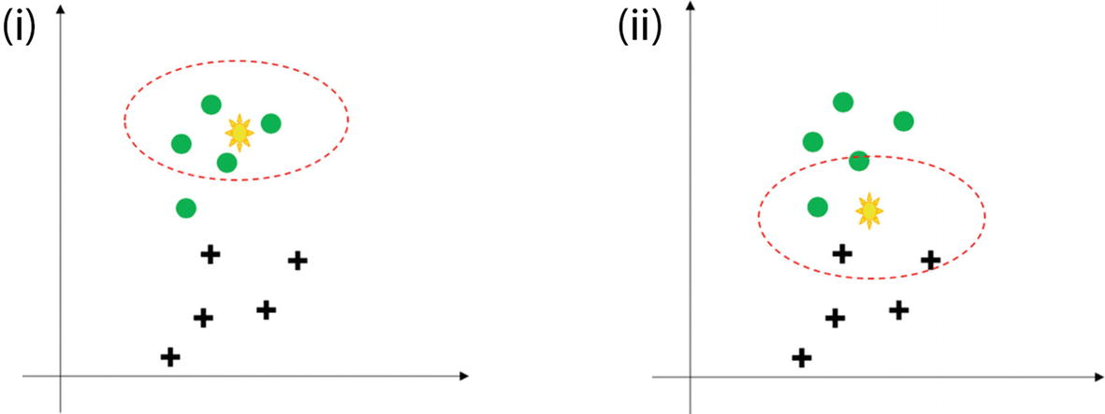

***Figure 3-6***

(i) The presence of new unseen data if we select four nearest neighbors. It is an easy decision to make. (ii) The right side shows that the new data point is difficult to classify as the four neighbors are mixed.

The four closest points to the yellow point all belong to circles or we can say that all the *neighbors* of the unknown yellow point are circles. Hence, with a good confidence level we can predict that the yellow point should belong to the circle. Here the choice was comparatively easy and straightforward. Refer to Figure [3-6](https://learning.oreilly.com/library/view/supervised-learning-with/9781484261569/html/499122_1_En_3_Chapter.xhtml#Fig6)(ii), where it is not that simple. Hence, the choice of k plays a very crucial role.

The steps which are followed in k-nearest neighbor are as follows:

1. 1.

We receive the raw and unclassified dataset which has to be worked upon.

1. 2.

We choose a distance matrix from Euclidean, Manhattan or Minkowski.

1. 3.

Then calculate the distance between the new data points and the known classified training data points.

1. 4.

The number of neighbors to be considered is defined by the value of “k”.

1. 5.

It is followed by comparing with the list of classes which have the shortest distance and count the number of times each class appears.

1. 6.

The class with the highest votes wins. This means that the class which has the highest frequency and has appeared the greatest number of times is assigned to the unknown data point.

**Tip**

Parametric models make some assumptions about the input data like having a normal distribution. However, nonparametric methodology believes that data distributions are undefinable by a finite set of parameters and hence do not make any assumptions.

From the steps discussed for k-nearest neighbor, we can clearly understand that the final accuracy depends on the distance matrix used and the value of “k”.

Popular distance matrices used are

1. 1.

**Euclidean Distance** : probably the most common and easiest way to calculate between two points. It is square root of the sum of the squares of distances:

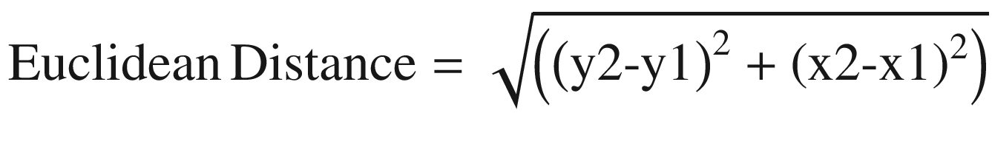

(Equation 3-14)

1. 2.

**Manhattan Distance** : The distance between two points measured along axes at right angles. Sometimes it is also referred to as city block distance. In a plane with p1 at (x1, y1) and p2 at (x2, y2), it is

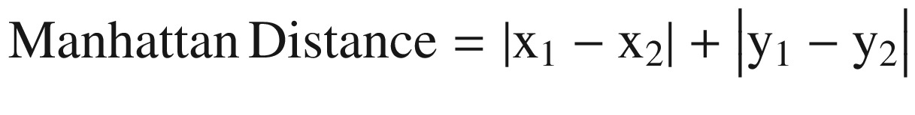

(Equation 3-15)

1. 3.

**Minkowski Distance** : This is a metric in a normed vector space. Minkowski distance is used for distance similarity of vectors. Given two or more vectors, find the distance similarity of these vectors. Mainly, the Minkowski distance is applied in ML to find out the distance similarity. It is a generalized distance metric and can be represented by the following formula:

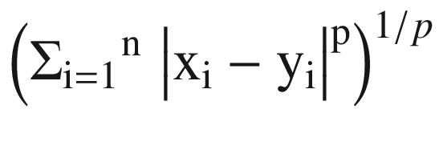

(Equation 3-16)

where by using different values of p we can get different values of distances. With the value of p = 1 we get Manhattan distance, with p = 2 we get Euclidean distance, and with p= ∞ we get Chebychev distance.

1. 4.

**Cosine Similarity**: It is a measure of similarity between two nonzero vectors of an inner product space that measures the cosine of the angle between them. The cosine of 0° is 1, and it is less than 1 for any angle in the interval (0,π] radians.

The various distances can be viewed as shown in Figure [3-7](https://learning.oreilly.com/library/view/supervised-learning-with/9781484261569/html/499122_1_En_3_Chapter.xhtml#Fig7).

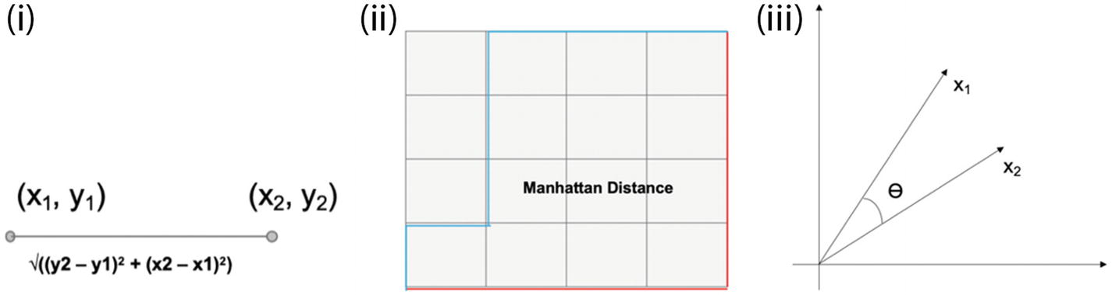

***Figure 3-7***

(i) Euclidean distance; (ii) Manhattan distance; (iii) cosine similarity

**Tip**

While approaching a knn problem, generally we start with Euclidean distance. In most business problems, it serves the purpose. Distance matrix is an important parameter in unsupervised clustering methods like k-means clustering.

The diagram below provides a summary of the different distance methods we have discussed and the decision process for choosing one over another for a particular problem. While it is not exhaustive, we hope it provides a starting point for your own clustering applications.

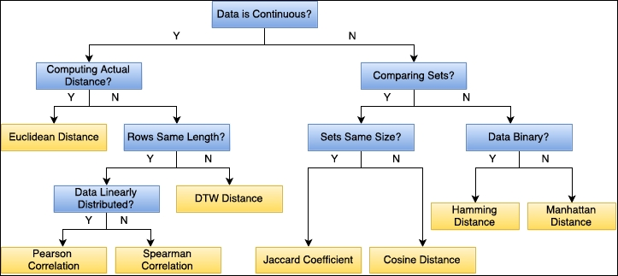

Advantages of k-nearest neighbor

1. 1.

It is a nonparametric method and does not make any assumptions about distributions of the various classes in vector space.

1. 2.

It can be used for the binary classification as well as multiclassification problems.

1. 3.

The method is quite easy to comprehend and implement.

1. 4.

The method is robust and if the value of k is large, it is not impacted by outliers.

Disadvantages of k-nearest neighbor

1. 1.

The accuracy depends on the value of k and hence finding the most optimal value can be a difficulty sometimes.

1. 2.

The method requires the class distributions to be non-overlapping.

1. 3.

There is no specific output as a model and if the value of k is small, it is negatively impacted by the presence of outliers.

1. 4.

The method is calculation intensive as it is a *lazy learner*. The distances have to be calculated between all the points and then a majority is to be taken. And hence, it is not that fast of a method to use.

There are other forms of knn too, which are as follows:

**Radius Neighbor Classifier**

1. 1.

This classifier implements the learning based on a number of neighbors. The neighbors are within a fixed radius r of each training point, where r is a floating point value specified by the user.

1. 2.

We prefer this method when the data sampling is not uniform. But, in case of quite a few independent variables and a sparse dataset, it suffers with the *curse of dimensionality.*

**Tip**

When the number of dimensions increases, the volume of space increases at a very fast pace and the resultant data becomes very sparse. This is called the curse of dimensionality. Data sparsity makes statistical analysis for any dataset quite a challenging task.

**KD Tree Nearest Neighbor**

1. 1.

This method is effective if the dataset is large but the number of independent variables is less.

1. 2.

The method takes less time to compute as compared to other methods.

It is now time to create a Python solution using knn, which we are executing next.

**Case Study: k-Nearest Neighbor**

The dataset to be audited, which consists of a wide variety of intrusions simulated in a military network environment, was provided. It created an environment to acquire raw TCP/IP dump data for a network by simulating a typical US Air Force LAN. The LAN was focused like a real environment and blasted with multiple attacks. A connection is a sequence of TCP packets starting and ending at some time duration between which data flows to and from a source IP address to a target IP address under some well-defined protocol. Also, each connection is labeled either as normal or as an attack with exactly one specific attack type. Each connection record consists of about 100 bytes. For each TCP/IP connection, 41 quantitative and qualitative features are obtained from normal and attack data (3 qualitative and 38 quantitative features).

The class variable has two categories: normal and anomalous.

**The Dataset**

The dataset is available at the git repository as Network_Intrusion.csv file. The code is also available at the Github link shared at the start of the chapter.

**Business Objective**

We have to fit a k-nearest neighbor algorithm to detect network intrusion.

**Step 1**: Import all the required libraries. We are importing pandas, numpy, matplotlib, seaborn.

import pandas as pd

import numpy as np

import seaborn as sns

import matplotlib.pyplot as plt

%matplotlib inline

**Step 2**: Import the dataset using read.csv method from pandas. Let’s have a look at the top five rows of the data first as follows:

network_data= pd.read_csv('Network_Intrusion.csv')

network_data.head()

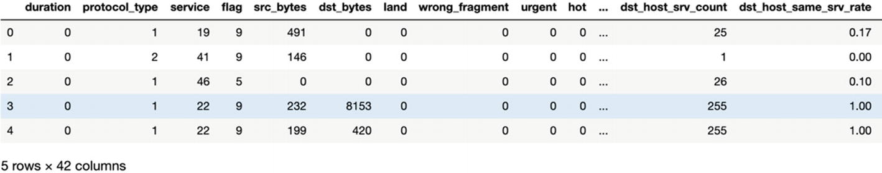

**Step 3**: Now we will do the regular checkup of the data using info() and describe command.

network_data.info()

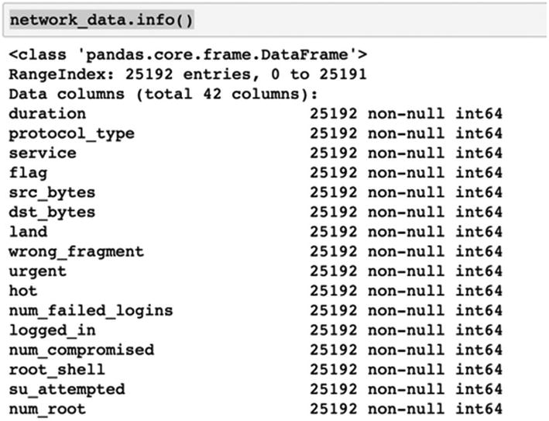

network_data.describe().transpose()

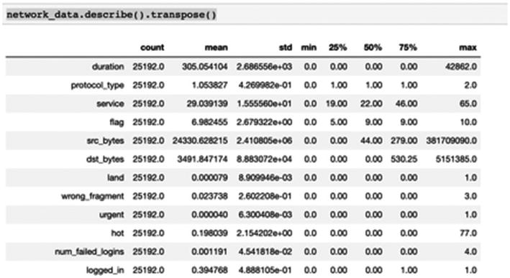

**Step 4**: Now check for the null values. In our dataset there are no null values fortunately.

network_data.isnull().sum()

**Note**

This dataset does not have any null values; we will study in detail on how to deal with null values, NA, NaN, and so on in Chapter [5](https://learning.oreilly.com/library/view/supervised-learning-with/9781484261569/html/499122_1_En_5_Chapter.xhtml).

**Step 5**: Let’s have a look at the class distribution. And we will visualize it too.

network_data["class"].value_counts(normalize=True)

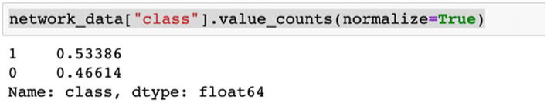

pd.value_counts(network_data["class"]).plot(kind="bar")

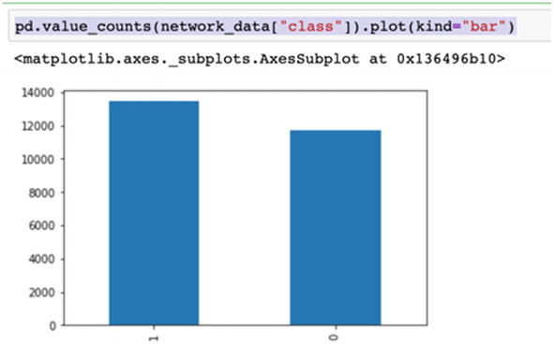

**Step 6**: There are a few categorical variables in our dataset. We have to convert them to numerical variables using *one-hot encoding* *.*

from sklearn.preprocessing import LabelEncoder

label_encoder = LabelEncoder()

network_data['class'] = label_encoder.fit_transform(dataset['class'])

network_data['protocol_type'] = label_encoder.fit_transform(dataset['protocol_type'])

network_data['service'] = label_encoder.fit_transform(dataset['service'])

network_data['flag'] = label_encoder.fit_transform(dataset['flag'])

**Step 7**: One-hot encoding increases the number of variables in the dataset. Let’s see the number of columns in the dataset with added variables:

network_data.columns

**Step 8**: Next we will standardize our dataset by using StandardScaler in scikit learn.

from sklearn import preprocessing

from sklearn.preprocessing import StandardScaler

X_std = pd.DataFrame(StandardScaler().fit_transform(network_data))

X_std.columns = network_data.columns

**Step 9**: Now it is the time to split the data in train and test. We are dividing the data in an 80:20 ratio.

import numpy as np

from sklearn.cross_validation import train_test_split

X = np.array(network_data.ix[:, 1:5]) #Transform data into features

y = np.array(network_data['class']) #Transform data into targets

X_train, X_test, y_train, y_test = train_test_split(X, y, test_size=0.2, random_state=7)

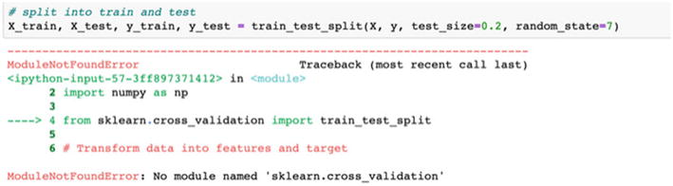

**Step 10**: The sklearn.cross_validation has deprecated and hence we received this error. Again, try to split in train and test using sklearn.model_selection.

from sklearn.model_selection import train_test_split

# Transform data into features and target

X = np.array(network_data.ix[:, 1:5])

y = np.array(network_data['class'])

# split into train and test

X_train, X_test, y_train, y_test = train_test_split(X, y, test_size=0.2, random_state=7)

**Step 11**: Print the shape of the data by print(X_train.shape).

print(y_train.shape)

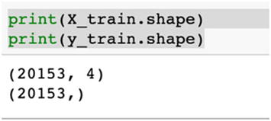

**Step 12**: Print the shape of the test data by print(X_test.shape).

print(y_test.shape)

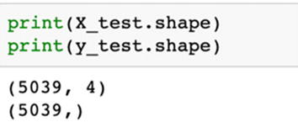

**Step 13**: We will now train the model using training data and iterate with different values of k=3,5,9.

from sklearn.neighbors import KNeighborsClassifier

from sklearn.metrics import accuracy_score

from sklearn.metrics import recall_score

# instantiate learning model (k = 3)

knn_model = KNeighborsClassifier(n_neighbors = 3)

Fitting the model

knn_model.fit(X_train, y_train)

y_pred = knn_model.predict(X_test) # predict the response

print(accuracy_score(y_test, y_pred)) # Evaluate accuracy

The answer is 0.9902758483826156

knn_model = KNeighborsClassifier(n_neighbors=5) # With k = 5

knn_model.fit(X_train, y_train) # Fitting the model

y_pred = knn_model.predict(X_test) # Predict the response

print(accuracy_score(y_test, y_pred)) # Evaluate accuracy

The answer is 0.9882913276443739

With k = 9

knn_model = KNeighborsClassifier(n_neighbors=9)

knn_model.fit(X_train, y_train) # Fitting the model

y_pred = knn_model.predict(X_test) # Predict the response

print(accuracy_score(y_test, y_pred)) # Evaluate accuracy

The answer is 0.9867037110537805

**Step 14**: We have tested with three values of k. We will now iterate on multiple values of k. We will run the knn with the no. of neighbors to be 1,3,5…19 and then find the optimal number of neighbors based on the lowest misclassification error.

k_list = list(range(1,20)) # creating odd list of K for KNN

k_neighbors = list(filter(lambda x: x % 2 != 0, k_list)) # subsetting just the odd ones

ac_scores = [] # empty list that will hold accuracy scores

# perform accuracy metrics for values from 1,3,5....19

for k in k_neighbors:

    knn_model = KNeighborsClassifier(n_neighbors=k)

    knn_model.fit(X_train, y_train)

    y_pred = knn_model.predict(X_test)   # predict the response

    scores = accuracy_score(y_test, y_pred)  # evaluate accuracy

    ac_scores.append(scores)

# changing to misclassification error

MSE = [1 - x for x in ac_scores]

# determining best k

optimal_k = k_neighbors[MSE.index(min(MSE))]

print("The optimal number of neighbors is %d" % optimal_k)

**Step 15**: Let’s print the impact of different values of k on the misclassification error.

import matplotlib.pyplot as plt

# plot misclassification error vs k

plt.plot(k_neighbors, MSE)

plt.xlabel('Number of Neighbors K')

plt.ylabel('Misclassification Error')

plt.show()

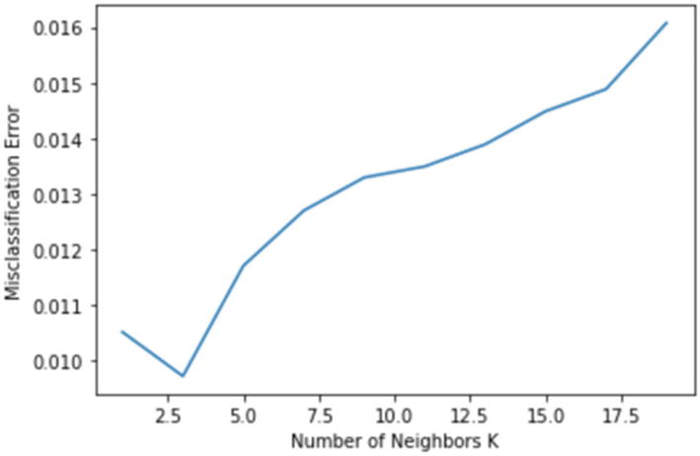

**Step 16**: It turns out that k=3 gives us the best result. Let’s implement it:

#Use k=3 as the final model for prediction

knn = KNeighborsClassifier(n_neighbors = 3)

# fitting the model

knn.fit(X_train, y_train)

# predict the response

y_pred = knn.predict(X_test)

# evaluate accuracy

print(accuracy_score(y_test, y_pred))

print(recall_score(y_test, y_pred))

The accuracy and recall are 0.9902758483826156 and 0.9911944869831547 respectively.

With k = 3, we are getting a very good accuracy and a great recall value too. This model can be considered as the final one to be used.

We developed a solution using knn and are getting good accuracies. k-nearest neighbor is very easy to explain and visualize. Not being very statistics- or mathematics-heavy, even for non–data science users, the method is not very tedious to understand. And this is one of the most important properties of this method. Being a nonparametric method, there is no assumption about the data and hence it requires less data preparation.

We have covered logistic regression, naïve Bayes, and k-nearest neighbor. Generally, when we start any classification solution, we start with these three algorithms to check their accuracy. The next in the series are tree-based algorithms: decision tree and random forest. We have discussed the theoretical concepts about both in Chapter [2](https://learning.oreilly.com/library/view/supervised-learning-with/9781484261569/html/499122_1_En_2_Chapter.xhtml). In the next section, we will cover the differences and then implement them on a dataset.

**Tree-Based Algorithms for Classification**

Recall in Chapter [2](https://learning.oreilly.com/library/view/supervised-learning-with/9781484261569/html/499122_1_En_2_Chapter.xhtml) that we studied decision trees to predict the values of a continuous variable. Since decision trees can be used for both classification and regression problems, in this chapter we will study classification solutions using decision tree. The building blocks for a decision tree remain the same as shown in Figure [3-8](https://learning.oreilly.com/library/view/supervised-learning-with/9781484261569/html/499122_1_En_3_Chapter.xhtml#Fig8).

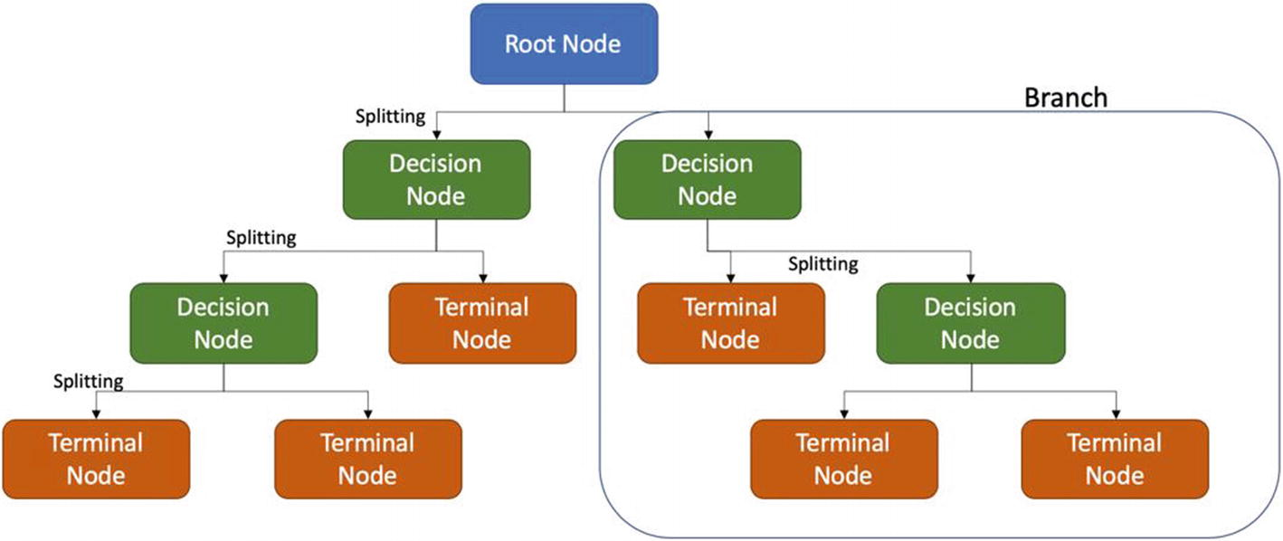

***Figure 3-8***

A decision tree is comprised of root node, decision node, and a terminal node. A subtree is called a branch

The difference is the process of splitting followed by a classification algorithm which is discussed now.

The objective of splitting is to create as many pure nodes as possible. If a resultant node after splitting contains all the data points belonging to the same class it is called *pure* or *homogeneous* . If the node contains records belonging to different classes, the node is *impure* or *heterogenous* . The objective is to create pure nodes. There are three primary ways to measure the impurity: entropy, Gini index, and classification error. We describe them in detail now and compare their respective processes. Consider that we have a dataset like in Table [3-3](https://learning.oreilly.com/library/view/supervised-learning-with/9781484261569/html/499122_1_En_3_Chapter.xhtml#Tab3).

***Table 3-3***

Transportation Mode Dependency on Other Factors Like Gender and Income Level

| Vehicle Count | Gender | Cost | Income | Transportation Mode |
| --- | --- | --- | --- | --- |
| 1 | Female | Less | Middle class | Train |
| 0 | Male | Less | Low income | Bus |
| 1 | Female | High | Middle class | Train |
| 1 | Male | Less | Middle class | Bus |
| 0 | Male | Medium | Middle class | Train |
| 1 | Male | Less | Middle class | Bus |
| 2 | Female | High | High class | Car |
| 0 | Female | Less | Low income | Bus |
| 2 | Male | High | Middle class | Car |
| 1 | Female | High | High class | Car |

We want to train an algorithm to predict the transportation mode. As per the preceding example, we can calculate that the respective probabilities are

Probability (Bus) = 4/10 = 0.4

Probability (Car) = 3/10 = 0.3

Probability (Train) = 3/10 = 0.3

The three methods are entropy, Gini index, and classification error, which are described now:

* **Entropy**: *Entropy* and *information gain* walk hand-in-hand. A pure node will require less information to describe itself while an impure node will require more information. It can be understood in the form of entropy too. (Information gain = 1 – Entropy.)



(Equation 3-17)

* where p and q are the probability of success and failure, respectively, in that node. The logarithm is to the base of 2 here.
* In the preceding example, entropy = –0.4 (log 0.4) – 0.3(log 0.3) – 0.3(log 0.3) = 1.571
* Entropy of a pure node is 0 and can be represented as Figure [3-9](https://learning.oreilly.com/library/view/supervised-learning-with/9781484261569/html/499122_1_En_3_Chapter.xhtml#Fig9).

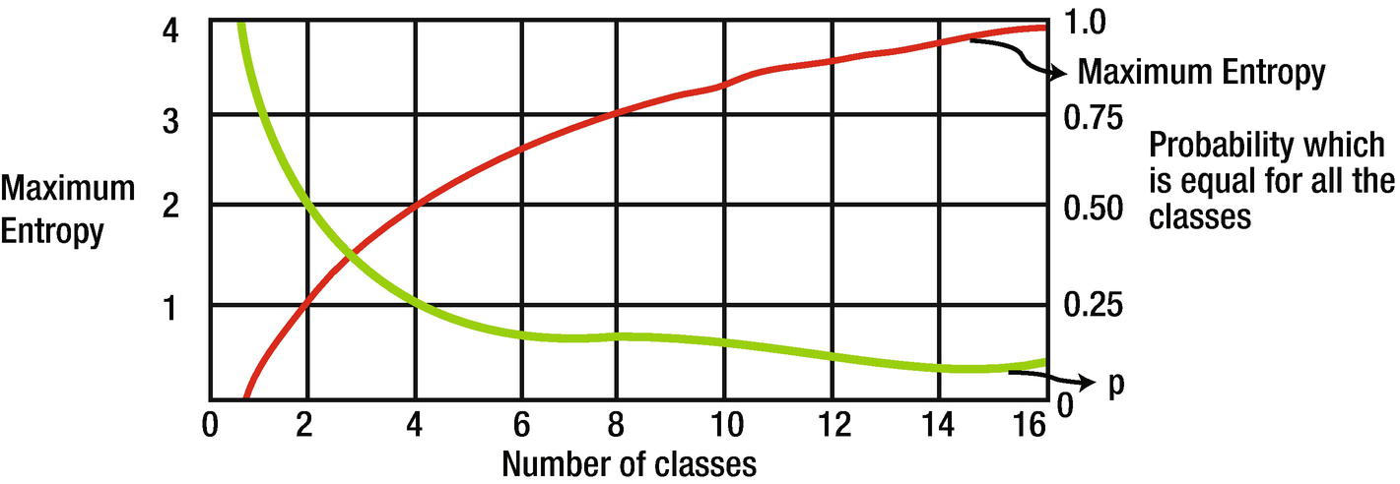

***Figure 3-9***

Values of maximum entropy for different numbers of classes (n). Probability p = 1/n.

* **Gini coefficient** : Gini index can also be used to measure the impurity. The formula to be used is as follows:

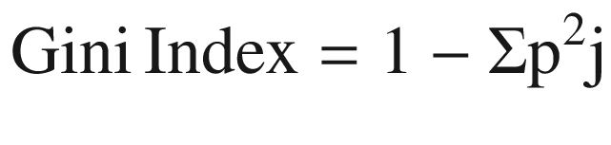

(Equation 3-18)

* In the preceding example, Gini index = 1 – (0.4^2 + 0.3^2 + 0.3^2) = 0.660
* Gini of a node containing a single class is 0 because the probability is 1. Like entropy, it also takes maximum value when all the classes in the node have the same probability. The movement of Gini can be represented as in Figure [3-10](https://learning.oreilly.com/library/view/supervised-learning-with/9781484261569/html/499122_1_En_3_Chapter.xhtml#Fig10).

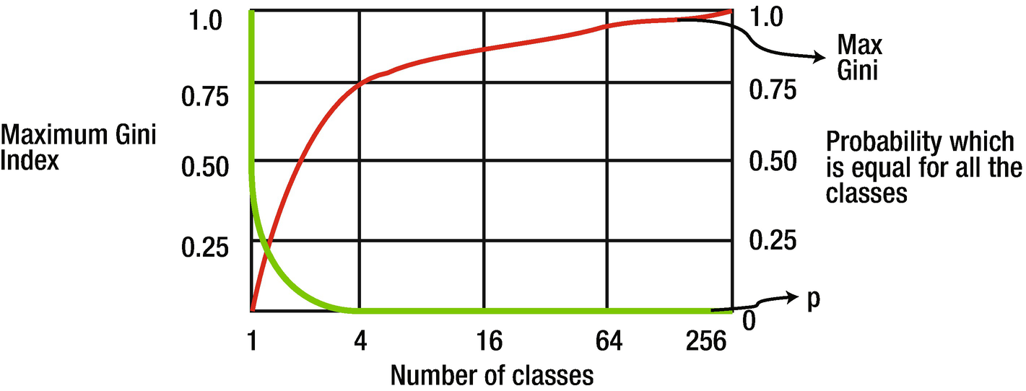

***Figure 3-10***

Values of maximum Gini index for different number of classes (n). Probability p = 1/n.

* The value of Gini will always be between 0 and 1 irrespective of the number of classes in the model.
* **Classification Error** : The next way to measure the degree of impurity is using classification error. It is given by the formula

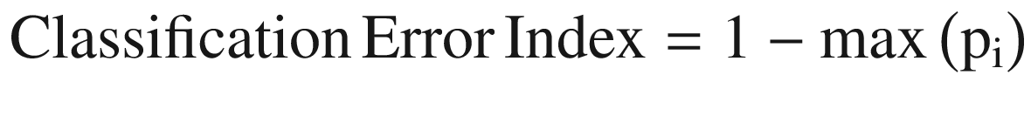

(Equation 3-19)

* where i is the number of classes
* Similar to the other two, its value lies between 0 and 1.
* For the preceding example, classification error index = 1 – max(0.4,0.3,0.3) = 0.6

We can use any of these three splitting methods for classification. There are some common decision tree algorithms which are used for regression and classification problems. Since we have studied both regression and classification concepts, it is a good time to examine different types of decision tree algorithms, which is the next section.

**Types of Decision Tree Algorithms**

There are some significant decision tree algorithms which are used in the industry. Some of them are suitable for classification problems while some are a better choice for regression solutions. We are discussing all the aspects of the algorithms.

The prominent algorithms are as follows:

1. 1.

**ID3** or Iterative Dichotomizer 3 is a decision tree algorithm using greedy search to split the dataset in each iteration. It uses entropy or information gain as a factor to perform the split iteratively. For each successive iteration in the model, it uses unused variables in the last iteration, calculates the entropy for those unused variables, and then selects the variable with lowest entropy. Or in other words, it selects the variable with highest information gain. ID3 can lead to overfitting and may not be the most optimal choice. It fares quite well with categorical variables. But when the dataset contains continuous variables, it becomes slower to converge since there are many values on which the node splitting can be done.

1. 2.

**CART** or classification and regression tree is a flexible tree-based solution. It can model for both continuous or categorical target variables and hence it is one of the highly used tree-based algorithms. Like a regular decision tree algorithm, we choose input variables and split the nodes iteratively till we achieve a robust tree to work upon. The selection of the input variables is done using a greedy approach with the objective to minimize the loss. The tree construction stops based on a predefined criteria like minimum observations to be present in each of the leaves. Python library scikit-learn uses an optimized version of CART but does not support categorical variables as of now.

1. 3.

**C4.5** is an extension of ID3 and is used for classification problems. Similar to ID3, it utilizes entropy or information gain to make the split. It is a robust choice since it can handle both categorical and continuous variables. For continuous variables, it assigns a threshold value and does the split based on the threshold. Variables with value above the threshold are in one bucket while variables with threshold less than or equal to threshold are in a different bucket. It allows missing variables in the data as the missing values are not considered while calculating the entropy values.

1. 4.

**CHAID (Chi-square automatic interaction detection** **)** is a popular algorithm in the field of market research and marketing; for example, if we want to understand how a certain group of customers will respond to a new marketing campaign. This marketing campaign can be for a new product or service and will be useful for the marketing team to strategize accordingly. CHAID is primarily based on adjusted significance testing and is mostly used when we have a categorical target variable and categorical independent variables. It proves to be quite a handy and convenient method to visualize such a dataset.

1. 5.

**MARS** or multivariate adaptive regression splines is a nonparametric regression technique. It is mostly suitable for measuring nonlinear relationships between variables. It is a flexible regression model which can handle both categorical and continuous variables. It is quite a robust solution to handle massive datasets and requires very much less data preparation, making is comparatively faster to implement. Owing to its flexibility and ability to model nonlinearities in the dataset, MARS generally is a good choice to tackle overfitting in the model.

The tree-based algorithms discussed previously are unique in their own way. Some of them are more suitable for classification problems, while some are a better choice for regression problems. CART can be used for both classification and regression problems.

Now it is time to develop a case study using decision tree.

The code and the dataset are available at the Github link shared at the start of this chapter.

We can use the same dataset we have used for the logistic regression problem. The implementation follows after we have created the training and testing data.

Step 1: Import the necessary libraries first.

from sklearn.tree import DecisionTreeClassifier

Step 2: Now we are calling the decision tree classifier and training the model.

dt_classifier = DecisionTreeClassifier()

dt_classifier.fit(X_train, y_train)

Step 3: Use the trained model to make a prediction on the test data.

y_pred = dt_classifier.predict(X_test)

Step 4: Get the confusion matrix. To visualize it, you are advised to use the method used in the logistic regression method.

print(confusion_matrix(y_test, y_pred))

ax= plt.subplot()

ax.set_ylim(2.0, 0)

annot_kws = {"ha": 'left',"va": 'top'}

sns.heatmap(mat_test, annot=True, ax = ax, fmt= 'g',annot_kws=annot_kws); #annot=True to annotate cells

ax.set_xlabel('Predicted labels');

ax.set_ylabel('True labels');

ax.set_title('Confusion Matrix');

ax.xaxis.set_ticklabels(['Not Approved', 'Approved']);

ax.yaxis.set_ticklabels(['Not Approved', 'Approved']);

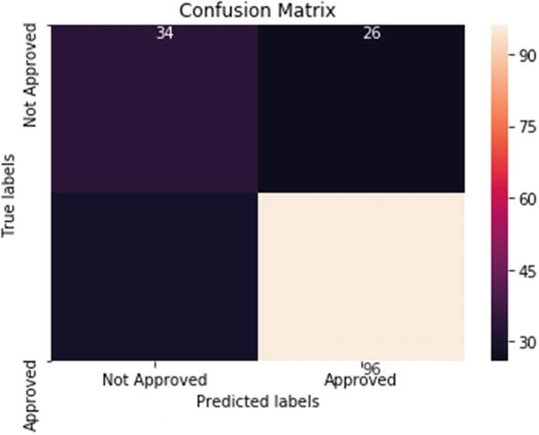

We will now model the same problem using a random forest model. Recall that random forest is an ensemble-based technique where it creates multiple smaller trees using a subset of data. The final decision is based on the *voting* mechanism by each of the trees. In the last chapter, we have used random forest for a regression problem; here we are using random forest for a classification problem.

**Tip**

Decision trees are generally prone to overfitting; ensemble-based random forest model is a good choice to tackle overfitting.

Step 1: Import the library and fit the model. Create the model with 500 trees.

from sklearn.ensemble import RandomForestClassifier

rf_model = RandomForestClassifier(n_estimators=500, bootstrap = True,

                               max_features = 'sqrt')

Now we will fit on training data

rf_model.fit(X_train, y_train)

Step 2: Predict on test data and plot the confusion matrix.

y_pred = rf_model.predict(X_test)

print(confusion_matrix(y_test, y_pred))

ax= plt.subplot()

ax.set_ylim(2.0, 0)

annot_kws = {"ha": 'left',"va": 'top'}

sns.heatmap(mat_test, annot=True, ax = ax, fmt= 'g',annot_kws=annot_kws); #annot=True to annotate cells

ax.set_xlabel('Predicted labels');

ax.set_ylabel('True labels');

ax.set_title('Confusion Matrix');

ax.xaxis.set_ticklabels(['Not Approved', 'Approved']);

ax.yaxis.set_ticklabels(['Not Approved', 'Approved']);

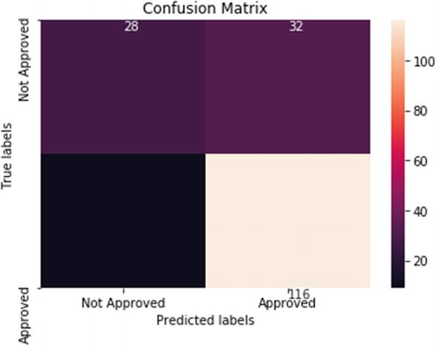

This is the implementation of a decision tree algorithm and ensemble-based random forest algorithm. Tree-based algorithms are very easy to comprehend and implement. They are generally the first few algorithms which we implement and test the accuracy of the system. Tree-based solutions are recommended if we want to create a quick solution, but they are prone to overfitting. We can use tree pruning or setting a constraint on tree size to overcome overfitting. We will again visit this concept in Chapter [5](https://learning.oreilly.com/library/view/supervised-learning-with/9781484261569/html/499122_1_En_5_Chapter.xhtml), in which we will discuss all the techniques to overcome the problem of overfitting in our ML model.

With this, we come to the end of our discussion on tree-based algorithms. In this chapter, we have studied the classification algorithms and implemented them too. These algorithms are quite popular in the industry and powerful enough to help us make a robust ML model. Generally, we test the data on these algorithms at the start and then choose the one which is giving us the best results. And then we tune it further till we achieve the most desirable output. The desirable output may *not* be the most complex solution but surely will be one which will deliver the desired level of measurement parameters, reproducibility, robustness, flexibility, and ease of deployment. Remember, complexity is *not* proportional to accuracy. A more complex model does *not* mean a higher degree of performance!

**Summary**

Prediction is a powerful tool in our hands. Using these ML algorithms, we can not only take a confident decision we can also ascertain the factors which affect that decision. These algorithms are heavily used across sectors like banking, retail, manufacturing, insurance, aviation, and so on. The uses include fraud detection, quality inspection, churn prediction, loan default prediction, and so on.

You should note that these algorithms are not the only sources of knowledge. A sound exploratory analysis is a prerequisite for a good ML algorithm. And the most important resource is “data” itself. A good-quality and representative dataset is of paramount importance. We have discussed the qualities of a good dataset in Chapter [1](https://learning.oreilly.com/library/view/supervised-learning-with/9781484261569/html/499122_1_En_1_Chapter.xhtml).

It is also imperative that a sound business problem has been created from the start. The choice of the target variable should align with the business problem at hand. The training data used to train the algorithm plays a very crucial role, as on it depends the patterns learned by the algorithm. It is important to note that we do measure the performance of the algorithms using the various parameters like precision, recall, AUC, F1 score, and so on. An algorithm which is performing well on training, testing, and validation datasets will be the best algorithm. But still there are a few other parameters based on which we choose the final algorithm which can be deployed into production, which we discuss in Chapter [5](https://learning.oreilly.com/library/view/supervised-learning-with/9781484261569/html/499122_1_En_5_Chapter.xhtml).

In Chapter [1](https://learning.oreilly.com/library/view/supervised-learning-with/9781484261569/html/499122_1_En_1_Chapter.xhtml), we examined ML, various types, data and attributes of data quality and ML process. In Chapter [2](https://learning.oreilly.com/library/view/supervised-learning-with/9781484261569/html/499122_1_En_2_Chapter.xhtml), we studied ML algorithms to model a continuous variable. In this third chapter, we complemented the knowledge with classification algorithms. These first chapters have created a firm base for you to solve most of the business problems in the data science world. Also, you are now ready to take the next step in Chapter [4](https://learning.oreilly.com/library/view/supervised-learning-with/9781484261569/html/499122_1_En_4_Chapter.xhtml).

In the first three chapters, we have discussed basic and intermediate algorithms. In the next chapter, we are going to cover much more complex algorithms like SVM, gradient boosting, and neural networks for regression and classification problems. So stay focused!

**Exercise Questions**

Question 1: How does a logistic regression algorithm make a classification prediction?

Question 2: What is the difference between precision and recall?

Question 3: What is posterior probability?

Question 4: What are the assumptions in a naïve Bayes algorithm?

Question 5: How can we choose the value of k in k-nearest neighbor?

Question 6: What are the various performance measurement parameters for classification algorithms?

Question 7: The sinking of the ship *Titanic* in 1912 was indeed heart-breaking. Some passengers survived, some did not. Download the dataset from <https://www.kaggle.com/c/titanic>. Using ML, predict which passengers were more likely to survive than others based on the various attributes of the passengers.

Question 8: Load the dataset Iris using the following command:

from sklearn.datasets import load_iris

iris = load_iris()

We have worked upon the same dataset in the last chapter. Here, you have to classify the type of the flower using classification algorithms and compare the results.

Question 9: Download the Bank Marketing Dataset from the link <https://archive.ics.uci.edu/ml/datasets/Bank+Marketing>. The data is related with direct marketing campaigns (phone calls) of a Portuguese banking institution. The classification problem goal is to predict if the client will subscribe to a term deposit. Create various classification models and compare the respective KPIs.

Question 10: Get the German Credit Risk data from <https://www.kaggle.com/uciml/german-credit>. The dataset contains attributes of each person who takes credit from the bank. The objective is to classify each person as a good or bad credit risk according to their attributes. Use classification algorithms to create the model and choose the best model.

Question 11: Go through the research paper on logistic regression at <https://www.ncbi.nlm.nih.gov/pmc/articles/PMC6696525/>.

Question 12: Go through the research paper on random forest at <https://aip.scitation.org/doi/pdf/10.1063/1.4977376>. There is one more good paper at <https://aip.scitation.org/doi/10.1063/1.4952607>.

Question 13: Examine the research paper on knn at <https://pdfs.semanticscholar.org/a196/39771e987588b378879c65300b61b4af86af.pdf>.

Question 14: Study the research paper on naïve Bayes at [https://www.cc.gatech.edu/~isbell/reading/papers/Rish.pdf](https://www.cc.gatech.edu/%257Eisbell/reading/papers/Rish.pdf).

4. Advanced Algorithms for Supervised Learning

Vaibhav Verdhan[**1**](https://learning.oreilly.com/library/view/supervised-learning-with/9781484261569/html/499122_1_En_4_Chapter.xhtml#Aff2)

(1)

Limerick, Ireland

*“A real intelligence is an art to simplify complex matters without losing the integrity of that matter.”*

*— Sumit Singh*

Our lives are complex. We have to deal with complexity everyday—at home, at work, with our commute, within family, and with our career goals. There are many paths to success, but the definition of success is subjective and complex. And we always strive to find the best ingredients to ease that path to success.

Like our lives too, data can be hugely complex at times. We need more advanced algorithms, sophisticated techniques, out-of-the-box approaches, and innovative processes to make sense of it. But the heart of any solution, any algorithm, any approach, and any process is the need to resolve the business problem at hand. Most of the business problems involve how to increase profits and to decrease costs. Using such advanced methodologies, we can make sense with the complex datasets that are generated by our systems.

In the first three chapters of the book, we studied ML for regression and classification problems using quite a few algorithms. We examined the concepts and developed Python solutions for them. In this chapter, we are going to work on advanced algorithms. We will be studying these algorithms and developing the mathematical concepts and coding logic for them. We will not be working on structured data alone. We will be working on unstructured datasets too—text and image—in this chapter.

In this chapter, advanced algorithms like boosting and SVMs will be examined. Then we will be diving into the world of text and image data, and solving such challenges using principles of natural language processing (NLP) and image analysis. Deep learning is used for solving the complex problems and hence we will be implementing deep learning to a structured data and unstructured image dataset. All the code files and datasets are provided with step-by-step explanations.

**Technical Toolkit Required**

We are going to use Python 3.5 or above in this book. You are advised to get Python installed on your machine. We will be using Jupyter notebook; installing Anaconda-Navigator is required for executing the codes. All the datasets and codes have been uploaded to the Github library at [https://github.com/Apress/supervised-learning-w-python/tree/master/Chapter%204](https://github.com/Apress/supervised-learning-w-python/tree/master/Chapter%25204) for easy download and execution.

The major libraries used are numpy, pandas, matplotlib, seaborn, scikit learn, and so on. You are advised to install these libraries in your Python environment. In this chapter, we are going to use NLP so will use NLTK library and RegexpTokenizer. We will also need Keras and TensorFlow libraries in this chapter.

Let us go into the ensemble-based boosting algorithms and study the concepts in detail!

**Boosting Algorithms**

Recall in the last chapter we studied ensemble-modeling techniques. We discussed bagging algorithms and created solutions using random forest. We will continue with ensemble-modeling techniques. The next algorithm is boosting.

Formally put, boosting is an ensemble method that creates a strong classifier from weak classifiers. In a sequence, we create a new model while assuring we are learning from the errors or misclassifications from the previous model as shown in Figure [4-1](https://learning.oreilly.com/library/view/supervised-learning-with/9781484261569/html/499122_1_En_4_Chapter.xhtml#Fig1). The idea is to give higher importance to the errors and improve the modeling subsequently, finally resulting in a very strong model.

Initially, a subset is taken from the training dataset and all the data points are given equal weight. We create a base version of the model (let’s call it M1) and then loss is calculated based on the wrong predictions. In the next iteration, the incorrect data points are awarded higher weights and another model (let’s call it M2) is created. The idea is M2 will be better than M1 as it is improving and trying to correct the errors from M1, and this process continues where multiple models are created, each improving the previous one. The final model is the weighted mean of all the previous models. The final model acts as a strong learner.

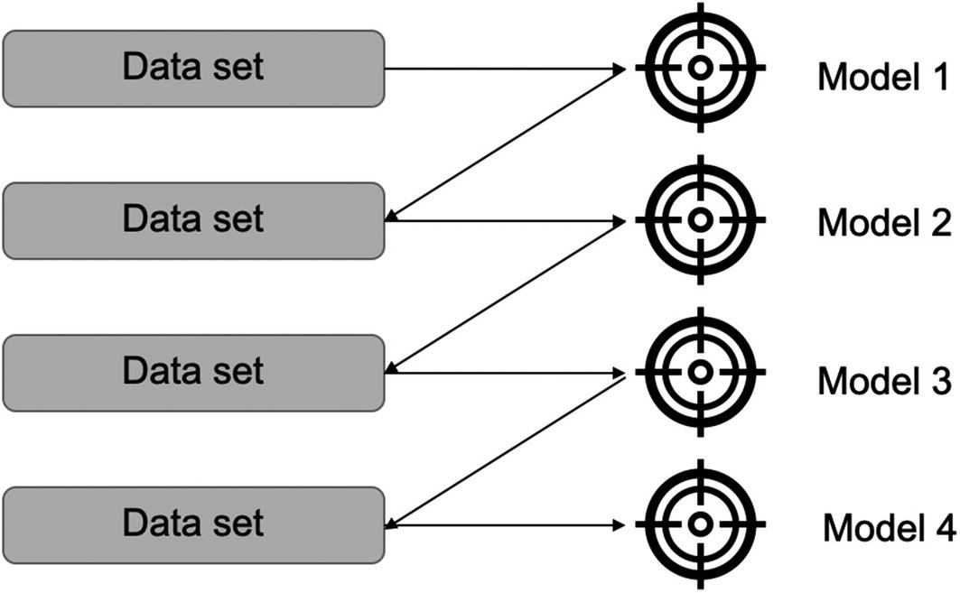

***Figure 4-1***

Boosting algorithms iteratively work and improve the previous version while assigning higher weights to the errors

There are multiple types of boosting algorithms available:

1. 1.

**Gradient boosting** : Gradient boosting can work for both classification and regression problems. For example, a regression tree can be used as a base learner and each subsequent tree will be an improvement over the previous tree. The overall learner gradually improves on the observations where the residuals have been initially high.

The properties of gradient boosting are as follows:

* 1. a.

A base learner is created by taking a subset of the complete dataset.

* 1. b.

The difficult observations are identified, or the *shifting* is done by identifying the value of the residuals in the previous model.

* 1. c.

The misclassifications are identified by the gradients calculated. This is the central idea of the algorithm. It creates new base learners which are correlated maximum with the negative gradient of the loss function, which in turn is associated with the complete ensemble solution.

* 1. d.

It then further dissects error components to add more information about the residuals.

1. 2.

**AdaBoosting** : AdaBoosting or adaptive boosting is considered as a special case of gradient boosting, wherein iterative models are created to improve upon the previous model. Initially, a base model is created using a subset of the data and is used to make predictions on the complete dataset. We measure the performance by calculating the error. Then while creating the next model, data points which have been predicted incorrectly are given higher weights. The weights are proportional to the error; that is, the higher the error, the higher is the weight assigned. Hence, the next model created is an improvement over the previous model, and this process continues. Once it is no longer possible to reduce the error further, the process stops and we conclude that we have reached the final model, which is the best model.

AdaBoost has the following properties:

* 1. a.

In AdaBoost, the shifting is done by assigning higher weights to the observations misclassified in the previous step.

* 1. b.

The misclassifications are identified by high-weight observations.

* 1. c.

The exponential loss in AdaBoost assigns greater value of weight for the sample which have ill-fitted in the previous model.

1. 3.

**Extreme gradient boosting**: Extreme gradient boosting of XGB is an advanced boosting algorithm. It has become quite popular lately and has won many data science and ML competitions. It is extremely accurate and quite a fast solution to implement.

The properties for XGB are as follows:

* 1. a.

XGB is quite a fast algorithm since it allows parallel processing and hence is faster than standard gradient boosting.

* 1. b.

It tackles overfitting by implementing regularization techniques.

* 1. c.

It works well with messy datasets having missing values, as it has an inbuilt mechanism to handle missing values present in the dataset. This is one of the biggest advantages, as we do not have to deal with missing values present in the data.

* 1. d.

It is quite a flexible algorithm and allows us to have a customized optimization objective and evaluation criteria.

* 1. e.

Cross-validation at each iteration results in an optimum number of boosting iterations, which makes it a better choice than its counterparts.

1. 4.

**CatBoost**: CatBoost is a fantastic solution if we are dealing with categorical variables. In typical ML models, we use one-hot encoding to deal with categorical variables. For example, if we have a dataset having a categorical variable as “City,” we convert it to numeric variables as shown in Table [4-1](https://learning.oreilly.com/library/view/supervised-learning-with/9781484261569/html/499122_1_En_4_Chapter.xhtml#Tab1).

***Table 4-1***

One-Hot Encoding to Convert Categorical Variables to Numeric Variables

|  |
| --- |
|  |

But if we have 100 unique values for the variable “City,” one-hot encoding will result in adding 100 additional dimensions to the dataset. Moreover, the resultant dataset will be quite *sparse*. Sparsity means that for a column only a few rows will be 1; the rest will be 0. For example, in Table [4-1](https://learning.oreilly.com/library/view/supervised-learning-with/9781484261569/html/499122_1_En_4_Chapter.xhtml#Tab1) Tokyo has got only one value as 1. That means that the matrix contains more 0’s than 1’s. Hence, the performance operation across will take a long time. Moreover, if the number of resultant dimensions are too large then we will have huge memory requirements.

CatBoost does not suffer from this problem. CatBoost deals with categorical variables internally and we do not have to spend time on dealing with them.

1. 5.

**Light gradient boosting** : As the name suggests, light gradient boosting is computationally less expensive than its counterparts. It is the choice of boosting algorithm if the dataset is extremely large. It implements tree-based algorithms and uses a leaf-based approach, as compared to others, which use a level-based approach, as shown in Figure [4-2](https://learning.oreilly.com/library/view/supervised-learning-with/9781484261569/html/499122_1_En_4_Chapter.xhtml#Fig2).

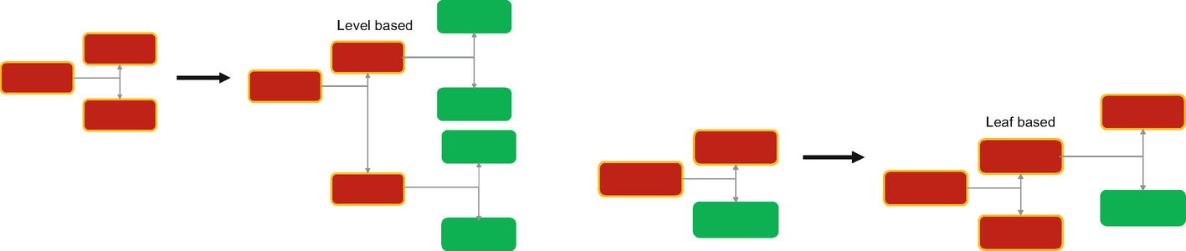

***Figure 4-2***

Level-based approach is used by other boosting algorithms, while leaf-based approach makes light gradient boosting a good fit for large datasets

We have now discussed the different types of boosting algorithms. Depending on the business problem at hand and the data set available, we will prefer one method over another. Recently extreme gradient boosting or XGB has gained a lot of popularity. It is quite a robust technique, gives better results, and deals with overfitting internally.

We will now implement a case in Python using gradient boosting algorithm.

**Using Gradient Boosting Algorithm**

In this case study, we are going to implement multiple algorithms. We have studied multiple algorithms till now, and some of them are ensemble-based advanced algorithms. It is the correct time to compare their respective accuracies.

We will perform EDA, create train-test split, and then implement decision tree, random forest, bagging, AdaBoost, and gradient boosting algorithm. Finally, we will compare the respective performance of all the algorithms.

The dataset and code can be downloaded from the Github link shared at the start of the chapter. The data is for predicting wine quality based on parameters like fixed acidity, volatile acidity, and so on.

Step 1: Import all the libraries first:

%matplotlib inline

import numpy as np

import pandas as pd

from sklearn.tree import DecisionTreeClassifier

import numpy as np

import pandas as pd

import seaborn as sns

from matplotlib import pyplot as plt

from sklearn.model_selection import train_test_split

from sklearn.tree import DecisionTreeClassifier

from sklearn import metrics

from sklearn.metrics import accuracy_score,f1_score,recall_score,precision_score, confusion_matrix

%matplotlib inline

from sklearn.feature_extraction.text import CountVectorizer

Step 2: Import the dataset:

wine_quality_data_frame = pd.read_csv('winequality-red-1.csv',sep=';')

Step 3: Print the first five samples from the data:

wine_quality_data_frame.head(5)

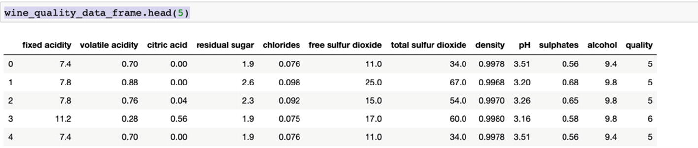

Step 4: Get the information about the data types:

wine_quality_data_frame.info()

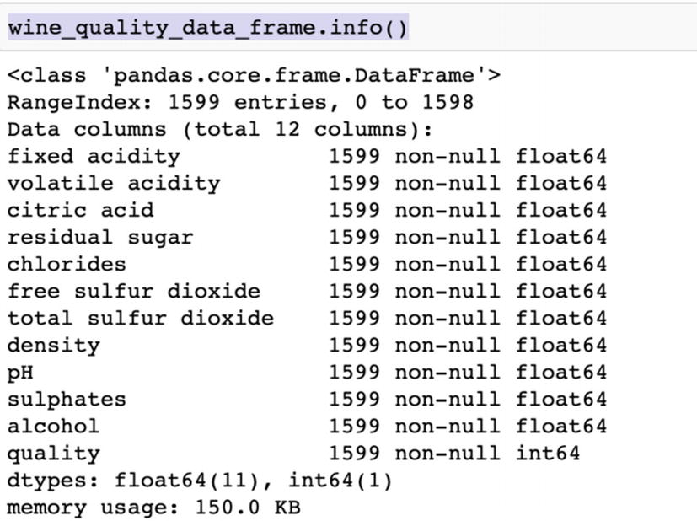

Step 5: Get the details about all the numeric variables present in the dataset:

wine_quality_data_frame.describe()

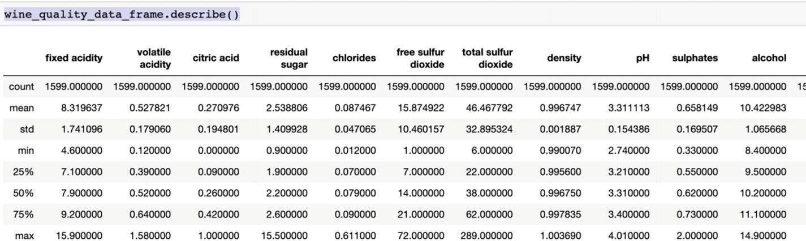

Step 6: We will perform some analysis and visualizations on the dataset now:

import matplotlib.pyplot as plt

import seaborn as sns

sns.countplot(wine_quality_data_frame['quality'])

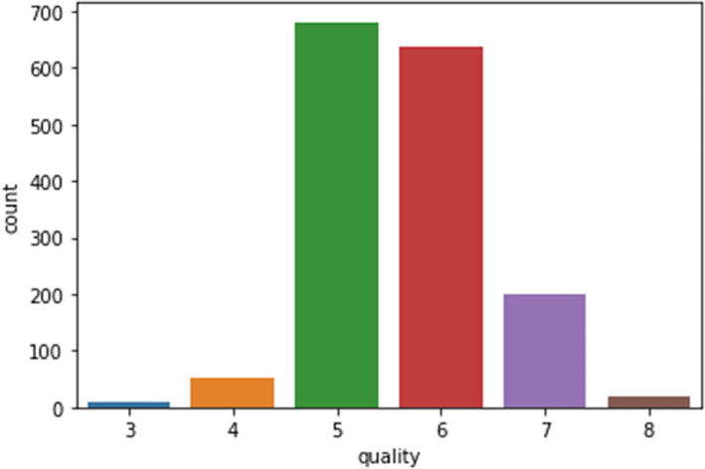

sns.distplot(wine_quality_data_frame['volatile acidity'])

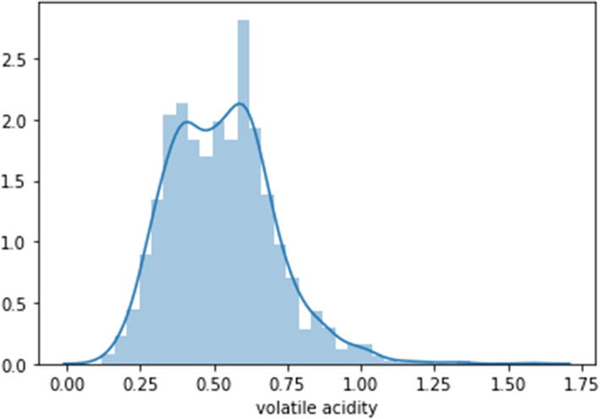

Correlation plot will be created to observe the relationships between the variables:

plt.figure(figsize=(10,10))

sns.heatmap(wine_quality_data_frame.corr(),

            annot=True,

            linewidths=.5,

            center=0,

            cbar=False,

            cmap="Blues")

plt.show()

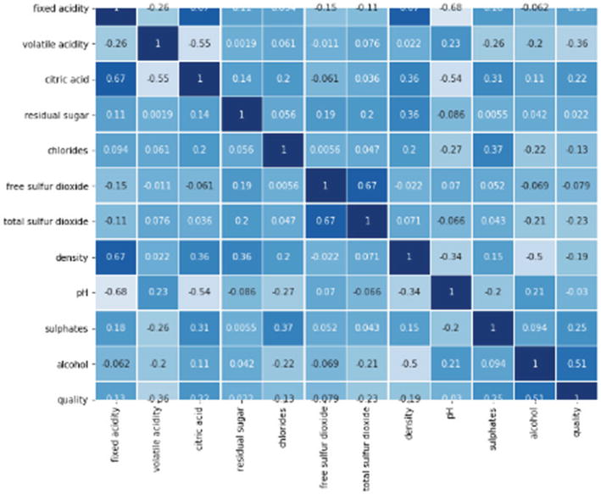

Step 7: We will analyze the frequency of target variables.

wine_quality_data_frame['quality'].value_counts()

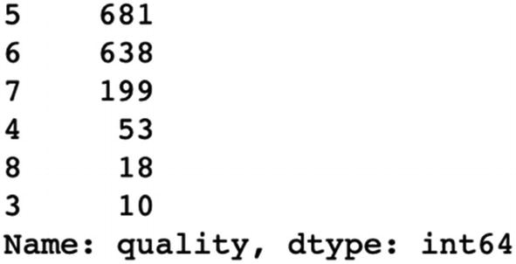

Step 8: We are combining a few levels here so that we can have a balanced target variable. As we can observe, levels 3, 4, and 8 are having lower values hence combining with other levels.

wine_quality_data_frame['quality'] = wine_quality_data_frame['quality'].replace(8,7)

wine_quality_data_frame['quality'] = wine_quality_data_frame['quality'].replace(3,5)

wine_quality_data_frame['quality'] = wine_quality_data_frame['quality'].replace(4,5)

wine_quality_data_frame['quality'].value_counts()

Step 9: Now split into training and testing data:

from sklearn.model_selection import train_test_split

X_train, X_test, y_train, y_test =train_test_split(wine_quality_data_frame.drop('quality',axis=1), wine_quality_data_frame['quality'], test_size=.20, random_state=5)

X_train.shape,X_test.shape

Step 10: Decision tree implementation is done next:

dt_entropy=DecisionTreeClassifier(criterion='entropy')

dt_entropy.fit(X_train, y_train)

dt_entropy.score(X_train, y_train)

dt_entropy.score(X_test, y_test)

The training accuracy is 100% and testing is 69% which means that the model is overfitting. Hence, we are pruning the tree to maximum depth of 4

clf_pruned = DecisionTreeClassifier(criterion = "entropy", random_state = 50, max_depth=4, min_samples_leaf=6)

clf_pruned.fit(X_train, y_train)

inde_variables = wine_quality_data_frame.drop('quality', axis=1)

feature_column = inde_variables.columns

prediction_pruned = clf_pruned.predict(X_test)

prediction_pruned_train = clf_pruned.predict(X_train)

print(accuracy_score(y_test,prediction_pruned))

print(accuracy_score(y_train,prediction_pruned_train))

acc_DT = accuracy_score(y_test, prediction_pruned)

Step 11: The overfitting has been handled but accuracy has not improved.

We are now getting the significant features for our dataset.

feature_importance = clf_pruned.tree_.compute_feature_importances(normalize=False)

feat_imp_dict = dict(zip(feature_column, clf_pruned.feature_importances_))

feat_imp = pd.DataFrame.from_dict(feat_imp_dict, orient="index")

feat_imp.sort_values(by=0, ascending=False)

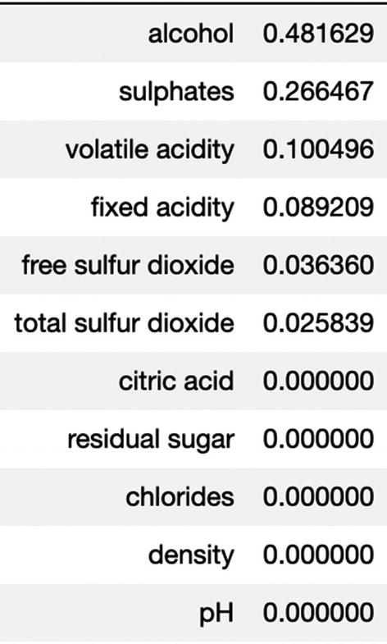

Step 12: We can deduce that alcohol, sulfate, volatile acidity, and total sulfur dioxide are significant. Next we are saving the results in a dataframe.

resultsDf = pd.DataFrame({'Method':['Decision Tree'], 'accuracy': acc_DT})

resultsDf = resultsDf[['Method', 'accuracy']]

resultsDf

Step 13: We will apply random forest now.

from sklearn.ensemble import RandomForestClassifier

rf_model = RandomForestClassifier(n_estimators = 50)

rf_model = rf_model.fit(X_train, y_train)

prediction_RF = rf_model.predict(X_test)

accuracy_RF = accuracy_score(y_test, prediction_RF)

tempResultsDf = pd.DataFrame({'Method':['Random Forest'], 'accuracy': [accuracy_RF]})

resultsDf = pd.concat([resultsDf, tempResultsDf])

resultsDf = resultsDf[['Method', 'accuracy']]

resultsDf

Step 14: We can compare the accuracies of both decision tree and random forest.

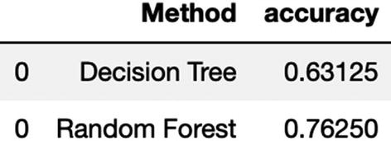

Step 15: We will now implement AdaBoost algorithm.

from sklearn.ensemble import AdaBoostClassifier

adaboost_classifier = AdaBoostClassifier( n_estimators= 150, learning_rate=0.05, random_state=5)

adaboost_classifier = adaboost_classifier.fit(X_train, y_train)

prediction_adaboost =adaboost_classifier.predict(X_test)

accuracy_AB = accuracy_score(y_test, prediction_adaboost)

tempResultsDf = pd.DataFrame({'Method':['Adaboost'], 'accuracy': [accuracy_AB]})

resultsDf = pd.concat([resultsDf, tempResultsDf])

resultsDf = resultsDf[['Method', 'accuracy']]

resultsDf

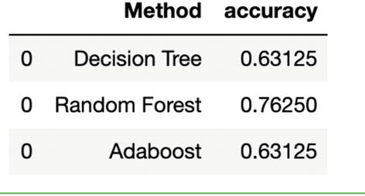

Step 16: We will implement bagging algorithm and compare the accuracies.

from sklearn.ensemble import BaggingClassifier

bagging_classifier = BaggingClassifier(n_estimators=55, max_samples= .5, bootstrap=True, oob_score=True, random_state=5)

bagging_classifier = bagging_classifier.fit(X_train, y_train)

prediction_bagging =bagging_classifier.predict(X_test)

accuracy_bagging = accuracy_score(y_test, prediction_bagging)

tempResultsDf = pd.DataFrame({'Method':['Bagging'], 'accuracy': [accuracy_bagging]})

resultsDf = pd.concat([resultsDf, tempResultsDf])

resultsDf = resultsDf[['Method', 'accuracy']]

resultsDf

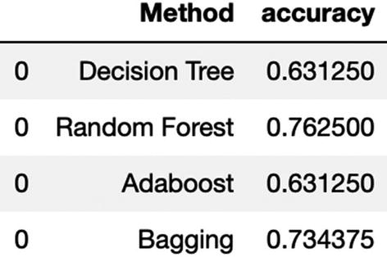

Step 17: We will now implement gradient boosting algorithm.

from sklearn.ensemble import GradientBoostingClassifier

gradientBoosting_classifier = GradientBoostingClassifier(n_estimators = 60, learning_rate = 0.05, random_state=5)

gradientBoosting_classifier = gradientBoosting_classifier.fit(X_train, y_train)

prediction_gradientBoosting =gradientBoosting_classifier.predict(X_test)

accuracy_gradientBoosting = accuracy_score(y_test, prediction_gradientBoosting)

tempResultsDf = pd.DataFrame({'Method':['Gradient Boost'], 'accuracy': [accuracy_gradientBoosting]})

resultsDf = pd.concat([resultsDf, tempResultsDf])

resultsDf = resultsDf[['Method', 'accuracy']]

resultsDf

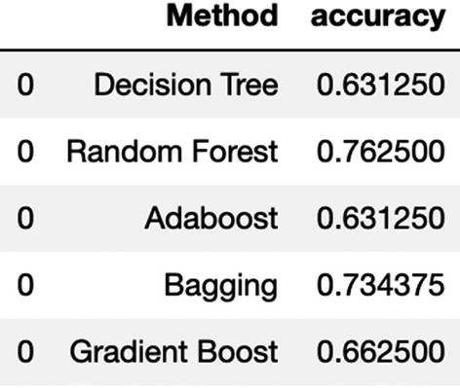

We can deduce that random forest has given us the best accuracy as compared to the other algorithms. This solution can be extended to any supervised classification problem.

Gradient boosting is one of the most popular techniques. Its power is due to the focus it puts on errors and misclassifications. It is very useful in the field of information retrieval system where ML-based ranking is implemented. With its variants like extreme gradient boosting it can combat overfitting and missing variables and with CatBoost it overcomes the challenges with categorical variables. Along with bagging techniques, boosting is extending the predictive power of ML algorithms.

**Note**

It is recommended to test random forest and gradient boosting while you are solving a real-world business problem since they offer higher flexibility and performance.

Ensemble methods are much more robust, accurate, and mature algorithms as compared to their counterparts. They enhance capabilities by combining the weak predictors and improve the overall performance. This is the reason they have outperformed other algorithms in many ML competitions. In the business world too, random forest and gradient boosting are frequently used to solve business problems.

We will now study another powerful algorithm called *Support Vector Machine* (*SVM*) , which is often used for small but complex datasets having a large number of dimensions. It is a common challenge in industries like medical research where the dataset is generally small but has a very high number of dimensions. SVM serves the purpose very well and is discussed in the next section.

**SVM**

We have already studied classical ML algorithms like regression, decision tree, and so on in the previous chapters. They are quite competent to solve any sort of regression or classification problems for us and work on live datasets. But for “really” complex datasets, we require much higher capability. SVMs allow us those capabilities to process those multidimensional complex data sources. Complexity of the data source will be owing to the multiple dimensions we have and due to the different types of variables present in the data. Here, SVMs help in creating a robust solution.

SVM is a fantastic solution for complex datasets, particularly where we have a dearth of training examples. Apart from the uses on structured datasets and simpler business problems, it is used for categorization of text in text analytics problems, image classification, bioinformatics field, and handwriting recognition.

SVM can be used for both regression and classification problems. The basis of SVM is on support vectors which are nothing but the representation of observations in a vector space.

The way to visualize is in Figure [4-3](https://learning.oreilly.com/library/view/supervised-learning-with/9781484261569/html/499122_1_En_4_Chapter.xhtml#Fig3). Imagine we have a dataset with “n” attributes. These n features can hence be represented in an n-dimensional space, where values of each attribute refer to the coordinates. In Figure [4-3](https://learning.oreilly.com/library/view/supervised-learning-with/9781484261569/html/499122_1_En_4_Chapter.xhtml#Fig3), we are representing only 2-dimensional space. A similar representation can be made for an n-dimensional space.

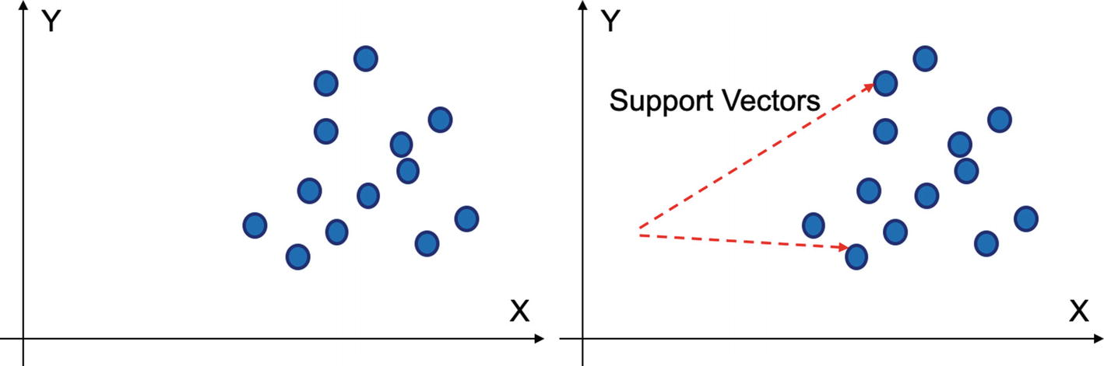

***Figure 4-3***

Support vectors are the representations of data points in a vector-space diagram

SVMs work on these representations or support vectors and model a supervised learning algorithm. In Figure [4-4](https://learning.oreilly.com/library/view/supervised-learning-with/9781484261569/html/499122_1_En_4_Chapter.xhtml#Fig4), we have two classes which need to be differentiated. SVM fixes this problem by creating hyperplane, which is most suitable for that decision.

As shown in Figure [4-4](https://learning.oreilly.com/library/view/supervised-learning-with/9781484261569/html/499122_1_En_4_Chapter.xhtml#Fig4), the distance between the nearest data point and the hyperplane is called the *margin*. In the problem, SVM finds a linear plane with maximum margin to be able to distinguish between the classes clearly. Unlike the linear classifiers where we want to minimize the sum of squares of errors, in SVM the objective is to find that linear plane which distinguishes two or more classes and separates them with maximum margin. SVM implementation can also be referred to as *maximum-margin hyperplane* .

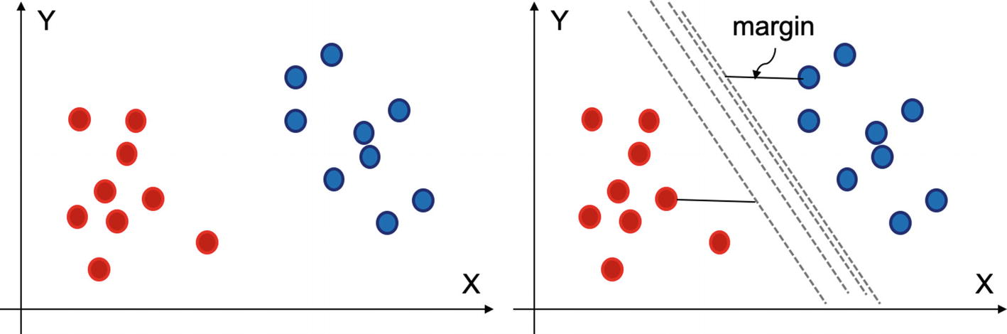

***Figure 4-4***

A hyperplane can be used to distinguish between two classes. Margin is used to select the best hyperplane

We have understood the purpose of the SVM. It is imperative we visualize them in a vector-space diagram to understand better. We are visualizing SVM in a 2-dimensional space in the next section.

**SVM in 2-D Space**

In a 2-dimensional space, the separating hyperplane is a straight line. And the classification is achieved by a perceptron.

A perceptron is an algorithm used to make binary classification. Simply put, it is trained on data with two classes and then it outputs a line that separates two classes clearly. In Figure [4-5](https://learning.oreilly.com/library/view/supervised-learning-with/9781484261569/html/499122_1_En_4_Chapter.xhtml#Fig5), we can try to achieve a hyperplane or a line which segregates the two classes.

Now there can be multiple hyperplanes which can serve the purpose of generating the correct classifications. As shown in Figure [4-5](https://learning.oreilly.com/library/view/supervised-learning-with/9781484261569/html/499122_1_En_4_Chapter.xhtml#Fig5), the first line separates the two classes clearly, but it is very close to the two classes or red and blue dots in this case. Though it is good for classification, this model is susceptible to higher *variance* if we deploy the model into production on a new, unseen dataset, due to which few of the observations will be classified wrong. The second line does not suffer from such an issue. The second line is at the maximum distance from both the classes simultaneously and hence will be selected.

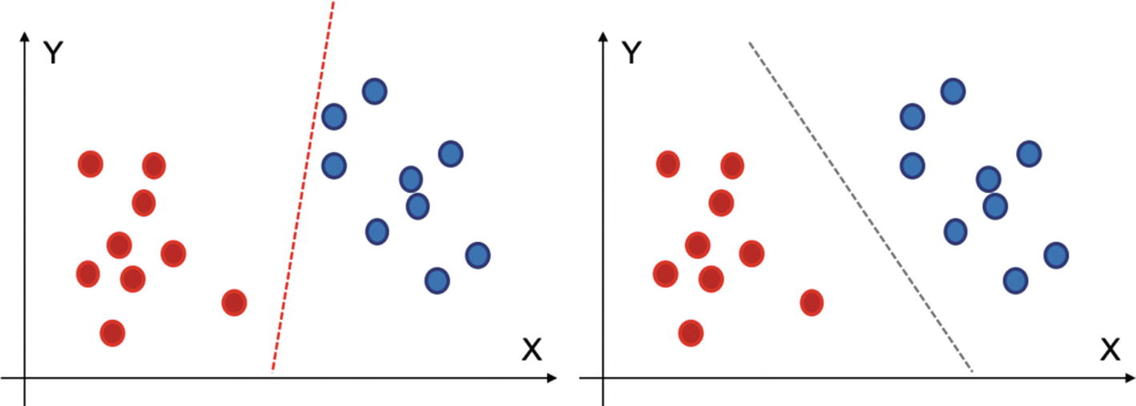

***Figure 4-5***

The red line, though able to classify between two classes, suffers from high variance. The black classifier on the right is better than the red one

So, we have decided that the second line is better than the first line. Let us say that the equation of the line is ax + by = c. Hence, the equation for the classification plane can be ax + by ≥ c for the red dots and ax + by < c for the blue ones.

But there can be a lot of options for a, b, or c, which brings us to the next question: how to choose the best plane. As shown in Figure [4-6](https://learning.oreilly.com/library/view/supervised-learning-with/9781484261569/html/499122_1_En_4_Chapter.xhtml#Fig6), there can be a number of options available for the hyperplanes.

In Figure [4-6](https://learning.oreilly.com/library/view/supervised-learning-with/9781484261569/html/499122_1_En_4_Chapter.xhtml#Fig6), for the figure on top left, the red separator is doing a better job in classifying the two classes than the black solid line. In the second figure, we can see that the red separator has a maximum margin as compared to the black one, hence it is chosen.

The third case shows the presence of a few outliers in the dataset. Still the SVM algorithm will be able to create a classification hyperplane with maximum margin. SVM works quite well even in the presence of outliers.

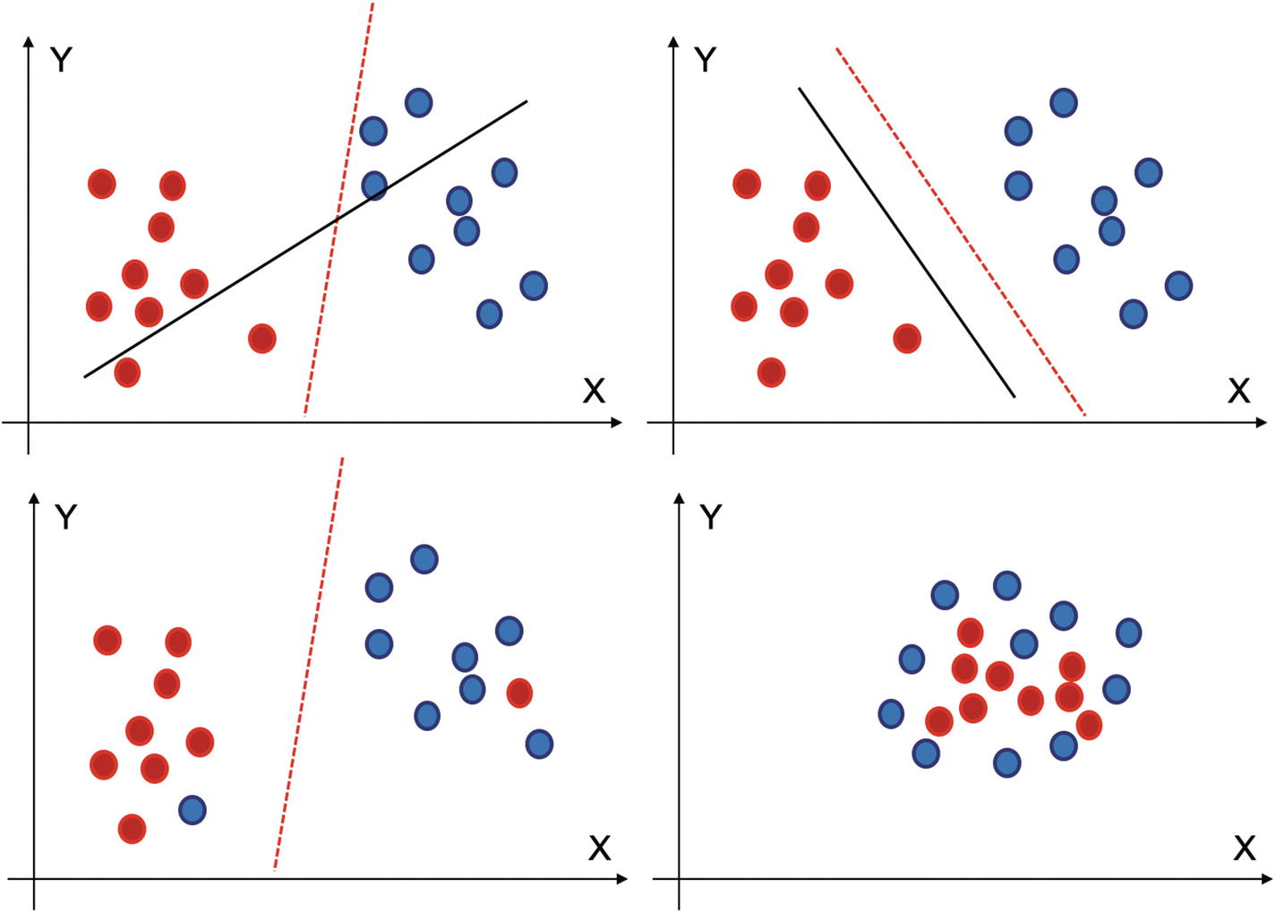

***Figure 4-6***

(i) At top left, the red classifier is better than the black one. (ii) In the second one, red is better as it has maximum margin. (iii) The third one has outliers but still SVM will be able to handle it. (iv) This is a special case where linear classifier will not be able to distinguish between the two classes

So far, we have discussed and visualized the implementations in a 2-D space, but if were to transform the mathematical vector space from a 2-dimensional one to higher dimensions, then we need to perform such mathematical operations. In Figure [4-6](https://learning.oreilly.com/library/view/supervised-learning-with/9781484261569/html/499122_1_En_4_Chapter.xhtml#Fig6), the fourth figure is such a special case. In the case shown, it is not possible to have a linear hyperplane, and in such a case we will have a nonlinear hyperplane to make the classifications for us, which is possible using *kernel SVM (KSVM)* , which we are discussing next.

**KSVM**

If we transform 2-dimensional space into high-dimensional space, the solution becomes more robust and the respective probability to separate the data points increases. For example, x**1** and x**2** have to be converted into higher degrees of polynomials x**12**, x**22**, x**32**, x**42**, x**52**, and so on. This is achieved by kernel or KSVM. It takes the data points into a higher-order mathematical space. In this high-dimensional space, they become separable linearly. Then we are able to draw a plan through these data points. If we represent the previous example using KSVM, the corresponding representation will be as shown in Figure [4-7](https://learning.oreilly.com/library/view/supervised-learning-with/9781484261569/html/499122_1_En_4_Chapter.xhtml#Fig7).

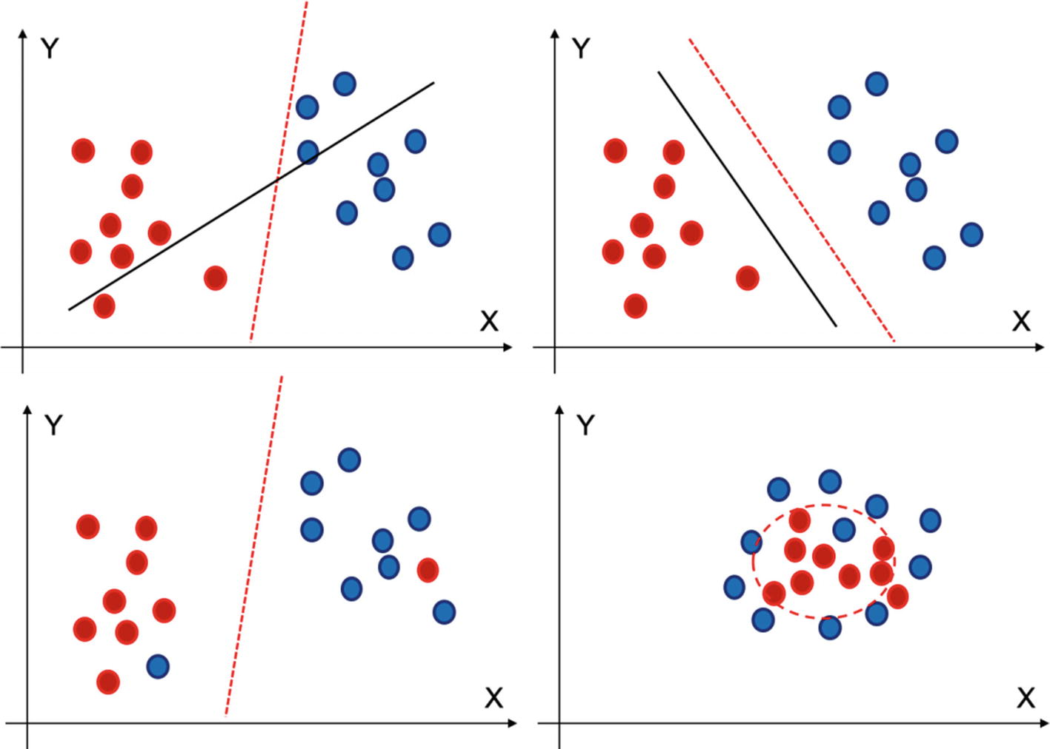

***Figure 4-7***

The fourth diagram is implementing a nonlinear classifier to distinguish between two classes

KSVM has created a nonlinear classifier to perform the classification between the two classes.

Here are some of the parameters of SVM:

1. 1.

**Kernel**: Kernel is used when we have the data which can become separable if expressed in higher dimensions. The various kernels available in sklearn are rbf, poly, sigmoid, linear, precomputed, and so on. If we use a “linear” kernel, it will use a linear hyperplane or a line in the case of 2-dimensional data. ‘rbf’, ‘poly’ are used for nonlinear hyperplanes .

1. 2.

**C**: C is used to represent the misclassification error or the *cost* parameter. If the value of C is low, the penalty of misclassification observations is low and hence the accuracy will be high. It is used to control the tradeoff between accurate classification of training data and having a smooth decision boundary.

1. 3.

**Gamma**: Gamma is used to define the radius of influence of the observations in a classification. It is primarily used for nonlinear hyperplanes. A higher gamma can lead to better accuracy, but results can be biased, and vice versa.

We have to iterate with various values of such parameters and reach the best solution. With a high value of gamma, the variance will be low and bias will be high, and vice versa. And when the value of C is large, variance will be high and bias will be low, and vice versa.

There are both advantages and some challenges with using SVM.

Advantages of SVM solution:

1. 1.

It is a very effective solution for complex datasets, where the number of dimensions is large .

1. 2.

It is the preferred choice when we have more dimensions and less training dataset.

1. 3.

The margin of separation by SVM is quite clear and provides a good, accurate, and robust solution.

1. 4.

SVM is easy to implement and is quite a memory-efficient solution to implement.

Challenges with SVM:

1. 1.

It takes time to converge with large sample size and hence may not be preferred for bigger datasets.

1. 2.

The algorithm is sensitive to messy data. If the target classes are not clearly demarcated and different, the algorithm tends to perform not so well.

1. 3.

SVM does not provide direct probabilities for the predictions. Instead they have to be calculated separately.

Despite a few challenges, SVM has repeatedly proven its worth. It offers a robust solution when we have a multidimensional smaller data set to analyze. We are now going to solve a case study in Python using SVM now.

**Case Study Using SVM**

We are solving a cancer detection case study. The dataset is available at the Github link shared at the start of the chapter.

Step 1: Import the necessary libraries first

import pandas as pd

import numpy as np

import seaborn as sns

import matplotlib.pyplot as plt

%matplotlib inline

Step 2: Import the dataset now

cancer_data = pd.read_csv('bc2.csv')

cancer_dataset = pd.DataFrame(cancer_data)

cancer_dataset.columns

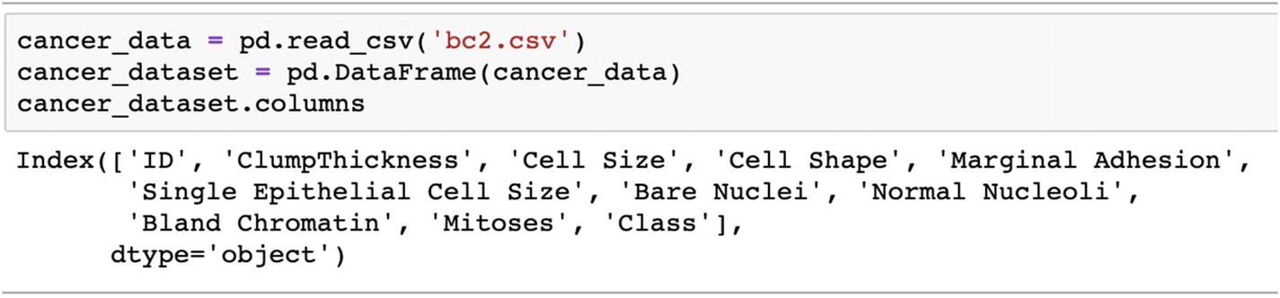

Step 3: Have a look at the columns

cancer_dataset.describe()

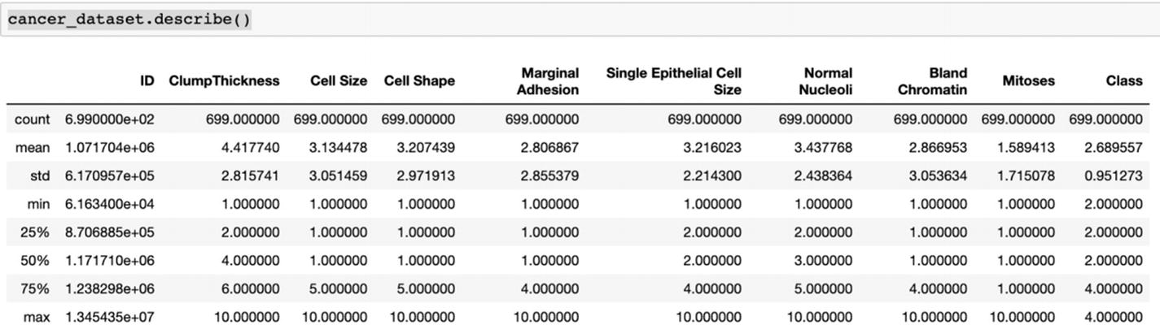

Step 4: Treat the missing values in the next step. We are filling them with median here.

cancer_dataset = cancer_dataset.replace('?', np.nan)

cancer_dataset = cancer_dataset.apply(lambda x: x.fillna(x.median()),axis=0)

Step 5: Now we are converting the 'Bare Nuclei' column string type to float

cancer_dataset['Bare Nuclei'] = cancer_dataset['Bare Nuclei'].astype('float64')

Step 6: Check if there are any NULL values present in the dataset

cancer_dataset.isnull().sum()

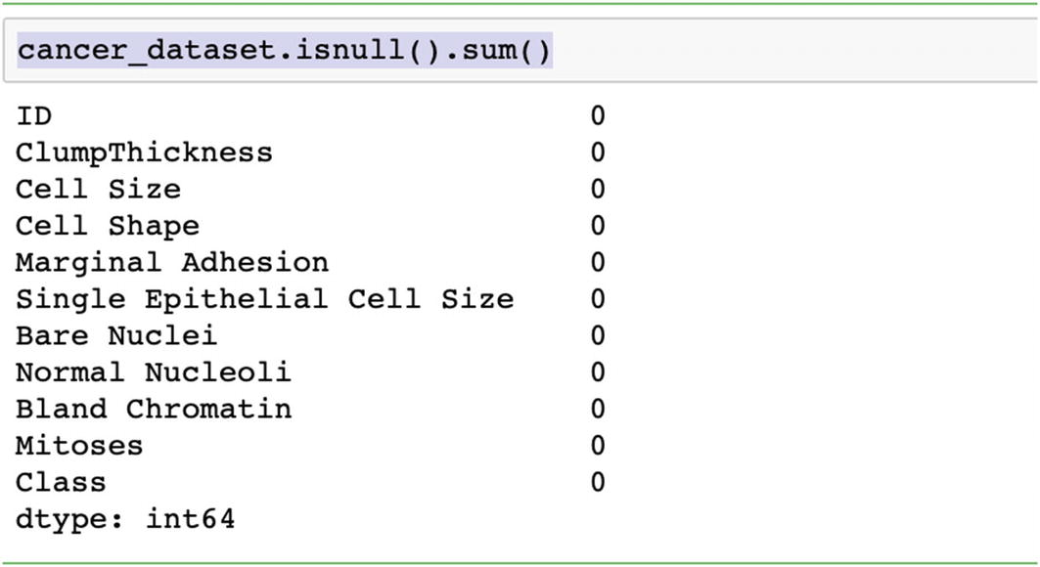

Step 7: Divide the data into train and test now.

from sklearn.model_selection import train_test_split

# To calculate the accuracy score of the model

from sklearn.metrics import accuracy_score, confusion_matrix

target_variable = cancer_dataset["Class"]

features = cancer_dataset.drop(["ID","Class"], axis=1)

X_train, X_test, y_train, y_test = train_test_split(features,target_variable, test_size = 0.25, random_state = 5)

Step 8: Train the model with linear kernel

from sklearn.svm import SVC

svc_model = SVC(C= .1, kernel="linear", gamma= 1)

svc_model.fit(X_train, y_train)

svc_prediction = svc_model .predict(X_test)

Step 9: Check the accuracy

print(svc_model.score(X_train, y_train))

print(svc_model.score(X_test, y_test))

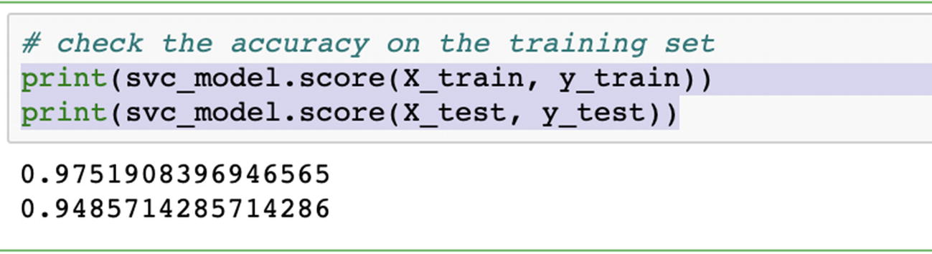

Step 10: Print the confusion matrix

print("Confusion Matrix:\n",confusion_matrix(svc_prediction,y_test))

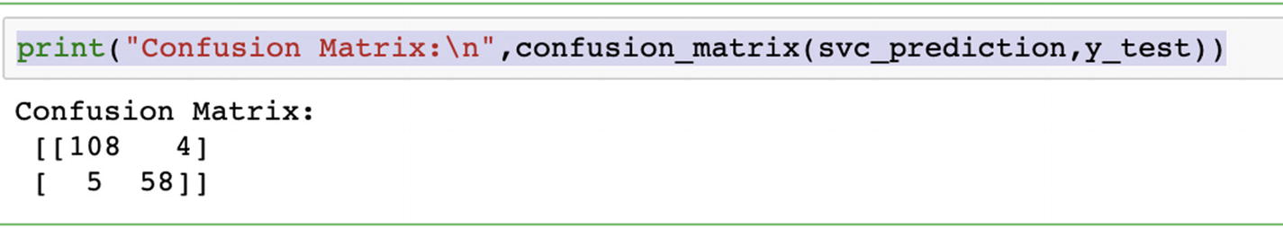

Step 11: In the next steps, we will change the kernel and get different accuracies

svc_model = SVC(kernel='rbf')

svc_model.fit(X_train, y_train)

print(svc_model.score(X_train, y_train))

print(svc_model.score(X_test, y_test))

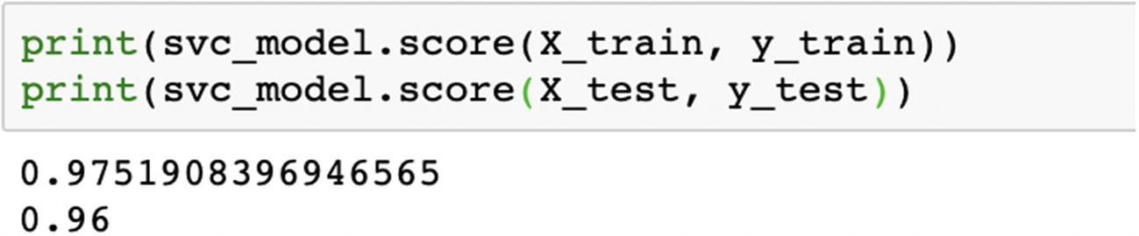

svc_model  = SVC(kernel='poly')

svc_model.fit(X_train, y_train)

svc_prediction = svc_model.predict(X_test)

print(svc_model.score(X_train, y_train))

print(svc_model.score(X_test, y_test))

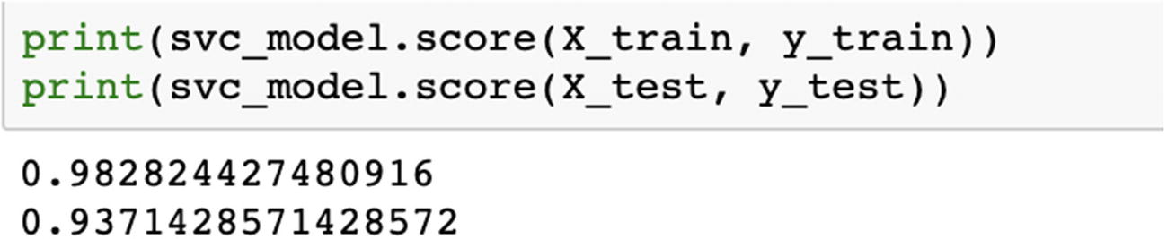

svc_model = SVC(kernel='sigmoid')

svc_model.fit(X_train, y_train)

svc_prediction = svc_model.predict(X_test)

print(svc_model.score(X_train, y_train))

print(svc_model.score(X_test, y_test))

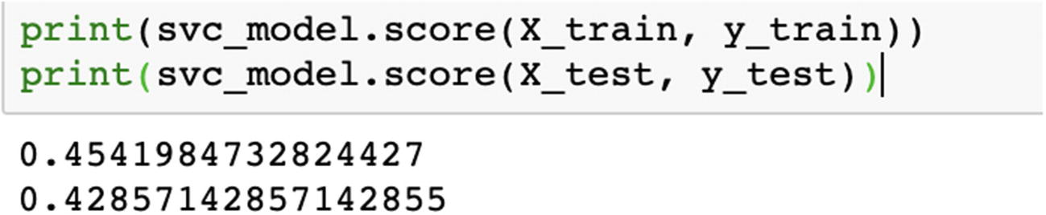

We can compare the respective accuracies for all the kernels and choose the best one. Ideally, accuracy should not be the only parameter; we should also compare recall and precision using confusion matrix.

In the preceding example, we can create a visualization using seaborn library. It is an additional step and can be done if needed.

sns.pairplot(cancer_dataset, diag_kind = "kde", hue = "Class")

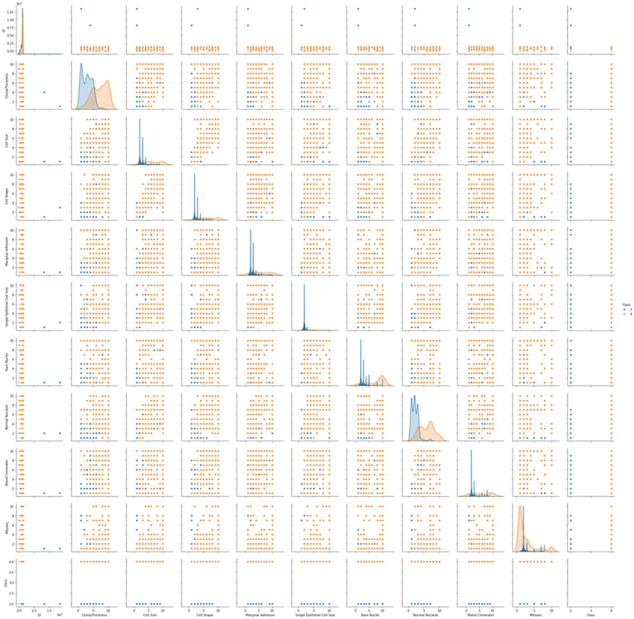

In the preceding example, we created a Python solution using SVM. When we change the kernel, the accuracy changes a lot. The SVM algorithm should be compared along with other ML models and then the best algorithm should be chosen.

**Note**

Ideally we test any problem with three or four algorithms and compare the precision, recall, accuracy and then decide which algorithm is best for us. These steps are discussed again in Chapter [5](https://learning.oreilly.com/library/view/supervised-learning-with/9781484261569/html/499122_1_En_5_Chapter.xhtml).

With this we have studied the SVM in detail. An easy-to-implement solution, SVM is one of the advanced supervised learning algorithms which is heavily recommended.

So far, we have studied and created solutions for structured data. We started with regression, decision trees, and so on in previous chapters. We examined the concepts and created a solution in Python. In this chapter, we continued with boosting algorithms and SVMs. Now we will start a much more advanced topic—supervised learning algorithms for unstructured data, which are text and images, in the next section. We will study the nuts and bolts, preprocessing steps, challenges faced, and use cases. And like always, we will create Python solutions to complement the knowledge.

**Supervised Algorithms for Unstructured Data**

We now have access to cameras, phone, processors, recorders, data management platforms, cloud-based infrastructure, and so on. And hence, our capabilities to record data, manage it, store it, transform it, and analyze it have also improved tremendously. We are not only able to capture complex datasets but also store them and process them. With the advent of neural network–powered deep learning, the processing has improved drastically. Deep learning is a revolution in itself. Neural networks are fueling the limitless capabilities being developed across domains and business. With superior processing powers, and more powerful machines like multicore GPU and TPU, sophisticated deep neural networks are able to process more information much faster, which is true for both structured and unstructured datasets. In this section, we are going to work on unstructured datasets and study supervised learning algorithms for unstructured datasets.

Recall in Chapter [1](https://learning.oreilly.com/library/view/supervised-learning-with/9781484261569/html/499122_1_En_1_Chapter.xhtml), we discussed structured and unstructured datasets as shown in Figure [4-8](https://learning.oreilly.com/library/view/supervised-learning-with/9781484261569/html/499122_1_En_4_Chapter.xhtml#Fig8). Text, images, audio, video, and so on fall into the unstructured datasets.

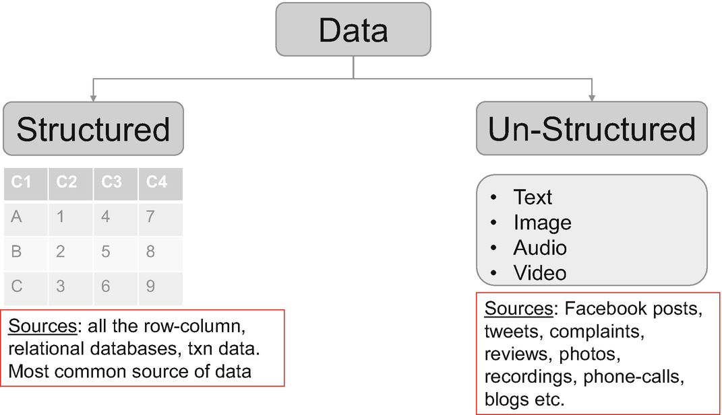

***Figure 4-8***

Data can be classified between structured and unstructured datasets

We will start studying the text data. We will examine all the concepts of cleaning the text data, preprocessing it, creating supervised learning solutions in Python using it, and what are the best practices to work with it. Let’s kick off now!

**Text Data**

Language is a gift to humanity. It is the most common medium to express ourselves. Language is involved in most interactions we have like speaking, messaging, writing, listening. This text data is everywhere. We generate it every day in the form of news, Facebook comments and posts, customer reviews and complaints, tweets, blogs, articles, literature, and so on. The datasets generated represent a wide range of emotions and expressions which are generally not captured in surveys and ratings. We do witness that in the form of online product reviews given by customers. The number of ratings given can be 5 out of 5, but the actual review text might give a different impression. Thus, it becomes even more crucial for businesses worldwide to pay attention to the text data.

Text data is much more expressive and direct. This data is to be analyzed as it holds the key to a lot of understanding we can generate about our customers, processes, products and services, our culture, our world, and our thoughts. Moreover, with the advent of Alexa, Google Assistant, Apple Siri, and Cortana the voice command is acting as an interface between humans and machines and generating more datasets for us. Massive and expressive, right!

Similar to the complexity, text data is a rich source of information and actions. Text data can be used for a plethora of solutions, which we discuss next.

**Use Cases of Text Data**

Text data is very useful. It expresses what we really feel in words. It is a powerful source to gauge the thoughts which often are not captured in surveys and questionnaires. It is directly sourced data and hence is less biased, though it can be a really noisy dataset to deal with.

Text data is quite rich and can be used for multiple use cases like the following:

1. 1.

**News categorization or document categorization** : We can have incoming news or a document. We want to categorize whether a news item belongs to sports, politics, science, business, or any other category. Incoming news will be classified based on the content of the news, which is the actual text. News about business will be different from a news article on sports as shown in Figure [4-9](https://learning.oreilly.com/library/view/supervised-learning-with/9781484261569/html/499122_1_En_4_Chapter.xhtml#Fig9). Similarly, we might want to categorize some medical documents into their respective categories based on the domain of study. For such purposes, supervised learning classification algorithms can be used to solve the problems.

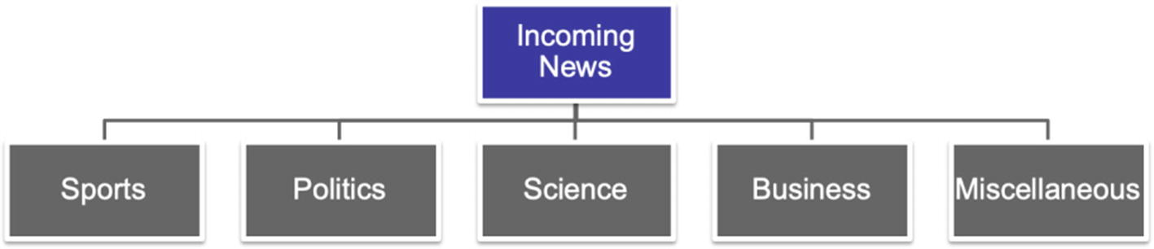

***Figure 4-9***

There can be multiple categories of incoming news as sports, politics, science, business, and so on

1. 2.

**Sentiment analysis** : Sentiment analysis is gauging what is the positiveness or negativity in the text data. There can be two such use cases:

* 1. a.

We receive reviews from our customers about the products and services. These reviews have to be analyzed. Let’s consider a case. An electric company receives complaints from its customers, reviews about the supply, and comments about the overall experience. The streams can be onboarding experience, ease of registration, payment process, supply reviews, power reviews, and so on. We want to determine the general context of the review—whether it is positive, negative, or neutral. Based on these comments, an improvement can be made on the product features or service levels.

* 1. b.

We might also want to assign a review to a specific department. For example, in the preceding case an incoming review will have to be shared with the relevant department. Using Natural Language Processing (NLP), this task can be done, the review can be shared with the finance department or operations team, and the respective team can follow up with the review and take the next course of action .

1. 3.

**Language translation** : Using NLP and deep learning, we are able to translate between languages (e.g., between English and French). A deep neural network requires training on the vocabulary and grammar of both the languages and multiple other training data points.

1. 4.

**Spam filtering** : Email spam filter can be composed using NLP and supervised ML. We can train an algorithm which can analyze incoming mail parameters and give a prediction if that email belongs to a spam folder or not. Going even one step further, based on the various parameters like sender email-id, subject line, body of the mail, attachments, time of mail, and so on, we can even determine if that is a promotional email or spam or an important one. Supervised learning algorithms help us in making that decision and automating the entire process.

1. 5.

**Text summarization** of the entire book or article can be done using NLP and deep learning. In this case too, we will be using deep learning and NLP to generate summaries of entire documents or articles. This helps in creating us an abridged version of the text.

1. 6.

**Part-of-speech (POS) tagging** : POS tagging refers to the identification of words as nouns, pronouns, adjectives, adverbs, conjunctions, and so on. It is the process of marking the words in the text corpus corresponding to a particular POS, based on its use, definition, and context in the sentence and larger body, as shown in Figure [4-10](https://learning.oreilly.com/library/view/supervised-learning-with/9781484261569/html/499122_1_En_4_Chapter.xhtml#Fig10).

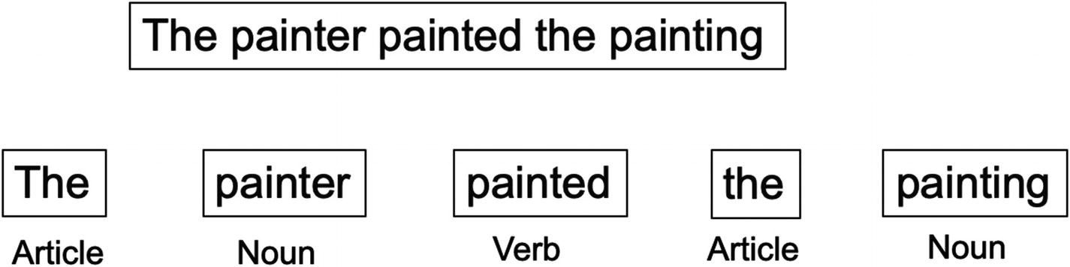

***Figure 4-10***

POS tagging for words into their respective categories

Text data can be analyzed using both supervised and unsupervised problems. We are focusing on supervised learning in this book. We use NLP to solve the problems. And deep learning further improves the capabilities we have. These are the tools which empower us to deal with such complex datasets.

But text data is difficult to analyze. It has to be still represented in the form of numbers and integers; only then can it be analyzed. Our computers and processors understand numbers and the algorithms also expect numbers only. We will now discuss the most common challenges we face with text data in the next section.

**Challenges with Text Data**

Text is perhaps the most difficult data to be analyzed and worked with. The number of permutations to express the same question or thought are many. For example, “what is your age” and “how old are you” mean one and the same thing. We have to resolve these challenges and come up with a dataset which is robust, complete, and representative while at the same time not losing the original context.

The most common challenges we face are as follows:

1. 1.

Language is unbounded. It changes every day and every moment new words are added to the dictionaries.

1. 2.

Languages are many: Hindi, English, French, Spanish, German, Italian, and so on. Each language follows its own rules and grammar, which are unique in usage and pattern. Some are written left to right; some might be right to left or maybe even vertically! A thought which is expressed in twelve words in one language might be expressed in only five words in another.

1. 3.

A word can change its meaning in a different context. For example, “I want to read this book” and “Please book the hotel for me.” A word can be an adjective and can be a noun too depending on the context.

1. 4.

A language can have many synonyms for the same word; for example, “good” can be replaced by “positive,” “wonderful,” “superb,” and “exceptional” in different scenarios. Similarly, words like “study,” “studying,” and “studies” are related to the same root word, “study.”

1. 5.

Words can completely even change their meaning with usage. For example, “apple” is a fruit, while “Apple” is a company producing Macintosh. “Tom” can be a name but when used as “Tom Software Consulting,” its usage is completely changed.

1. 6.

Tasks which are very easy for humans might be very difficult for machines. We do have memory, while machines tend to forget. For example, “John is from London and he moved to Australia and is working with Allan over there. He missed his family back there.” Humans can easily recall and understand that “he” in the second sentence is John and not Allan.

These are not the only challenges, and the preceding list is not exhaustive. Managing this massive dataset, storing it, cleaning it, and refreshing it is a Herculean task in itself. But using sophisticated processes and solutions, we are able to resolve most of them, if not all. Some of these techniques we discuss in the next section on preprocessing the text data and extracting the features from the text data.

Like any other ML project, text analytics follow the principles of ML, albeit the process is slightly different. We will discuss the text analytics process now in the next section.

**Text Analytics Modeling Process**

Text analytics is complex owing to the complexity of data we are dealing with and the data preprocessing required. At a high level the various process heads remain the same, but still a lot of the subprocesses are customized for text. They are also dependent on the business problem we want to solve. The typical text analytics process is shown in Figure [4-11](https://learning.oreilly.com/library/view/supervised-learning-with/9781484261569/html/499122_1_En_4_Chapter.xhtml#Fig11).

Text analytics process, similar to any other project, starts with the definition of a *business problem*. The business problem can be the use cases which we have discussed in the previous section, which can be sentiment analysis or text summarization.

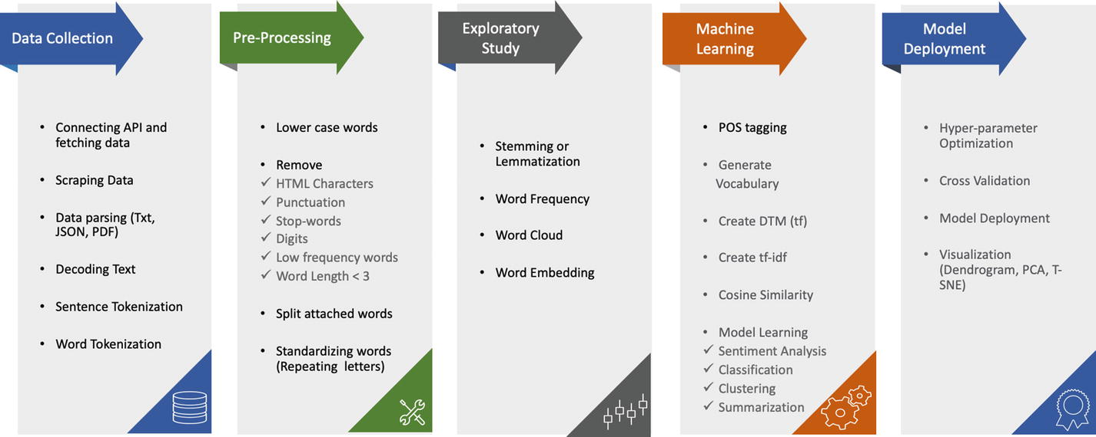

***Figure 4-11***

End-to-end process in a text analytics project from data collection to the deployment

Let’s consider the same business problem we discussed in the last section: sentiment analysis for an electric company. The business problem can be that we receive customer complaints, reviews about our products, and services through many mediums like call centers, emails, phone calls, messages, and so on. At the same time, many customers post on Facebook or other social media platforms. This generates a lot of text data for us. We want to analyze this text data and generate findings and insights about

1. 1.

Our customer’s satisfaction regarding the products and services.

1. 2.

The major pain points and dissatisfactions, what drives the engagement, which services are complex and time-consuming, and which are the most liked services.

1. 3.

The products and services which are most popular, which are least popular, and any popularity patterns.

1. 4.

How best to represent these findings by means of a dashboard. This dashboard will be refreshed at a regular cycle like monthly or quarterly refresh.

This business use case will drive the following business benefits:

1. 1.

The products and services which are most satisfactory and are most liked ones should be continued.

1. 2.

The ones which are receiving a negative score have to be improved and challenges have to be mitigated.

1. 3.

The respective teams like finance, operations, complaints, CRM, and so on can be notified, and they can work individually to improve the customer experience.

1. 4.

The precise reasons for liking or disliking the services will be useful for the relevant teams to work in the correct direction.

1. 5.

Overall, it will provide a benchmark to measure the Net Promoter Score (NPS) for the customer base. The business can strive to enhance the overall customer experience.

A concise, precise, measurable, and achievable business problem is the key to success. Once the business problem is frozen, we will work on securing the dataset, which we will discuss next.

**Text Data Extraction and Management**

As discussed in the last section, customer text data can be generated through a number of sources. The entire dataset in text analytics is referred to as a *corpus*. Formally put, a corpus represents a large collection of text data (generally labeled but can be unlabeled too), which is used for statistical analysis and hypothesis testing.

In Figure [4-12](https://learning.oreilly.com/library/view/supervised-learning-with/9781484261569/html/499122_1_En_4_Chapter.xhtml#Fig12), we are depicting a process of receiving the text data from multiple sources like call center calls, complaints, reviews, blogs, tweets, and so on. These data points are first moved to a staging area.

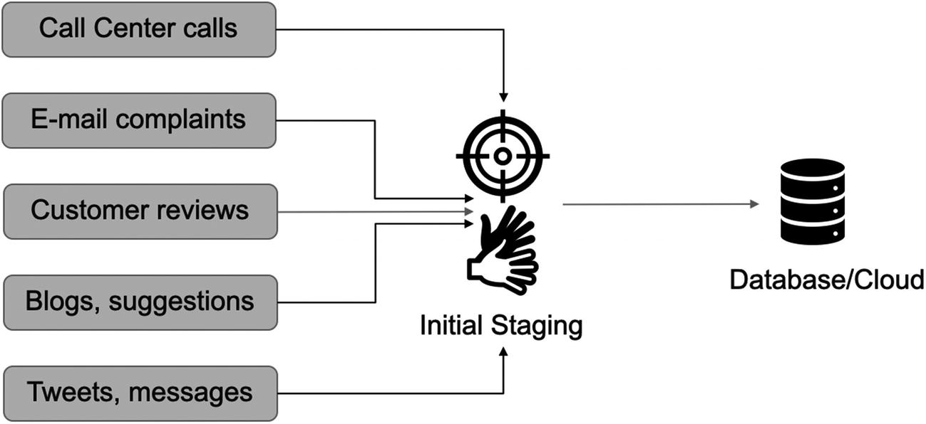

***Figure 4-12***

Data management process of text data, starting from data collection to the final storage

To be noted is that these various data sources might have different types of data points like .csv, .xls, .txt, logs, files or databases, json or .pdf, and so on. We might even fetch data from APIs. During the staging area load, all of these data points have to be merged and cleaned. It will involve creation of databases, tables, views, and so on. In the case study shared previously, the database table can look like the following structure in Table [4-2](https://learning.oreilly.com/library/view/supervised-learning-with/9781484261569/html/499122_1_En_4_Chapter.xhtml#Tab2).

***Table 4-2***

Customer Reviews Having Customer Details Like ID, Date, Product, City, and Actual Review Text

|  |
| --- |
|  |

Here, we have the unique customer ID, product purchased, date of the review, city, source, and actual review text of the customer. This table can have many more data points then we have shown. And there can be other tables having customer details like was the complaint resolved, time to resolve, and so on, which can serve as additional information to analyze.

All such data points have to be maintained and refreshed. The refresh cycle can be determined as per the business requirements: it can be a monthly, quarterly, or yearly refresh.

There is one more important source of data which is very insightful and can be used for wider strategy creation. There are plenty of online channels and platforms where a customer can review a product/service. Online marketplaces like Amazon also have details of customer reviews. These platforms have reviews of the competitive brands too. For example, Nike might be interested in Puma’s and Reebok’s customer reviews. These online reviews have to be scraped and maintained. Again, these reviews might be in a different format and will have to be cleaned.

During this data maintenance phase, we clean a lot of text data like junk characters like *&^# which are present in the data. They might occur because of formatting errors while loading the data or the data itself might have junk characters. The text data is cleaned to the maximum possible extent, and further cleaning can take place in the next step of data preprocessing.

Text data is really tough data to deal with. There are a lot of complexities and data is generally messy. We have discussed a few of the challenges in the last section. We will be examining a few again and examining solutions to tackle them in the next section. We are starting with extracting features from the text data, representing them in a vector-space diagram and creating ML models using these features.

**Preprocessing of Text Data**

Text data, like any other data source, can be messy and noisy. We clean some of it in the data discovery phase and a lot of it in the preprocessing phase. At the same time, we have to extract the features from our dataset. This cleaning process is a standard one and can be implemented on most of the text datasets.

There are multiple processes in which we complete these steps. We will start with cleaning the raw text first.

**Data Cleaning**

There is no second thought about the importance of data quality. The cleaner the text data is, the better the analysis will be. At the same time, reducing the size of the text data will result in a lower-dimensional data. And hence, the processing during the ML phase and training the algorithms become less complex and time-consuming.

Text data is to be cleaned as it contains a lot of junk characters, irrelevant words, noise and punctuation, URLs, and so on. The primary ways of cleaning the text data are

1. 1.

**Stop-word removal** : Stop words are the most common words in a vocabulary which carry less importance than the keywords. For example, “is,” “an,” “the,” “a,” “be,” “has,” “had,” “it,” and so on. It reduces the dimensions of the data and hence complexity is reduced. But due caution is required while we remove stop words. For example, if we ask the question “Is it raining?” then the answer “It is” is a complete answer in itself.

**Note**

When we are working with problems where contextual information is important like machine translation, we should avoid removing stop words.

1. 2.

**Library-based cleaning** : This involves cleaning of data based on a predefined library. We can create a repository of words which we do not want in our text and can iteratively remove from the text data. This approach is preferred if we do not want to use a stop-word approach but want to follow a customized one.

1. 3.

**Junk characters** : We can remove URL, hashtags, numbers, punctuations, social media mentions, special characters, and so on from the text. We have to be careful as some words which are not important for one domain might be quite useful for a different domain.

**Note**

Due precaution is required when data is cleaned. We have to always keep the business context in mind while we remove words or reduce the size.

1. 4.

**Lexicon normalization** : Depending on the context and usage, the same word might get represented in different manners. During lexicon normalization we clean such ambiguities. The basic idea is to reduce the word to its root form. Hence, words which are derived from each other can be mapped to the central word provided they have the same core meaning.

For example, study might get represented as study, studies, studied, studying, and so on as shown in Figure [4-13](https://learning.oreilly.com/library/view/supervised-learning-with/9781484261569/html/499122_1_En_4_Chapter.xhtml#Fig13). The root word “study” remains the same, but its representations differ.

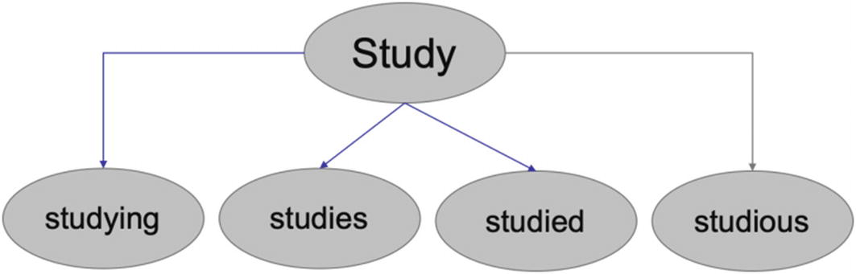

***Figure 4-13***

The root word is “study,” but there are many forms of it like “studying” and “studies”

There are two ways to deal with this, namely, stemming and lemmatization:

1. a.

*Stemming* is a very basic rule-based approach of removing “es,” “ing,” “ly,” “ed,” and so on from the end of the word. For example, “studies” will become “studi” and “studying” will become “study.” As visible being a rule-based approach, the output spellings might not always be accurate.

1. b.

In contrast to stemming, *lemmatization* is an organized approach which reduces words to their dictionary form. A *lemma* of a word is its dictionary or canonical form. For example, “studies,” “studied,” and “studying” all have the same root word, “study.”

1. 5.

**Standardization**: With the advent of modern communication devices and social media, our modes of communications have changed. Along with it, our language has also changed. We have new limitations and rules, like a tweet can be of 280 characters only.

Hence, the dictionaries have to change too. We have newer references which are not a part of any standard dictionary, are ever-changing, and are different for each language, country, and culture. For example, “u” refers to “you,” “luv” is “love,” and so on.

We have to clean such text too. In such a case, we create a dictionary of such words and replace them with the correct full form.

These are only some of the methods to clean the text data. These techniques should resolve most of the issues. Still, we will not get completely clean data. Business acumen is required to further make sense to it.

Once the data is cleaned, we have to start representation of data so that it can be processed by ML algorithms—our next topic.

**Extracting Features from Text Data**

Text data, like any other data source, can be messy and noisy. We clean some of it in the data discovery phase and in the preprocessing phase. Now the data is clean and ready to be used. The next step is to represent this data in a format which can be understood by our algorithms.

In the simplest understanding, we can simply perform *one-hot encoding* on our words and represent them in a matrix. The words can be first converted to lowercase and then sorted in an alphabetical order. And then a numeric label can be assigned. And finally, words are converted to binary vectors. We will explain it using an example.

For example, the text is “He is going outside.” We will use the following steps:

1. 1.

We will convert the words to lowercase, resulting in – he, is, going, outside.

1. 2.

Next, arrange the words in alphabetical order, which gives the output as – going, he, is, outside.

1. 3.

We can now assign values to each word as going:0, he:1, is:2, outside:3.

1. 4.

Finally, they are transformed to binary vectors as

[[0. 1. 0. 0.] #he

[0. 0. 1. 0.] #is

[1. 0. 0. 0.] #going

[0. 0. 0. 1.]] #outside

Though this approach is quite intuitive and simple to comprehend, it is pragmatically not possible due to the massive size of the corpus and the vocabulary. Moreover, handling such data size with so many dimensions will be computationally very expensive. The resulting matrix thus created will be very sparse too. Hence, we look at other means and ways to represent our text data.

There are better alternatives available to one-hot encoding. These techniques focus on the frequency of the word or the context in which the word is being used. This scientific method of text representation is much more accurate, robust, and explanatory. It generates better results too.

There are multiple such techniques like tf-idf, bag-of-words (BOW) approach, and so on. We discuss a few of these techniques in the next sections. But we will examine the important concept of tokenization first!

**Tokenization**

Text data has to be analyzed, and hence we can represent the words as *tokens*. Tokenization is breaking a text or a set of text into individual tokens. It is the building block of NLP. Tokens are usually individual words, but this is not necessary. We can tokenize a word or subwords or characters in the word. We can represent word tokenization as shown in Figure [4-14](https://learning.oreilly.com/library/view/supervised-learning-with/9781484261569/html/499122_1_En_4_Chapter.xhtml#Fig14).

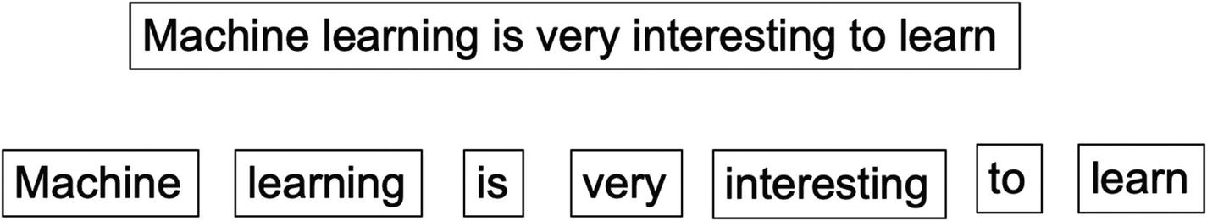

***Figure 4-14***

Tokenization of a sentence results in individual tokens for all the words

In the case of subwords, the same sentence can have subword tokens as interest-ing. For tokenization at a character level, it can be i-n-t-e-r-e-s-t-i-n-g. In fact, in the one-hot encoding approach discussed in the last section as a first step, tokenization was done on the words.

There are multiple methods of tokenizing based on the regular expressions to match either tokens or separators between tokens. *Regexp* tokenization uses the given pattern arguments to match the tokens or separators between the tokens. *Whitespace* tokenization treats any sequence of whitespace characters as a separator. Then we have *blankline* which uses a sequence of blank lines as a separator. And *wordpunct* tokenizes by matching sequence of alphabetic characters and sequence of non-alphabetic and non-whitespace characters.

Tokenization hence allows us to assign unique identifiers or tokens to each of the words. These tokens are further useful in the next stage of the analysis.

Now, we will explore more methods to represent text data. The first such method is the “bag of words.”

**Bag-of-Words Model**

In the bag-of-words approach , or BOW, text is tokenized for each observation it finds and then the respective frequency of each token is calculated. This is done disregarding grammar or word order; the primary goal is to maintain simplicity. Hence, we will represent each text (sentence or a document) as a *bag of its own words*.

Figure [4-15](https://learning.oreilly.com/library/view/supervised-learning-with/9781484261569/html/499122_1_En_4_Chapter.xhtml#Fig15) shows that in the first example, each word has occurred only once and hence the frequency is 1. In the second sentence, the frequency of “is” and “drinking” is 2. This is called the bag of words for each token.

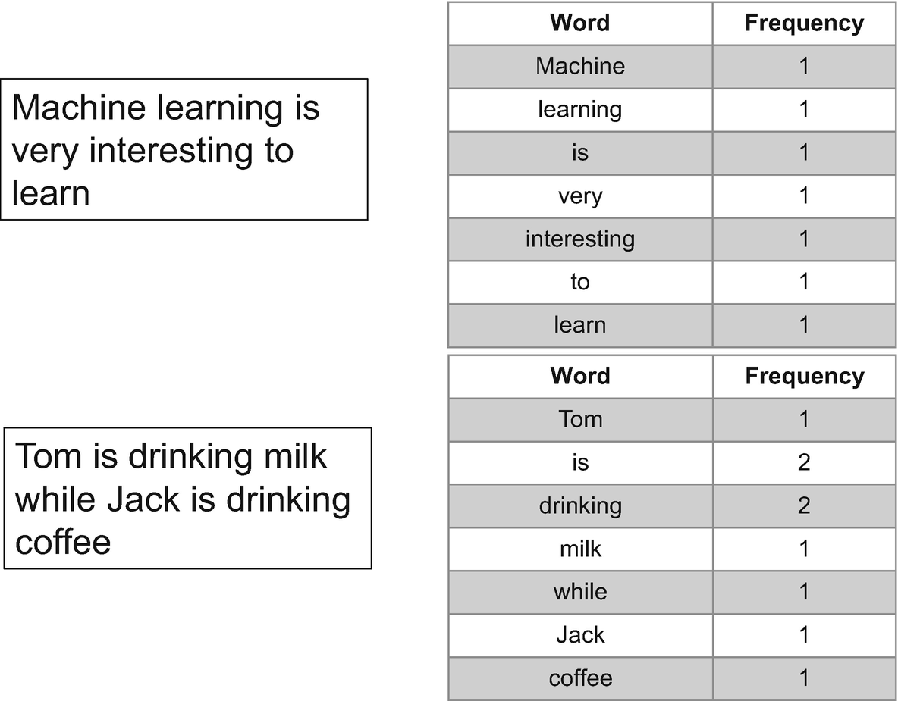

***Figure 4-15***

Bag-of-words approach showing that words with higher frequency are given higher values

In the BOW approach for the entire document, we define the vocabulary of the corpus as all the unique words present in the corpus. We can also set a threshold, that is, the upper and lower limit for the frequency. Then each sentence or document is defined by a vector of the same dimension as the base vocabulary containing the frequency of each word of the vocabulary in the sentence.

For example, if we imagine that the last two sentences—“Machine learning is very interesting to learn” and “Tom is an eating apple while Jack is drinking coffee”—as the only two sentences present in the entire vocabulary, then we will represent the first sentence as shown in Figure [4-16](https://learning.oreilly.com/library/view/supervised-learning-with/9781484261569/html/499122_1_En_4_Chapter.xhtml#Fig16). We should note that drinking and milk are given 0 in this vector for “Machine learning is very interesting to learn.”

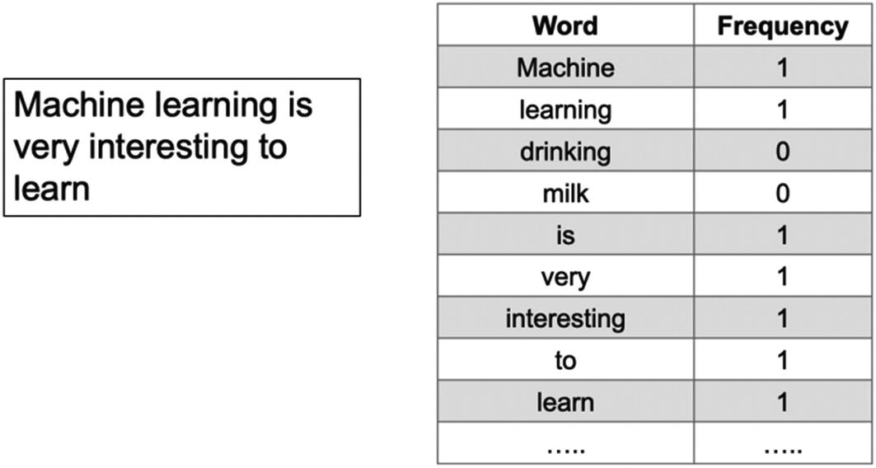

***Figure 4-16***

Bag-of-words representation of a sentence based on the entire vocabulary

The BOW approach has not considered the order of the words or the context. It focuses only on the frequency of the word. Hence, it is a very fast approach to represent the data. Since it is frequency based, it is commonly used for document classifications. At the same time, owing to pure frequency-based methods the model accuracy can take a hit. And that is why we have other advanced methods which consider more parameters then frequency alone. One of such methods is tf-idf or term frequency and inverse-document frequency, which we are studying next .

**Term-Frequency and Inverse-Document Frequency**

In the bag-of-words approach, we gave importance to the frequency of a word only. In term-frequency and inverse-document-frequency (tf-idf), we consider the relative importance of the word. tf-idf is made up of tf (term frequency) and idf (inverse-document frequency).

Term frequency (tf) is the count of a term in the entire document. For example, the count of the word “x” in the document “d.”

Inverse-document frequency (idf) is the log of the ratio of total documents (N) in the entire corpus and number of documents (df) which contain the word “x.”

So, the tf-idf formula will give us the relative importance of a word in the entire corpus. It is a multiplication of tf and idf and is given by

    w**i, j** = tf**i, j** ×  log (N/df**i**)    (Equation 4-1)

where N is the total number of documents in the corpus

tf**i,j** is the frequency of the word in the document

df**i** is the number of documents in the corpus which contain that word.

Let’s understand this with an example.

Consider we have a collection of 1 million medical documents. In these documents, we want to calculate tf-idf value for the words “medicine” and “penicillin.”

Let’s assume that there is a document of 100 words having “medicine” five times and “penicillin” only twice. So tf for “medicine” is 5/100 = 0.05 and for “penicillin” is 2/100 = 0.02.

Now, we assume that “medicine” appears in 100,000 documents out of 1 million documents, while “penicillin” appears only in 10. So, idf for “medicine” is log (1,000,000/100,000) = log (10) = 1. For “penicillin” it will be log (1,000,000/10) = log (100,000) = 5.

Hence, the final values for “medicine” and “penicillin” will be 0.05×1 = 0.05 and 0.02×5 = 0.1, respectively.

In the preceding example, we can clearly deduce that using tf-idf the relative importance of “penicillin” for that document has been identified. This is the precise advantage of tf-idf; it reduces the impact of tokens that occur quite frequently. Such tokens which have higher frequency might not offer any information as compared to words which are rare but carry more importance and weight.

The next type of representations we want to discuss are n-grams and language models.

**N-gram and Language Models**

In the last sections we have studied the bag-of-words approach and tf-idf. Now we are focusing on language models. We understand that to analyze the text data they have to be converted to feature vectors. N-gram models help in creating those feature vectors so that text can be represented in a format which can be analyzed further.

Language models assign probabilities to the sequence of words. N-grams are the simplest in language models. In the n-gram model we calculate the probability of the N**th** word given the sequence of (N–1) words. This is done by calculating the relative frequency of the sequence occurring in the text corpus. If the items are words, n-grams may be referred to as *shingles*. Hence, if we have a unigram it is a sequence of one word, for two words it is bi-gram, for three words it is tri-gram, and so on. Let us study by means of an example.

Consider we have a sentence, “Machine learning is very interesting.” This sentence can be represented using N=1, N=2, and N=3. You should note how the sequence of words and their respective combinations are getting changed for different values of N, as shown in Figure [4-17](https://learning.oreilly.com/library/view/supervised-learning-with/9781484261569/html/499122_1_En_4_Chapter.xhtml#Fig17).

So, a tri-gram model will approximate the probability of a word given all the previous words by using the conditional probability of only the preceding two words. Whereas a bi-gram will do the same by considering only the preceding word. This is a very strong assumption indeed—that the probability of a word will depend only on the preceding words—and is referred to as a *Markov* assumption.

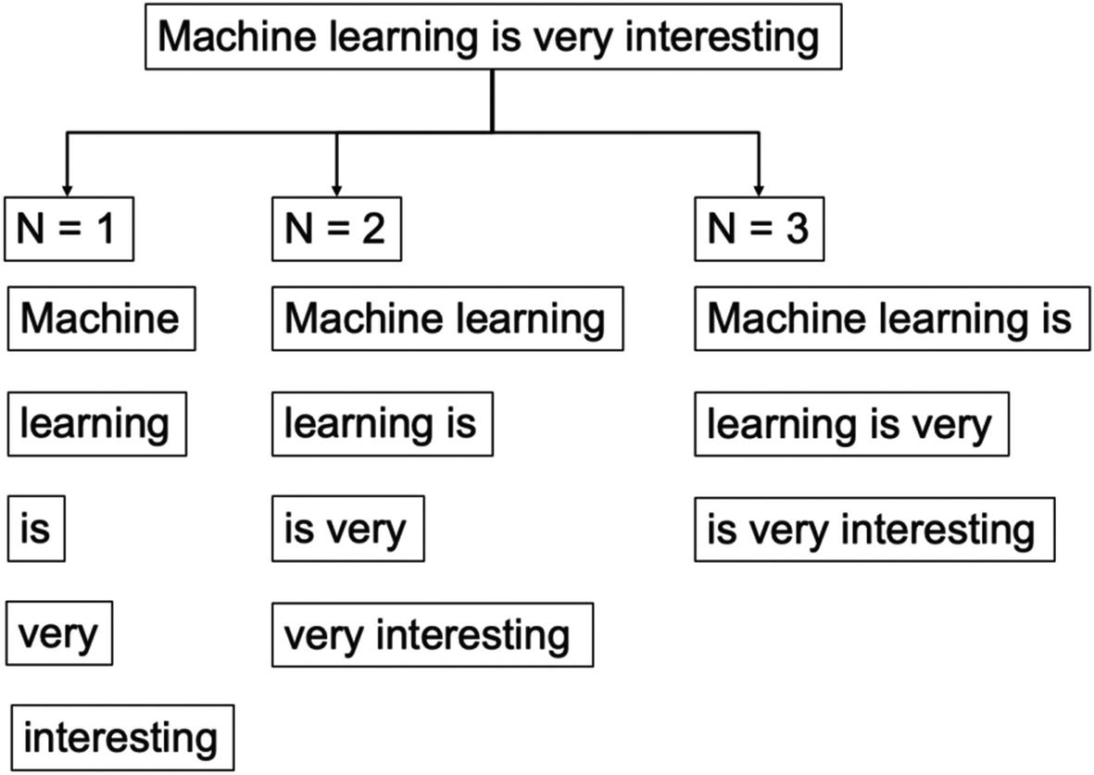

***Figure 4-17***

Unigram, bi-gram, tri-gram representation of the same sentence showing different results

Generally, N > 1 is considered to be much more informative than unigrams. But this approach is very sensitive to the choice of N. It also depends significantly on the training corpus which has been used, which makes the probabilities heavily dependent on the training corpus. So, if we have trained an ML model using a known corpus, we might face difficulties when we encounter an unknown word.

We have studied concepts to clean the text data, tokenize the data, and represent it using multiple techniques. It is time for us to create the first solution in NLP using Python.

**Case study: Customer complaints analysis using NLP**

In the last section, we examined how to represent text data into feature spaces which can be consumed by an ML model. It is the only difference a text data has from a standard ML model we have created in previous chapters.

In other words, the preprocessing and feature extraction will clean the text data and generate features. The resultant features can then be consumed by any standard supervised learning problem. After the step of feature extraction, a standard ML approach can be followed. We will now solve a case on text data and will create a Python supervised learning algorithm.

Consider we have a dataset of customer complaints. For each customer complaint, we have a corresponding product related to it. We will be using NLP and ML to create a supervised learning model to assign any incoming new complaint to the corresponding product.

The dataset and the code have been uploaded to the Github link shared at the start of the chapter.

Step 1: Import all the necessary libraries and load the dataset.

from sklearn.feature_extraction.text import TfidfVectorizer

from sklearn.model_selection import train_test_split

import pandas as pd

complaints_df = pd.read_csv('complaints.csv')

Step 2: Let us have a look at a complaint.

complaints_df['Consumer complaint narrative'][1]

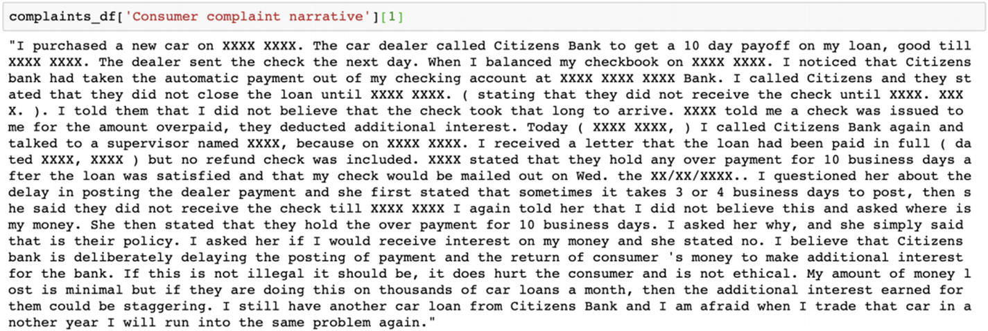

Step 3: Now we will find out the respective categories for a complaint.

print(complaints_df.Product.unique())

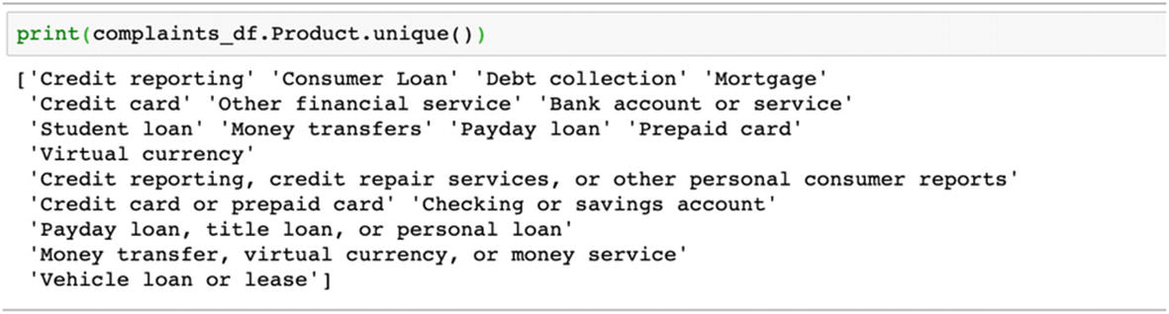

Step 4: Next divide the data into training and testing.

X_train, X_test, y_train, y_test = train_test_split(

    complaints_df['Consumer complaint narrative'].values, complaints_df['Product'].values,

    test_size=0.15, random_state=0)

Step 5: Next we calculate the tf-idf scores for each of the unique tokens in the dataset.

vectorizer = TfidfVectorizer()

vectorizer.fit(X_train)

X_train = vectorizer.transform(X_train)

X_test = vectorizer.transform(X_test)

X_train, X_test

Step 6: We will select the most significant features now.

from sklearn.feature_selection import SelectKBest, chi2

ch2 = SelectKBest(chi2, k=5000)

X_train = ch2.fit_transform(X_train, y_train)

X_test = ch2.transform(X_test)

X_train, X_test

Step 7: Fit a naïve Bayes model now.

from sklearn.naive_bayes import MultinomialNB

from sklearn.metrics import accuracy_score

clf = MultinomialNB()

clf.fit(X_train, y_train)

pred = clf.predict(X_test)

Step 8: Print the predictions in the next step.

print(accuracy_score(y_test, pred))

0.7656024029369229

The accuracy of the model is 76.56%. This standard model can be applied to any supervised classification problem in text analytics. Here we have a multiclass model. It can be scaled down to a binary classification as (Pass/Fail) or to create a sentiment analysis model like (positive, neutral, negative).

We have studied bag-of-words, tf-idf, and N-gram approaches so far. But in all of these techniques, the relationship between words has been neglected. We will now study an important concept which extends the learnings we have in the light of relationships between words—and it is called *word embeddings* *.*

**Word Embeddings**

In the last sections, all the techniques discussed ignore the contextual relationship between words. At the same time, the resultant data is very high-dimensional. Word embeddings provide a solution to the problem. They convert the high-dimensional word features into lower dimensions while maintaining the contextual relationship. We can understand the meaning by looking at an example.

In the example in Figure [4-18](https://learning.oreilly.com/library/view/supervised-learning-with/9781484261569/html/499122_1_En_4_Chapter.xhtml#Fig18), the relation of “man” to “woman” is like that of “king” to “queen”; “go” to “going” is like “run” to “running”; and “UK” to “London” is like “Ireland” to “Dublin.” This approach considers the context and relationships between the words as compared to frequency-based methods discussed in the last sections, and hence are better suited for text analytical problems.

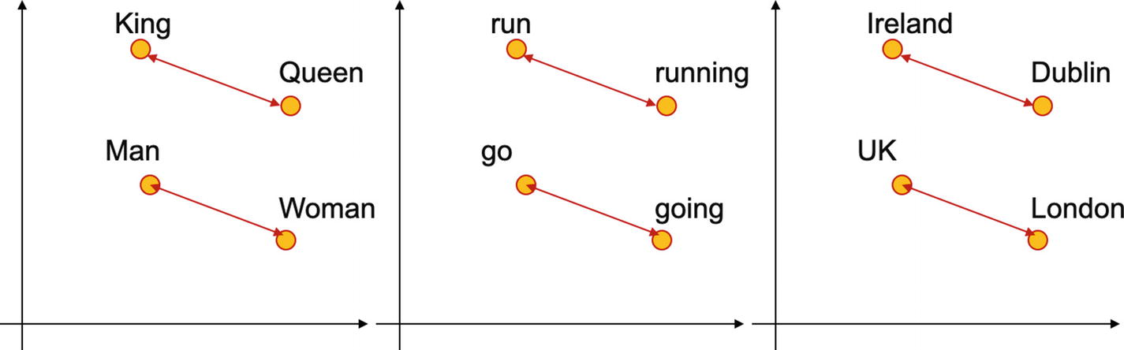

***Figure 4-18***

Word embeddings help in finding the contextual relationship between words which are used in the same context and hence improve understanding

In the example shown previously, the relation of “man” to “woman” is like that of “king” to “queen”; “go” to “going” is like “run” to “running”; and “UK” to “London” is like “Ireland” to “Dublin.”

There are two popular word embedding models: Word2Vec and GloVe. *Word2Vec* provides dense embeddings that understand the similarities between “king” and “queen.” *GloVe* (Global Vectors for word representations) is an unsupervised algorithm for obtaining representations of words where the training has been performed on aggregated global word-to-word co-occurrence statistics from a corpus.

Both models learn and understand the geometrical encodings or in other words vector representation of their words from the co-occurrence information. Co-occurrence means how frequently the words appear together in the large corpus. The prime difference is that Word2Vec is a prediction-based model, while GloVe is frequency based. Word2Vec predicts the context given a word while GloVe learns the context by creating a co-occurrence matrix on how frequently a word appears in a context. The mathematical details for Word2Vec and GloVe are beyond the scope of this book.

**Case study: Customer complaints analysis using word embeddings**

We will now use Python and word embeddings to work on the same complaints data we used in the last section.

Step 1: Import the necessary libraries as the first step.

from nltk.tokenize import RegexpTokenizer

import numpy as np

import re

Step 2: Load the complaints dataset.

import pandas as pd

complaints_dataframe = pd.read_csv('complaints.csv')

Step 3: Let us now have a look at the first few rows of the data.

complaints_dataframe.head()

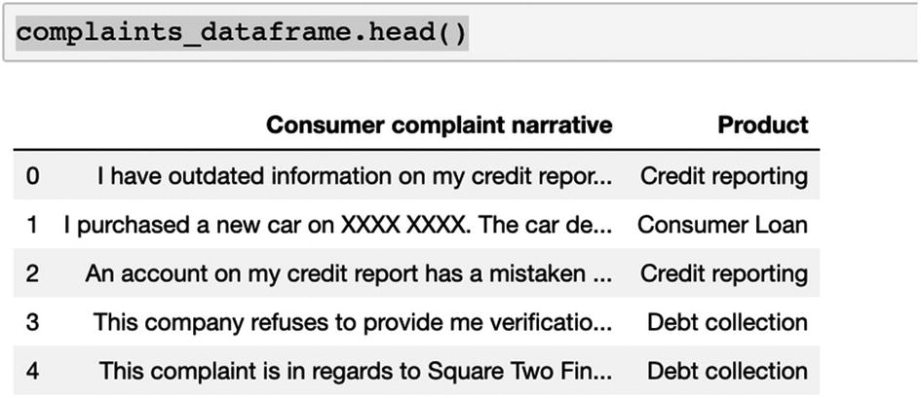

Step 4: A function has been defined to tokenize the words.

def convert_complaint_to_words(comp):

    converted_words = RegexpTokenizer('\w+').tokenize(comp)

    converted_words = [re.sub(r'([xx]+)|([XX]+)|(\d+)', '', w).lower() for w in converted_words]

    converted_words = list(filter(lambda a: a != '', converted_words))

    return converted_words

Step 5: Now we will extract all the unique words from the dataset.

all_words = list()

for comp in complaints_dataframe['Consumer complaint narrative']:

    for w in convert_complaint_to_words(comp):

        all_words.append(w)

Step 6: We will now have a look at the size of the vocabulary.

print('Size of the vocabulary is {}'.format(len(set(all_words))))

76908

Step 7: Print the complaints and the tokens generated.

print('Complaint is \n', complaints_dataframe['Consumer complaint narrative'][10], '\n')

print('Tokens are\n', convert_complaint_to_words (complaints_dataframe['Consumer complaint narrative'][10]))

Step 8: Now we index each unique word in the dataset by assigning it a unique number.

index_dictionary = dict()

count = 1

index_dictionary['<unk>'] = 0

for word in set(all_words):

    index_dictionary[word] = count

    count += 1

Step 9: In the next step, indexed words are used to replace words by index, to make the dataset numeric and keras readable.

embeddings_index = {}

f = open('glove.6B.300d.txt')

for line in f:

    values = line.split()

    word = values[0]

    coefs = np.asarray(values[1:], dtype="float32")

    embeddings_index[word] = coefs

f.close()

Step 10: Now we take an average of all the word embeddings in a sentence to generate the sentence representation.

complaints_list = list()

for comp in complaints_dataframe['Consumer complaint narrative']:

    sentence = np.zeros(300)

    count = 0

    for w in convert_complaint_to_words (comp):

        try:

            sentence += embeddings_index[w]

            count += 1

        except KeyError:

            continue

    complaints_list.append(sentence / count)

Step 11: In this step , we convert categorical variables to numeric ones and then one-hot encode them.

from sklearn import preprocessing

le = preprocessing.LabelEncoder()

le.fit(complaints_dataframe['Product'])

complaints_dataframe['Target'] = le.transform(complaints_dataframe['Product'])

complaints_dataframe.head()

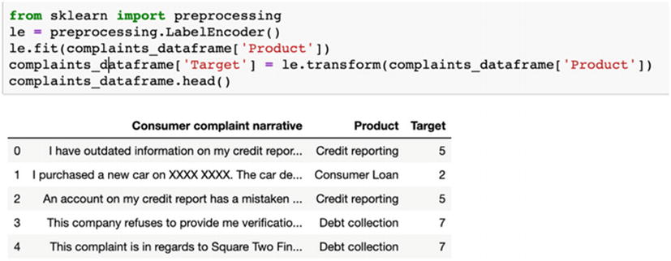

from sklearn.model_selection import train_test_split

X_train, X_test, y_train, y_test = train_test_split(np.array(complaints_list), complaints_dataframe.Target.values,

    test_size=0.15, random_state=0)

Step 12: Train and test the classifier now.

from sklearn.naive_bayes import BernoulliNB

from sklearn.metrics import accuracy_score

clf = BernoulliNB()

clf.fit(X_train, y_train)

pred = clf.predict(X_test)

print(accuracy_score(y_test, pred))

In the preceding example, we have used word embeddings to create a supervised classification algorithm. This is a very standard and robust process which can be implemented for similar datasets. For accuracy in a text data, data preprocessing holds the key; the cleaner the data is, the better is the algorithm!

Text data is one of the most interesting datasets to work upon. They are not easy to clean and often require a huge investment of time and processing power to create a model. But despite that, text holds the key to very insightful patterns present in the data. We can use text data for multiple use cases and can generate insights which might not be possible from standard structured data sources.

This concludes our discussion on the text data. We will now move to images, which are as interesting and equally challenging. Since images mostly perform better with deep learning, we will be studying building blocks of neural networks to solve supervised learning case studies for images.

**Image Data**

If the power of conversation is a gift, vision is a boon to us. We see, we observe, we remember, and we recall whatever we have seen. Through our power of vision, we create a world of images. Images are everywhere. Using our cameras and phones, we click photos. We view photos on social media and at online marketplaces. Images are changing the experience we have, the way we shop, the way we communicate, and the way a business can get its customers.

Similar to test data, images can fall under unstructured data categories. An image is made up of pixels. For each colored image, each pixel can have RGB (red, green, blue) values which range from 0 to 255. We can hence represent each image in pixel values (i.e., in the form of matrix) and do the necessary computations on them.

For illustration purposes in Figure [4-19](https://learning.oreilly.com/library/view/supervised-learning-with/9781484261569/html/499122_1_En_4_Chapter.xhtml#Fig19), we show how an image can be represented in a matrix. These numbers are for illustration only but should give an idea of how we can represent an image in data form, which will be further used for analysis and model building.

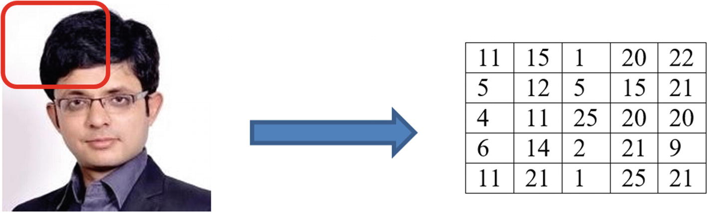

***Figure 4-19***

Illustration to show how can an image be represented in a matrix; the numbers are shown only as an example and are not necessarily correct

Images are a very powerful source of information. Image data can be analyzed and used for multiple business use cases, which we will discuss next.

**Use Cases of Image Data**

Consider this. You want to get a coffee from a coffee vending machine. You go to the machine, and the machine recognizes you, recalls your preferences, and delivers precisely what you wanted. The coffee vending machine has recognized your face and based on your previous transactions has given you the desired flavor. Or the attendance monitoring system at an office uses a facial recognition system to mark attendance instead of swiping cards. Analysis of image data and computer vision are enhancing the capabilities and automating processes everywhere.

Image analysis is making ripples across the domains and processes of business. Here are a few use cases:

1. 1.

**Healthcare** : Image analysis allows us to identify tumors and illnesses from the x-rays, MRIs, and CT scans. The trained ML model can identify if the image is good or bad, which means are there any signs of illness? The solutions can then locate the problem and then the doctors and medical professionals can use the insights generated and focus on the issues. Patients in remote locations can have their images shared with experts and can get a faster response. We use image segmentation and image classification techniques to identify anomalies and perform analysis.

1. 2.

**Retail** industry is harnessing image analysis techniques in a novel way. Customers can upload their pictures of their preferred products like watches, T-shirts, glasses, and so on online and can get a recommendation from the engine. In the background, the online engine will search for similar products and show them to the customer. Moreover, inventory management becomes a lot easier with better image detection techniques. Image segmentation, classification, and computer vision techniques solve the purpose for us.

1. 3.

**Manufacturing**: The manufacturing sector employs image analysis techniques in a number of ways:

* 1. a.

**Defect identification** is done to separate faulty products from the good ones. It can be implemented using computer vision and image classification.

* 1. b.

**Predictive maintenance** gets improved by identifying the tools and systems which require maintenance. It makes use of image classification and image segmentation techniques.

1. 4.

**Security and monitoring**: Computer vision allows direct monitoring using a security camera and prevents thefts and crime. The capabilities help in crowd management and crowd control, passenger activity movement, and so on. Live monitoring using cameras allows the security teams to prevent any mishaps. Facial recognition techniques allow us to achieve the results.

1. 5.

**Agriculture**: The field of agriculture is no different. It also makes use of image recognition and classification techniques to identify weeds amid the plants or any type of disease and infection on the plantations. Soil quality can be checked, and the quality of the grain can be improved. Computer vision is really changing the face of one of the oldest occupations of mankind.

1. 6.

**Insurance** : Image analysis is helping the insurance industry by inspecting images from accident sites. Assessment can be made of the damage based on the images from the accident site and claims can be assessed. Image segmentation and image classification drive the solution for the insurance industry.

1. 7.

**Self-driving cars** are a very good example of harnessing the power of object detection. Cars, pedestrians, trucks, signs, and so on can be detected and appropriate action can be taken.

1. 8.

**Social media platforms and online marketplaces** employ sophisticated image recognition techniques to identify the face, features, expressions, product, and so on based on the photos of the user. It helps them to improve the consumer experience, and improve speed and ease of access.

The preceding use cases are only a few of many use cases where image recognition, object detection, image tracking, image classification, and so on are generating out-of-the-box solutions for us. It is propelled by the latest technology stack of neural networks, convolutional neural networks, recurrent neural networks, reinforcement learning, and so on. They push the boundaries as these solutions are capable of processing tons of complex data easily and generating insights from them. We are able to train the algorithms in a much faster way using modern computing resources and cloud-based infrastructure.

But still we have to explore the full potential of images; we have to improve the existing capabilities and enhance the levels of accuracy. A lot of research is going on in this field with several organizations contributing to the advancement of the sector.

Images are a complex dataset to capture and manage. We will now examine the common challenges we face with the images.

**Challenges with Image Data**

Images are not an easy dataset to handle. It is a complex amalgamation and a very bulky data point to deal with. Similar to any other dataset, images too are messy and require thorough cleaning. Some of the challenges we face with the image dataset are as follows:

1. 1.

**Complexity**: An image of a car will look different from different angles. Front pose vs. left pose vs. right pose of the same person might look completely different, which makes identification of a person or an object by a machine a difficult process. This level of complexity makes image data tougher to analyze.

1. 2.

**Size of the dataset**: Size of an image is the next challenge we face with image data. An image can easily be in MB, and based on the frequency of generation, the net size of the image dataset can be really huge.

1. 3.

**Images are multidimensional** as compared to any structured data. It also changes as per the image color scale. A multicolored image will have three channels (RGB) and it will increase to the number of dimensions further.

1. 4.

**Unclean data**: Images are not always clean. While capturing the dataset itself we face multiple issues. Here are a few of them:

* 1. a.

Blurred images are created if the images are out of focus.

* 1. b.

There can be shadows on the image which makes it unusable.

* 1. c.

Image quality depends on the surrounding lights. If the background light changes, an image will change its compositions.

* 1. d.

Distortions happen in the image due to multiple factors like camera vibrations, or the corners are cut or there are marks (like thumb impressions) on the lens.

1. 5.

**Human variability**: While capturing the image data, human-generated variance results in different datasets for the same type of problem. For example, if we have to capture the images of crops from a field, different people will capture images from different angles and with different camera modes.

Images are a difficult data set to store and process. Particularly, due to their size, the amount of space required is quite high. We now discuss the image data management process, which concentrates on a few such aspects.

**Image Data Management Process**

We generate images from multiple sources, and we have to have a concrete data management process for the images. A good system will be able to accept the incoming images, store them, and make them accessible for future analysis. The process of image data management will depend on the design of the system: is it a real-time image analysis project or a batch-processing project? The various sources of images are to be staged, cleaned, and finally stored in a place where they can be accessed as shown in Figure [4-20](https://learning.oreilly.com/library/view/supervised-learning-with/9781484261569/html/499122_1_En_4_Chapter.xhtml#Fig20).

For a real-time image monitoring system, the images are fed to an algorithm in real time and decisions will have to be made in real time. For example, consider if we have a number plate–reading system in a parking lot. The car parking images are generated in real time and have to be processed really fast.

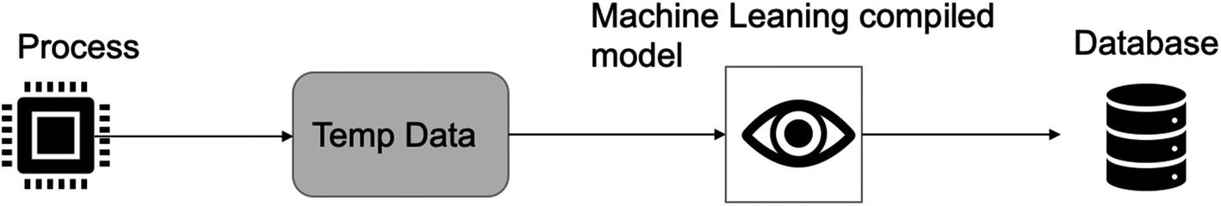

***Figure 4-20***

Real-time process and data management for an ML model

In the process diagram shown previously, the term “process” represents the source of image data generation. In the number plate reading case discussed previously, it will be the raw image generated by a camera. These raw images might need to be stored temporarily before they are fed to the compiled ML model. The ML model will generate the prediction about the image. In the preceding case, it will be the car registration number. The prediction and the images, both have to then be stored in the final destination database.

For the batch-processing image analysis system, the process changes as shown in Figure [4-21](https://learning.oreilly.com/library/view/supervised-learning-with/9781484261569/html/499122_1_En_4_Chapter.xhtml#Fig21). For example, in the same use case as in the preceding example, if we want to identify how many cars have entered the parking lot in a day, the same image processing system will be different.

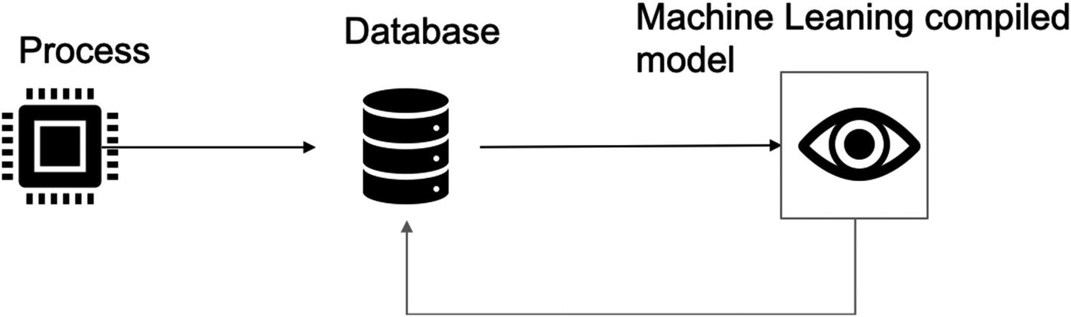

***Figure 4-21***

Batch-processing of image data can receive data from a database, make a prediction, and share the results back to the database to be stored

For the batch-processing image analysis system, the “process” will generate the images. Those raw images will have to be stored in a database. Then they are fed to the ML model, which generates the predictions for them. In the preceding case, raw images of the cars will be stored as and when they are generated. They are then fed to the image-processing solution as a batch, which generates the registration number for each car. The predictions and the raw images are then sent back to the database and saved.

A good image data management system should be robust, flexible, and easy to access. The size of the images will play a big role in designing the system. It also defines the cost associated with such a database repository. It is worthwhile to note that such a repository will get consumed very soon, so depending on the critical nature of the business and the domain, we might not save all the images. It is also possible that data which is older than a desired frequency might be deleted from the database.

We will now start with the ML modeling process on image data. And for this, we will start with concepts of deep learning in the next section.

**Image Data Modeling Process**

An image is still a data source. We represent an image as features in a vector-space diagram or as metrics and then perform mathematical modeling on the data. But for images, our classical algorithms might not be able to do justice. This is due to the following reasons:

1. 1.

An image dataset has much greater number of dimensions as compared to structured data, and this makes processing difficult.

1. 2.

The background noise in case of images is much higher. There can be distortions, blurring, multiple angles shot, gray-scale images, and so on in the image dataset.

1. 3.

The size of the input data is again higher than the structured datasets.

Because of a few of the preceding reasons, we prefer to use neural networks to create the image supervised learning algorithms for us, which we discuss in the next section.

**Fundamentals of Deep Learning**

Deep learning is changing the way we perceive information. It is enhancing the power of data to new levels. Using sophisticated neural networks, we are able to process many complex datasets, which are many dimensional and are of a great size. Neural networks are truly changing the landscape of ML and AI.

Deep learning has created capabilities which were only a thought a few years ago. In the area of image processing, we are implementing neural networks for image classification, object detection, object tracking, image captioning, semantic segmentation, human pose estimation, and so on. The GPUs and TPUs are increasingly allowing us to push the barriers of processing tons of dataset in no time.

In the following section, we are going to discuss the building blocks of neural networks and will be developing a use case in Python.

**Artificial Neural Networks**

Artificial neural networks or ANNs are arguably inspired by the functioning of a human brain. When we humans see an object for the first time, we create an image of it in our mind and register it. When the same object comes in front of us again, we are able to recognize it easily. The task, which is too easy for us, is quite difficult for algorithms to understand and learn.

**Note**

Depth in deep learning represents the number of hidden layers in the neural network. Generally, the higher the number of hidden layers, the greater is the accuracy. But that is true to a certain extent only, and sometimes the accuracy might not increase even with increasing the number of layers.

We train neural networks like we train any ML algorithm—there is an input dataset, we process it, and the algorithm will generate the output predictions for us. A neural network can be used for both regression and classification problems. It can be used for both structured and unstructured data sources. The levels of accuracy by a neural network are generally higher than a classical ML algorithm like regression, decision tree, and so on. But that might not always be true.

The biggest advantage we have with a neural network is its ability to process complex data like images and videos. Then, recall for classical ML algorithms we choose the significant variables. In the case of neural networks, it is the responsibility of the network to pick the most significant attributes from the data.

A typical neural network looks like Figure [4-22](https://learning.oreilly.com/library/view/supervised-learning-with/9781484261569/html/499122_1_En_4_Chapter.xhtml#Fig22).

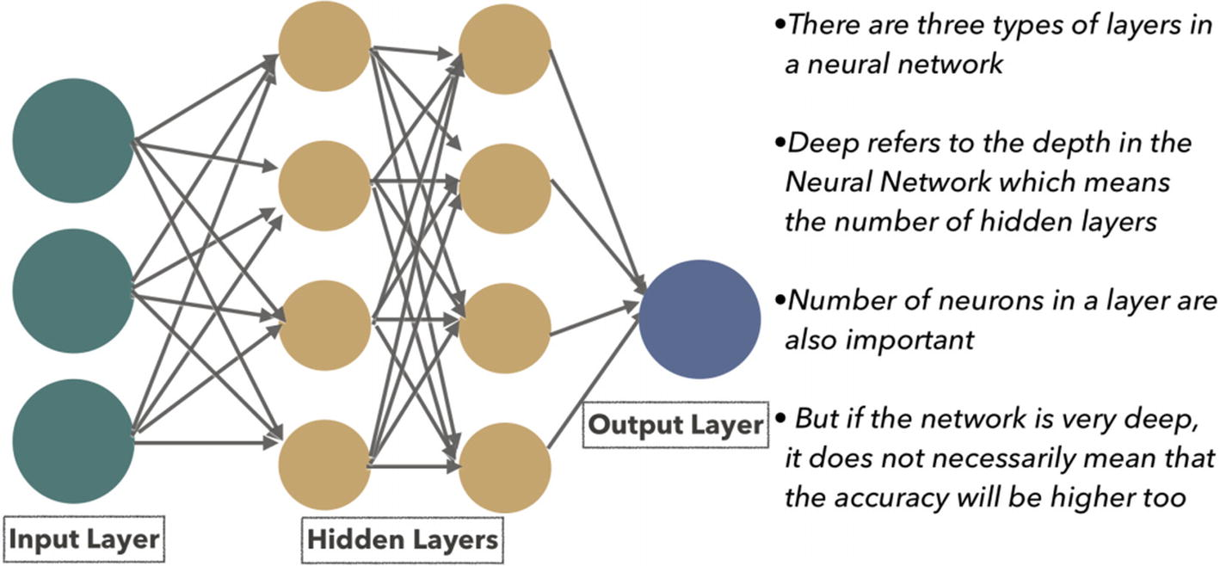

***Figure 4-22***

A neural network has input layer, hidden layers, and output layer

In the structure of the network shown previously, there are few important building blocks which are as follows:

1. 1.

**Neuron**: A neuron is a foundation of a neural network. All the calculations and complex processing take place inside a neuron only. It expects an input data like image and will generate an output. That output might be consumed by the next layer in the network or might be used to generate the final result. A neuron can be represented as shown in Figure [4-23](https://learning.oreilly.com/library/view/supervised-learning-with/9781484261569/html/499122_1_En_4_Chapter.xhtml#Fig23). Here, x**0**, x**1**, and x**2** represent the input variables, and w**0**, w**1**, and w**2** are their respective weights. “f” is the activation function and “b” is the bias term.

A neuron receives input from the previous layers and then based on the conditions set, decides whether it should *fire* or not. Simply put, a neuron will receive an input, perform a mathematical calculation on it, and then based on the threshold set inside itself will pass on the value to the next neuron.

During the training of the ML model or the network in this case, weights and bias terms get trained and we get the most optimized value. We will be discussing the training mechanism and activation term in the next section.

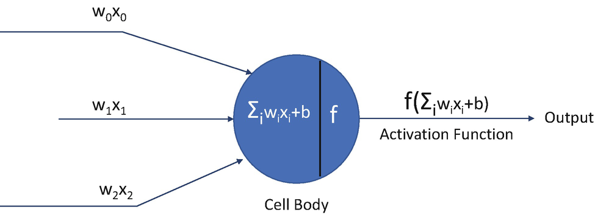

***Figure 4-23***

Basic structure of a neuron showing inputs, weights, activation function, and an output

1. 2.

**Input Layer**: As the name signifies, input layer accepts the input data. It can be in the form of images (raw or processed). This input layer is the first step in the network.

1. 3.

**Hidden Layer**: Hidden layers are the most important segment in a neural network. All the complex processes and mathematical calculations take place in the hidden layer only. They accept the data from the input layer, process it layer by layer, and then feed it to the output layer.

1. 4.

**Output Layer**: Output layer is the last layer in a neural network. It is responsible for generating the prediction, which can be a continuous variable for a regression problem or a probability score for a supervised classification problem.

With these building blocks of a neural network, in the next section we will discuss the other core elements of a network, which are activation functions.

**Activation Functions**

Activation functions play a central role in training of a neural network. An activation function’s primary job is to decide whether a neuron should fire or not. It is the function which is responsible for the calculations which take place inside a neuron.

The activation functions are generally nonlinear in nature. This property of theirs allows the network to learn complex behaviors and patterns.

There are many types of activation functions available to be used, such as the following:

1. 1.

**Sigmoid activation function** : Thist is a bounded mathematical function as shown in Figure [4-24](https://learning.oreilly.com/library/view/supervised-learning-with/9781484261569/html/499122_1_En_4_Chapter.xhtml#Fig24). The range of a sigmoid function is between 0 and 1. The function is S shaped and has a non-negative derivative function.

Mathematically, a sigmoid function is

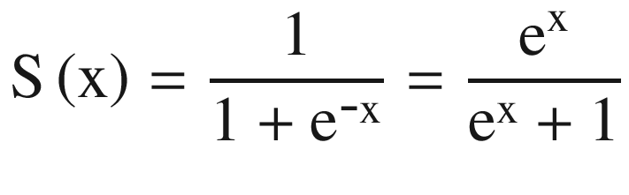

(Equation 4-2)

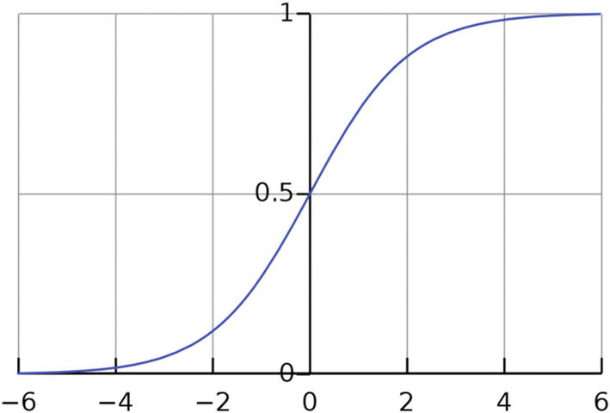

***Figure 4-24***

A sigmoid function has an S-like shape

It is usually used for binary classifications and in the final output layer of the neural network. But it can be used in the hidden layers of the network too.

1. 2.

**tanh activation function** : Tangent hyperbolic function or tanh is a scaled version of the sigmoid function as visible in Figure [4-25](https://learning.oreilly.com/library/view/supervised-learning-with/9781484261569/html/499122_1_En_4_Chapter.xhtml#Fig25). As compared to the sigmoid function, tanh is zero centered. The value ranges between –1 and +1 for tanh function.

Mathematically, tanh function is given by

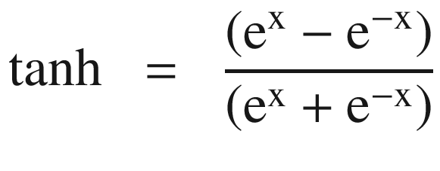

(Equation 4-3)

tanh activation function is generally used in the hidden layers of the neural network. It makes the mean closer to zero, which makes the training easier for the network.

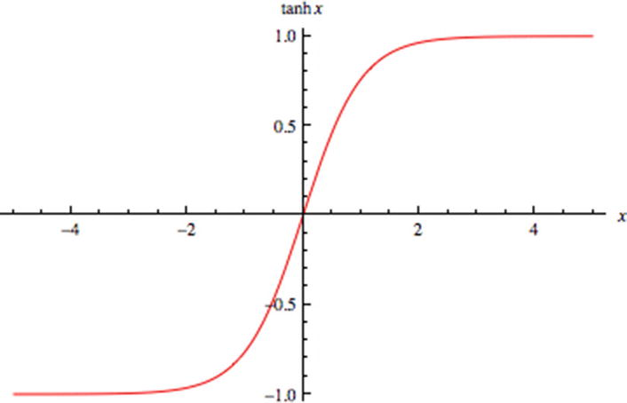

***Figure 4-25***

A tanh function is centered at zero

1. 3.

**ReLU activation function** : Perhaps the most popular of the activation functions is the ReLU activation function. ReLU is a rectified linear unit and is shown in Figure [4-26](https://learning.oreilly.com/library/view/supervised-learning-with/9781484261569/html/499122_1_En_4_Chapter.xhtml#Fig26).

F(x) = max (x,0) gives the output as x if x>0; otherwise, the output is 0.

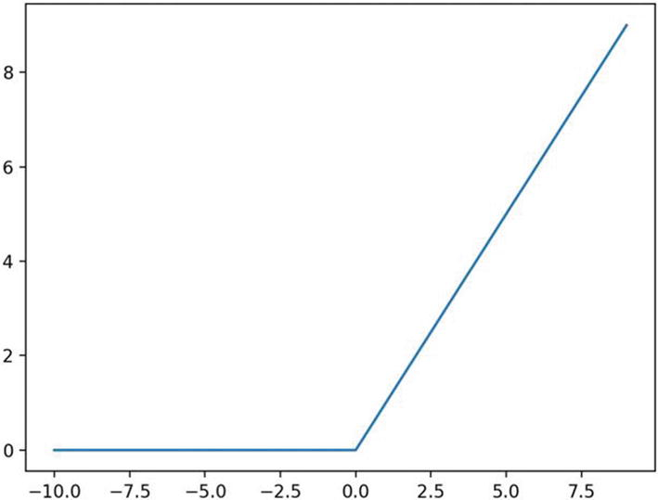

***Figure 4-26***

A ReLU function

ReLU is a very simple function to compute, as visible from the simple mathematical function. It makes ReLU very easy to compute and very fast to train. It is used in the hidden layers of the network.

1. 4.

**Softmax function** : The softmax function is used in the final layer of the network used for classification problems. It is used for generating the predictions in the network. The function generates probability scores for each of the target classes, and the class which receives the highest probability is the predicted class. For example, if the network is aimed to distinguish between a cat, dog, a horse, and a tiger, the softmax function will generate four probability scores. The class which receives the highest probability is the predicted class.

Activation functions play a central role in training the network. They define the training progress and are responsible for all the calculations which take place in various layers of the network. A well-designed network will be optimized and then the training of the model will be suitable to be able to make the final predictions. Similar to a classical ML model, a neural network aims to reduce the error in predictions, also known as the loss function, which we cover in the next section.

**Loss Function in a Neural Network**

We create an ML model to make predictions for the unseen dataset. An ML model is trained on a training dataset, and we then measure the performance on a testing or validation dataset. During measuring the accuracy of the model, we always strive to minimize the error rate. This error is also referred to as *loss*.

Formally put, loss is the difference between the actual values and predicted values by the network. For us to have a robust and accurate network, we always strive to keep this loss to the minimum.

We have different loss functions for regression and classification problems. *Cross-entropy* is the most popular loss function for classification problems, and mean squared error is preferred for regression problems. Different loss functions give a different value for the loss and hence impact the final training of the network. The objective of training is to find the minimum loss, and hence the loss function is also called *objective function*.

**Note**

binary_crossentropy can be used as a loss function for binary classification model.

The neural network is trained to minimize this loss and the process to achieve it is discussed next.

**Optimization in a Neural Network**

During the training of the neural network, we constantly strive to reduce the loss or error. The loss is calculated by comparing the actual and predicted values. Once we have generated the loss in the first pass, the weights have to be updated to reduce the error further. The direction of this weight update is defined by the *optimization function*.

Formally put, optimization functions allow us to minimize the loss and reach the global minimum. One way to visualize the optimization is as follows: imagine you are standing on top of a mountain. You have to reach the bottom of the mountain. You can take steps in any direction. The direction of the step will be wherever we have the steepest slope. Optimization functions allow us to achieve this. The amount of step we can take in one stride is referred to as the *learning rate.*

We have many choices to use for an optimization function. Here are a few of these choices:

1. 1.

**Gradient descent** is one of the most popular optimization functions. It helps us achieve this optimization. Gradient descent optimization is quite fast and easy to implement. We can see gradient descent in Figure [4-27](https://learning.oreilly.com/library/view/supervised-learning-with/9781484261569/html/499122_1_En_4_Chapter.xhtml#Fig27).

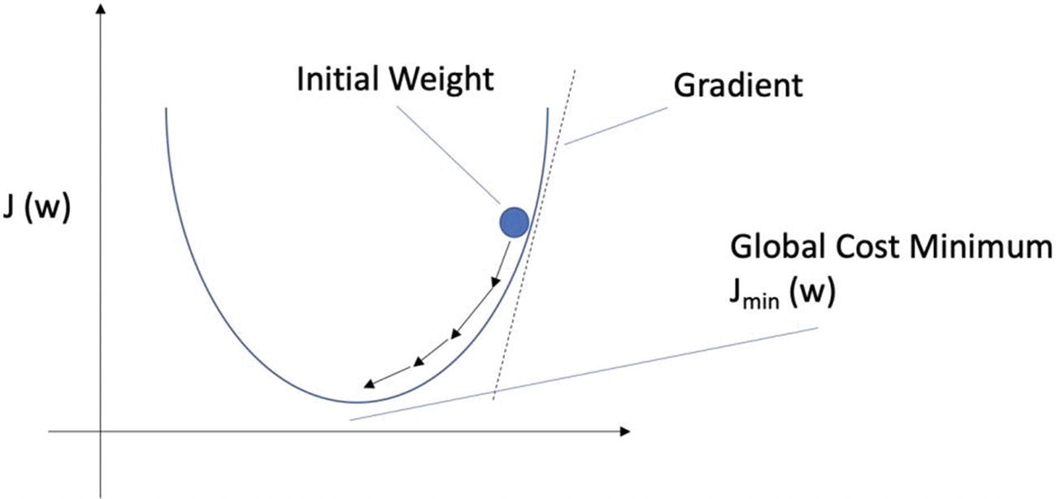

***Figure 4-27***

Gradient descent is used to optimize the loss for a neural network

But gradient descent can be trapped at the local minima and it requires more resources and computation power to be executed.

1. 2.

**Stochastic gradient descent** or SGD is a version of gradient descent only. As compared to its parent, it updates the parameters after each training example, that is, after the loss has been calculated after each training example. For example, if the dataset contains 5000 observations, gradient descent will update the weights after all the computations are done and only once, whereas SGD will update the weights 5000 times. While this increases accuracy and decreases computation memory requirements, it results in overfitting of the model too.

1. 3.

**Minibatch gradient descent** is an improvement over SGD. It combines best of the gradient descent and SGD. In minibatch gradient descent, instead of updating the parameters after each training example, it updates them in batches. It requires a minimum amount of computation memory and is not prone to overfitting.

1. 4.

There are other optimization functions too like Ada, AdaDelta, Adam, Momentum, and so on which can be used. The discussion of these optimizers is beyond the scope of this book.

**Note**

Adam optimizer and SGD can be used for most problems.

Optimization is a very important process in neural network training. It makes us reach the global minima and achieve the maximum accuracy. Hence, due precaution is required while we choose the best optimization function.

There are a few other terms which you should be aware of, before we move to the training of a network.

**Hyperparameters**

A network learns quite a few parameters itself by analyzing the training examples but a few parameters are required to be fed. Before the training of the neural network commences, we set these parameters to initiate the process. These variables determine the structure of the network, the process, variables, and so on which are used in the final training. They are referred to as *hyperparameters* *.*

We set a number of parameters like the learning rate, the number of neurons in each layer, activation functions, number of hidden layers, and so on. We also set the number of epochs and batch size. The number of epochs represents the number of times the network will analyze the entire dataset completely. Batch size is the number of samples the network analyzes before updating a model parameter. A batch can contain one or more than one samples.

Simply put, if we have a training data size of 10,000 images, we set batch size as 10 and number of epochs as 50; this means that the entire data will be divided into 10 batches each having 1000 images. The model’s weight will be updated after each of those 10 batches. This also means that in one epoch 1000 images will be analyzed 10 times, or in each epoch the weights will be updated 10 times. The entire process will run 50 times as the number of epochs is 50.

**Note**

There are no fixed values of epoch and batch-size. We iterate, measure the loss and then get the best values for the solution.

But training a neural network is a complex process, which we will discuss next. There are processes of forward propagation and backward propagation which are also covered in the next section.

**Neural Network Training Process**

A neural network is trained to achieve the business problem for which the ML model is being created. It is a tedious process with a lot of iterations. Along with all the layers, neurons, activation functions, loss functions, and so on, the training works in a step-by-step fashion. The objective is to create a network with minimum loss and optimized to generate the best predictions for us.

To design and create deep learning solutions, we have libraries and frameworks. Here are a few of the popular tools which are used for deep learning:

1. 1.

**TensorFlow**: It is developed by Google and is one of the most popular frameworks. It can be used with Python, C++, Java, C#, and so on.

1. 2.

**Keras**: It is an API-driven framework and is built on top of TensorFlow. It is very simple to use and one of the most recommended libraries to use.

1. 3.

**PyTorch**: PyTorch is one of the other popular libraries by Facebook. It is a very great solution for prototyping and cross-platform solutions.

1. 4.

**Sonnet**: It is a product by DeepMind and is primarily used for complex neural architectures.

There are many other solutions like MXNet, Swiftm Gluon, Chainer, and so on. We are using Keras to solve the case studies in Python.

Now we will start examining the learning of a neural network. Learning or training in the case of a network refers to finding the best possible values of the weights and the bias terms while keeping an eye on the loss. We strive to achieve the minimum loss after training the entire network.

The major steps while training a neural network are as follows:

Step 1: In the first step, as shown in Figure [4-28](https://learning.oreilly.com/library/view/supervised-learning-with/9781484261569/html/499122_1_En_4_Chapter.xhtml#Fig28), the input data is passed on to the input layer of the network. The input layer is the first layer. The data is fed into a format acceptable by the network. For example, if the network expects an input image of size 25×25, that image data is changed to that shape and is fed to the input layer.

Next, the data is passed and fed to the next layer or the first hidden layer of the network. This hidden layer will transform the data as per the activation functions associated with that particular layer. It is then fed to the next hidden layer and the process continues.

In the diagram shown in Figure [4-28](https://learning.oreilly.com/library/view/supervised-learning-with/9781484261569/html/499122_1_En_4_Chapter.xhtml#Fig28), we have two hidden layers, and each layer has some weights associated with it. Once the respective transformations are done, the final prediction is generated. Recall in the last section, we discussed the softmax layer, which generates the prediction probabilities for us. These predictions are then to be analyzed in the next step.

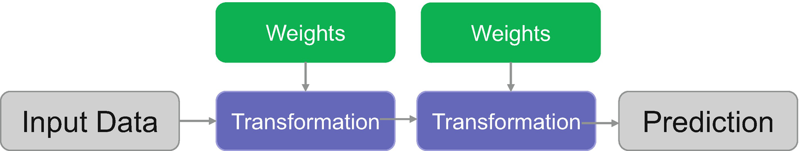

***Figure 4-28***

Step 1 in the neural network showing the input data is transformed to generate the predictions

Step 2: Now we have achieved the predictions from the network. We have to check if these predictions are accurate or not and how far the predicted values are from the actual values. This is done in this step as shown in Figure [4-29](https://learning.oreilly.com/library/view/supervised-learning-with/9781484261569/html/499122_1_En_4_Chapter.xhtml#Fig29).

Here, we compare the actual and predicted values using a loss function and the value of loss is generated in this step.

The feeding of information in this fashion in a forward direction is called a *forward propagation step.*

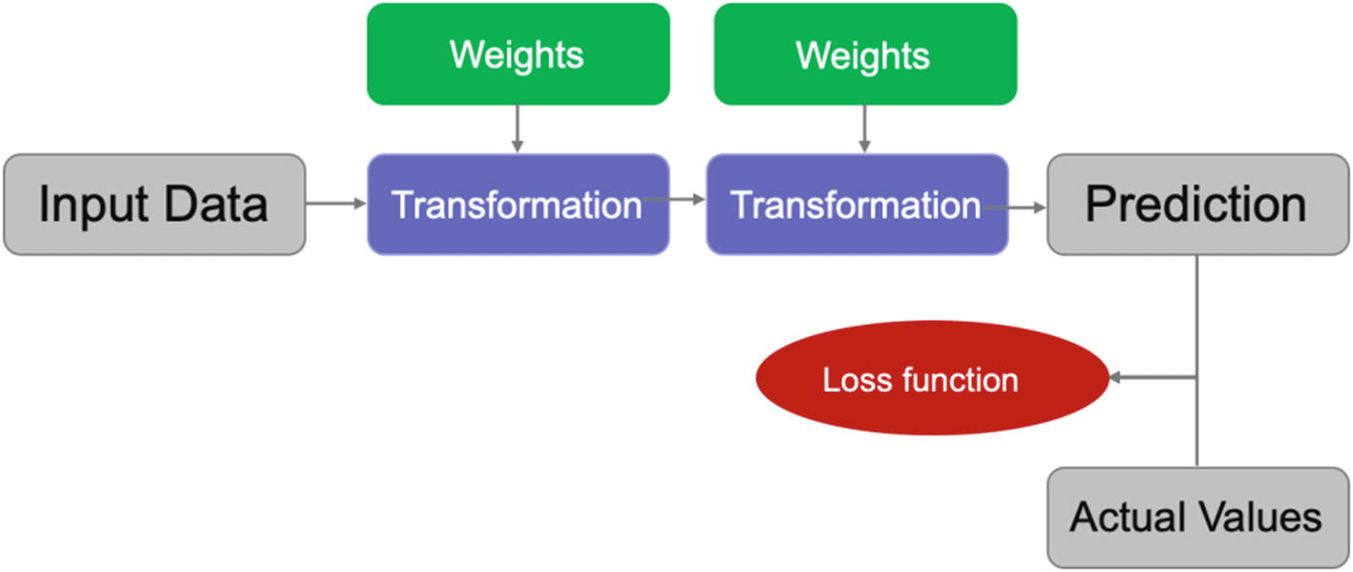

***Figure 4-29***

Loss is calculated by comparing the actual and predicted values

Now we have generated the perceived loss from the first iteration of the network. We still have to optimize and minimize this loss, which is done in the next step of training.

Step 3: In this step, once the loss is calculated, this information travels back to the network. The optimization function will be changing the weights to minimize this loss. The respective weights are updated across all the neurons, and then a new set of predictions are generated. The loss is calculated again and again the information travels backward for further optimization, as shown in Figure [4-30](https://learning.oreilly.com/library/view/supervised-learning-with/9781484261569/html/499122_1_En_4_Chapter.xhtml#Fig30).

This travel of information in a backward direction to optimize the loss is referred to as *backward propagation* in a neural network training process.

**Note**

Backward propagation is sometimes called the central algorithm in deep learning.

This process continues iteratively till we arrive at a point where it is not possible to optimize the loss. And then we can conclude that our network is trained.

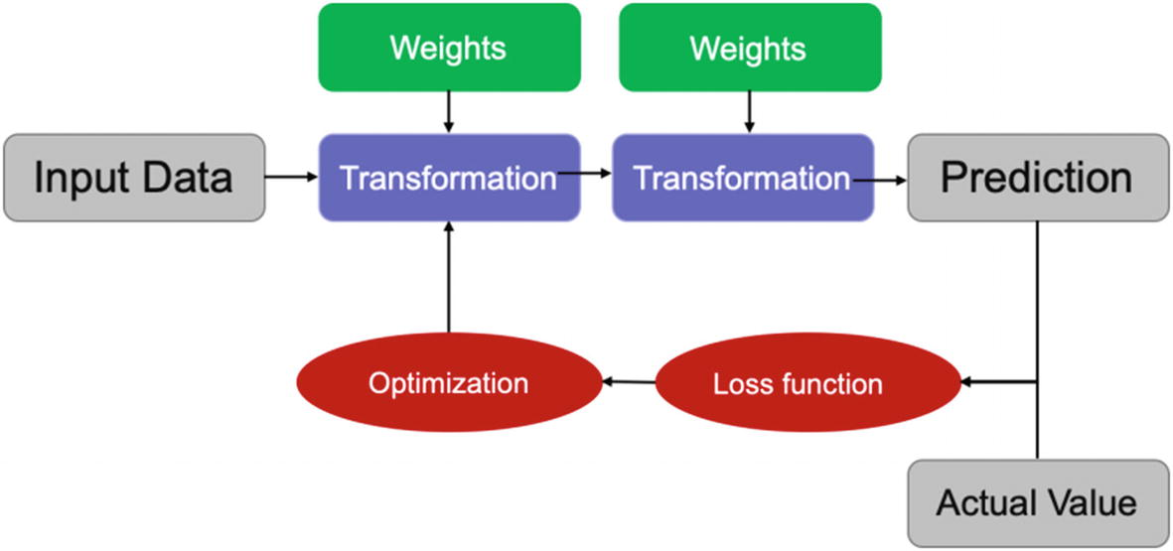

***Figure 4-30***

The optimization is done to minimize the loss and hence reach the best solution

This is the process for a network to train itself and generate a compiled model for us. The training for a neural network is also referred to as *learning* of a network. Formally put, learning of a network refers to finding the most optimal values and best combinations of weights for all layers of the network.

Initially, all the weights are initialized with some random values. The network makes the first prediction, and due to obvious reasons, the loss or the error in the first pass will be quite high. Now, the network encounters new training examples and based on the loss calculated the weights are updated. The backpropagation plays the central role here by acting as a feedback loop. During the process of training the network, these weights are updated during each iteration. The direction of iteration is defined by the gradient of the loss function which allows us to move in the direction to minimize the loss. Once the loss can no longer be decreased, we can say that the network is trained now.

We will now learn how a neural network is trained by creating two use cases in Python: one on structured data and another for images.

**Case Study 1: Create a Classification Model on Structured Data**

We are using the diabetes data set. The objective is to diagnostically predict if a patient has diabetes or not based on certain diagnostic measurements. The code and dataset are uploaded at Github.

Step 1: Import the libraries first.

import numpy as np

import pandas as pd

import seaborn as sns

import matplotlib.pyplot as plt

%matplotlib inline

Step 2: Load the data now and have a look at the first five rows:

pima_df = pd.read_csv('pima-indians-diabetes.csv')

pima_df.head()

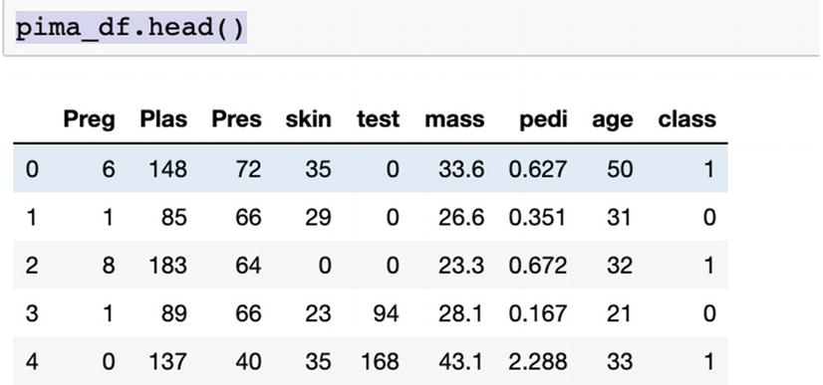

Step 3: Let’s now generate the basic KPI.

pima_df.describe()

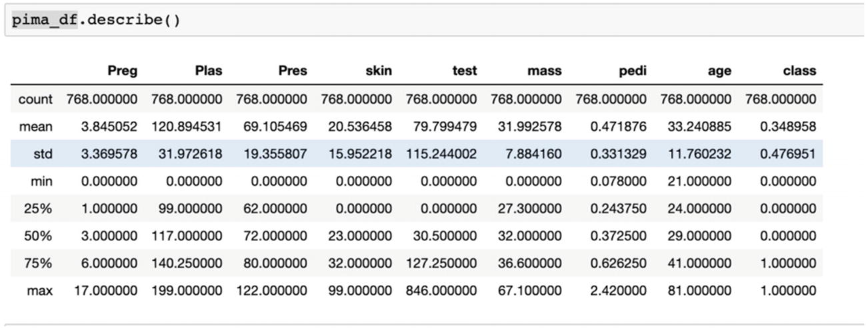

Step 4: Plot the data next.

sns.pairplot(pima_df, hue="class")

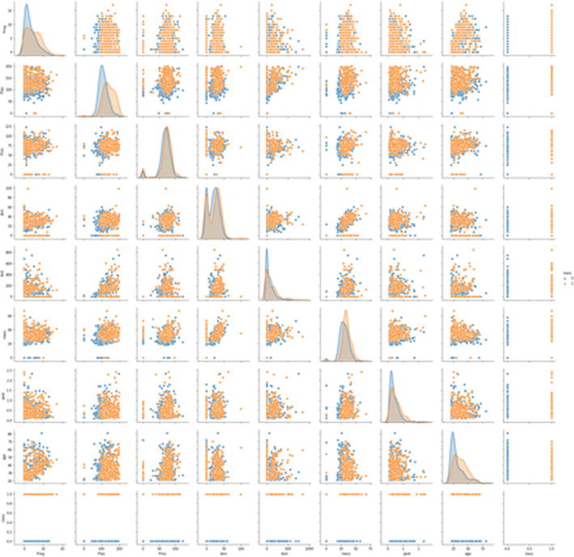

Step 5: We will now generate the correlation plot.

sns.heatmap(pima_df.corr(), annot=True)

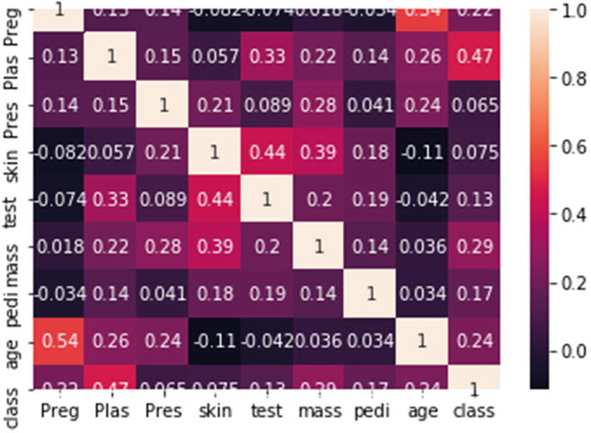

Step 6: Scale the dataset now.

X= pima_df.iloc[:,0:8]

y= pima_df.iloc[:,8]

from sklearn.preprocessing import StandardScaler

standard_scaler = StandardScaler()

X = standard_scaler.fit_transform(X)

X

Step 7: Split into train and test datasets next.

from sklearn.model_selection import train_test_split

X_train, X_test, y_train, y_test = train_test_split(X, y, test_size=0.2)

Step 8: Import the libraries for the neural network creation.

from keras import Sequential

from keras.layers import Dense

Step 9: Designing of the network begins.

diabetes_classifier = Sequential()

#First Hidden Layer of the network. In this case, the activation function is ReLU, and the number of neurons is 5. We are initializing the weights as random normal.

diabetes_classifier.add(Dense(5, activation="relu", kernel_initializer="random_normal", input_dim=8))

#Second Hidden Layer. Like the last layer, the activation function is ReLU, number of neurons is 5. We are initializing the weights as random normal.

diabetes_classifier.add(Dense(5, activation="relu", kernel_initializer="random_normal"))

#Output Layer. The activation function is sigmoid. We are initializing the weights as random normal.

diabetes_classifier.add(Dense(1, activation="sigmoid", kernel_initializer="random_normal"))

We are using adam optimizer with cross_entropy as the loss. Accuracy is the metric which has to be optimized.

diabetes_classifier.compile(optimizer ='adam',loss='binary_crossentropy', metrics =['accuracy'])

Fit the model now.

diabetes_classifier.fit(X_train,y_train, batch_size=10, epochs=50)

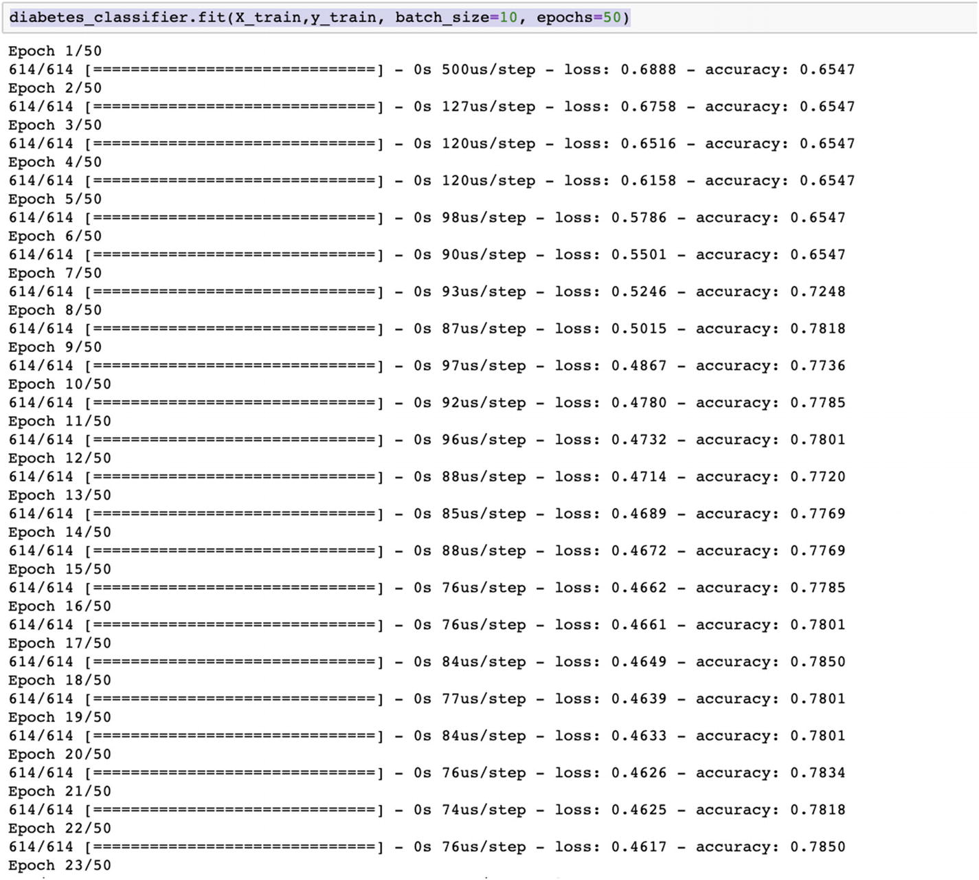

Step 10: Check the accuracy of the model using confusion matrix.

y_pred=diabetes_classifier.predict(X_test)

y_pred =(y_pred>0.5)

from sklearn.metrics import confusion_matrix

cm = confusion_matrix(y_test, y_pred)

print(cm)

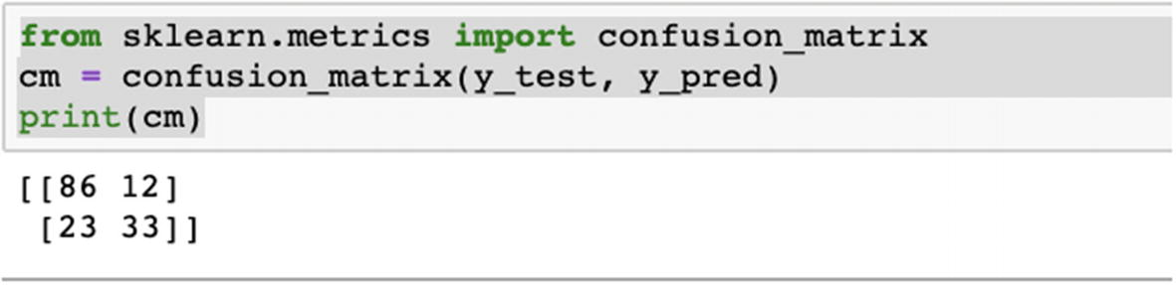

Here we can deduce that the model has an accuracy of 77.27%.

You are advised to test and iterate by

1. 1.

Increasing the complexity of the network by adding one or two more layers.

1. 2.

Testing with different activation functions. We have used sigmoid; you can use tanh.

1. 3.

Increasing the number of epochs and checking the performance.

1. 4.

Preprocessing the data better and then again checking the performance over the revised dataset.

**Case Study 2: Image Classification Model**

We will develop an image classification model on fashion MNIST dataset. It has 70,000 grayscale images in 10 different categories. This dataset is used for image classification problems and is a standard dataset to be used. It comes prebuilt with Keras and can be loaded easily.

Step 1: Import the libraries first.

import tensorflow as tf

from tensorflow import keras

import numpy as np

import matplotlib.pyplot as plt

Step 2: Import the fashion MNIST dataset which is shipped with Keras and divide into train and test images.

fashion_df = keras.datasets.fashion_mnist

(x_train, y_train), (x_test, y_test) = fashion_df.load_data()

Step 3: The various groups of apparel available to us are

apparel_groups = ['T-shirt/top', 'Trouser', 'Pullover', 'Dress', 'Coat', 'Sandal', 'Shirt', 'Sneaker', 'Bag', 'Ankle boot']

Step 4: We will explore the data next.

x_train.shape

len(y_train)

Step 5: Let’s have a look at an element of the data and then preprocess the dataset. We have to standardize the dataset by dividing by 255 (the pixel values range from 0 to 255; hence we are dividing by 255 to standardize the values for all the datasets).

plt.figure()

plt.imshow(x_train[1])

plt.show()

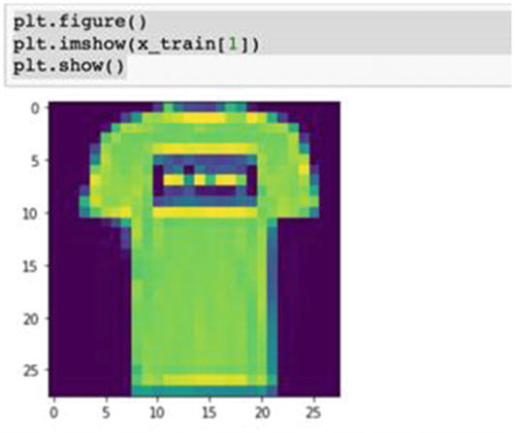

x_train = train_images / 255.0

x_test = test_images / 255.0

Step 6: Let’s have a look at some samples. We will also check if the data is in correct order.

plt.figure(figsize=(25,25))

for i in range(10):

    plt.subplot(10,10,i+1)

    plt.xticks([])

    plt.yticks([])

    plt.grid(False)

    plt.imshow(x_train[i], cmap=plt.cm.binary)

    plt.xlabel(apparel_groups[y_train[i]])

plt.show()

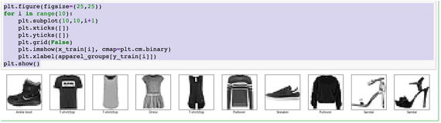

Step 7: We are building the neural network model now.

fashion_model = keras.Sequential([

    keras.layers.Flatten(input_shape=(28, 28)),

    keras.layers.Dense(256, activation="relu"),

    keras.layers.Dense(20)

])

Here, the input image shape is 28,28. The flatten layer transforms the format of images to 28×28. It only reformats the data and has nothing to learn. Next is the layer that has ReLU as an activation function and 256 neurons. The last layer has 20 neurons and returns a logit array indicating if an image belongs to one of the ten classes we are training upon.

Step 8: Compile the model now.

fashion_model.compile(optimizer='adam',

              loss=tf.keras.losses.SparseCategoricalCrossentropy(from_logits=True),

              metrics=['accuracy'])

The parameters are loss functions to measure how accurate the model is during training. The optimizer determines how the model is updated based on the data it sees and its loss function. We are using accuracy to monitor the training and testing steps.

Step 9: We will train the model now, trying to fit with a batch size of 10 and 50 epochs.

fashion_model = fashion_model.fit(x_train, y_train,

          batch_size=10,

          epochs=50,

          verbose=1,

          validation_data=(x_test, y_test))

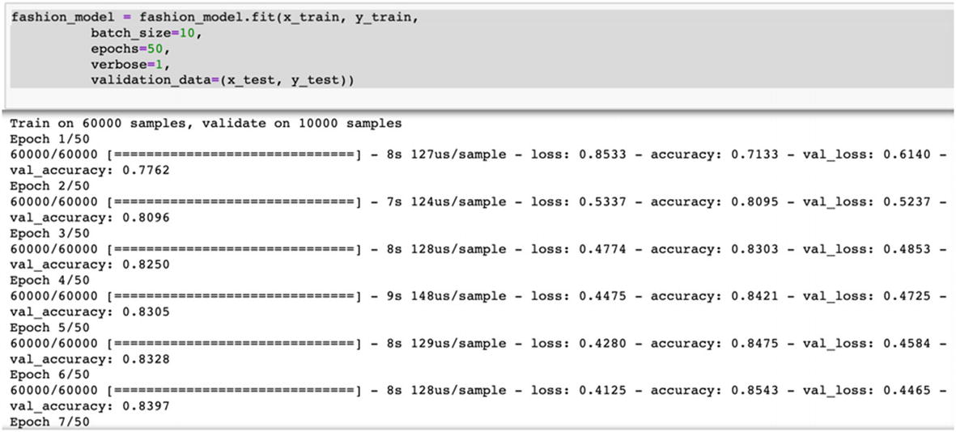

Step 10: We will plot the training and validating accuracy now.

import matplotlib.pyplot as plt

f, ax = plt.subplots()

ax.plot([None] + fashion_model.history['accuracy'], 'o-')

ax.plot([None] + fashion_model.history['val_accuracy'], 'x-')

ax.legend(['Train acc', 'Validation acc'], loc = 0)

ax.set_title('Training/Validation acc per Epoch')

ax.set_xlabel('Epoch')

ax.set_ylabel('acc')

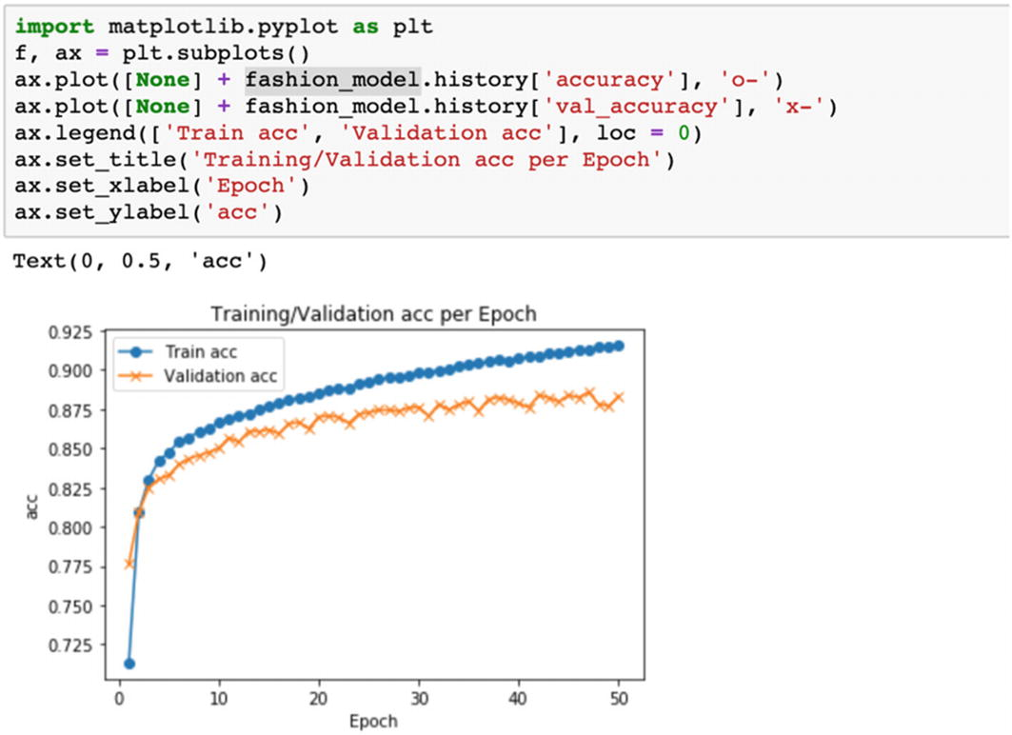

Step 11: We are plotting the training and validating loss.

import matplotlib.pyplot as plt

f, ax = plt.subplots()

ax.plot([None] + fashion_model.history['loss'], 'o-')

ax.plot([None] + fashion_model.history['val_loss'], 'x-')

ax.legend(['Train loss', 'Validation loss'], loc = 0)

ax.set_title('Training/Validation loss per Epoch')

ax.set_xlabel('Epoch')

ax.set_ylabel('acc')

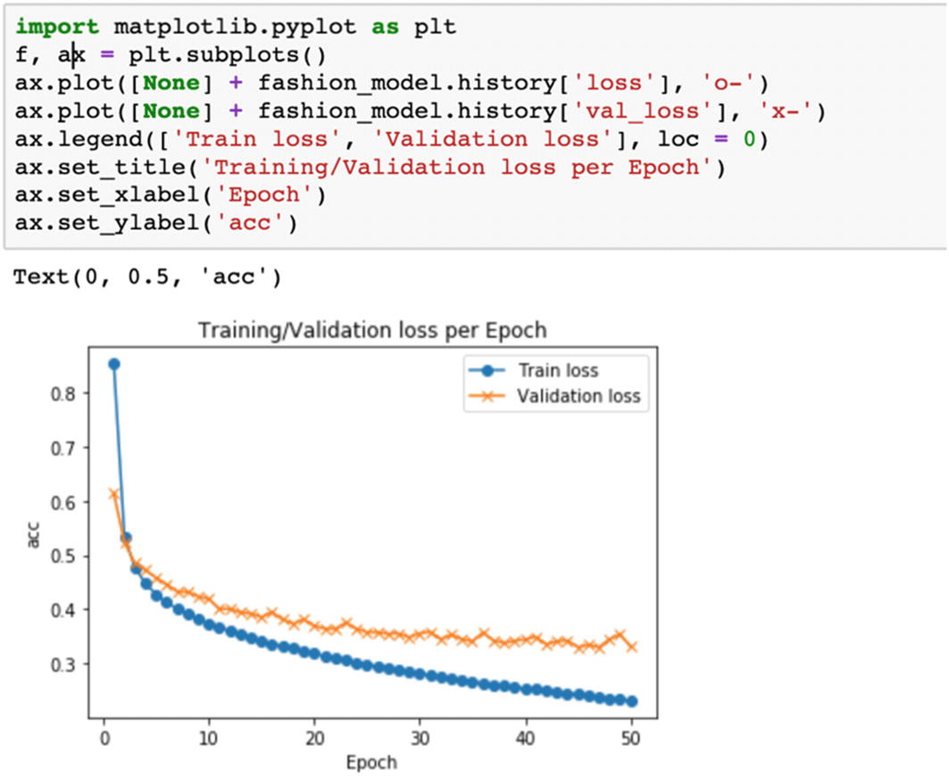

Step 12: We will print the test accuracy we are getting from the model.

test_loss, test_acc = fashion_model.model.evaluate(x_test,  y_test, verbose=2)

print('Test accuracy:', test_acc)

The test accuracy of the model is 89.03%. Like the last case study, you are advised to iterate by changing the network architecture by adding layers and neurons, and by measuring the performance with different values of epoch, batch_size etc.

We have thus implemented two use cases for structured and unstructured data using deep learning.

Deep learning is the power which allows us to improve capabilities further. For unstructured datasets, neural networks are leading the path in getting solutions which were unheard of before. Advanced neural networks like convolutional neural networks, recurrent neural networks, long short term memory (LSTM), GRU, and so on are doing wonders in every field. We can now detect cancer better, enhance security systems, improve agricultural yields, reduce shopping time, use facial features for allowing or restricting users—the use cases are plenty. And across all the domains, we can feel the ripple effect of deep learning.

With this, we are coming to the end of the fourth chapter of the book. Let’s summarize the chapter now.

**Summary**

This chapter is quite special as it works with advanced concepts. But these advanced concepts are built on top of the basics we have created in the initial chapters. These advanced concepts and algorithms are the need of the hour. With better processing power and enhanced systems, we can implement faster solutions. The required computation power, which is now available, was not in existence a decade back. We now have GPUs and TPUs at our disposal. We now can store and manage terabytes or petabytes of data. Our data collection strategy has improved a lot. We can collect real-time data in a much more structured way. Our data management tools are now not limited to standalone servers only, but have expanded to cloud-based infrastructures. It provides tools and confidence to implement much more advanced ML-based techniques to further improve the capabilities.

At the same time, we cannot undermine the importance of algorithms studied in the previous chapters. Linear regression, decision tree, knn, naïve Bayes, and so on are the foundation of ML algorithms. They are still a preferred choice for shortlisting significant variables. These algorithms set up a benchmark of performance. Ensemble techniques of bagging and boosting then enhance the capabilities further. Hence, before starting with boosting or bagging algorithms, we should always test and benchmark the performance with the base algorithms.

With the advent of deep learning, we are able to process much more complex datasets. Deep learning gives an extra push to the performance. But for processing deep learning algorithms, we require better hardware systems. Cloud-based infrastructures offer good services in this case. We can deploy our code in Google Colaboratory and run the code, thereby utilizing the processing power of the servers.

With this, we have discussed the supervised learning algorithms within the scope of the book. In Chapter [1](https://learning.oreilly.com/library/view/supervised-learning-with/9781484261569/html/499122_1_En_1_Chapter.xhtml), we introduced ML. In Chapters [2](https://learning.oreilly.com/library/view/supervised-learning-with/9781484261569/html/499122_1_En_2_Chapter.xhtml) and [3](https://learning.oreilly.com/library/view/supervised-learning-with/9781484261569/html/499122_1_En_3_Chapter.xhtml), we examined regression and classification algorithms. In this fourth chapter we studied advanced algorithms like boosting, SVMs, and deep learning models and worked on both structured and unstructured data. In the next chapter, which is the last chapter of the book, we will examine the end-to-end process of a model’s life—from scratch to maintenance.

You should now be able to answer the following questions.

**Exercise Questions**

Question 1: What are different versions of gradient boosting available?

Question 2: How does an SVM algorithm distinguish between classes?

Question 3: What are the data preprocessing steps for text data?

Question 4: What are the various layers in a neural network?

Question 5: What is the function of a loss function and an optimization function in a neural network?

Question 6: Take the datasets used in the last chapter for classification problems and test the accuracy using SVM and boosting algorithms.

Question 7: Download the breast cancer classification data from <https://www.kaggle.com/uciml/breast-cancer-wisconsin-data>. Clean the data and compare performance of random forest and SVM algorithms.

Question 8: Get the Amazon reviews dataset from <https://www.kaggle.com/bittlingmayer/amazonreviews>. Here the problem is to analyze customer reviews on Amazon as input text and output ratings as the output label. Clean the text data using the techniques discussed and create a classification algorithm to make predictions.

Question 9: Download the movie reviews text dataset from [http://ai.stanford.edu/~amaas/data/sentiment/](http://ai.stanford.edu/%257Eamaas/data/sentiment/) and create a binary sentiment classification problem.

Question 10: Get the images from <https://www.kaggle.com/c/dogs-vs-cats> and create a binary image classification solution using neural network to distinguish between a dog and a cat.

Question 11: Extend the preceding problem to multiclass problem by downloading the data from [https://www.cs.toronto.edu/~kriz/cifar.html](https://www.cs.toronto.edu/%257Ekriz/cifar.html).

Question 12: Go through the following research papers:

1. (1)

<https://www.sciencedirect.com/science/article/abs/pii/S0893608014002135>

1. (2)

<https://www.sciencedirect.com/science/article/pii/S0893608019303363>

1. (3)

<https://www.aclweb.org/anthology/W02-1011/>

1. (4)

<http://www.jatit.org/volumes/research-papers/Vol12No1/1Vol12No1.pdf>

1. (5)

<https://ieeexplore.ieee.org/document/7493959>

Automatically estimating the number of clusters using DBSCAN algorithm

When we discussed the k-means algorithm, we saw that we had to give the number of clusters as one of the input parameters. In the real world, we wouldn't have this information available. We can definitely sweep the parameter space to find out the optimal number of clusters using the silhouette coefficient score, but this would be an expensive process! Wouldn't it be nice if there were a method that can just tell us the number of clusters in our data? This is where **Density-Based Spatial Clustering of Applications with Noise** (**DBSCAN**) comes into the picture.

This works by treating datapoints as groups of dense clusters. If a point belongs to a cluster, then there should be a lot of others points that belong to the same cluster. One of the parameters that we can control is the maximum distance of this point from other points. This is called **epsilon**. No two points in a given cluster should be further away than epsilon. You can learn more about it at <http://staffwww.itn.liu.se/~aidvi/courses/06/dm/Seminars2011/DBSCAN(4).pdf>. One of the main advantages of this method is that it can deal with outliers. If there are some points located alone in a low-density area, DBSCAN will detect these points as outliers as opposed to forcing them into a cluster.

**How to do it…**

1. The full code for this recipe is given in the estimate_clusters.py file that's already provided to you. Let's look at how it's built. Create a new Python file, and import the necessary packages:
2. from itertools import cycle
3. import numpy as np
4. from sklearn.cluster import DBSCAN
5. from sklearn import metrics
6. import matplotlib.pyplot as plt

from utilities import load_data

1. Load the input data from the data_perf.txt file. This is the same file that we used in the previous recipe, which will help us compare the methods on the same dataset:
2. # Load input data
3. input_file = 'data_perf.txt'

X = load_data(input_file)

1. We need to find the best parameter. Let's initialize a few variables:
2. # Find the best epsilon
3. eps_grid = np.linspace(0.3, 1.2, num=10)
4. silhouette_scores = []
5. eps_best = eps_grid[0]
6. silhouette_score_max = -1
7. model_best = None

labels_best = None

1. Let's sweep the parameter space:
2. for eps in eps_grid:
3. # Train DBSCAN clustering model
4. model = DBSCAN(eps=eps, min_samples=5).fit(X)
5. # Extract labels

labels = model.labels_

1. For each iteration, we need to extract the performance metric:
2. # Extract performance metric
3. silhouette_score = round(metrics.silhouette_score(X, labels), 4)
4. silhouette_scores.append(silhouette_score)

print "Epsilon:", eps, " --> silhouette score:", silhouette_score

1. We need to store the best score and its associated epsilon value:
2. if silhouette_score > silhouette_score_max:
3. silhouette_score_max = silhouette_score
4. eps_best = eps
5. model_best = model

labels_best = labels

1. Let's plot the bar graph:
2. # Plot silhouette scores vs epsilon
3. plt.figure()
4. plt.bar(eps_grid, silhouette_scores, width=0.05, color='k', align='center')
5. plt.title('Silhouette score vs epsilon')
6. # Best params

print "\nBest epsilon =", eps_best

1. Let's store the best models and labels:
2. # Associated model and labels for best epsilon
3. model = model_best

labels = labels_best

1. Some datapoints may remain unassigned. We need to identify them, as follows:
2. # Check for unassigned datapoints in the labels
3. offset = 0
4. if -1 in labels:

offset = 1

1. Extract the number of clusters:
2. # Number of clusters in the data
3. num_clusters = len(set(labels)) - offset

print "\nEstimated number of clusters =", num_clusters

1. We need to extract all core samples:
2. # Extracts the core samples from the trained model
3. mask_core = np.zeros(labels.shape, dtype=np.bool)

mask_core[model.core_sample_indices_] = True

1. Let's visualize the resultant clusters. We will start by extracting the set of unique labels and specifying different markers:
2. # Plot resultant clusters
3. plt.figure()
4. labels_uniq = set(labels)

markers = cycle('vo^s<>')

1. Let's iterate through the clusters and plot the datapoints using different markers:
2. for cur_label, marker in zip(labels_uniq, markers):
3. # Use black dots for unassigned datapoints
4. if cur_label == -1:
5. marker = '.'
6. # Create mask for the current label
7. cur_mask = (labels == cur_label)
8. cur_data = X[cur_mask & mask_core]
9. plt.scatter(cur_data[:, 0], cur_data[:, 1], marker=marker,
10. edgecolors='black', s=96, facecolors='none')
11. cur_data = X[cur_mask & ~mask_core]
12. plt.scatter(cur_data[:, 0], cur_data[:, 1], marker=marker,
13. edgecolors='black', s=32)
14. plt.title('Data separated into clusters')

plt.show()

1. If you run this code, you will get the following on your Terminal:

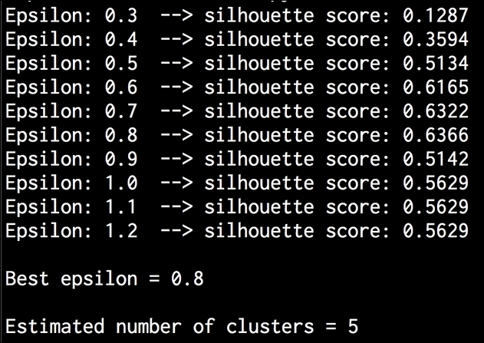

1. You will get the following bar graph:

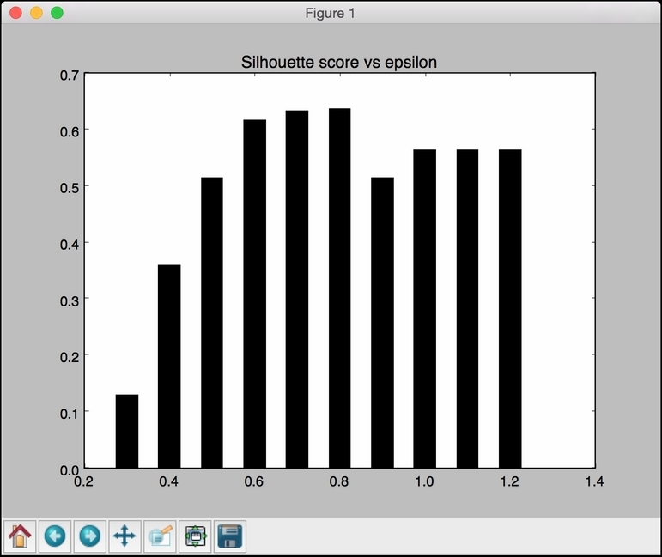

1. Let's look the labeled datapoints along with unassigned datapoints marked by solid points in the following figure:

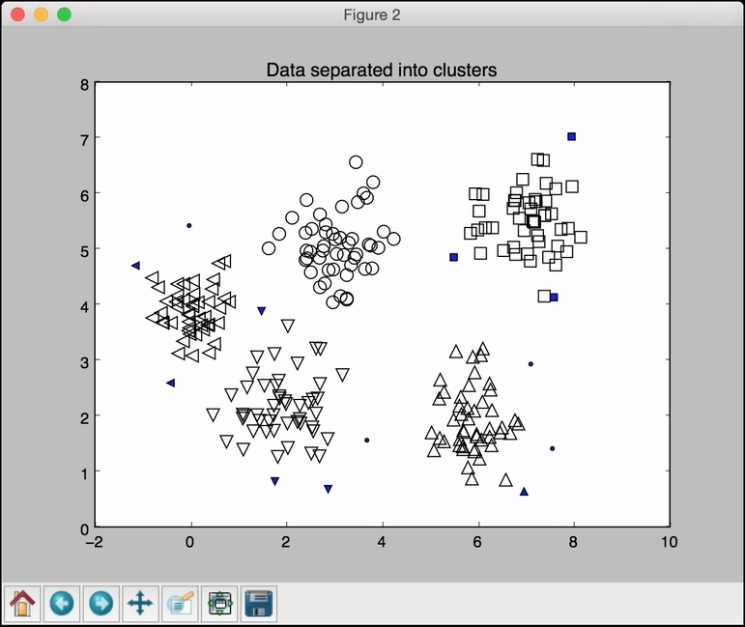

12. Clustering

Joos Korstanje[**1**](https://learning.oreilly.com/library/view/machine-learning-on/9781484282878/html/526781_1_En_12_Chapter.xhtml#Aff2)

(1)

VIELS MAISONS, France

In this fourth and last chapter on machine learning, we will cover clustering. To get this technique in perspective, let’s do a small recap of what we have gone through in terms of machine learning until now.

The machine learning topics started after the introduction of interpolation. In interpolation, we tried to estimate a target variable for locations at which the value of this target variable is unknown. Interpolation uses a mathematical formula to decide on the best possible theoretical way to interpolate these values.

After interpolation, we covered classification and regression, which are the two main categories in supervised modeling. In supervised modeling, we build a model that uses X variables to predict a target (y) variable. The great thing about supervised models is that we have a large number of performance metrics available that can help us in tuning and improving the model.

**Introduction to Unsupervised Modeling**

In this chapter, we will go deeper into unsupervised models. They are the opposite of supervised models in the sense that there is no notion of target variable in unsupervised models. There are two main types inside unsupervised models:

1. 1.

Feature reduction

1. 2.

Clustering

In feature reduction, the goal is to take a dataset with a large number of variables and then redefine these variables in a more efficient variable definition. Especially when many of the variables are strongly correlated, you can reduce the number of variables in the dataset in such a way that the new variables are not correlated.

Feature reduction will be a great first step for machine learning data preprocessing and can also be used for data analysis. Examples of methods are PCA, Factor Analysis, and more. Feature reduction is not much different on geospatial data than on regular data, which is why we will not dedicate more space for this technique.

A second family of models within unsupervised models is clustering. Clustering is very different from feature reduction, except from the fact that the notion of target variable is absent in both types of models. Clustering on spatial data is quite different from clustering on regular data, which is why this chapter will present clustering on geodata in depth.

**Introduction to Clustering**

In clustering, the goal is to identify clusters, or groups, of observations based on some measure of similarity or distance. As mentioned before, there is no target variable here: we simply use all of the available variables about each observation to create groups of similar observations.

Let’s consider a simple and often used example. In the graph in Figure [12-1](https://learning.oreilly.com/library/view/machine-learning-on/9781484282878/html/526781_1_En_12_Chapter.xhtml#Fig1), you’ll see a number of people (each person is an observation) of which we have collected the spending on two product groups at a supermarket: snacks and fast food is the first category and healthy products is the second.

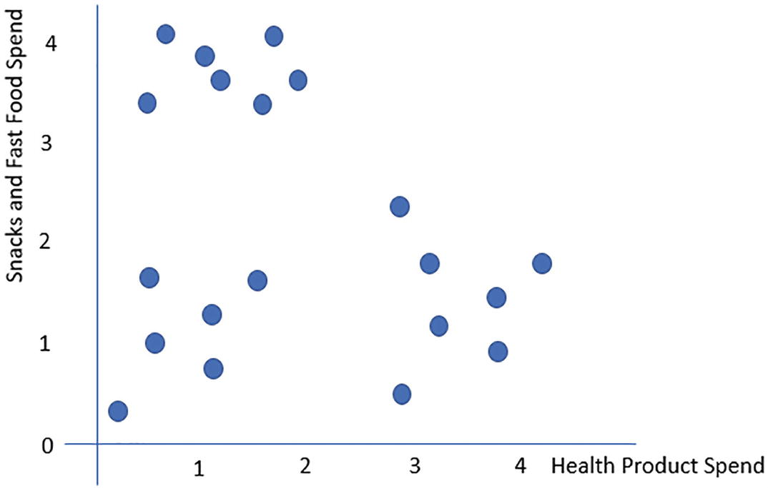

***Figure 12-1***

The graph showing the example. Image by author

As this data has only two variables, it is relatively easy to identify three groups of clients in this database. A subjective proposal for boundaries is presented in the graph in Figure [12-2](https://learning.oreilly.com/library/view/machine-learning-on/9781484282878/html/526781_1_En_12_Chapter.xhtml#Fig2).

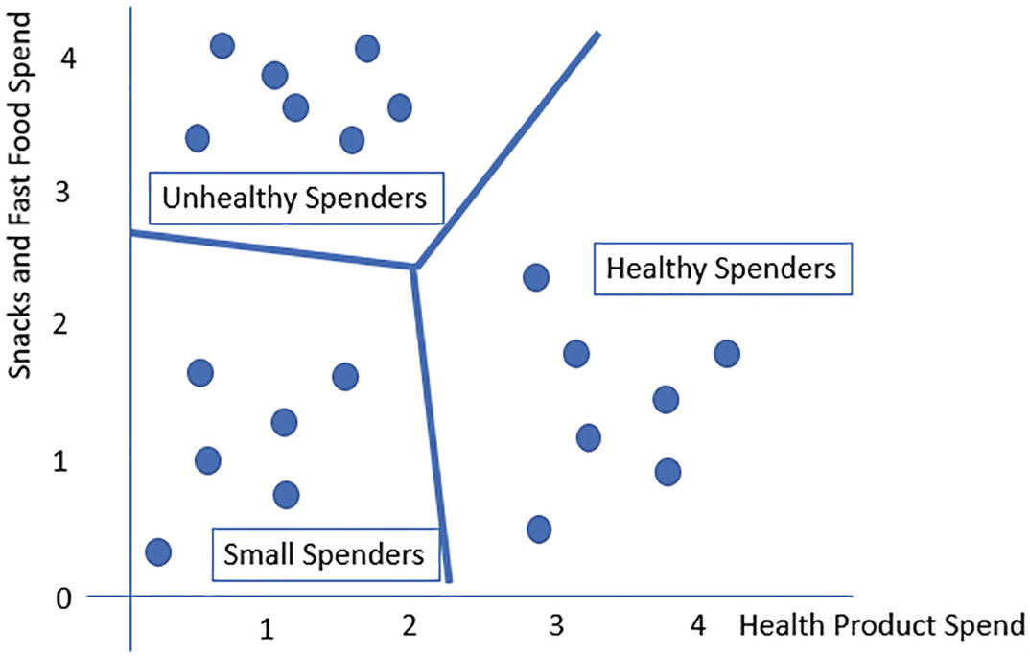

***Figure 12-2***

The graph showing a clustering example. Image by author

In this graph, you see that the clients have been divided in three groups:

1. 1.

Unhealthy spenders: A cluster of clients who spend a lot in the category snacks and fast food, but not much in the category healthy

1. 2.

Healthy spenders: A cluster of clients who spend a lot on healthy products but not much on snacks and fast food

1. 3.

Small spenders: People who do not spend a lot at all

An example of a way in which a supermarket could use such a clustering is sending personalized advertisements or discount coupons to those clients of which they know they’ll be interested.

**Different Clustering Models**

Now, instead of doing this manual split on the graph, we will need a more precise mathematical machine learning model to define such splits. Luckily, a large number of such models exist. Examples are

* The k-means algorithm
* Hierarchical clustering
* DBSCAN
* OPTICS
* Gaussian mixture
* And many more. The following source contains a rich amount of information on different clustering methods: <https://scikit-learn.org/stable/modules/clustering.html>.

Many of those models, however, are unfortunately not usable for spatial data. The problem with most models is that they compute Euclidean distances between two data points or other distance and similarity metrics.

In spatial data, as covered extensively in this book, we work with latitude and longitude coordinates, and there are specific things to take into account when computing distances from one coordinate to the other. Although we could use basic clustering models as a proxy, this would be wrong, and we’d need to hope that the impact is not too much. It will be better to choose clustering methods that are specifically designed for spatial data and that can take into account correct measures of distance.

The main thing that you need to consider very strongly in clustering on spatial data is the distance metric that you are going to use. There is no one-size-fits-all method here, but we’ll discover such approaches and considerations throughout the spatial clustering use case that is presented in this chapter.

**Spatial Clustering Use Case**

In the remainder of this chapter, we will go through a use case for clustering on spatial data. The use case is the identification on points of interest based solely on GPS tracks of people.

With those tracking points, we will try to identify some key locations during their trip, based on the idea that people have spent a little time at that location and therefore will have multiple points in a cluster of interest. On the other hand, the points will be more spread out and less clustered when people are on transportation between points.

We can use clustering for this, since we can expect clustering to find the clusters representing the points of interest. After this, we will use the center points of the identified clusters as an estimate of the real point of interest.

The steps that we will take from here are

* Importing and inspecting the data
* Building a cluster model for one user
* Tuning the clustering model for this user
* Applying the tuned model to the other users

Let’s start by importing the data in the next section.

**Importing and Inspecting the Data**

Let’s get started by importing and inspecting the data. The data is provided as a KML file. You can use the code in Code Block [12-1](https://learning.oreilly.com/library/view/machine-learning-on/9781484282878/html/526781_1_En_12_Chapter.xhtml#PC1) to import the data into Python.

import geopandas as gpd

import fiona

gpd.io.file.fiona.drvsupport.supported_drivers['KML'] = 'rw'

geodata = gpd.read_file('chapter_12_data.kml')

geodata.head()

***Code Block 12-1***

Importing the data

The geodataframe looks as shown in Figure [12-3](https://learning.oreilly.com/library/view/machine-learning-on/9781484282878/html/526781_1_En_12_Chapter.xhtml#Fig3).

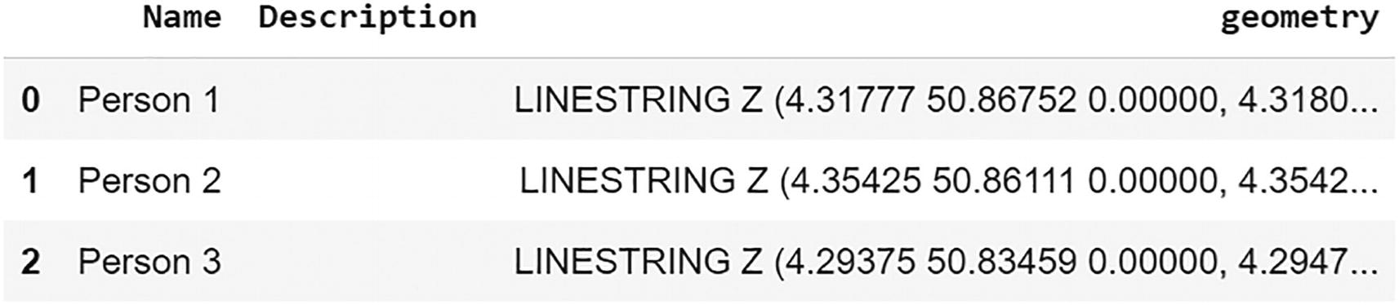

***Figure 12-3***

The data. Image by author

The data are stored as one LineString for each person. There are no additional variables available. Let’s now make a simple plot to have a better idea of the type of trajectories that we are working with. This can be done using the code in Code Block [12-2](https://learning.oreilly.com/library/view/machine-learning-on/9781484282878/html/526781_1_En_12_Chapter.xhtml#PC2).

geodata.plot()

***Code Block 12-2***

Plotting the data

The resulting plot is shown in Figure [12-4](https://learning.oreilly.com/library/view/machine-learning-on/9781484282878/html/526781_1_En_12_Chapter.xhtml#Fig4).

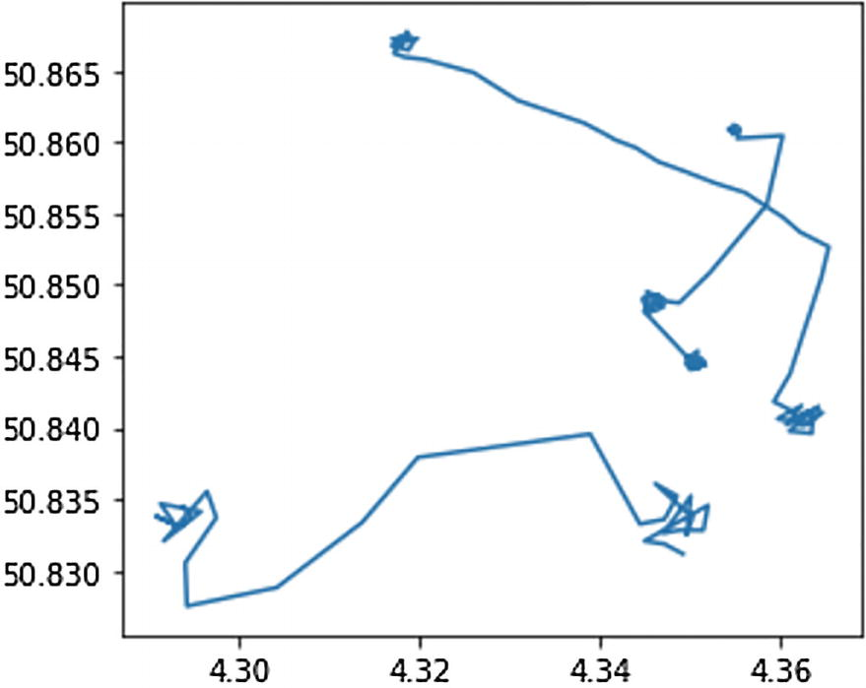

***Figure 12-4***

The plotted trajectories. Image by author

To add a bit of context to these trajectories, we can add a background map to this graph using the code in Code Block [12-3](https://learning.oreilly.com/library/view/machine-learning-on/9781484282878/html/526781_1_En_12_Chapter.xhtml#PC3).

import contextily as cx

ax = geodata.plot(figsize=(15,15), markersize=64)

cx.add_basemap(ax, crs = geodata.crs)

***Code Block 12-3***

Plotting with a background map

The resulting map is shown in Figure [12-5](https://learning.oreilly.com/library/view/machine-learning-on/9781484282878/html/526781_1_En_12_Chapter.xhtml#Fig5).

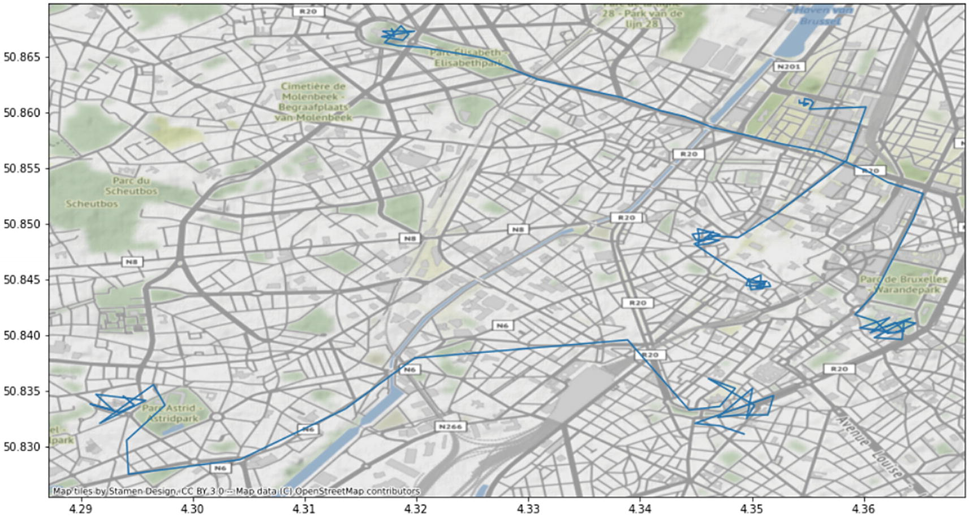

***Figure 12-5***

The map resulting from Code Block [12-3](https://learning.oreilly.com/library/view/machine-learning-on/9781484282878/html/526781_1_En_12_Chapter.xhtml#PC3). Image by author using contextily source data and image as referenced in the image

The three trajectories are based in the city of Brussels. For each of the three trajectories, you can visually identify a similar pattern: there are clustered parts where there are multiple points in the same neighborhood, indicating points of interest. Then there are also some parts where there is a real line-like pattern which indicates movements from one point of interest to another.

**Cluster Model for One Person**

Let’s now move on to the machine learning part. In this section, we start by extracting only one trajectory, so one person. We will apply a clustering to this trajectory to see if it can identify clusters in this trajectory.

We start by extracting the data for the first person using the code in Code Block [12-4](https://learning.oreilly.com/library/view/machine-learning-on/9781484282878/html/526781_1_En_12_Chapter.xhtml#PC4).

#Let's start with finding POI of one person

one_person = geodata[geodata['Name'] =='Person 1']

one_person

***Code Block 12-4***

Extract data of Person 1

The data for Person 1 looks as shown in Figure [12-6](https://learning.oreilly.com/library/view/machine-learning-on/9781484282878/html/526781_1_En_12_Chapter.xhtml#Fig6).

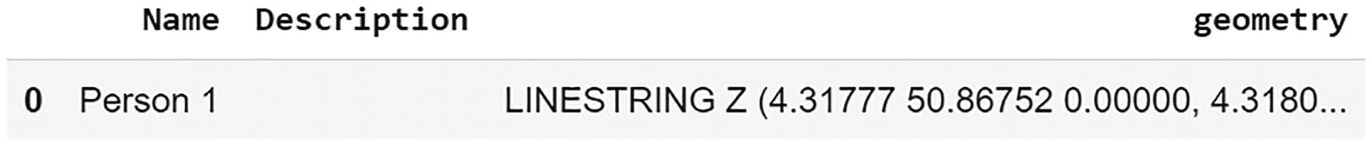

***Figure 12-6***

The result from Code Block [12-4](https://learning.oreilly.com/library/view/machine-learning-on/9781484282878/html/526781_1_En_12_Chapter.xhtml#PC4). Image by author

Let’s plot the trajectory of this person in order to have a more detailed vision of the behavior of this person. This map can be made using the code in Code Block [12-5](https://learning.oreilly.com/library/view/machine-learning-on/9781484282878/html/526781_1_En_12_Chapter.xhtml#PC5).

ax = one_person.plot(figsize=(15,15), markersize=64)

cx.add_basemap(ax, crs = one_person.crs)

***Code Block 12-5***

Creating a map of the trajectory of Person 1

The resulting map is shown in Figure [12-7](https://learning.oreilly.com/library/view/machine-learning-on/9781484282878/html/526781_1_En_12_Chapter.xhtml#Fig7).

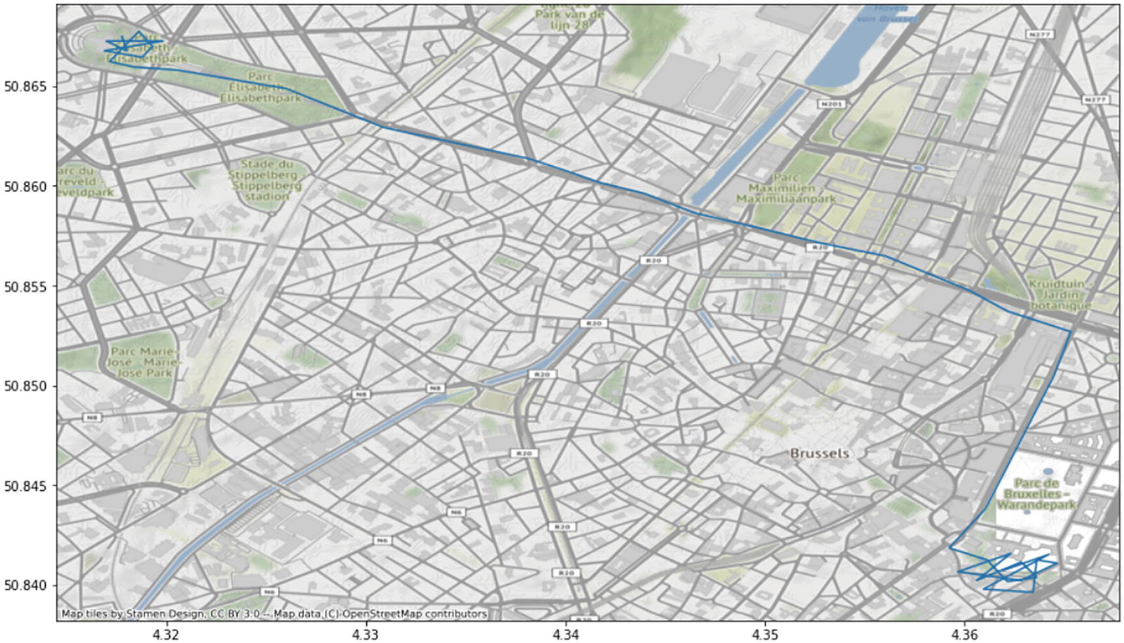

***Figure 12-7***

The map resulting from Code Block [12-5](https://learning.oreilly.com/library/view/machine-learning-on/9781484282878/html/526781_1_En_12_Chapter.xhtml#PC5). Image by author using contextily source data and image as referenced in the image

You can see from this visualization that the person has been at two locations for a longer period: one location on the top left of the map and a second point of interest on the bottom right. We want to reach a clustering model that is indeed capable of capturing these two locations.

To start building a clustering model for Person 1, we need to convert the LineString into points. After all, we are going to cluster individual points to identify clusters of points. This is done using the code in Code Block [12-6](https://learning.oreilly.com/library/view/machine-learning-on/9781484282878/html/526781_1_En_12_Chapter.xhtml#PC6).

import pandas as pd

one_person_points_df = pd.DataFrame(

    [x.strip('(').strip(')').strip('0').strip(' ').split(' ')

    for x in str(one_person.loc[0, 'geometry'])[13:].split(',')],

    columns=['long','lat']

)

one_person_points_df = one_person_points_df.astype(float)

one_person_points_df.head()

***Code Block 12-6***

Convert the LineString into points

The data format that results from this code is shown in Figure [12-8](https://learning.oreilly.com/library/view/machine-learning-on/9781484282878/html/526781_1_En_12_Chapter.xhtml#Fig8).

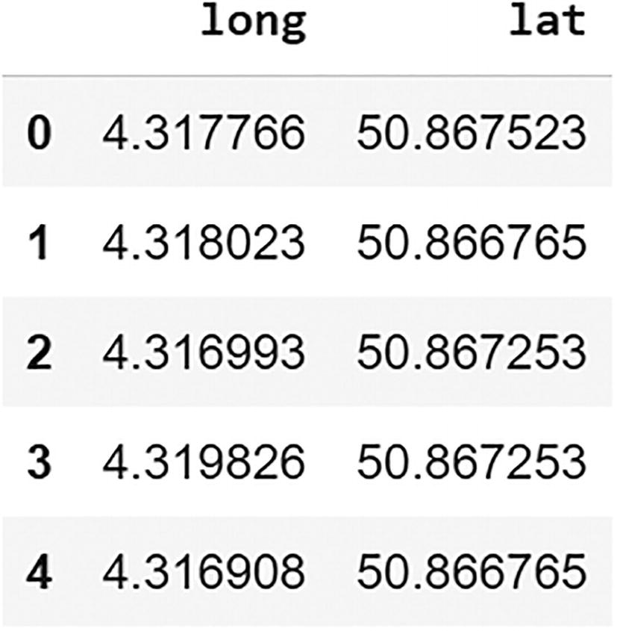

***Figure 12-8***

The new data format of latitude and longitude as separate columns. Image by author

Now that we have the right data format, it is time to apply a clustering method. As our data is in latitude and longitude, the distance between two points should be defined using haversine distance. We choose to use the OPTICS clustering method, as it applies well to spatial data. Its behavior is the following:

* OPTICS decides itself on the number of clusters that it wants to use. This is opposed to a number of models in which the user has to decide on the number of clusters.
* OPTICS can be tuned to influence the number of clusters that the model chooses. This is important, as the default settings may not result in the exact number of clusters that we want to obtain.
* OPTICS is able to discard points: when points are far away from all identified clusters, they can be coded as –1, meaning an outlier data point. This will be important in the case of spatial clustering, as there will be many data points that are on a transportation part of the trajectory that will be quite far away from the cluster centers. This option is not available in all clustering methods, but it is there in OPTICS and some other methods like DBSCAN.

Let’s start with an OPTICS clustering that uses the default settings. This is done in the code in Code Block [12-7](https://learning.oreilly.com/library/view/machine-learning-on/9781484282878/html/526781_1_En_12_Chapter.xhtml#PC7).

from sklearn.cluster import OPTICS

import numpy as np

clustering = OPTICS(metric='haversine')

one_person_points_df.loc[:,'cluster'] = clustering.fit_predict(np.radians(one_person_points_df[['lat', 'long']]))

***Code Block 12-7***

Apply the OPTICS clustering

The previous code has created a column called cluster in the dataset, which now contains the cluster that the model has found for each row, each data point. The code in Code Block [12-8](https://learning.oreilly.com/library/view/machine-learning-on/9781484282878/html/526781_1_En_12_Chapter.xhtml#PC8) shows how to have an idea of how the clusters are distributed.

one_person_points_df['cluster'].value_counts()

***Code Block 12-8***

Show the value counts

The result is shown in Figure [12-9](https://learning.oreilly.com/library/view/machine-learning-on/9781484282878/html/526781_1_En_12_Chapter.xhtml#Fig9).

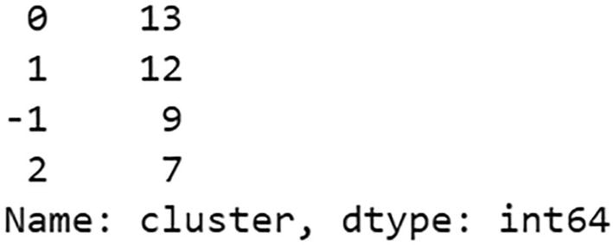

***Figure 12-9***

The result of the OPTICS clustering. Image by author

Now, as said before, the cluster –1 identified outliers. Let’s delete them from the data with the code in Code Block [12-9](https://learning.oreilly.com/library/view/machine-learning-on/9781484282878/html/526781_1_En_12_Chapter.xhtml#PC9).

# remove all the observations with cluster -1 (outliers)

one_person_points_df = one_person_points_df[one_person_points_df[‘cluster’] != -1]

***Code Block 12-9***

Remove the outlier cluster

We can now compute the central points of each cluster by computing the median point with a groupby operation. This is done in Code Block [12-10](https://learning.oreilly.com/library/view/machine-learning-on/9781484282878/html/526781_1_En_12_Chapter.xhtml#PC10).

medians_of_POI = one_person_points_df.groupby(['cluster'])[['lat', 'long']].median().reset_index(drop=False)

medians_of_POI

***Code Block 12-10***

Compute medians of clusters

Figure [12-10](https://learning.oreilly.com/library/view/machine-learning-on/9781484282878/html/526781_1_En_12_Chapter.xhtml#Fig10) shows the median coordinate for clusters 0, 1, and 2.

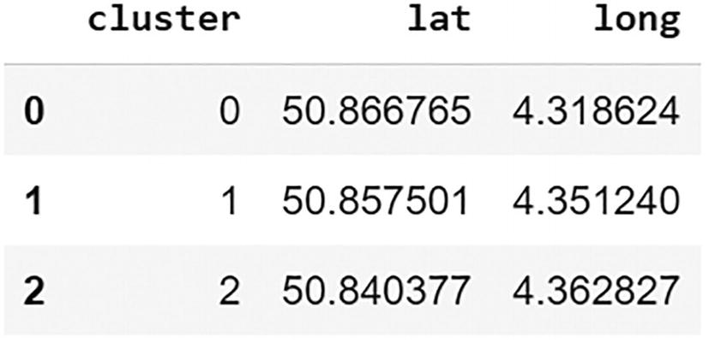

***Figure 12-10***

The resulting clusters. Image by author

Let’s plot those central coordinates on a map using the code in Code Block [12-11](https://learning.oreilly.com/library/view/machine-learning-on/9781484282878/html/526781_1_En_12_Chapter.xhtml#PC11).

from shapely.geometry.point import Point

medians_of_POI_gdf = gpd.GeoDataFrame(medians_of_POI, geometry=[Point(x) for x in zip( list(medians_of_POI['long']), list(medians_of_POI['lat']))])

medians_of_POI_gdf.plot()

***Code Block 12-11***

Plotting the central coordinates of Person 1

The basic plot with the three central points is shown in Figure [12-11](https://learning.oreilly.com/library/view/machine-learning-on/9781484282878/html/526781_1_En_12_Chapter.xhtml#Fig11).

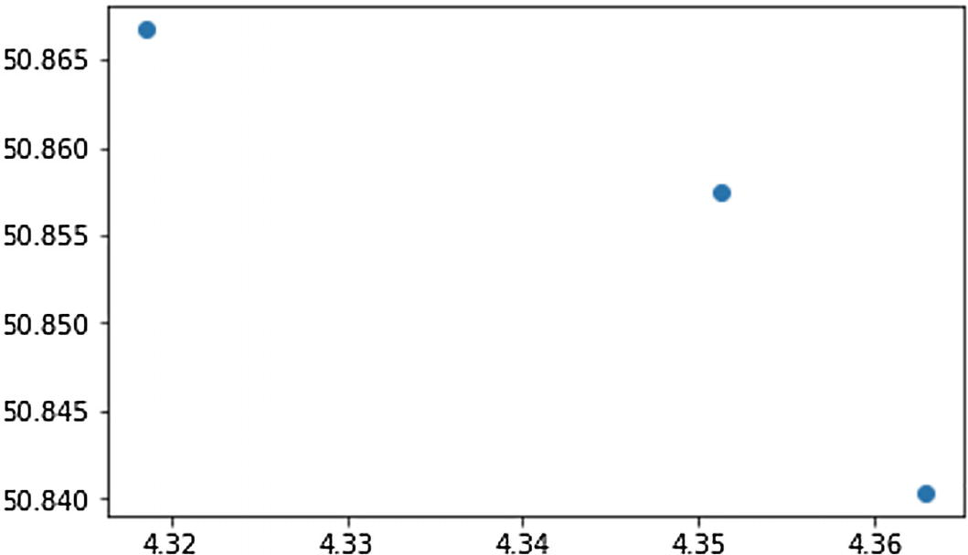

***Figure 12-11***

The plot with the three central points of Person 1. Image by author

Let’s use the code in Code Block [12-12](https://learning.oreilly.com/library/view/machine-learning-on/9781484282878/html/526781_1_En_12_Chapter.xhtml#PC12) to add more context to this map.

ax = one_person.plot(figsize=(15,15))

medians_of_POI_gdf.plot(ax=ax,markersize=128)

cx.add_basemap(ax, crs = one_person.crs)

***Code Block 12-12***

Plot a basemap behind the central points

The result is shown in Figure [12-12](https://learning.oreilly.com/library/view/machine-learning-on/9781484282878/html/526781_1_En_12_Chapter.xhtml#Fig12).

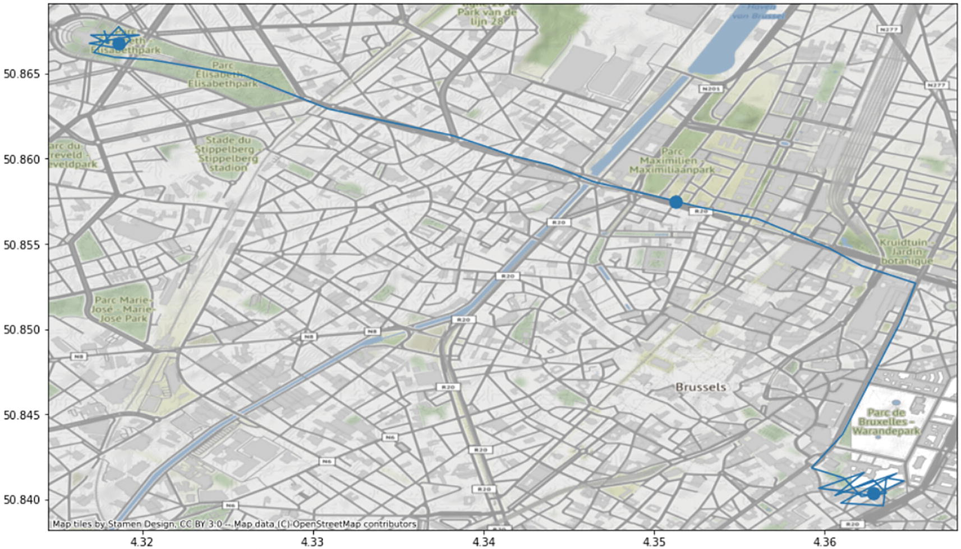

***Figure 12-12***

Plotting the central points to a background map. Image by author using contextily source data and image as references in the image

This map shows that the clustering was not totally successful. The cluster centroid on the top left did correctly identify a point of interest, and the one bottom right as well. However, there is one additional centroid in the middle that should not have been identified as a point of interest. In the next section, we will tune the model to improve this result.

**Tuning the Clustering Model**

Tuning models is much more complicated in unsupervised models than in supervised models. After all, we do not have an annotated dataset: the “real” points of interest are not known. The best thing is to do some manual checks and keep in mind what your objective really is. In the current case, we want to find centroids, and only centroids of points of interest.

In the following code, a different setting has been set in the OPTICS model:

* Min_samples is set to 10.

The number of samples in a neighborhood for the point to be considered a core point.

* Max_eps is set to 2.

This hyperparameter indicates the maximum distance for a point to a cluster centroid that is allowed to still be considered part of the cluster.

* Min_cluster_size is set to 8.

The minimum number of data points that have to be in a cluster if the cluster is to be kept.

* Xi is set to 0.05.

Helps in tuning the number of clusters.

These hyperparameter values have been obtained by trying out different settings and then looking whether the identified centroids coincided with the points of interest on the map. The code is shown in Code Block [12-13](https://learning.oreilly.com/library/view/machine-learning-on/9781484282878/html/526781_1_En_12_Chapter.xhtml#PC13).

# try different settings

one_person_points_df = pd.DataFrame(

    [x.strip('(').strip(')').strip('0').strip(' ').split(' ')

    for x in str(one_person.loc[0, 'geometry'])[13:].split(',')],

    columns=['long','lat']

)

one_person_points_df = one_person_points_df.astype(float)

clustering = OPTICS(

      min_samples = 10,

      max_eps=2.,

      min_cluster_size=8,

      xi = 0.05,

      metric='haversine')

one_person_points_df.loc[:,'cluster'] = clustering.fit_predict(

      np.radians(one_person_points_df[['lat', 'long']]))

one_person_points_df =

      one_person_points_df[one_person_points_df['cluster'] != -1]

medians_of_POI = one_person_points_df.groupby(['cluster'])[['lat', 'long']].median().reset_index(drop=False)

print(medians_of_POI)

medians_of_POI_gdf = gpd.GeoDataFrame(medians_of_POI,

      geometry=

             [Point(x) for x in

                  zip(

                        list(medians_of_POI['long']),

                        list(medians_of_POI['lat'])

                  )

            ])

ax = one_person.plot(figsize=(15,15))

medians_of_POI_gdf.plot(ax=ax,markersize=128)

cx.add_basemap(ax, crs = one_person.crs)

***Code Block 12-13***

Applying the OPTICS with different settings

The result of this new clustering is shown in Figure [12-13](https://learning.oreilly.com/library/view/machine-learning-on/9781484282878/html/526781_1_En_12_Chapter.xhtml#Fig13).

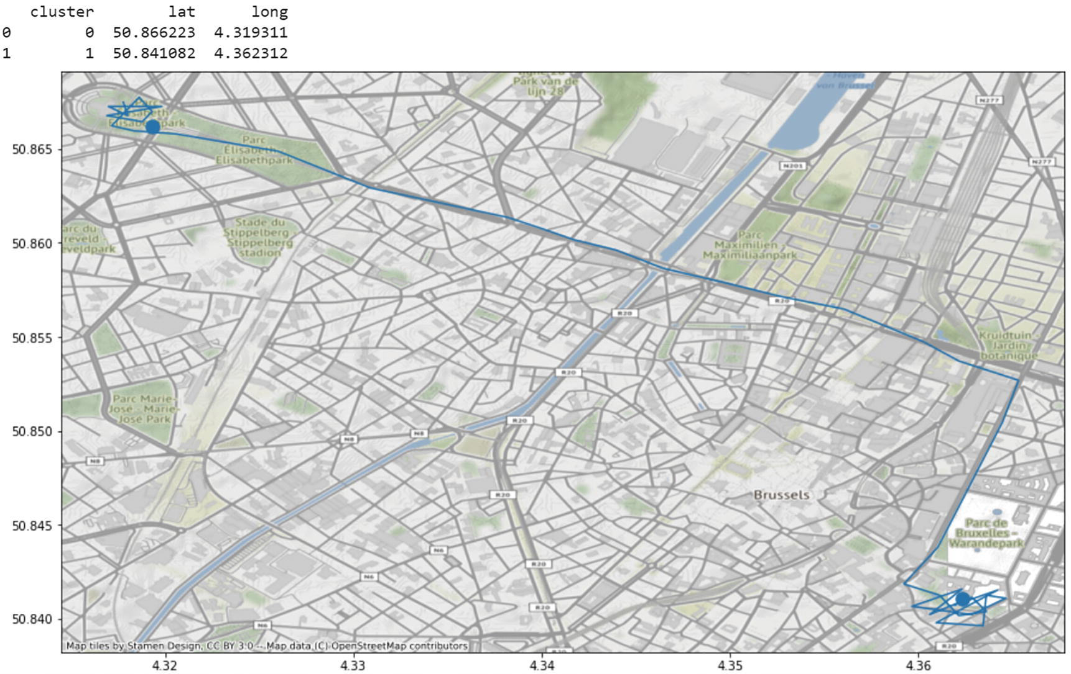

***Figure 12-13***

The map resulting from Code Block [12-13](https://learning.oreilly.com/library/view/machine-learning-on/9781484282878/html/526781_1_En_12_Chapter.xhtml#PC13). Image by author using contextily data and image as referenced in the map

As you can see, the model has correctly identified the two points (top left and bottom right) and no other points. The model is therefore successful at least for this person. In the next section, we will apply this to the other data as well and see whether the new cluster settings give correct results for them as well.

**Applying the Model to All Data**

Let’s now loop through the three people in the dataset and apply the same clustering method for each of them. For each person, the cluster centroids will be printed and plotted on a map against the original trajectory. This will allow us to check whether the result is correct. The code to do all this is shown in Code Block [12-14](https://learning.oreilly.com/library/view/machine-learning-on/9781484282878/html/526781_1_En_12_Chapter.xhtml#PC14).

import matplotlib.pyplot as plt

for i,row in geodata.iterrows():

  print(row)

  one_person_points_df = pd.DataFrame(

    [x.strip('(').strip(')').strip('0').strip(' ').split(' ')

    for x in str(row['geometry'])[13:].split(',')],

    columns=['long','lat']

  )

  one_person_points_df = one_person_points_df.astype(float)

  clustering = OPTICS(

                 min_samples = 10,

                 max_eps=2.,

                 min_cluster_size=8,

                 xi = 0.05,

                 metric='haversine')

  one_person_points_df.loc[:,'cluster'] = clustering.fit_predict(

      np.radians(one_person_points_df[['lat', 'long']]))

  one_person_points_df =

      one_person_points_df[one_person_points_df['cluster'] != -1]

  medians_of_POI =

      one_person_points_df.groupby(['cluster'])[['lat', 'long']].median().reset_index(drop=False)

  print(medians_of_POI)

  medians_of_POI_gdf = gpd.GeoDataFrame(medians_of_POI,

           geometry=

                 [Point(x) for x in

                       zip(

                            list(medians_of_POI['long']),

                            list(medians_of_POI['lat'])

                           )

                 ])

  ax = gpd.GeoDataFrame([row],

      geometry=[row['geometry']]).plot(figsize=(15,15))

  medians_of_POI_gdf.plot(ax=ax,markersize=128)

  plt.show()

***Code Block 12-14***

Apply the model to all data

The resulting output and graphs will be shown hereafter in Figures [12-14](https://learning.oreilly.com/library/view/machine-learning-on/9781484282878/html/526781_1_En_12_Chapter.xhtml#Fig14), [12-15](https://learning.oreilly.com/library/view/machine-learning-on/9781484282878/html/526781_1_En_12_Chapter.xhtml#Fig15), and [12-16](https://learning.oreilly.com/library/view/machine-learning-on/9781484282878/html/526781_1_En_12_Chapter.xhtml#Fig16).

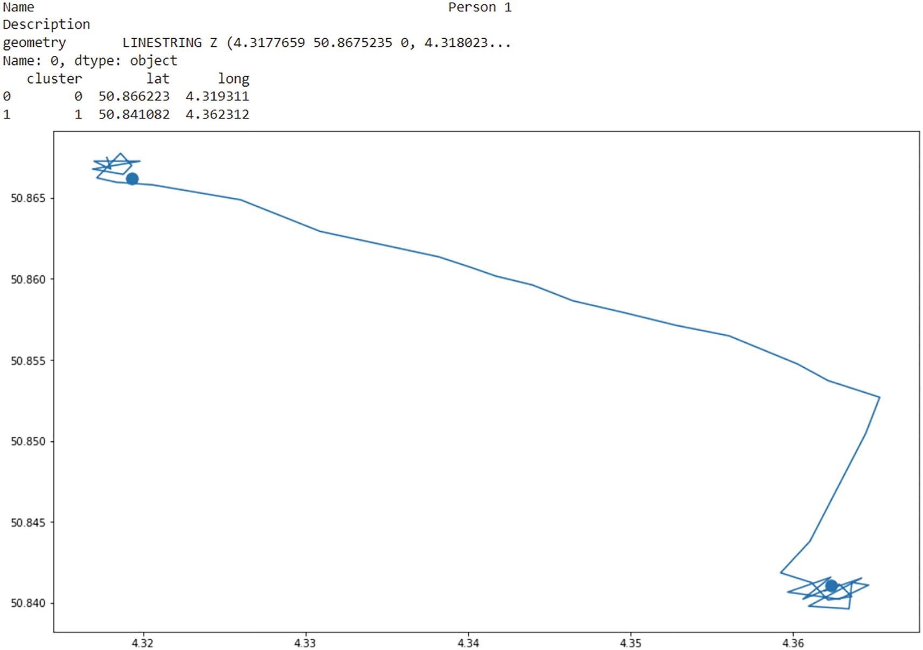

***Figure 12-14***

Central points on trajectory of Person 1. Image by author

This first map shows the result that we have already used before. Indeed, for Person 1, the OPTICS model has correctly identified the two points of interest. Figure [12-15](https://learning.oreilly.com/library/view/machine-learning-on/9781484282878/html/526781_1_En_12_Chapter.xhtml#Fig15) shows the results for Person 2.

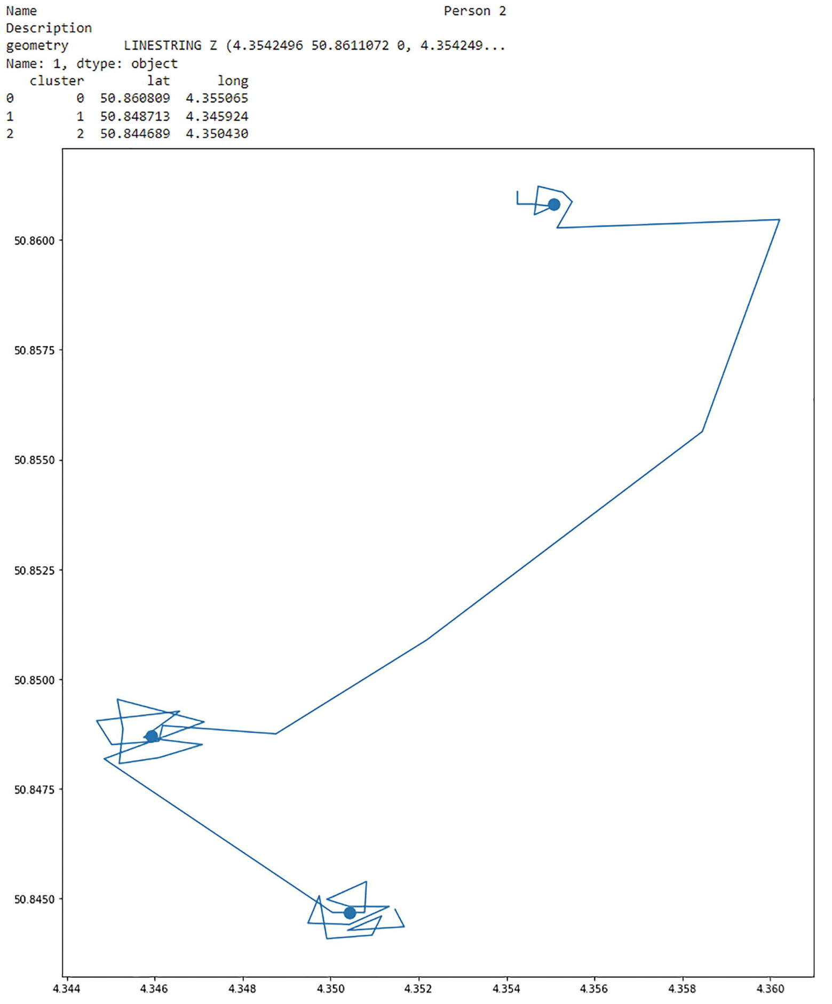

***Figure 12-15***

The three central points of Person 2 against their trajectory. Image by author

For Person 2, we can see that there are three points of interest, and the OPTICS model has correctly identified those three centroids. The model is therefore considered successful on this person. Let’s now check the output for the third person in Figure [12-16](https://learning.oreilly.com/library/view/machine-learning-on/9781484282878/html/526781_1_En_12_Chapter.xhtml#Fig16).

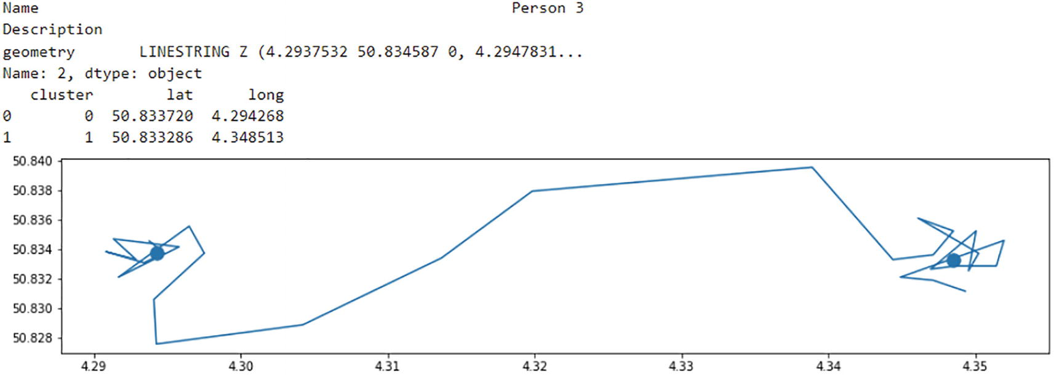

***Figure 12-16***

The two centroids of Person 3 against their trajectory

This result for Person 3 is also successful. There were two points of interest in the trajectory of Person 3, and the OPTICS model has correctly identified those two.

**Key Takeaways**

1. 1.

Unsupervised machine learning is a counterpart to supervised machine learning. In supervised machine learning, there is a ground truth with a target variable. In unsupervised machine learning, there is no target variable.

1. 2.

Feature reduction is a family of methods in unsupervised machine learning, in which the goal is to redefine variables. It is not very different to apply feature reduction in spatial use cases.

1. 3.

Clustering is a family of methods in unsupervised machine learning that focuses on finding groups of observations that are fairly similar. When working with spatial data, there are some specifics to take into account when clustering.

1. 4.

The OPTICS clustering model with haversine distance was used to identify points of interest in the trajectories of three people in Brussels. Although the default OPTICS model did not find those points of interests correctly, a manual tuning has resulted in a model that correctly identifies the points of interest of each of the three people observed in the data.

12. Neural Network and PyTorch Basics

Ashwin Pajankar[**1**](https://learning.oreilly.com/library/view/hands-on-machine-learning/9781484279212/html/516449_1_En_12_Chapter.xhtml#Aff3) and Aditya Joshi[**2**](https://learning.oreilly.com/library/view/hands-on-machine-learning/9781484279212/html/516449_1_En_12_Chapter.xhtml#Aff4)

(1)

Nashik, Maharashtra, India

(2)

Haldwani, Uttarakhand, India

In the past chapters, we have formed a foundation for machine learning approaches. These “traditional” machine learning methods have been used in academic research and industry applications for decades. However, the subject of focus in the new innovations in the past few years has been neural networks – the capability, the performance, and the versatility of various deep neural network architectures.

This and the next few chapters primarily focus on neural networks as well as deep neural network architectures, mainly the convolutional neural networks and the recurrent neural networks that are directly applicable in many situations. In this chapter, we will discuss how neural networks work, how are they applicable in so many different types of solutions, and how PyTorch can be used.

There are several software libraries and toolkits that have become popular in the past few years. Python has become the most popular choice for most of the projects that involve machine learning – and for deep learning, PyTorch is one of the competing tools whose popularity has been increasing in the recent past. We will limit ourselves to this library – though the API and the way of using the library might be different compared to the other tools, the ideas are still directly relevant and applicable.

In this chapter, we will begin with basics of perceptrons, which are the basic building block of neural networks. This will also involve basic mathematical operations that are required in constructing neural networks. We will then have a crisp introduction of PyTorch and look at the basic features. We will learn to do basic computations using PyTorch. Throughout this chapter and the next, you will be introduced to features of PyTorch based on their relevance.

Neural networks are interconnected nodes of computations that are at the heart of deep learning algorithms. The most basic element of neural networks is called a perceptron, which performs very basic vector arithmetic operations. Perceptrons can be combined together to depend on each other’s results for further computation and thus be arranged in layers of computing units. Such networks are called neural networks.

We will discuss more details about neural networks, starting with the basic unit, the perceptron, in the further sections.

Though the simplicity of design is the main source of power and popularity of neural networks, these computations can often grow too big and complex to program and manipulate using basic programming tools, which led to the rise of frameworks for neural network programming.

PyTorch is one of the most popular tools often applauded for being simple and more Pythonic – thus leading to easy learning and improved developer productivity. PyTorch is also at par, and, in some cases, faster than other popular deep learning libraries. The benefits are summarized by a highly cited AI scientist in his tweet[**1**](https://learning.oreilly.com/library/view/hands-on-machine-learning/9781484279212/html/516449_1_En_12_Chapter.xhtml#Fn1) (Figure [12-1](https://learning.oreilly.com/library/view/hands-on-machine-learning/9781484279212/html/516449_1_En_12_Chapter.xhtml#Fig1)).



***Figure 12-1***

Andrej Karpathy’s tweet about PyTorch. Andrej is presently leading AI and autopilot vision at Tesla

**Installing PyTorch**

One of the most preferred ways to install PyTorch is to use Anaconda distribution’s package manager tool – conda. If you do not have Anaconda installed, you may download the suitable package for your system at the Anaconda website.[**2**](https://learning.oreilly.com/library/view/hands-on-machine-learning/9781484279212/html/516449_1_En_12_Chapter.xhtml#Fn2) Anaconda is a popular Python distribution that gives powerful environment management and package management capabilities. Once you have installed Anaconda, you can use this command:

conda install pytorch torchvision torchaudio cudatoolkit=10.2 -c pytorch

This will instruct conda to install PyTorch and the required libraries, including cudatoolkit, which provides an environment for creating high-performance gpu-based programming.

Alternatively, you can install using Python’s package manager, pip.

pip3 install torch torchvision torchaudio

To explore more alternative ways to install, you can refer to the Getting Started[**3**](https://learning.oreilly.com/library/view/hands-on-machine-learning/9781484279212/html/516449_1_En_12_Chapter.xhtml#Fn3) page of PyTorch, which gives you more options to configure your installation depending on your system and requirements.

After installation, you can perform a simple test to verify that your PyTorch installation works as expected. Open Jupyter Notebook or Python Shell to import torch and verify the PyTorch version.

import torch

torch.__version__

Out: '1.9.1'

**PyTorch Basics**

In PyTorch, tensor is a term that refers to any generic multidimensional array. In practice, tensor establishes a multilinear relationship between the sets of algebraic objects related to a vector space. In PyTorch, tensor is the primary data structure that encodes the inputs, outputs, as well as the model parameters.

**Creating a Tensor**

Tensors are similar to Ndarrays in NumPy. You can create a tensor from a Python’s list or multidimensional lists of lists. You can also create a tensor from an existing NumPy array.

mylist = [1,2,3,4]

mytensor = torch.tensor(mylist)

mytensor

Out: tensor([1, 2, 3, 4])

As you might expect, you can also create a tensor from a NumPy array.

import numpy as np

myarr = np.array([[1,2],[3,4]])

mytensor_2 = torch.from_numpy(myarr)

mytensor_2

Out: tensor([[1, 2],

        [3, 4]], dtype=torch.int32)

When you create a tensor from a NumPy array, it is not copied to a new memory location – but both the array and tensor share the same memory location. If you make any change in the tensor, it will be reflected in the original array from which it was created.

mytensor_2[1,1]=5

myarr

Out: tensor([[1, 2],

        [3, 5]], dtype=torch.int32)

Inversely, you can also use mytensor_2.numpy() to return a NumPy array object that shares the same data. Just like NumPy Ndarrays, PyTorch tensors are also homogeneous; that is, all the elements in the tensor have same data type. There are other tensor creation methods similar to NumPy’s array creation methods. This is an example of creating a simple tensor.

torch.zeros((2,3))

Out: tensor([[0., 0., 0.],

        [0., 0., 0.]])

This will create a tensor of shape 3x3 with all values as zeros. A similar function in NumPy is np.zeros(3,3). It returns an array of shape 3x3. Though the representation is similar, tensors are the primary unit of data representation in PyTorch. You can use a similar functions to create arrays of ones, or random values of user-defined size.

torch.ones((2,3))

Out: tensor([[1., 1., 1.],

        [1., 1., 1.]])

torch.rand((2,3))

Out: tensor([[0.0279, 0.5261, 0.9984],

        [0.7442, 0.3559, 0.3686]])

PyTorch also includes a method to create or initialize a tensor with properties (like shape) of another tensor.

torch.ones_like(mytensor_2)

Out: tensor([[1, 1],

       [1, 1]], dtype=torch.int32)

**Tensor Operations**

PyTorch tensors support several operations in a similar manner as NumPy’s arrays – though the capabilities are more. Arithmetic operations with scalers are broadcasted, that is, applied to all the elements of the tensor. Matrix operations between tensors of compatible shapes are applied in a similar fashion.

myarr = np.array([[1.0,2.0],[3.0,4.0]])

tensor1 = torch.from_numpy(myarr)

tensor1+1

Out: tensor([[2., 3.],

        [4., 5.]], dtype=torch.float64)

tensor1/ tensor1

Out: tensor([[1., 1.],

        [1., 1.]], dtype=torch.float64)

tensor1.sin()

Out: tensor([[ 0.8415,  0.9093],

        [ 0.1411, -0.7568]], dtype=torch.float64)

tensor1.cos()

Out: tensor([[ 0.5403, -0.4161],

        [-0.9900, -0.6536]], dtype=torch.float64)

tensor1.sqrt()

Out: tensor([[1.0000, 1.4142],

        [1.7321, 2.0000]], dtype=torch.float64)

The functions for describing the data can also be used in a similar manner:

mean, median, min_val, max_val = tensor1.mean(), tensor1.median(), tensor1.min(), tensor1.max()

print ("Statistical Quantities: ")

print ("Mean: {}, \nMedian: {}, \nMinimum: {}, \nMaximum: {}".format(mean, median, min_val, max_val))

print ("The 90-quantile is present at {}".format(tensor1.quantile(0.5)))

These operations give the following output:

Statistical Quantities:

Mean: 2.5,

Median: 2.0,

Minimum: 1.0,

Maximum: 4.0

The 90-quantile is present at 2.5

Similar to NumPy, PyTorch also provides operations like cat, hstack, vstack, etc., to join the tensors. Here are the examples:

tensor2 = torch.tensor([[5,6],[7,8]])

torch.cat([tensor1, tensor2], 0)

This method would concatenate the two tensors. The direction (or axis) of concatenation is provided as the second argument. 0 signifies that the tensors will be joined vertically, and 1 would signify that they will be joined horizontally.

tensor([[1., 2.],

        [3., 4.],

        [5., 6.],

        [7., 8.]], dtype=torch.float64)

Other similar functions are hstack and vstack, which can also be used to join two or more tensors horizontally or vertically.

torch.hstack((tensor1,tensor2))

Out: tensor([[1., 2., 5., 6.],

        [3., 4., 7., 8.]], dtype=torch.float64)

torch.vstack((tensor1,tensor2))

Out: tensor([[1., 2.],

        [3., 4.],

        [5., 6.],

        [7., 8.]], dtype=torch.float64)

There’s a reshape function that changes the shape of the tensor. To convert the tensor into a single row with an arbitrary number of columns, we can use shape as (1,-1):

torch.reshape(tensor1, (1, -1))

Out: tensor([[1., 2., 3., 4.]], dtype=torch.float64)

We will continue discussing more operations based on their use in the future sections and chapters.

**Perceptron**

Perceptron, shown in Figure [12-2](https://learning.oreilly.com/library/view/hands-on-machine-learning/9781484279212/html/516449_1_En_12_Chapter.xhtml#Fig2), is the simplest form of neural network. It takes one or more quantities often describing features of a data item as input, performs a simple computation on it, and produces a single output. The simplest form of perceptron is a single-layer perceptron – it is easy to understand, quick to run, and simple to implement, though it can classify only linearly separable data.

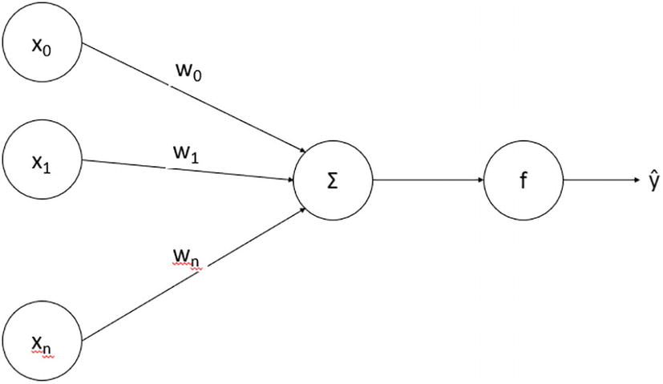

***Figure 12-2***

A simple perceptron structure with constituent computations

As illustrated in Figure [12-2](https://learning.oreilly.com/library/view/hands-on-machine-learning/9781484279212/html/516449_1_En_12_Chapter.xhtml#Fig2), perceptron applies a simple computation to predict the class label based on the input vector x, with features being represented as [x**1**, x**2**, x**3** … x**n**], and a weight vector, with features being represented as [w**1**, w**2**, w**3**, … w]. We usually add an additional bias term that doesn’t affect the output based on the input as w**0**. To ease the computation, we add an input feature as x**0**, with its value being set as 1. Thus, the two vectors, x and w, lead to the final output based on a simple step function:

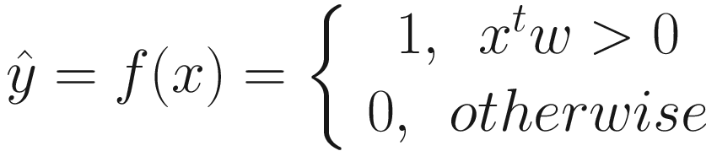

Here, x is the input vector with n+1 dimensions, w is the weight vector, and the objective of the learning process is to learn the best possible weights so that the error computed by comparing the results with the training labels is minimized.

To train the perceptron, we first initialize the weights with random values. We use the training dataset to find the predicted output based on the formula shown previously. Because the algorithm has not learned the right set of weights yet, the results may be far than we expected – thus leading to an error. To reduce the noise in next iterations, we apply the following update to the weights based on the current outputs:

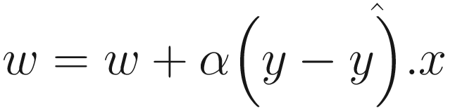

Here, we have also added a step parameter, α, which controls how severely are the weights impacted. We iteratively repeat this process till a predetermined number of times (or till convergence) and hope to reach a good enough weight vector by the end, which may lead to a low error. To predict the output, we simply plug in the features x to the same computation.

The computation function we saw in the previous section is called a stepper function. In many cases, you might rather see sigmoid function, that is:

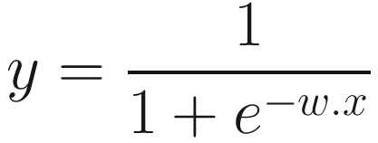

Let’s see how to program these first using basic Python and NumPy, and later we will use PyTorch to do the same.

**Perceptron in Python**

We will first create a simple separable dataset using Scikit-learn’s dataset module. You can use any other dataset that we have used before.

from sklearn import datasets

import matplotlib.pyplot as plt

X, y = datasets.make_blobs(n_samples=100,n_features=2, centers=2, random_state=42, shuffle=1)

These lines will create 100 rows of data with two features, which is divided into two major blobs. Let’s visualize it before building the perceptron.

fig = plt.figure(figsize=(10,8))

plt.plot(X[:, 0][y == 0], X[:, 1][y == 0], 'b+')

plt.plot(X[:, 0][y == 1], X[:, 1][y == 1], 'ro')

plt.xlabel("Feature 1")

plt.ylabel("Feature 2")

The data points are clearly visible as shown in Figure [12-3](https://learning.oreilly.com/library/view/hands-on-machine-learning/9781484279212/html/516449_1_En_12_Chapter.xhtml#Fig3), and we deliberately chose this kind of randomly generated dataset to keep the classification boundary simple.

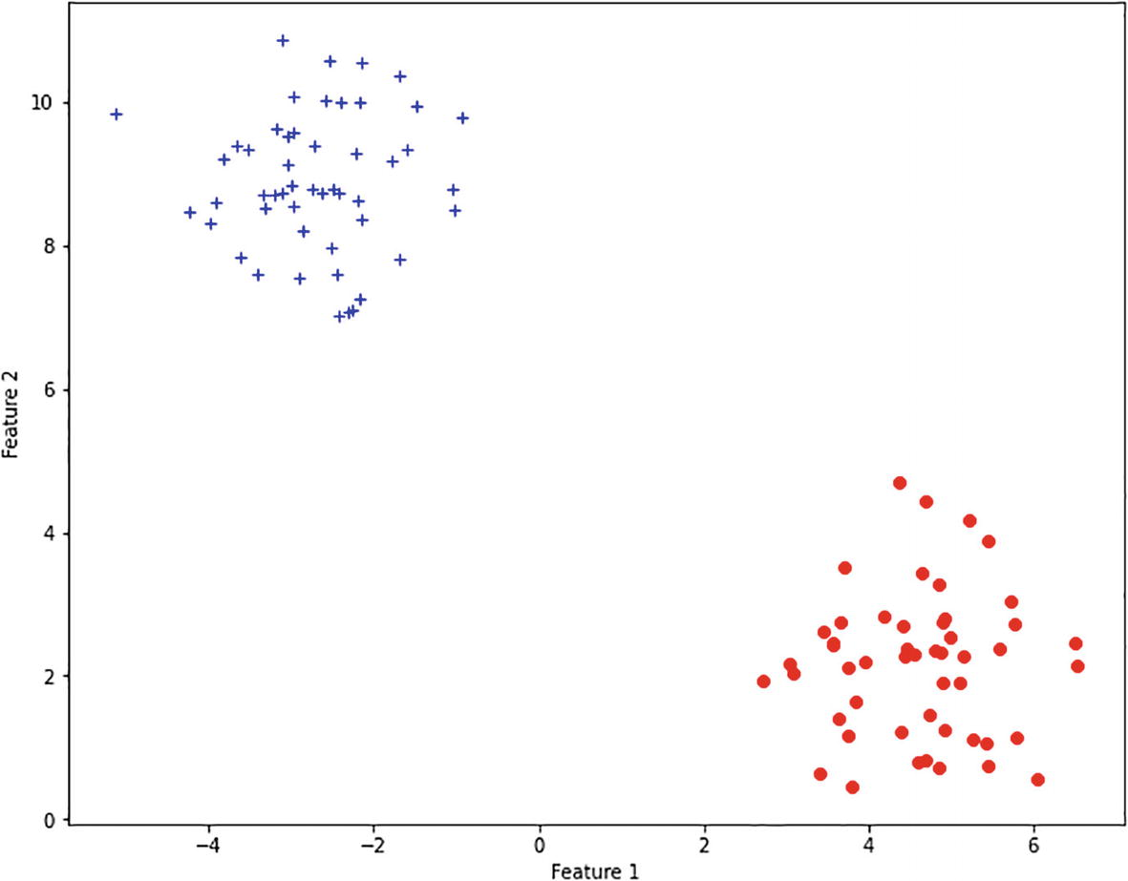

***Figure 12-3***

Simple dataset generated using make_blobs

We have X and y. Let’s create fit() and predict() methods from scratch. You know that weights are updated based on the predicted value of each data point at the current step. In the formula 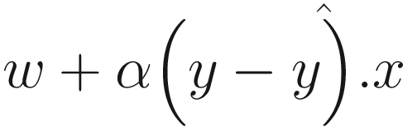, we already know x and y; *α* is a hyperparameter that you can configure to set the steps, and w is the set of weights that we will learn in this process.

Because our dataset contains two features, we need three (2 + 1 for the bias term) weights in the weight vector. Let’s implement the predict function first.

def predict(X, weight):

  return np.where(np.dot(X, weight) > 0.0, 1, 0)

This implements the formula for  by first computing the product between the input data and weight and then applies the case to compare if the resulting product is larger than 0. This function can act as the prediction function as well as help us find the right value to update the weights.

Remember there are three weights, though the dataset still has two columns. We will add a column to compensate for the bias, thus leading to a shape of 100x3. We will initialize the weights to random values.

  X = np.concatenate( (np.ones((X.shape[0],1)), X), axis=1)

  weight = np.random.random(X.shape[1])

After initialization, we will run an iterative process till a predetermined number of iterations (or epochs) and, within each iteration, process each point and update the weights. The fit() method should now look like the following:

def fit(X, y, niter=100, alpha=0.1):

  X = np.concatenate( (np.ones((X.shape[0],1)), X), axis=1)

  weight = np.random.random(X.shape[1])

  for i in range(niter):

     err = 0

     for xi, target in zip(X, y):

        weight += alpha * (target - predict(xi, weight)) * xi

  return weight

We have not structured the code as a class which might store the weights internally – but have to return it, which can be supplied to the predict method. To learn the weights, we can now call

w = fit(X,y)

w

Out: array([ 0.21313539,  0.96752865, -0.84990543])

W is a weight vector with three values representing the bias and corresponding coefficient for each feature. We can use the predict() method to predict the output. Let’s pick some random elements from X to compare how our perceptron labels them:

random_elements = np.random.choice(X.shape[0], size=5, replace=False)

X_test = X[random_elements, :]

X_test will now contain five random rows from the dataset. Before calling the predict method, we will need to add an additional column with ones.

X_test = np.concatenate( (np.ones((X_test.shape[0],1)), X_test), axis=1)

Now let’s call the predict method and compare the results with the actual values.

print (predict(X_test, w))

print (y[random_elements])

Out:

[0 0 1 0 0]

[0 0 1 0 0]

The results look good because the dataset is too simple – however, remember that a simple perceptron doesn’t perform well in cases where decision boundaries are not so clear. We will discuss how to combine such simple computation units to create a more complex neural network in the next chapters.

**Artificial Neural Networks**

A simple perceptron learns how important each feature of the dataset is through a single threshold logic unit, when it attempts to combine the weighted sum of features and pass it to a function. We used a simple step function that was implemented by if-else conditions in Python, or np.where function while using NumPy. We may use a sigmoid function or other alternate functions to manipulate how and when a feature set produces the output – or activates the neuron. We can combine multiple activations like these and connect them in the form of a fully connected layer.

Such networks surpass the simplicity of using a simple perceptron and allow you to create multiple fully connected layers, thus leading to creation of hidden layers, thus creating a multilayer perceptron as shown in Figure [12-4](https://learning.oreilly.com/library/view/hands-on-machine-learning/9781484279212/html/516449_1_En_12_Chapter.xhtml#Fig4). The output may become input to the next layer, which is further manipulated by a new set of weights at the next layer.

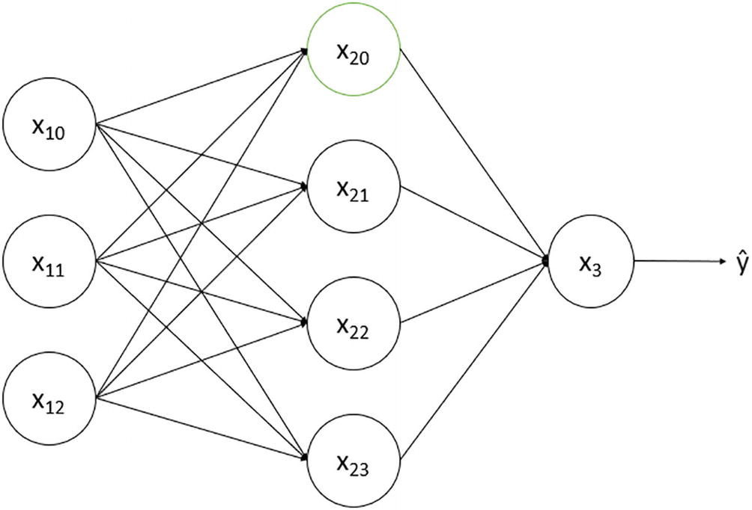

***Figure 12-4***

A simple multilayer perceptron with one output unit

Computation units can be arranged in a different fashion to create more diverse deep neural networks. The convolutional neural networks (CNNs) use a special kind of layers that apply a filter to an input image by sliding the filter to produce an activation map. CNNs are a highly preferable choice in many computer vision (CV) or natural language processing (NLP) applications. We will discuss more about them in depth in Chapter [14](https://learning.oreilly.com/library/view/hands-on-machine-learning/9781484279212/html/516449_1_En_14_Chapter.xhtml).

Another popular neural network architecture is called recurrent neural network (RNN), which has an internal state whose value is maintained based on input data in order to produce an output using a combination of the state and an input sample. This might also update the internal state and affect the future outputs. This thus helps interpret the sequential information in the data, which is highly helpful in NLP applications. We will study about this in Chapter [15](https://learning.oreilly.com/library/view/hands-on-machine-learning/9781484279212/html/516449_1_En_15_Chapter.xhtml).

**Summary**

In this chapter, we have discussed the basics of neural networks and have started to explore PyTorch to define tensors and create simple neural units that can learn to classify data. The next chapter discusses the algorithms that are used to learn network weights in neural networks, thus leading to feedforward and backward propagation.

**Footnotes**

[1](https://learning.oreilly.com/library/view/hands-on-machine-learning/9781484279212/html/516449_1_En_12_Chapter.xhtml#Fn1_source)

[https://​twitter.​com/​karpathy/​status/​8681789540325130​24](https://twitter.com/karpathy/status/868178954032513024)

[2](https://learning.oreilly.com/library/view/hands-on-machine-learning/9781484279212/html/516449_1_En_12_Chapter.xhtml#Fn2_source)

[www.​anaconda.​com/​products/​individual](http://www.anaconda.com/products/individual)

[3](https://learning.oreilly.com/library/view/hands-on-machine-learning/9781484279212/html/516449_1_En_12_Chapter.xhtml#Fn3_source)

[https://​pytorch.​org/​get-started/​locally/​](https://pytorch.org/get-started/locally/)

12. Containers

Moshe Zadka[**1**](https://learning.oreilly.com/library/view/devops-in-python/9781484279960/html/470619_2_En_12_Chapter.xhtml#Aff2)

(1)

Belmont, CA, USA

Many modern applications are deployed as containers. Containers are a way of running applications in isolation. This isolation allows for building self-contained images with all dependencies an application needs to run.

There are several ways to run containers. A popular one used by Kubernetes and Docker is containerd.

For a container runner to run an application as a container, the application needs to be inside of an Open Container Initiative (OCI) image.

There are several ways to build images. The most popular ways—buildctl, docker build, and nerdctl build—wrap buildkit.

Internally, buildkit uses a format called Low-Level Builder (LLB), which is not designed for people to write container build specifications. Instead, many LLB front ends compile a specification.

The most common front end for LLB is dockerfile.v0. This front end is sometimes referred to as a Dockerfile because, by default, the front end looks for a file named Dockerfile as the source for the build specification.

The most common way to enable running Python code as a container is to write a Dockerfile containing a build specification. This Dockerfile is then given to buildkit to produce an OCI Image.

Writing a Dockerfile to build a Python application into a container image is different from writing a *good* Dockerfile. When creating container images, there are a lot of concerns to address.

Container images should be small, have fast build times, build reproducibly, and be easy to update with third-party security patches. These goals are, at least partially, in conflict with one another.

Making good choices or appropriate trade-offs when writing a Dockerfile for a Python application is why a good Dockerfile is subtle to achieve. It requires understanding the consequences of different ways of using the commands in a Dockerfile and how Python applications can be installed.

**12.1 Choosing a Base Image**

One of the first lines in a dockerfile.v0 build specification starts with FROM. This indicates the base of the image. Images can be made from scratch, but starting from a popular Linux distribution is more common. Almost all distributions have an official container image or images.

**12.1.1 GNU C Library Support**

Because Python portable binary wheels (manylinux wheels) only support GNU C Library (glibc), it is usually good to stick to a glibc-based distribution. The most popular non-glibc-based distribution is Alpine Linux. It is possible to build Alpine-based container images for Python applications, but it is harder.

**12.1.2 Long-Term Support**

The packages installed in the container image, either in the base image or using the distributions package manager, inevitably have bugs or security issues. The container image needs to be rebuilt when there is a need to integrate a patch for a bug or security issue.

Such rebuilds can often be time-sensitive if the problem is urgent. Minimizing the changes needed to the container to integrate such fixes allows faster deployment. Less testing is required, and the chances that these changes require another part of the application to change are lower.

This makes rolling distributions, which integrate new upstream versions continuously, a bad fit as bases for Python-based container images. Distributions with conservative policy about adding changes to an existing release, and long-term security and bug fix support for a release, are better. Distributions like Arch and Fedora should be avoided as a base for Python-based container images.

**12.1.3 Avoiding Unexpected Changes**

Official distribution images hosted on public registries are regularly updated with fixes. This is true whether they are on general public registries such as registy.hub.docker.com/library/debian or ones with a more focused purpose like registry.suse.com/suse/sle15.

Even the images exposed under specific tags, such as registry.suse.com/suse/sle15:15.3, can change. In the case of SUSE, this can reflect 15.3.17.8.25 or 15.3.17.8.24.

It is possible to address images by the specific digest, as shown in the following example.

FROM \

registry.hub.docker.com/library/debian@sha256:8a71adf557086b1f0379142a24cbea502d9bc864b890f48819992b009118c481

There is no guarantee that the digest is still available at the upstream registry. The old container image might get the garbage collector when a new image gets uploaded to the same tag.

A good practice is to keep the base image in a locally controlled registry. It should be updated regularly, but tags and versions are now under direct local control; for example, images can be tagged by the pulling date and guaranteed to last 60 days. The images, tags, frequency of pulling, and expiration policies should be clearly documented. It is often useful to centralize this process and support a small number of organization-wide blessed base images.

How centralized the process should be and how many base images to support depends on local needs, compliance requirements, and the size of the organization. This can be a contentious issue. One way to partially mitigate that is to clearly document the process and the trade-offs made and how decisions were made.

**12.2 Installing the Python Interpreter**

There are a few potential sources for the Python interpreter. Native Python distributions have a few downsides.

* A Python distribution is optimized for distributing Python packages; it is not optimized to be a development platform.
* New versions of Python, even patch versions, might not be available until a new version of the distribution is available.

**12.2.1 conda**

One option is installing conda and then installing Python in a conda environment. This is a good option if you are willing to commit to conda, creating conda environments, and installing things inside them.

This option is especially attractive when needing other features of conda, such as the availability of prebuilt binaries that are not Python-specific. This can be useful, especially in containers for data science and machine learning applications.

Unless the application developers are already using conda as their day-to-day development environment, adding another tool that developers must be familiar with can have significant downsides. This is not the best choice to get a Python interpreter in those cases.

**12.2.2 Third-Party Repositories**

Some third-party repositories, like deadsnakes for Ubuntu, build versions of Python designed to be used for development. Adding these repositories as an extra upstream, and installing Python through them, is one way to get Python into a container image.

Some due diligence should be done to vet the build process and options to make sure the Python builds are appropriate for the application. It is also important to understand how soon a new version of Python is available through the repository after it is released.

**12.2.3 Building Python in the Container**

The pyenv tool downloads and installs a version of Python. It can be used on any Unix-like operating system, including containers.

When pyenv builds and deploys Python, it also deploys shims. These are designed to switch between versions of Python.

Since a container image usually only has one version of Python, these shims are superfluous. It is possible to build Python directly with python-build, a pyenv subproject.

Finally, it is possible to download the source code from Python.org, unpack it, and run it.

Regardless of which one is used, this is time-consuming and requires quite a few build requirements. Because of this, this is usually done as an internal base image build, which is then used by an application-specific image build. Using a multistage build, where the Python interpreter’s directory is copied to the second, can avoid the build dependencies.

The directory also contains some things which are not needed in a runtime image. For example, the tests and static libraries are not useful.

It is important to verify that some built-in modules are correctly built, or some packages fail in strange ways. Some of the usual culprits are ssl, sqlite3, and lzma.

**12.2.4 Python Base Image**

If Debian as a base is a reasonable choice, the python images on Docker Hub are a useful alternative. Note that images intended for runtime should be started from a –slim variant.

**12.3 Installing Python Applications**

A container image for a Python application has to have an application installed. It is almost always the base that a dedicated virtual environment, or a conda environment, is a good idea.

Although a container image only runs one application, having the application in a virtual environment costs little and simplifies a few potential next steps. The most important is that virtual environments can be copied from one stage to the next.

This allows the application to be installed in a stage that, for example, includes installing any relevant build tools for dependencies or other steps. The runtime stage does not need these tools, only the installed version in the virtual environment.

After creating the virtual environment and installing any non-Python dependencies, the next step is to install the Python dependencies. Dependencies should be installed from a requirements.txt file.

When using Poetry or Pipenv, it makes sense to export the requirement.txt file from those systems. Otherwise, pip-compile can be used for that.

In either case, requirements.txt should be *checked in* and not generated during the build process. This makes the container image build reproducible; rebuilding the image at a later date installs the same dependencies.

After installing the dependencies, the application itself needs to be installed. The best way to do it is in two steps.

* python -m build to generate a wheel
* Install the wheel using pip install --no-dependencies

Separating the build step from the install step means that the build does not need to be installed in the virtual environment for the runtime. Installing without dependencies means that no superfluous dependencies are installed.

After installing, use pip check in the environment to check that there are no missing dependencies and that all versions are compatible.

Since the results of pip check depend only on the wheel and the requirements.txt file, this depends only on the source code.

A container image build step can be added to the continuous integration system workflow that is triggered on suggested code patches (pull requests or merge requests). If such a step is added, it can be made into a “gating” step: code changes cannot be merged unless it succeeds. Installing versions of the dependencies that are described in the source code, and having the container build verified in continuous integration, allows for confidence when building the image on the main branch. Since container images built from the main branch are often the ones used in production, this is an important goal.

Putting it all together, a Dockerfile for an application that uses Pyramid might look like the following.

FROM python:bullseye **as** venv-builder

RUN pip install build

RUN mkdir /src/

WORKDIR /src

RUN python -m venv /opt/pyr-venv/

COPY requirements.txt /src/

RUN /opt/pyr-venv/bin/pip install -r /src/requirements.txt

COPY setup.cfg pyproject.toml /src/

*# copy source code*

RUN python -m build

RUN /opt/pyr-venv/bin/pip install --no-dependencies dist/*.whl

RUN /opt/pyr-venv/bin/pip check

FROM python:slim-bullseye **as** runtime

COPY --from=venv-builder /opt/pyr-venv /opt/pyr-venv

The setup.cfg file only declares loose dependencies.

[metadata]

name = pyrapp

version = 0.0.1

[options]

install_requires =

    pyramid

    gunicorn

The requirements.txt file has complete, pinned dependencies.

$ wc -l requirements.txt

33 requirements.txt

$ egrep 'pyramid|gunicorn' requirements.txt |grep -v '#'

gunicorn==20.1.0

pyramid==2.0

If a requirement is added to the setup.cfg, the build fails.

$ tail -4 setup.cfg

install_requires =

    pyramid

    gunicorn

    attrs

$ docker build .

...

Step 11/13 : RUN /opt/pyr-venv/bin/pip check

---> Running in 6a186bd1f533

pyrapp 0.0.1 requires attrs, which is not installed.

The command '/bin/sh -c /opt/pyr-venv/bin/pip check' ...

**12.4 Optimizing Container Build Cache**

The buildkit container image build has sophisticated caching capabilities. Understanding how to use those can improve build speed by a significant amount.

The first thing to consider is the base image. Neither the distribution packages nor the Python interpreter tends to change often. Even the most diligent of compliance policies do not require updating with security patches that have been released for less than a day.

In other words, creating a daily image with the latest distribution packages and the desired Python version can be done daily. The base can be tagged with the date.

For example, it can follow a naming convention like internal-registry.example.com/base-python-image:3. 9-2022-03-10. An ONBUILD instruction can be used to enforce a compliance policy, such as refusing to build if the date is more than 60 days from the build date.

The advantage of enacting such a policy is that the first line in a Dockerfile can start with a specific FROM image.

FROM internal-registry.example.com/base-python-image:3.9-2022-03-10

Since this image never changes, the cache is not invalidated by a new image uploaded to this tag. When images change, cache behavior can be dependent on local configuration. It either invalidates the entire cache, or it might not notice it.

In the latter cache, the advice is sometimes to build without caching. This makes container image builds slower and more frustrating.

The first line is all-important because all other steps must be re-executed if it invalidates the cache. It is worth it to carefully tune it to improve container image build times.

After this line, the next step is to be careful about COPY lines and do as much work as possible before another COPY line.

Look at the following example.

COPY requirements.txt setup.cfg ... /app/sources/

RUN python -m venv /app/runtime/

RUN /app/runtime/bin/pip install -r /app/sources/requirements.txt

RUN pip install build

RUN cd /app/sources/ && python -m build

RUN /app/runtime/bin/pip install --no-dependencies /app/sources/dist/*.whl

Instead, it is better to move the pip install build line to the base build, removing the need to carefully manage the dependencies of build while still generating reproducible builds.

The remaining lines are better off broken and reordered.

RUN python -m venv /app/runtime/

Creating the virtual environment is a reasonably fast operation. However, there is no need to delay it. It does not depend on files and can be cached forever or if the FROM line is the same.

COPY requirements.txt /app/sources/

RUN /app/runtime/bin/pip install -r /app/sources/requirements.txt

Copying only the requirements.txt allows the cache to avoid rerunning the pip install if this file has not changed. Re-pinning the dependency list is not a frequent process; even the most diligent programmer rarely updates more than once per day.

COPY setup.cfg ... /app/sources/

RUN cd /app/sources/ && python -m build

RUN /app/runtime/bin/pip install --no-dependencies /app/sources/dist/*.whl

This part depends on every single source file, the most volatile part of the code. It is also pretty fast in general. The most time-consuming step is python -m build since it might require installing dependencies in a virtual environment.

If this might be a problem, there is a solution. The following runs a mock build, which might fail, with only pyproject.toml and setup.cfg copied.

COPY setup.cfg pyproject.toml /app/sources/

RUN cd /app/sources/ && (python -m build --no-isolation || true)

RUN rm -rf /app/soures/dist

COPY setup.cfg ... /app/sources/

RUN cd /app/sources/ && python -m build --no-isolation

RUN /app/runtime/bin/pip install --no-dependencies /app/sources/dist/*.whl

Adding --no-isolation installs the build dependencies in the environment where build is installed. The first run primes installing the build dependencies.

The pyproject.toml and setup.cfg files tend to change less than the Python source code itself. Because priming is invalidated only if one of those files changes, it allows caching the installation of the build dependencies.

The real python -m build run does not need to reinstall these dependencies. This means that changing only Python code and running another container image build does not require reinstalling the build dependencies.

Carefully considering which files change and how often and copying files at the right point can make a big difference in build times.

When using continuous integration to build images, it is a good idea to export and import the cache from a persistent store. Often CI (Continuous Integration) workers are short-lived. The correct persistent store to use depends on factors like availability and the CI system itself.

After optimizing the Dockerfile to take advantage of the cache, it is worthwhile to spend time considering how to use this cache correctly in CI. The buildkit documentation covers which caches are available and how to use them, including registry, inline, local, and a specialized one for GitHub actions: gha.

**12.5 Rebuilding Containers**

Building containers reproducibly and in a cache-friendly way means that the dependencies are not upgraded when running a new build. This is good for predictability, but dependencies should be eventually upgraded.

Since dependencies eventually need to be upgraded, it is easier to *continuously* upgrade them. Otherwise, the latest version might be far ahead of the current version when needing to upgrade.

Most open source projects try to deprecate things slowly and mindfully. Upgrading to a newer version might require changes, but rarely big changes. Upgrading to a version that is a year ahead might be much harder.

Some upgrades need to be done quickly, such as integrating a patch for a security fix. Upgrading continuously builds up the experience to make those upgrades much easier.

This means that regularly rebuilding on top of the newest dependencies is the best practice. A good frequency is between one to two weeks.

Do the following when upgrading.

1. 1.

Regenerate the requirements.txt, pinning to the latest versions.

1. 2.

Update the FROM header to use the latest date (or one day before).

Because both the Dockerfile and the requirements.txt file are under source control, this can be handled no differently than any other merge request. It can be generated automatically or semi-automatically.

Regardless of how it is generated, it needs to go through the usual development cycle. This usually means a green continuous integration result on the branch. It might also mean a manual or automated run against a staging environment. If either fails, and the branch cannot be merged, it should be the responsibility of someone in the team to triage and fix it.

If the immediate fix is too big, usually, this is the cause of one or two new dependencies. Those dependencies can be pinned in the source (for example, setup.cfg when using setuptools, or Pipenevif using Pipenv).

This should be treated as a temporary solution. A good practice is to annotate those pins linked to a ticket or issue in the ticket management system and prioritize those.

There are some tools to automate the creation of these change requests. Using them, at least, alleviates needing to remember to generate the requests. The other tasks, reviewing the CI, checking what other tests need to happen before the merge, and triaging problems, are usually harder to automate.

**12.6 Container Security**

There are three important things to keep in mind to improve the security of a container image.

* Avoid unneeded files
* Keep dependencies up to date
* Follow the principle of least privilege

A good technique to reduce unneeded files is to use a multistage build and copy over the virtual environment, as shown earlier. Keeping dependencies up to date is mostly an exercise updating regularly, as shown earlier.

The last part to cover is the principle of least privilege. To do that at all, the processes in the container should not be run as root. This can be done at container image build time by ensuring there is a less-privileged user, say runtime, and including a line to set the default user executing the processes.

USER runtime

Even without any other work, this already eliminates, or makes significantly harder, a few potential attacks. For example, most container-escape attacks depend on root privileges. Forcing an attacker to find a root escalation hole makes attacks harder, takes more time, and potentially triggers more auditing events, allowing a security team to respond.

Security can further be improved by giving the runtime user few file system access permissions. If it is possible to make no part of the file system writable by this user, this is best. If it is not possible to eliminate file system writes completely, the virtual environment running the process should not be writable by this user.

One way to test that is to pip install in a test that uses the resulting container image. If the pip install succeeds, the test should fail.

**12.7 Summary**

Python is a popular language for different kinds of back-end applications, such as machine learning and web applications. These applications are often built into container images and then deployed into various container runtimes.

Building a container image that hosts a Python application should balance the local considerations. Typical considerations include development speed, being able to ship hotfixes, and being able to update when new security fixes become available.

Rather than being reactive, gather the requirements in advance and build a container image build process that satisfies them. When different criteria need to be traded off against each other, it is easier to do such trade-offs in advance rather than as a response to an emergency.

When done well, container images can be a part of the developer experience throughout the software development life cycle. This eliminates a source of friction: differences between the developer environments and the production environment. Building good container images is not a complete solution for this, but it is a necessary part.

13. Amazon Web Services

Moshe Zadka[**1**](https://learning.oreilly.com/library/view/devops-in-python/9781484279960/html/470619_2_En_13_Chapter.xhtml#Aff2)

(1)

Belmont, CA, USA

Amazon Web Services (AWS) is a popular cloud platform. It allows using computation and storage resources in a data center and other services.

Amazon provides a *free tier* for some services. In general, services are pay-by-usage.

**Note**

When experimenting with AWS, note that you are charged for any services you consume. Monitor your billed usage carefully, and turn off any services you do not use to avoid paying more than you intend.This chapter is not, and cannot be, a comprehensive introduction to all AWS services. It explains some specific ways to interact with some of the services using Python and some general techniques for using AWS API through API.

One of the central principles of AWS is that all interactions with it should be possible via an API. The web console, where computing resources can be manipulated, is just another front-end to the API. This allows automating the infrastructure configuration—infrastructure as code, where the computing infrastructure is reserved and manipulated programmatically.

The Amazon Web Services team supports a package on PyPI, boto3, to automate AWS operations. This is one of the best ways to interact with AWS.

**Note**

There are different ways to configure boto3. Setting the AWS_DEFAULT_REGION environment variable to an AWS region, such as us-west-2, means that passing an explicit region name to boto3 setup functions is optional. Some of the examples in this chapter take advantage of that to focus on other aspects of the library or AWS.

While AWS does support a console UI, it is usually best to use that as a read-only window into AWS services. When making changes through the console UI, there is no repeatable record of it. While it is possible to log actions, this does not help reproduce them.

Combining boto3 with Jupyter, as discussed in an early chapter, makes for a powerful AWS operations console. Actions taken through Jupyter, using the boto3 API, can be repeated, automated, and parameterized as needed.

When making ad hoc changes to the AWS setup to solve a problem, it is possible to attach the notebook to the ticket tracking the problems to have a clear record of what was done to address the problem. This serves both to understand what was done if this caused some unforeseen issues and to easily repeat this intervention if this solution is needed again.

As always, notebooks are not an *auditing* solution; for one, when allowing access via boto3, actions do not have to be performed via a notebook. AWS has internal ways to generate *audit* logs. The notebooks are there to document intent and allow repeatability.

**13.1 Security**

For automated operations, AWS requires *access keys*. Access keys can be configured for the root account, but this is not a good idea. There are no restrictions possible on the root account, so this means that these access keys can do everything.

AWS platform for roles and permissions is called *identity and access management* (IAM). The IAM service is responsible for users, roles, and policies.

In general, it is better to have a separate IAM user for each human user and each automated task that needs to be taken. Even if they all share an access policy, having distinct users means it is easier to do key management and have accurate audit logs of who (or what) did what.

**13.1.1 Configuring Access Keys**

With the right security policy, users can be in charge of their own access keys. A single access key comprises the access key *ID* and the access key *secret*. The *ID* does not need to be kept secret and remains accessible via the IAM user interface after generation. This allows, for example, disabling or deleting an access key by ID.

A user can configure up to two access keys. Having two keys allows for doing 0-downtime key rotations. The first step is to generate a new key. Then replace the old key everywhere. Afterward, disable the old key. *Disabling* the old key makes anything that tries to use it fail. If such a failure is detected, it is easy to *re-enable* the old key until the task using that key can be upgraded to the new key.

After a certain amount of time, when no failures have been observed, it should be safe to delete the old key.

Local security policies generally determine how often keys should be rotated, but this should usually be at least a yearly ritual. This should generally follow practices for other API secrets used in the organization.

Note that in AWS, different computation tasks can have their own IAM credentials.

For example, an EC2 machine can be assigned an IAM role. Other higher-level computation tasks can also be assigned a role. For example, an Elastic Container Service (ECS) task, which runs one or more containers, can be assigned an IAM role. Serverless Lambda functions, which run on infrastructure allocated on an as-needed basis, can also be assigned an IAM role.

The boto3 client automatically uses these credentials if running from such a task. This removes the need to explicitly manage credentials and is often a safer alternative.

**13.1.2 Creating Short-Term Tokens**

AWS supports short-term tokens (STS), which can be used for several things. They can be used to convert alternative authentication methods into tokens that can be used with any boto3-based program, for example, by putting them in an environment variable.

For example, the following code takes the configured *default credentials* and uses them to get a short-term token for a role.

**import boto3**

response = client.assume_role(

    DurationSeconds=120,

    RoleArn='arn:aws:iam::123456789012:role/demo',

)

credentials = response['Credentials']

session = boto3.Session(

    aws_access_key_id=credentials['AccessKeyId'],

    aws_secret_access_key=credentials['SecretAccessKey'],

    aws_session_token=credentials['SessionToken'],

)

print(session.client('ec2').describe_instances())

This can be used to improve auditing or to reduce the security impact of lost or stolen credentials.

A more sophisticated example could be used in a web portal with assume_role_with_saml.

**import boto3**

**import base64**

**def** credentials_from_saml_assertion(assertion):

    assertion = base64.b64encode(assertion.encode("ascii")).decode("ascii")

    response = boto3.client('sts').assume_role_with_saml(

        RoleArn='arn:aws:iam::123456789012:role/demo',

        PrincipalArn='arn:aws:iam::123456789012:role/princpal',

        SAMLAssertion=assertion,

        DurationSeconds=120

    )

**return** response['Credentials']

With this logic, the web portal has no special access to the AWS account. After the user logs in, it uses the assertion to create a short-term token for operations.

On an account that has been configured with cross-account access, assume_token can return credentials for the granting account.

Even when using a single account, sometimes it is useful to create a short-term token. For example, this can be used to limit permissions. It is possible to create an STS with a limited security policy. Using limiting tokens in code that is more prone to vulnerabilities, such as direct user interactions, limits the attack surface.

**13.2 Elastic Computing Cloud (EC2)**

The Elastic Computing Cloud (EC2) is the most basic way to access AWS compute (CPU and memory) resources. EC2 runs machines of various types. Most are virtual machines (VMs) that run with other VMs on physical hosts. The AWS infrastructure takes care of fairly dividing resources between the VMs.

The EC2 service also handles the resources that machines need to work properly: operating system images, attached storage, and networking configuration, among others.

**13.2.1 Regions**

EC2 machines run in regions. Regions usually have a human-friendly name (such as Oregon) and an identifier used for programs (such as us-west-2).

There are several regions in the United States, including North Virginia (us-east-1), Ohio (us-east-2), North California (us-west-1), and Oregon (us-west-2). There are also several regions in Europe, Asia Pacific, and more.

When you connect to AWS, you connect to the region you need to manipulate; boto3.client("ec2", region_name="us-west-2") returns a client that connects to the Oregon AWS data center.

It is possible to specify default regions in environment variables and configuration files, but it is often best to be explicit in code (or retrieve it from higher-level application configuration data).

EC2 machines also run in the *availability zone*. While regions are objective (every customer sees the region the same), availability zones are not: one customer’s us-west-2a might be another’s us-west-2c.

Amazon puts all EC2 machines into a virtual private cloud (VPC) network. For simple cases, an account has one VPC per region, and all EC2 machines belonging to that account are in that VPC.

A *subnet* is how a VPC intersects with an availability zone. All machines in a subnet belong to the same zone. A VPC can have one or more *security groups*. Security groups can set up various firewall rules about what network connections are allowed.

**13.2.2 Amazon Machine Images**

To start an EC2 machine, you need an operating system image. While it is possible to build custom Amazon Machine Images (AMIs), you can often use a ready-made one.

There are AMIs for all major Linux distributions. The AMI ID for the right distribution depends on the AWS *region* you want to run the machine. Once you have decided on the region and the distribution version, you need to find the AMI ID.

The ID can sometimes be non-trivial to find. If you have the *product code*, for example, aw0evgkw8e5c1q413zgy5pjce, you can use describe_images.

client = boto3.client('ec2', region_name='us-west-2')

description = client.describe_images(Filters=[{

    'Name': 'product-code',

    'Values': ['aw0evgkw8e5c1q413zgy5pjce']

}])

print(description)

The CentOS wiki contains product codes for all relevant CentOS versions.

AMI IDs for Debian images can be found on the Debian wiki. The Ubuntu website has a tool to find the AMI IDs for various Ubuntu images based on region and version. Unfortunately, there is no centralized, automated registry. It is possible to search for AMIs with the UI, but this is risky. The best way to guarantee the authenticity of the AMI is to look at the creator's website.

**13.2.3 SSH Keys**

For ad hoc administration and troubleshooting, it is useful to be able to SSH into the EC2 machine. This might be for manual SSH, using Paramiko, Ansible, or bootstrapping Salt.

Best practices for building AMIs, which are followed by all major distributions for their default images, use cloud-init to initialize the machine. One of the things cloud-init does is allow a preconfigured user to log in via an SSH public key retrieved from the machine’s user data.

Public SSH keys are stored by region and account. There are two ways to add an SSH key; letting AWS generate a key-pair and retrieving the private key, or generating a key-pair ourselves and pushing the public key to AWS.

The first way is done as follows.

key = boto3.client("ec2").create_key_pair(KeyName="high-security")

fname = os.path.expanduser("~/.ssh/high-security")

**with** open(fname, "w") **as** fpout:

    os.chmod(fname, 0o600)

    fpout.write(key["KeyMaterial"])

There are a few things to note about this example.

* Keys are ASCII-encoded. Using string (rather than byte) functions is safe.
* It is a good idea to change the file permissions *before* putting in sensitive data.
* The ~/.ssh directory tends to have conservative permissions.
* This code only works once since key names are unique per region. To retry it, delete the keys in the console, or add some unique identifier to the key.

**13.2.4 Bringing up Machines**

The run_instances method on the EC2 client can start new instances. Choose IMAGE_ID based on the image you want to run by searching the console.

If you have already created any machines through the console-based wizard, you have a reasonable security group you can use for SECURITY_GROUP. Creating an initial security group that is reasonable is non-trivial. If you are new to AWS and not just to boto3, create and immediately destroy an EC2 instance through the console to get a security group.

client = boto3.client("ec2")

client.run_instances(

    ImageId=IMAGE_ID,

    MinCount=1,

    MaxCount=1,

    InstanceType='t2.micro',

    KeyName=ssh_key_name,

    SecurityGroupIds=[SECURITY_GROUP]

)

The API is a little counter-intuitive. In almost all cases, both MinCount and MaxCount need to be 1. For running several identical machines, it is much better to use an AutoScaling Group (ASG), which is beyond the scope of the current chapter. It is worth remembering that as AWS's first service, EC2 has the oldest API, with the least lessons learned on designing good cloud automation APIs.

While the API generally allows running more than one instance, this is not often done. The SecurityGroupIds imply which VPC the machine is in. When running a machine from the AWS console, a fairly liberal Security group is automatically created. Using this security group is a useful shortcut for debugging purposes, although it is better to create custom security groups.

The AMI chosen here is a CentOS AMI. While KeyName is not mandatory, it is highly recommended to create a key-pair, or import one, and use the name.

The InstanceType indicates the amounts of computation resources allocated to the instance. t2.micro is, as the name implies, a fairly minimal machine. It is useful mainly for prototyping but usually cannot support all but the most minimal production workloads.

**13.2.5 Securely Logging In**

When logging in via SSH, it is good to know beforehand what public key you expect. Otherwise, an intermediary can hijack the connection. Especially in cloud environments, the Trust On First Use (TOFU) approach is problematic. There are a lot of first uses whenever you create a new machine. Since VMs are best treated as disposable, the TOFU principle is of little help.

The main technique in retrieving the key is to realize that the key is written to the console as the instance boots up. AWS has a way for you to retrieve the console output.

client = boto3.client('ec2')

output = client.get_console_output(InstanceId=sys.argv[1])

result = output['Output']

Unfortunately, boot-time diagnostic messages are not well structured, so the parsing must be somewhat ad hoc.

rsa = next(line

**for** line **in** result.splitlines()

**if** line.startswith('ssh-rsa'))

Look for the first line that starts with ssh-rsa. Now that you have the public key, there are several things you can do with it. If you just want to run the SSH command line, and the machine is not VPN-accessible-only, you want to store the public IP in known_hosts.

This avoids a TOFU situation. boto3 uses certificate authorities to connect securely to AWS, so the SSH key’s integrity is guaranteed. Especially for cloud platforms, TOFU is a poor security model. Since it is so easy to create and destroy machines, the lifetime of machines is sometimes measured in weeks or even days.

resource = boto3.resource('ec2')

instance = resource.Instance(sys.argv[1])

known_hosts = (f'{instance.public_dns_name},'

               f'{instance.public_ip_address} {rsa}')

**with** open(os.path.expanduser('~/.ssh/known_hosts'), 'a') **as** fp:

    fp.write(known_hosts)

**13.2.6 Building Images**

Building your own images can be useful. One reason to do it is to accelerate start-up. Instead of booting up a vanilla Linux distribution and then installing needed packages, setting configuration, and so on, it is possible to do it once, store the AMI, and then launch instances from this AMI.

Another reason to do it is to have known upgrade times; running apt-get update && apt-get upgrade means getting the latest packages at the time of upgrade. Instead, doing this in an AMI build allows knowing all machines are running from the same AMI. Upgrades can be done by first replacing some machines with the new AMI, checking the status, and replacing the rest. This technique (used by Netflix, among others) is called an *immutable image*. While there are other approaches to immutability, this is one of the first successfully deployed in production.

One way to prepare machines is to use a configuration management system. Both Ansible and Salt have a local mode that runs commands locally instead of via a server/client connection.

The steps are as follows.

1. 1.

Launch an EC2 machine with the right base image (for example, vanilla CentOS).

1. 2.

Retrieve the host key for securely connecting.

1. 3.

Copy over the Salt code.

1. 4.

Copy over the Salt configuration.

1. 5.

Via SSH, run Salt on the EC2 machine.

1. 6.

At the end, call client("ec2").create_image to save the current disk contents as an AMI.

$ pex -o salt-call -c salt-call salt-ssh

$ scp -r salt-call salt-files $USER@$IP:/

$ ssh $USER@$IP /salt-call --local --file-root /salt-files

(botovenv)$ python

...

>>> client.create_image(....)

This approach means a simple script running on a local machine or in a CI environment can generate an AMI from source code.

**13.3 Simple Storage Service (S3)**

The simple storage service (S3) is an object storage service. Objects, which are byte streams, can be stored and retrieved. This can store backups, compressed log files, video files, and similar things.

S3 stores objects in *buckets* by a *key* (a string). Objects can be stored, retrieved, or deleted. However, objects cannot be modified in place.

S3 buckets names must be globally unique, not just per account. This uniqueness is often accomplished by adding the account holder’s domain name; for example, large-videos.production.example.com.

Buckets can be set to be publicly available, in which case objects can be retrieved by accessing a URL composed of the bucket’s name and the object’s name. This allows S3 buckets, properly configured, to be static websites.

**13.3.1 Managing Buckets**

In general, bucket creation is a fairly rare operation. New buckets correspond to new code *flows*, not code *runs*. This is partially because buckets need to have unique names. However, it is sometimes useful to create buckets automatically, perhaps for many parallel test environments.

response = client("s3").create_bucket(

    ACL='private',

    Bucket='my.unique.name.example.com',

)

There are other options, but those are usually not needed. Some of those have to do with granting permissions on the bucket. In general, a better way to manage bucket permissions is how all permissions are managed by attaching policies to roles or IAM users.

In order to list possible keys, you can use the following.

response = client("s3").list_objects(

    Bucket=bucket,

    MaxKeys=10,

    Marker=marker,

    Prefix=prefix,

)

The first two arguments are important. It is necessary to specify the bucket, and it is a good idea to make sure that responses are of known maximum size.

The Prefix parameter is useful, especially when using the S3 bucket to simulate a file system. For example, this is what S3 buckets that serve as websites usually look like. When exporting CloudWatch logs to S3, it is possible to specify a prefix exactly to simulate a file system. While internally, the bucket is still flat, you can use something like Prefix="2018/12/04/" to get only the logs from December 4, 2018.

When more objects qualify than MaxKeys, the response is truncated. The IsTruncated field in the response is True, and the NextMarker field is set. Sending another list_objects with the Marker set to the returned NextMarker retrieve the next MaxKeys objects. This allows pagination through consistent responses even in the face of mutating buckets, in the limited sense that you get at least all *objects* that were not mutated while paginating.

To retrieve a single object, you use get_object.

response = boto3.client("s3").get_object(

    Bucket=BUCKET,

    Key=OBJECT_KEY,

)

value = response["Body"].read()

The value is a bytes object.

Especially for small to medium-sized objects, say up to several megabytes, this allows simple retrieval of all data.

To push such objects into the bucket, you can use the following.

response = boto3.client("s3").put_object(

    Bucket=BUCKET,

    Key=some_key,

    Body=b'some content',

)

Again, this works well for the case where the body all fits in memory.

As alluded to earlier, when uploading or downloading larger files (for example, videos or database dumps), you would like to be able to upload incrementally without keeping the whole file in memory at once.

The boto3 library exposes a high-level interface to such functionality using the *_fileobj methods. For example, you can transfer a large video file using the following.

client = boto3.client('s3')

**with** open("meeting-recording.mp4", "rb") **as** fpin:

    client.upload_fileobj(

        fpin,

        my_bucket,

        "meeting-recording.mp4"

    )

You can also use similar functionality to download a large video file.

client = boto3.client('s3')

**with** open("meeting-recording.mp4", "wb") **as** fpout:

    client.upload_fileobj(

        fpin,

        my_bucket,

        "meeting-recording.mp4"

    )

Finally, it is often the case that you would like objects to be transferred directly out of S3 or into S3 without the data going through the custom code, but you do not want to allow unauthenticated access.

For example, a continuous integration job might upload its artifacts to S3. You would like to be able to download them through the CI web interface, but having the data pass through the CI server is unpleasant. This server now needs to handle potentially larger files where people would care about transfer speeds.

S3 allows you to generate pre-signed URLs. These URLs can be given as links from another web application or sent via email or other methods and allow time-limited access to the S3 resource.

url = s3.generate_presigned_url(

    ClientMethod='get_object',

    Params={

        'Bucket': my_bucket,

        'Key': 'meeting-recording.avi'

    }

)

This URL can now be sent via email to people who need to view the recording, and they can download the video and watch it. In this case, you saved yourself any need to run a web server.

An even more interesting use case is allowing pre-signed *uploads*. This is especially interesting because uploading files sometimes requires subtle interplays between the web server and the web application server to allow large requests to be sent in.

Instead, uploading directly from the client to S3 allows you to remove all the intermediaries. For example, this is useful for some document-sharing applications.

post = boto3.client("s3").generate_presigned_post(

    Bucket=my_bucket,

    Key='meeting-recording.avi',

)

post_url = post["url"]

post_fields = post["fields"]

You can use this URL from code with something like the following.

**with** open("meeting-recording.avi", "rb"):

    requests.post(post_url,

                  post_fields,

                  files=dict(file=file_contents))

This lets you upload the meeting recording locally, even if the meeting recording device does not have S3 access credentials. It is also possible to limit the maximum size of the files via generate_presigned_post to prevent potential harm from an unknown device uploading these files.

Note that pre-signed URLs can be used multiple times. Making a pre-signed URL only valid for a limited time can mitigate any risk of potentially mutating the object after uploading. For example, if the duration is one second, you can avoid checking the uploaded object until the second is done.

**13.4 Summary**

AWS is a popular infrastructure as a service platform, which is generally used on a pay-as-you-go basis. It is suitable for automation of infrastructure management tasks, and boto3, maintained by AWS, is a powerful way to approach this automation.

14. Kubernetes

Moshe Zadka[**1**](https://learning.oreilly.com/library/view/devops-in-python/9781484279960/html/470619_2_En_14_Chapter.xhtml#Aff2)

(1)

Belmont, CA, USA

Kubernetes is a popular *container orchestration framework*. It runs containers on Linux machines (virtual or physical) based on various parameters.

You can run Kubernetes (often shortened to K8s) as an open source project. Many cloud providers offer a service of managed Kubernetes, where they run Kubernetes and manage its low-level reliability.

There are two main ways that Python interacts with Kubernetes. First, Kubernetes runs Python applications. There are some important things to consider when packaging Python applications to run with Kubernetes. Second, Python can automate Kubernetes through its API.

Both are covered here.

**14.1 Pods**

One of the main concepts in Kubernetes is the pod. A pod is a group of containers that share a common network namespace but not a common file system. They are always run together.

Many pods (and in some Kubernetes installations, all pods) have only one container. If there is more than one container, there usually be the main container and other supporting containers, sometimes called *sidecars*. A sidecar container can do anything from terminating SSL traffic to exporting metrics and many things in between.

**14.1.1 Liveness and Readiness**

When configuring a pod, there are two important notions.

* Readiness
* Liveness

A *liveness* check determines whether the container needs to be restarted. If a liveness check fails, Kubernetes restarts the pod.

A Kubernetes service selects pods with criteria. Only pods where the readiness check succeeds are included in the service.

A service is often used by different methods of load-balancing traffic to decide where to send the traffic. For a service used in this way, a failed readiness check means no traffic is sent to the relevant pod. Ideally, for web-based applications, a dedicated endpoint or several endpoints is configured to determine health and readiness.

While it is possible to configure liveness checks to wait for an initial boot-up time, this is not the best way to do so.

If an application has a slow start-up time, the best way to handle it is to start responding to *liveness* early, as the application does any pre-computing or initial configuration, and configure a readiness check to indicate the initial configuration is done, and the application is ready to receive traffic.

Slow start-up is sometimes caused by needing some initial data. This data might come from a slow data service or might need slow pre-processing before being in the proper shape to respond to queries. In the following example, for simplicity, we avoid a back-end service altogether and focus on an application that requires a heavy computation before it starts.

In this toy example, a web service returns many copies of the same line: the fortieth number of the Fibonacci sequence, divided by 1000. To get a proper slow start-up, the Fibonacci sequence is implemented using the naive, slow algorithm.

**def** fibonacci(n):

**if** n < 2:

**return** 1

**return** fibonacci(n - 1) + fibonacci(n - 2)

There are faster ways to compute Fibonacci numbers. This function is useful as a stand-in for a slow computation that is harder to optimize.

To have the application be faster, there is a cache of the relevant Fibonacci numbers.

fibonacci_results = {}

If the application starts with the following, it takes quite a while to start up.

fibonacci_results[40]  =  fibonacci(40)

On a test machine, this took 10 to 20 seconds.

When configuring a *liveness* check, it is useful if it has a short timeout. After the application is started, something has gone seriously wrong if the liveness check takes more than a second.

However, configuring a liveness check with a 1-second timeout results in a pod that goes into a Kubernetes crash loop. This is a case where a better start-up, combined with separate readiness and liveness checks, can be useful.

The application in this example uses the klein web framework, which uses Twisted as its underlying networking framework.

The initialization logic can be deferred to a thread, and the result stored in the cache when it is available.

**import functools, operator**

**from twisted.internet.threads import** deferToThread

set_40 = functools.partial(operator.setitem, fibonacci_results, 40)

d = deferToThread(fibonacci, 40)

d.addCallback(set_40)

The code for the core business logic can be written using the cached value.

**from klein import** route

**@route**("/")

**def** fibonacci_40(request):

    stuff = fibonacci_results[40] // 1000

**return** "a line\n" * stuff

**from klein import** run

run("localhost", 8080)

Notice that this code *fails* if the cache is not initialized yet. Because of this, the pod should be configured with a readiness check.

Note that while / could be configured as the readiness endpoint since it fails if the result is missing, this is suboptimal. If it does *not* fail, it does some extra computation: creating a big string and sending it to the client.

In a more realistic example, this could be even worse. For example, this might call back to a back-end service or have some undesirable side effect.

Configuring a dedicated readiness check is better.

**@route**("/ready")

**def** ready(request):

**if** 40 in fibonacci_results:

**return** "Yes"

**raise** ValueError("still initializing")

In this case, failure is accomplished by raising an exception. In a more sophisticated readiness code, it is sometimes worthwhile to send a specific HTTP error code and give more details. This can help in troubleshooting.

Finally, since neither of these endpoints would serve as a useful *liveness* check, the application needs a dedicated endpoint. Again, in general, it is useful to give applications dedicated health checks.

Those can do more than just serve as a way to make sure that the application’s web framework is functional. They can also check configuration and connectivity, for example.

**@route**("/health")

**def** healthy(request):

**return** "Yes"

A Kubernetes pod definition for this application might have the following lines in it.

apiVersion: v1

kind: Pod

*# ...*

spec:

    containers:

    - name: fibonacci

*# ...*

     livenessProbe:

        httpGet:

            path: /health

            port: 8080

        periodSeconds: 3

    readinessProbe:

        httpGet:

            path: /ready

            port: 8080

        periodSeconds: 3

This pattern of starting up immediately but having a readiness check that stops incoming traffic is powerful. In this case, we configured a pod directly. In more realistic cases, this configuration would be part of a deployment.

Having a fast start-up and careful readiness makes blue/green deployment patterns easier to accomplish. It allows configuring which colors are active based on how many nodes are ready. Unlike initialDelaySeconds configured in Kubernetes, optimizations to application start-up time are immediately reflected in better use of computing resources.

Even better, *degradations* in application start-up time cause degradation in the use of computing resources, not a catastrophic failure. While the degradation should be fixed, allowing the deployment to go forward based on human decisions, not Kubernetes configuration, is an operational advantage.

**14.1.2 Configuration**

When writing applications that are designed to run on Kubernetes, it is important to consider where their configuration comes from. In this context, configuration refers to things that need to be different between environments (development, staging, production, etc.). Any configuration that does *not* change between the environments can be added to the container images.

**Environment Variables**

Environment variables are often a recommended mechanism to pass in configuration parameters. For example, this is considered the correct way in The Twelve-Factor App methodology.

Environment variables serve as a simple namespace that is accessible from anywhere in the application code and contains arbitrary data. Setting environment variables via Kubernetes is done by adding an env stanza to the container spec.

env:

- name: GEM_LEVEL

  value:   "diamond"

To access the environment variable, the application code uses the os.environ dict-like object.

gem_level  =  os.environ["GEM_LEVEL"]

This can be done anywhere in the application code. For the most testable code, this is best done at as high a level as possible. In web applications, this can be done where a WSGI application is constructed.

The following example uses the Pyramid web framework. With Pyramid, the code for a web application that uses the GEM_LEVEL environment variable might look as follows.

**from pyramid import** config **as** configlib, response

**def** gem_level(request):

    level = request.registry.settings["gem_level"]

**return** response.Response(f"Level: {level}")

**def** make_app(environ):

    settings = dict(gem_level=os.environ["GEM_LEVEL"])

**with** configlib.Configurator(settings=settings) as config:

        config.add_route('gem_level', '/')

        config.add_view(gem_level, route_name='gem_level')

    app = config.make_wsgi_app()

**return** app

Note that so far, none of this code touches the os.environ dict-like object itself. It defined a make_app() function, which accepts a dict-like object as a parameter.

This makes the code easier to test without trying to patch environment variables. The top-level code creating the WSGI app would look as follows.

**import os**

application  =  make_app(os.environ)

This Python code is in a file gem_level.py.

The application object is a WSGI-compatible application. When running locally, it can be run using

(gem-testing)  $  pip  install  gunicorn  pyramid

(gem-testing) $ GEM_LEVEL=2 gunicorn gem_level

When running code locally, create and activate a virtual environment before running pip install.

Since gunicorn uses the application variable in a module by default, this code runs correctly and use the GEM_LEVEL environment variable.

The relevant Dockerfile might end with a line like the following.

ENTRYPOINT ["gunicorn", "gem_level"]

For example, for a proof-of-concept, it is possible to write a short Dockerfile.

FROM python

RUN pip install gunicorn pyramid

COPY gem_level.py /

ENTRYPOINT ["gunicorn", "gem_level"]

Note that this is not a Dockerfile suited for production use; for that, refer to Chapter [12](https://learning.oreilly.com/library/view/devops-in-python/9781484279960/html/470619_2_En_12_Chapter.xhtml).

**Configuration Files**

Kubernetes pods, and therefore, deployments, support configmap. While configmap settings can set environment variables or command-line parameters, there are different ways to set them.

One thing that configmap solves uniquely is being able to set, through the Kubernetes configuration, data that appears as a file inside a container in a pod.

This is especially useful when porting an existing Python program that already uses a configuration file to set parameters to Kubernetes. For example, gunicorn can be used to read a Paste-compatible configuration file to run a WSGI application.

For example, a Paste-based version of the Pyramid application would look as follows.

**def** make_app_ini(global_config, **settings):

**with** configlib.Configurator(settings=settings) **as** config:

        config.add_route('gem_level', '/')

        config.add_view(gem_level, route_name='gem_level')

        app = config.make_wsgi_app()

**return** app

When using this, the line application = make_app(os.environ) should be removed from gem_level.py.

The following is a relevant configuration for the diamond level.

[app:main]

use = call:gem_level:make_app_ini

[DEFAULT]

gem_level = diamond

In this case, a pod configuration might be set up as follows.

apiVersion: v1

kind: ConfigMap

metadata:

   name: gem-level-config-diamond

data:

     paste.ini: |

         [app:main]

         use = call:gem_level:make_app_ini

         [DEFAULT]

         gem_level = diamond

--

apiVersion: v1

kind: Pod

metadata:

   name: configmap-demo-pod

spec:

   containers:

       - name: gemlevel

         image: ...

         command: ["gunicorn", "--paste", "/etc/gemlevel/paste.ini"]

         volumeMounts:

             - name: config

               mountPath: "/etc/gemlevel"

               readOnly: true

   volumes:

      - name: config

        configMap:

        name: gem-level-config-diamond

        items:

          - key: "paste.ini"

            path: "paste.ini"

Especially when many parameters come from the paste.ini, this can be a quicker path to moving the application to Kubernetes than moving each one to an environment variable. Note that in this case, part of the paste.ini was not configured as defined. The first two lines would be the same in every environment.

[app:main]

use = call:gem_level_ini:make_app

This is a common issue in moving applications when configuration files include a mix of application configuration and environment configuration.

There are ways to work around this, such as by merging configuration files. The best solution depends on the local situation and can vary.

**Secrets**

Secrets are similar to configmaps. The main difference is that if Kubernetes is set up properly, secrets are stored encrypted in the API server.

Note that this is not true by default! Setting up secret encryption in Kubernetes is a complicated topic. It often depends on the capabilities in the environment that Kubernetes is running on, whether a cloud provider or on-premises.

However, assuming secret encryption has been properly set up, this is the right place to store database passwords, API tokens, and the like.

For example, if a pod needs access to the code for a planetary defense system or the code on someone’s luggage, the following configuration might work.

apiVersion: v1

kind: Secret

metadata:

   name: luggage

type: Opaque

data:

    code: MTIzNDU=

The code, in this case, is base64 encoded 12345. You can retrieve the secret from Kubernetes using

$ kubectl get secret luggage -o=jsonpath='{.data.code}'| base64 decode

In a production-grade Kubernetes deployment, secrets are protected by at-rest encryption and access controls. This command can be used when debugging local or testing Kubernetes clusters.

Kubernetes secrets can be set as files or environment variables. In general, it is best to pass them into containers as files.

Environment variables have many paths to leak accidentally or intentionally. For example, many error-reporting systems capture all environment variables to help debug.

Mounting a secret as a file is similar to mounting a configuration map.

spec:

   containers:

   - name: acontainer

*# ...*

     env:

     - name: SECRET_CODE

       value: /etc/secrets/code

     volumeMounts:

     - name: secrets

       mountPath: "/etc/secrets"

       readOnly: true

volumes:

   - name: secrets

     secret:

     secretName: luggage

     items:

     - key: code

       path: code

This is a typical configuration. The application is still configured mainly via environment variables. However, the environment variable *itself* is not sensitive; it is just the literal value /etc/secrets/code. Inside the application, code might look like the following.

**with** open(os.environ["SECRET_CODE"]) as fpin:

    code = fpin.read()

The secret itself is only stored in the file system and the application’s memory, never in an environment variable.

**14.1.3 Python Sidecars**

Until now, the pods in the examples were single-container pods. One of the main benefits of pods is that they can include more than one container.

All containers in a pod share a network namespace but not the filesystem. In practice, containers in a pod can be built using different stacks and different container images. They can communicate using 127.0.0.1 as an endpoint.

Containers designed to go as the other container in the pod, next to the main one, are called sidecars. It is important to note that from the perspective of Kubernetes, nothing makes a container. When managing pods, though, it is usually the case that one container does the real work while the rest are in support positions.

As a contrived example, imagine an application with a JSON diagnostic endpoint, say on /status. The HTTP status code is always 200. One of the fields in the JSON result is "database-connected": BOOLEAN, where the BOOLEAN is a JSON boolean: either true or false.

The application should not be considered ready if the database is not connected. An httpGet probe is not enough. It always returns successfully.

In a pod, all containers must be ready for the pod to receive connection. A sidecar container’s readiness check can grab the main containers’ status and check the database connection.

**def** readiness(request):

    result = httpx.get("http://127.0.0.1:8080").json()

**if not** result["database-connected"]:

**raise** ValueError("database not connected", result)

**return** Response("connected")

**with** configlib.Configurator() **as** config:

    config.add_route('readiness', '/ready')

    config.add_view(readiness, route_name='readiness')

    application = config.make_wsgi_app()

This is a better alternative to using exec probes, which rely on running commands inside a container. Sidecars can be used for more than readiness checks: exporting metrics, proxying, scheduled cleanup, and more are just a small sample of what can be done with sidecars.

Since sidecar container images are often built ad hoc for existing images, Python is a useful language for them even if the main container is not written in Python.

**14.2 REST API**

Kubernetes has an OpenAPI-based RESTful API. Because the API is described using OpenAPI, clients can be automatically generated for many languages.

This has its downsides. The documentation for the Python Kubernetes client can be impenetrable at times. It is not well organized.

It is, however, explorable using a Python prompt. Describing the entire API is beyond the length of a single chapter, but it is useful to understand a few basic concepts.

The Python Kubernetes API client is installable using pip install kubernetes. In this package, two important modules are often imported.

The config module allows reading a kubectl-compatible configuration and connecting to the same endpoint. Since most Kubernetes management tools give such a configuration, this is useful.

The API documentation usually suggests loading a global configuration. In general, such implicit globals make code harder to understand, test, and debug.

A better approach is to use the kubernetes.client.new_client_from_config() function. Given no argument, this function reads the kubectl configuration.

If the code runs in a container run by Kubernetes, Kubernetes can have the container access a service account. If this is done, new_client_from_config() connects to Kubernetes as the relevant account. This allows managing Kubernetes automation and its permission directly from Kubernetes.

**from kubernetes import** config **as** k8config

client = k8config.new_client_from_config()

The kubernetes subpackages have generic names. It is often a good idea to use import as to make it easier to read the code that uses them.

The client returned by the function is of little use by itself. Instead, specific API areas in Kubernetes correspond to specific classes in kubernetes.client.

For example, the core v1 API is accessed through kubernetes.client.CoreV1Api. Explicitly passing the client to the code allows easier testing and centralized management of client configuration.

**from kubernetes import** client **as** k8client, config **as** k8config

client = k8config.new_client_from_config()

core = k8client.CoreV1Api(client)

This is the API that manages the core objects in Kubernetes: pods, namespaces, and similar low-level objects. For example, using this API, it is possible to get a list of all pods.

**from kubernetes import** client **as** k8client, config **as** k8config

client = k8config.new_client_from_config()

core = k8client.CoreV1Api(client)

res = core.list_pod_for_all_namespaces()

**for** pod **in** res.items:

**for** container **in** pod.spec.containers:

    print(container.image)

This prints all container images for containers currently running in the Kubernetes installation.

**14.3 Operators**

Kubernetes operators are a powerful tool for customizing Kubernetes. There is only one twist: operators are not a Kubernetes concept. Instead, operators are a pattern. The pattern consists of several parts.

* One or more inputs
* One or more outputs

The operator then runs a *reconcilation loop*.

* Retrieve inputs
* Retrieve outputs
* Calculate correct inputs for the outputs
* Check the difference between the previous two steps
* Fix the differences

Fixing the differences can be done in one of two ways.

* Deleting outputs that should not exist and creating output that should
* Modifying incorrect output

Some things in Kubernetes cannot be modified, and only the first option is valid. Writing operators in this way tends to be easier, so this is usually the first version of an operator.

**14.3.1 Permissions**

Kubernetes operators need permissions to read the inputs and read/write the outputs. Since operators are regular Kubernetes API clients, they get permissions the same way all other clients get permissions: Resource-Based Access Control (RBAC).

The full details of Kubernetes RBAC are beyond the current scope. One important thing to note is that a common pattern is that operators are deployed as a Kubernetes deployment. Usually, this means the operator uses a deployment running the operators’ code in pods.

These pods can be assigned a Kubernetes service role with the appropriate permissions. In this case, the API client has the right access, as long as it uses the automatically mounted API configuration to access Kubernetes.

**14.3.2 Custom Types**

To avoid having the inputs having any other effect, many operators also define a *custom resource type*. Kubernetes allows adding a custom type. The operator can do this, but more commonly, it is done as part of whatever process sets up the operator.

Output types may or may not be custom types; for example, if the output type is a Deployment or a ReplicaSet, it is a standard type. However, for higher-level operators, the outputs might be inputs to a lower-level operator, so a custom type.

Definining a Kubernetes custom resource type is done by creating an object of kind CustomResourceDefinition.

A useful example for the rest of the explanation is a Character type for characters from *The Wizard of Oz*. Since the story has multiple remakes, let’s assign each character to a universe. Dorothy from universe 5 can only interact with characters in universe 5.

apiVersion: apiextensions.k8s.io/v1

kind: CustomResourceDefinition

metadata:

   name: characters.wizardofoz.example.org

spec:

   group: wizardofoz.example.org

   versions:

     - name: v1

       served: true

       storage: true

       schema:

         openAPIV3Schema:

           type: object

           properties:

             spec:

               type: object

               properties:

                 name:

                   type: string

                 universe:

                   type: integer

   scope: Namespaced

   names:

      plural: characters

      singular: character

      kind: Character

The most important part of the definition is the spec. In this case, it notes that the object has two properties: name, a string, and universe, an integer.

A Character is also created using kubectl and a YAML file.

apiVersion: "wizardofoz.example.org/v1"

kind: Character

metadata:

   name: a-dorothy

spec:

   name: Dorothy

   universe: 42

Since this is a relatively simple object, the definition is pretty short. In this case, the Character object represents Dorothy from universe 42.

Similarly, the Quest type is defined using CustomResourceDefinition.

apiVersion: apiextensions.k8s.io/v1

kind: CustomResourceDefinition

metadata:

   name: quests.wizardofoz.example.org

spec:

   group: wizardofoz.example.org

   versions:

     - name: v1

       served: true

       storage: true

       schema:

         openAPIV3Schema:

           type: object

           properties:

             spec:

               type: object

               properties:

                 goal:

                   type: string

                 universe:

                   type: integer

   scope: Namespaced

   names:

     plural: quests

     singular: quest

      kind: Quest

**14.3.3 Retrieval**

An operatorfirst has to get all the input objects. This is one advantage of having a custom input kind: all objects of that kind are relevant.

For non-custom types, the Kubernetes Python classes have autogenerated classes. However, for custom ones, it does not. One alternative is to regenerate the client. This is complicated and error-prone.

A quicker, though messier, an alternative is to write ad hoc classes.

Kubernetes objects have metadata. The metadata structure is consistent, so it makes sense to wrap it up in its own class.

**import attr**

**from typing import** AbstractSet, Tuple

**@attr**.frozen

**class Metadata:**

    uid: str = attr.ib(eq=False)

    name: str = attr.ib(eq=False)

    namespace: str

    labels: AbstractSet[Tuple[str, str]]

**@classmethod**

**def** from_api(cls, result):

**return** cls(

           uid=result["metadata"]["uid"],

           name=result["metadata"]["name"],

           namespace=result["metadata"]["namespace"],

           labels=frozenset(result["metadata"].get("labels", {}).items()),

        )

This representation of the metadata, with frozenset for labels and an attr.frozen decorator makes Metadata immutable.

Immutable objects are hashable by value and can be added to sets and used as dictionary keys. Although the operator does not require it, this is a powerful invariant in more complicated operators.

The metadata is important to the operator: the reconciliation loop needs to match the right input to the right output. It is also the most complicated part because, in this case, the character and quest objects only have two attributes each.

**@attr**.define

**class Character**:

    crd_plural = "characters"

    metadata: Metadata = attr.ib(repr=False)

    name: str

    universe: int

**@classmethod**

**def** from_api(cls, result):

**return** cls(

            metadata=Metadata.from_api(result),

            **result["spec"],

        )

**@attr**.define

**class Quest**:

    crd_plural = "quests"

    metadata: Metadata = attr.ib(repr=False)

    goal: str

    universe: int

**@classmethod**

**def** from_api(cls, result):

**return** cls(

           metadata=Metadata.from_api(result),

           **result["spec"],

        )

Putting the logical parsing code and interpreting the raw dictionary inside the object’s named constructor makes the retrieval code concise and generic.

**from kubernetes import** client **as** k8client

**def** get_custom(client, klass):

    custom = k8client.CustomObjectsApi(client)

    results = custom.list_cluster_custom_object(

        group="wizardofoz.example.org",

        version="v1",

        plural=klass.crd_plural,

    )

**for** result **in** results["items"]:

**yield** klass.from_api(result)

**14.3.4 Goal State**

After retrieving the input objects, the reconciliation loop needs to calculate the goal state: what is the right state for the output objects given the input objects.

This is the business logic of the operator. The parts until now were the plumbing: representing and getting the data from Kubernetes.

The code here is based on the book *The Wizard of Oz*.

* Dorothy wants to go home.
* The Scarecrow wants a brain.
* The Tin Man wants a heart.
* The Cowardly Lion wants courage.

Other characters in this journey-style story are encountered, but none have a quest. When the operator encounters a different character, such as Glinda, it does not create a quest for it.

**import uuid**

**def** quests_from_characters(characters):

    name_to_goal = dict(

        Dorothy="Going home",

        Scarecrow="Brain",

        Tinman="Heart",

        Lion="Courage",

    )

**for** character in characters:

        name = character.name

**try**:

              goal = name_to_goal[name]

**except** KeyError:

**continue**

        quest = Quest(

           Metadata(

               uid="",

               name=str(uuid.uuid4()),

               labels=frozenset([("character-name", character.metadata.name)]),

               namespace=character.metadata.namespace,

           ),

           goal=goal,

           universe=character.universe,

        )

**yield** quest

Note that the name is automatically generated as a UUID. This is useful since it guarantees there are no collisions with little effort. Many Kubernetes loops, including built-in loops like Deployment and ReplicaSet, include a UUID-like name.

**14.3.5 Comparison**

This representation of the goal state as a generator of quests is not the most convenient. The easiest way to compare the existing quests to the goal quests is to match them to the original character.

**def** by_character(quests):

    ret_value = {

        dict(quest.metadata.labels).get("character-name"):  quest

**for** quest **in** quests

    }

**if None** in ret_value:

**del** ret_value[**None**]

**return** ret_value

A quest not marked with a character-name label is assumed to have been manually added. The operator leaves such quests alone. In a more realistic example, one of the labels added would have been to note the quest as created by the operator, and those not created by the operator would have been filtered out.

After conveniently representing the data, the operator *compares* the goal state with the existing state.

**import enum**

**@enum.**unique

**class Action**(enum.Enum):

    delete = enum.auto()

    create = enum.auto()

**def** compare(*, existing, goal):

**for** character, quest in goal.items():

**try**:

            current_quest = existing[character]

**except** KeyError:

**pass**

**else**:

**if** current_quest == quest:

**continue**

**yield** Action.delete, current_quest

**yield** Action.create, quest

**for** character, current_quest **in** existing.items():

**if** character **in** goal:

**continue**

**yield** Action.delete, current_quest

The comparison generates an Action.delete result for any quest that exists and should not and an Action.create result for any quest that does exist and should. Some operators instead choose to disable invalid goals and delete them later as part of a garbage collection process. This can be useful for troubleshooting operators.

**14.3.6 Reconciliation**

To reconcile the desired state with the existing state, the actions need to be performed by the Kubernetes API client. There are two options: using the CustomObjectsApi or using DynamicClient.

The DynamicClient requires a more upfront setup, though it leads to simpler code for creating objects. Since this is a simple operator, the overhead of an upfront setup is more than its worth.

The reconciliation code in this operator uses CustomObjectsApi to delete and create objects.

**def** perform_actions(actions):

    custom = k8client.CustomObjectsApi(client)

**for** kind, details **in** actions:

**if** kind == Action.delete:

            custom.delete_namespaced_custom_object(

                "wizardofoz.example.org",

                "v1",

                "default",

                "quests",

                details.metadata.name,

            )

**elif** kind == Action.create:

            body = dict(

                apiVersion="wizardofoz.example.org/v1",

                kind="Quest",

                metadata=dict(

                    name=details.metadata.name,

                    labels=dict(details.metadata.labels)

                ),

                spec=dict(goal=details.goal, universe=details.universe),

            )

            custom.create_namespaced_custom_object(

                "wizardofoz.example.org",

                "v1",

                "default",

                "quests",

                body

            )

Note that with the CustomObjectsApi the creation logic has to duplicate some parameters between the body and the call to create_namespaced_custom_object().

**14.3.7 Combining the Pieces**

Now that all the pieces are in place, the reconcile() function takes a preconfigured client objects and puts those pieces together to get the data and generate the reconciliation API calls.

**def** reconcile(client):

    goal_quests = by_character(

        quests_from_characters(get_custom(client, Character))

    )

    existing_quests = by_character(get_custom(client, Quest))

    actions = compare(existing=existing_quests, goal=goal_quests)

     perform_actions(actions)

Finally, running the code depends on how the operator is configured. In the following example, the assumption is that the default configuration is enough. If this is not the case, it might make sense to pass configuration more explicitly.

**from kubernetes import** config **as** k8config

**import time**

client = k8config.new_client_from_config()

**while True**:

    reconcile(client)

    time.sleep(30)

It is possible to avoid polls by using the watch() API, which makes the code slightly more complicated. In practice, polling loops have little enough overhead. They are easier to write and troubleshoot, so it is usually a good idea to avoid the watch() API until it has proven necessary.

**14.4 Summary**

Kubernetes is a popular choice for container orchestration. In practice, it ends up running many Python-based containerized applications. Understanding the capabilities it offers allows building containers that take advantage of those capabilities.

Automating Kubernetes is possible through its API. This API allows retrieving and manipulating data. This can be used in CI/CD systems to trigger deployment and troubleshoot scripts to quickly find issues.

One kind of automation is called the *operator pattern*, which is a reconciliation loop creating, deleting, or modifying Kubernetes API objects based on different objects. In a more general sense, either the operator’s inputs or outputs can be external. For example, an operator can be triggered by the existence of a row in a database or might update values in a web service.

Python is well-suited to writing ad hoc, local operators. Those can harmonize the way the Kubernetes cluster is set up, avoiding the need to synchronize tooling and configuration in a separate place from the cluster, such as a chart or template repository.

# Chapter 9. MLOps for GCP

*By Noah Gift*

*The best bonsai teachers have both a mastery of the reality and an ability not only to explain but to inspire. John once said, “Jin this part and wire it so it will dry with a nice shape.” “What shape?” I asked. “You decide,” he replied, “it’s not for me to sing your song for you!”*

Dr. Joseph Bogen

The Google Cloud Platform (GCP) is unique compared to its competitors. On the one hand, it has been marginally enterprise-focused; on the other, it has world-class research and development that has created category-leading technology, including products like Kubernetes and TensorFlow. Yet one more unique aspect of the Google Cloud is the rich collection of educational resources available to students and working professionals through [https://edu.google.com](https://edu.google.com/).

Let’s dive into the Google Cloud with an emphasis on using it to perform MLOps.

# Google Cloud Platform Overview

Every cloud platform has pros and cons, so let’s start by covering the three main cons of the Google Cloud Platform. First, with Google trailing AWS and Microsoft Azure, one disadvantage of using Google is that it has fewer certified practitioners. In [Figure 9-1](https://learning.oreilly.com/library/view/practical-mlops/9781098103002/ch09.html#Figure-9-3), you can see that in 2020, AWS and Azure controlled over 50% of the market, and Google Cloud was less than 9%. Hiring talent for the Google Cloud Platform is more challenging as a result.

A second disadvantage is that Google is part of what Harvard Professor [Shoshana Zuboff](https://oreil.ly/le2OC) calls surveillance capitalism, in which “Silicon Valley and other corporations are mining users’ information to predict and shape their behavior.” Thus, it is theoretically possible that technology regulation could impact market share in the future.

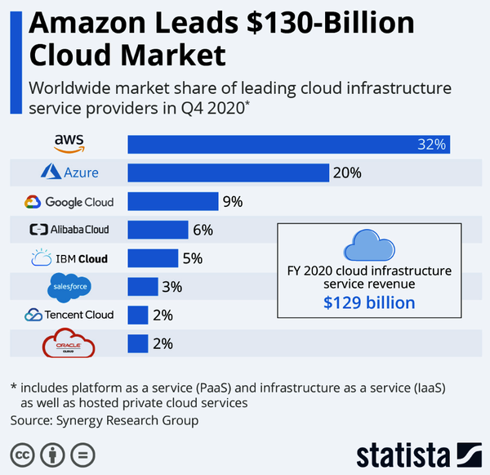

###### **Figure 9-1. GCP Cloud market share**

Finally, Google has a reputation for a poor user and customer experience and frequently abandons products like Google Hangouts and the Google Plus social network. Could it then discontinue Google Cloud if it remains the third-best option in the next five years?

While these are substantial challenges, and Google would be wise to address the cultural issues that led to these cons quickly, there are many unique advantages to the Google platform due to its culture. For example, while AWS and Microsoft are customer service-oriented cultures with a rich history of enterprise customer support, Google famously didn’t have phone support for most products. Instead, its culture focuses on intense “leet code” style interviews to only “hire the best.” Additionally, research and development of mind-numbingly complex solutions that work at “planet-scale” is something it does well. In particular, three of Google’s most successful open source projects show this cultural strength: Kubernetes, the Go language, and the deep learning framework TensorFlow.

Ultimately the number one advantage of using the Google Cloud may be that its technology is ideal for a multicloud strategy. Technologies like Kubernetes and Tensor Flow work well on any cloud and are widely adopted. As a result, using Google Cloud could be a hedge for large companies wanting to check the power of their vendor relationship with either AWS or Azure. Additionally, these technologies have wide adoption, so it is relatively straightforward to hire for positions that require expertise in TensorFlow.

Let’s take a look at Google Cloud’s core offerings. These services divide into four clean categories: Compute, Storage, Big Data, and Machine Learning, as shown in [Figure 9-2](https://learning.oreilly.com/library/view/practical-mlops/9781098103002/ch09.html#Figure-9-3_2).

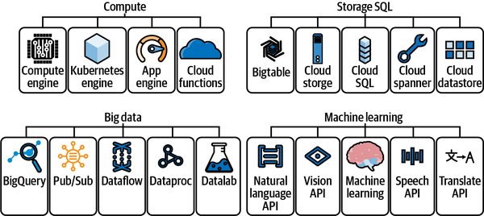

###### **Figure 9-2. GCP Cloud services**

Let’s define the major components of Google Cloud next, starting with Compute:

*Compute Engine*

Like other cloud vendors (notably AWS and Azure), GCP offers virtual machines as a service. Compute Engine is a service that enables you to create and run virtual machines on Google’s infrastructure. Perhaps the most critical takeaway is that there are many different virtual machines, including Compute Intensive, Memory Intensive, Accelerator Optimized, and General Purpose. Additionally, there are preemptible VMs, available for up to 24 hours, suited for batch jobs, and they can save up to 80% on storage costs.

As an MLOps practitioner, it is critical to use suitable types of machines for the task at hand. Costs do matter in the actual world, and the ability to accurately forecast costs could make or break a company doing machine learning. For example, with deep learning, it could be optimal to use Accelerator Optimized instances since they could leverage the additional massively parallel capabilities of NVIDIA GPUs. On the other hand, it would be incredibly wasteful to use these instances for machine learning training that cannot take advantage of GPUs. Similarly, by architecting around preemptible VMs for batch machine learning, an organization could save up to 80% of the cost.

*Kubernetes Engine and Cloud Run*

Since Google created Kubernetes and maintains it, the support for doing work on Kubernetes is excellent through its GKE (Google Kubernetes Engine). Alternatively, Cloud Run is a high-level service that abstracts away many of the complexities of running containers. Cloud Run is a good starting point for the Google Cloud Platform for organizations wanting a simple way to deploy containerized machine learning applications.

*App Engine*

Google App Engine is a fully managed PaaS. You can write code in many languages, including Node.js, Java, Ruby, C#, Go, Python, or PHP. MLOps workflows could use App Engine as the API endpoint of a fully automated continuous delivery pipeline using GCP Cloud Build to deploy changes.

*Cloud Functions*

Google Cloud Functions act as a FaaS (functions as a service). FaaS works well with an event-driven architecture. For example, Cloud Functions could trigger a batch machine learning training job or deliver an ML prediction in response to an event.

Next, let’s talk about storage on Google Cloud. Concerning MLOps, the main option to discuss is its Cloud Storage product. It offers unlimited storage, worldwide accessibility, low latency, geo-redundancy, and high durability. These facts mean that for MLOps workflows, the data lake is the location where unstructured and structured data resides for batch processing of machine learning training jobs.

Closely associated with this offering are the big data tools available from GCP. Many offerings assist in moving, querying, and computing big data. One of the most popular offerings is Google BigQuery because it offers a SQL interface, serverless paradigm, and the ability to do machine learning within the platform. Google BigQuery is a great place to start doing machine learning on GCP because you can solve the entire MLOps value chain from this one tool.

Finally, the machine learning and AI capabilities coordinate in a product called Vertex AI. One advantage of Google’s approach is that it aims to be an MLOps solution from the beginning. The workflow of Vertex AI allows a structured approach to ML, including the following:

* Dataset creation and storage
* Training an ML model
* Storing the model in Vertex AI
* Deploying the model to an endpoint for prediction
* Testing and creating prediction requests
* Using traffic splitting for endpoints
* Managing the lifecycle of ML models and endpoints

According to Google, these capabilities factor into how Vertex AI enables MLOps, as shown in [Figure 9-3](https://learning.oreilly.com/library/view/practical-mlops/9781098103002/ch09.html#Figure-9-3-1). At the center of these seven components is data and model management, the central element of MLOps.

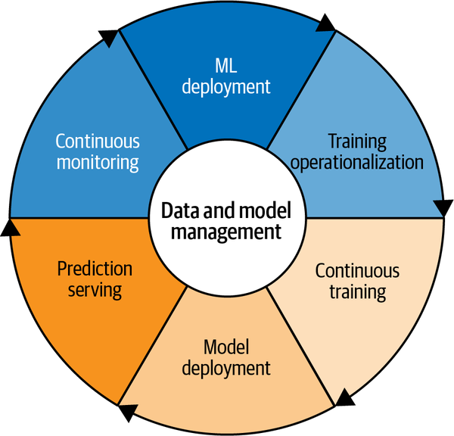

###### **Figure 9-3. Google’s seven components of MLOps**

This thought process culminates in Google’s idea of end-to-end MLOps, as described in [Figure 9-4](https://learning.oreilly.com/library/view/practical-mlops/9781098103002/ch09.html#Figure-9-3-2). A comprehensive platform like Vertex AI enables a comprehensive way to manage MLOps.

In a nutshell, MLOps on the Google Cloud Platform is straightforward due to Vertex AI and subcomponents of this system like Google BigQuery. Next, let’s get into more detail on CI/CD on GCP, a nonoptional foundational component of MLOps.

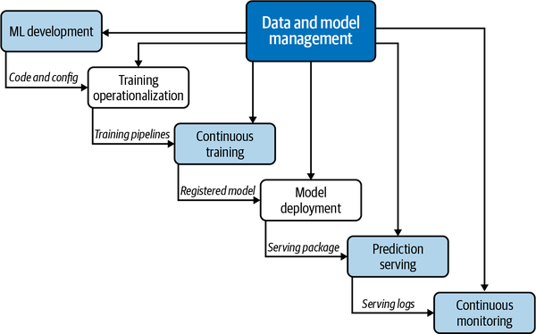

###### **Figure 9-4. End-to-end MLOps on GCP**

## Continuous Integration and Continuous Delivery

One of the most important and yet neglected areas of a project involves continuous integration. Testing is a fundamental component to doing both DevOps and MLOps. For GCP, there are two main continuous integration options: use a SaaS offering like GitHub Actions or use the cloud native solution [Cloud Build](https://oreil.ly/oTafJ). Let’s take a look at both options. You can view an entire starter project scaffold in this [gcp-from-zero GitHub repository](https://oreil.ly/34TQt).

First, let’s take a look at Google Cloud Build. Here is an example of the configuration file for Google Cloud Build, [cloudbuild.yaml](https://oreil.ly/wWbRS):

steps:

- name: python:3.7

id: INSTALL

entrypoint: python3

args:

- '-m'

- 'pip'

- 'install'

- '-t'

- '.'

- '-r'

- 'requirements.txt'

- name: python:3.7

entrypoint: ./pylint_runner

id: LINT

waitFor:

- INSTALL

- name: "gcr.io/cloud-builders/gcloud"

args: ["app", "deploy"]

timeout: "1600s"

images: ['gcr.io/$PROJECT_ID/pylint']

A recommended way to work with Google Cloud is to use the built-in editor alongside the terminal, as shown in [Figure 9-5](https://learning.oreilly.com/library/view/practical-mlops/9781098103002/ch09.html#Figure-9-2). Note that a Python virtual environment is activated.

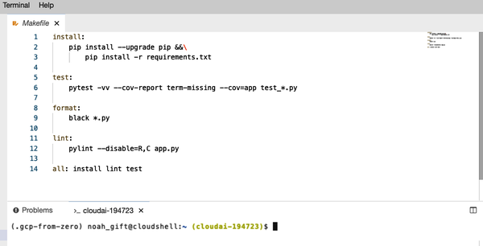

###### **Figure 9-5. GCP editor**

One takeaway is that Google Cloud Build is a bit clunky with testing and linting code compared to GitHub Actions, but it does make deploying services like Google App Engine easy.

Now let’s look at how GitHub Actions works. You can reference the python-publish.yml [configuration file](https://oreil.ly/mJd0T):

name: Python application test with GitHub Actions

on: [push]

jobs:

build:

runs-on: ubuntu-latest

steps:

- uses: actions/checkout@v2

- name: Set up Python 3.8

uses: actions/setup-python@v1

with:

python-version: 3.8

- name: Install dependencies

run: |

make install

- name: Lint with pylint

run: |

make lint

- name: Test with pytest

run: |

make test

- name: Format code

run: |

make format

A critical difference between the two approaches is that GitHub focuses on delivering an incredible developer experience, while GCP focuses on the cloud experience. One strategy is to use GitHub Actions for developer feedback, i.e., linting and testing code, and to use Google Cloud Build for deployment.

With a handle on CI/CD systems on GCP, let’s explore a core Google compute technology, Kubernetes.

## Kubernetes Hello World

One way of thinking about Kubernetes is as a “mini-cloud” or a “cloud-in-a-box.” Kubernetes allows for the creation of near-infinite application complexity. A few of the capabilities of Kubernetes that make it ideal for MLOps include:

* High-availability architecture
* Autoscaling
* Rich ecosystem
* Service discovery
* Container health management
* Secrets and configuration management
* Kubeflow (end-to-end ML platform for Kubernetes)

[Figure 9-6](https://learning.oreilly.com/library/view/practical-mlops/9781098103002/ch09.html#Figure-9-3-3) notes that ML frameworks from TensorFlow to scikit-learn coordinate on top of the core Kubernetes architecture. Finally, Kubernetes, as discussed earlier, can run in many clouds or in your own data center.

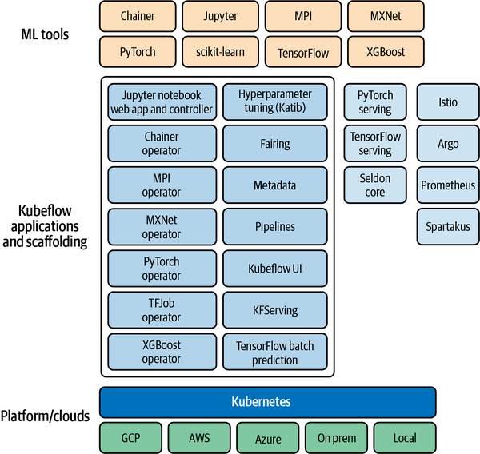

###### **Figure 9-6. Kubeflow architecture**

The foundation of the Kubernetes architecture in [Figure 9-7](https://learning.oreilly.com/library/view/practical-mlops/9781098103002/ch09.html#Figure-9-3-4) shows the core operations involved in Kubernetes include the following:

* Creating a Kubernetes cluster.
* Deploying an application into the cluster.
* Exposing application ports.
* Scaling an application.
* Updating an application.

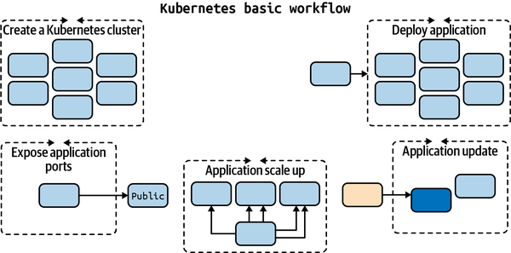

###### **Figure 9-7. Kubernetes basics**

The Kubernetes hierarchy in [Figure 9-8](https://learning.oreilly.com/library/view/practical-mlops/9781098103002/ch09.html#Figure-9-3-5) shows a Kubernetes control node that manages the other nodes containing one or more containers inside a pod.

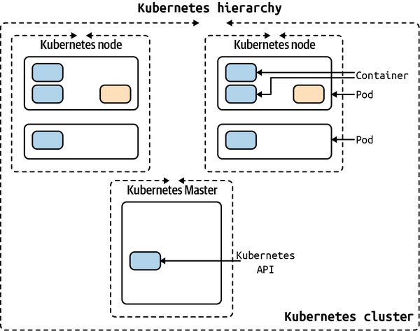

###### **Figure 9-8. Kubernetes hierarchy**

###### NOTE

There are two main methods: set up a local cluster (preferably with Docker Desktop) or provision a cloud cluster: Amazon through Amazon EKS, Google through Google Kubernetes Engine GKE, and Microsoft through Azure Kubernetes Service (AKS).

One of the “killer” features of Kubernetes is the ability to set up autoscaling via the Horizontal Pod Autoscaler (HPA). The Kubernetes HPA will automatically scale the number of pods (remember they can contain multiple containers) in a replication controller, deployment, or replica set. The scaling uses CPU utilization, memory, or custom metrics defined in the Kubernetes Metrics Server.

In [Figure 9-9](https://learning.oreilly.com/library/view/practical-mlops/9781098103002/ch09.html#Figure-9-3-6), Kubernetes is using a control loop to monitor metrics for the cluster and perform actions based on the metrics received.

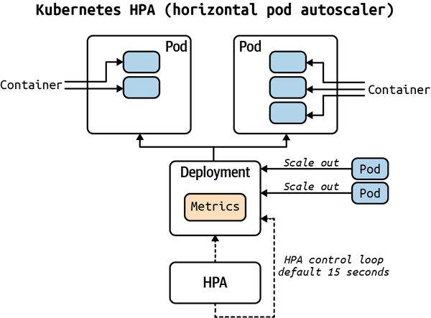

###### **Figure 9-9. Kubernetes autoscaler**

Since Kubernetes is a core strength of the Google Platform and how much of MLOps works on the platform, let’s dive right into a “hello world” Kubernetes example. This project uses [a simple Flask app that returns correct change](https://oreil.ly/sOcdS) as the base project and converts it to Kubernetes. You can find the [complete source in the repository on GitHub](https://oreil.ly/ISgrh).

In [Figure 9-10](https://learning.oreilly.com/library/view/practical-mlops/9781098103002/ch09.html#Figure-9-4) the Kubernetes nodes attach to the Load Balancer.

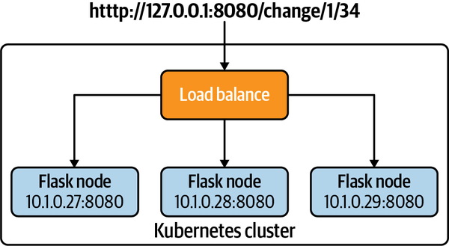

###### **Figure 9-10. Kubernetes hello world**

Let’s look at the assets in the repository.

* [Makefile](https://oreil.ly/HSX9G): Builds project
* [Dockerfile](https://oreil.ly/2Znkk): Container configuration
* [app.py](https://oreil.ly/G2Tjt): Flask app
* [kube-hello-change.yaml](https://oreil.ly/BCARa): Kubernetes YAML Config

To get started, do the following steps:

1. Create Python virtual environment:

python3 -m venv ~/.kube-hello && source ~/.kube-hello/bin/activate

1. Run make all to execute multiple build steps, including installing the libraries, linting the project, and running the tests.

##### MAKING USE OF CERTIFIED CONTAINERS

One of the Docker workflow advantages for developers is using certified containers from the “official” development teams. In this diagram, a developer uses the official Python base image developed by the core Python developers. This step works using the FROM statement, which loads in a previously created container image.

As the developer changes to the Dockerfile, they test locally and then push the changes to a private Docker Hub repo. For example, in [Figure 9-11](https://learning.oreilly.com/library/view/practical-mlops/9781098103002/ch09.html#Figure-9-4-1), the changes can become available by a deployment process to a cloud or another developer.

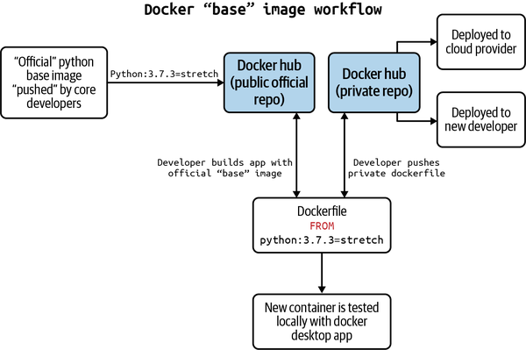

###### Figure 9-11. Docker developer workflow

Next, build and run a Docker Container:

1. Install [Docker Desktop](https://oreil.ly/oUB0E)
2. To build the image locally, do the following:

docker build -t flask-change:latest .

or run make build, which has the same command.

1. To verify container run docker image ls
2. To run the container do the following:

docker run -p 8080:8080 flask-change

or run make run, which has the same command.

1. In a separate terminal, invoke the web service via curl, or run make invoke which has the same command:

curl http://127.0.0.1:8080/change/1/34

Here’s the output:

$ kubectl get nodes

[

{

"5": "quarters"

},

{

"1": "nickels"

},

{

"4": "pennies"

}

]

1. Stop the running Docker container by using Ctrl+C command

Next, run Kubernetes locally:

1. Verify Kubernetes is working via docker-desktop context:
2. (.kube-hello) ➜ kubernetes-hello-world-python-flask git:(main) kubectl \
3. get nodes
4. NAME STATUS ROLES AGE VERSION

docker-desktop Ready master 30d v1.19.3

1. Run the application in Kubernetes using the following command, which tells Kubernetes to set up the load-balanced service and run it:

kubectl apply -f kube-hello-change.yaml

or run make run-kube, which has the same command.

You can see from the config file that a load balancer along with three nodes are the configured application:

apiVersion: v1

kind: Service

metadata:

name: hello-flask-change-service

spec:

selector:

app: hello-python

ports:

- protocol: "TCP"

port: 8080

targetPort: 8080

type: LoadBalancer

---

apiVersion: apps/v1

kind: Deployment

metadata:

name: hello-python

spec:

selector:

matchLabels:

app: hello-python

replicas: 3

template:

metadata:

labels:

app: hello-python

spec:

containers:

- name: flask-change

image: flask-change:latest

imagePullPolicy: Never

ports:

- containerPort: 8080

1. Verify the container is running:

kubectl get pods

Here is the output:

NAME READY STATUS RESTARTS AGE

flask-change-7b7d7f467b-26htf 1/1 Running 0 8s

flask-change-7b7d7f467b-fh6df 1/1 Running 0 7s

flask-change-7b7d7f467b-fpsxr 1/1 Running 0 6s

1. Describe the load balanced service:

kubectl describe services hello-python-service

You should see output similar to this:

Name: hello-python-service

Namespace: default

Labels: <none>

Annotations: <none>

Selector: app=hello-python

Type: LoadBalancer

IP Families: <none>

IP: 10.101.140.123

IPs: <none>

LoadBalancer Ingress: localhost

Port: <unset> 8080/TCP

TargetPort: 8080/TCP

NodePort: <unset> 30301/TCP

Endpoints: 10.1.0.27:8080,10.1.0.28:8080,10.1.0.29:8080

Session Affinity: None

External Traffic Policy: Cluster

Events: <none>

1. Invoke the endpoint to curl it:

make invoke

In the next section, run the command make invoke to query the microservice. The output of that action is shown here:

curl http://127.0.0.1:8080/change/1/34

[

{

"5": "quarters"

},

{

"1": "nickels"

},

{

"4": "pennies"

}

]

To clean up the deployment, run kubectl delete deployment hello-python.

The next step beyond this basic tutorial is to use either GKE (Google Kubernetes Engine), Google Cloud Run (container as a service), or Vertex AI to deploy a machine learning endpoint. You can use the [Python MLOps Cookbook repo](https://oreil.ly/EYAvj) as a base to do this. The Kubernetes technology is an excellent foundation for building ML-powered APIs, and with GCP, there are many options available if you use Docker format containers from the start.

With the basics of computing on GCP out of the way, let’s discuss how cloud native databases like Google BigQuery go a long way toward adopting MLOps.

## Cloud Native Database Choice and Design

One of the crown jewels of the Google Cloud Platform is Google BigQuery, for a few reasons. One of the reasons is how easy it is to get started, and another reason is the widespread publicly available databases. A good list of Google BigQuery open datasets is available [on this Reddit page](https://oreil.ly/2FdDK). Finally, from an MLOps perspective, one of the killer features of Google BigQuery is the ability to train and host ML models inside the Google BigQuery platform.

In looking at [Figure 9-12](https://learning.oreilly.com/library/view/practical-mlops/9781098103002/ch09.html#Figure-9-4-2), notice that Google BigQuery is the center of an MLOps pipeline that can export products to both business intelligence and machine learning engineering, including Vertex AI. This MLOps workflow is made possible because of the DataOps (Operationalization of Data) inputs such as public datasets, streaming API, and the Google Dataflow product. The fact that Google BigQuery performs machine learning inline streamlines the processing of big datasets.

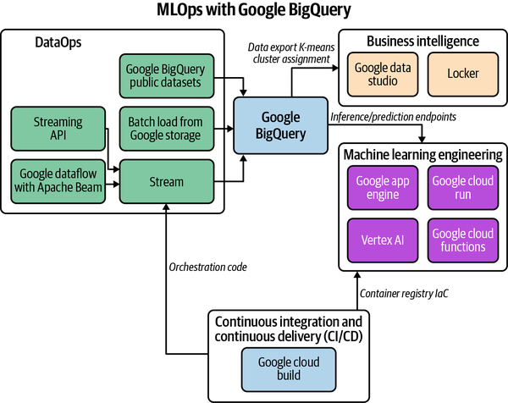

###### **Figure 9-12. Google BigQuery MLOps workflow**

An example of this workflow is shown in [Figure 9-13](https://learning.oreilly.com/library/view/practical-mlops/9781098103002/ch09.html#Figure-9-4-3), where after the ML modeling occurred in Google BigQuery, the results export to Google Data Studio. The artifact created from BigQuery is K-means clustering analysis [shown in this shareable report](https://oreil.ly/JcpbT).



###### **Figure 9-13. Google Data Studio K-means clustering**

As a starting point for doing MLOps on the GCP platform, BigQuery is an optimal choice due to the platform’s flexibility. Next, let’s talk about DataOps and Applied Data Engineering on the GCP platform.

# DataOps on GCP: Applied Data Engineering

Data is input necessary for building machine learning at scale, and as such, it is a critical aspect of MLOps. In one sense, the GCP has an almost unlimited amount of ways to automate data flow. This fact is due to the variety of computing and storage options available, including high-level tools like Dataflow.

For the sake of simplicity, let’s use a serverless approach to data engineering using Cloud Functions. To do this, let’s look at how Google Cloud Functions work and how they can serve double duty as both the ML solution via an AI API call or an MLOps pipeline using Cloud Functions talking to [Google Pub/Sub](https://oreil.ly/DKj58).

Let’s start with an intentionally simple Google Cloud Function that returns the correct change. You can find [the complete example here](https://oreil.ly/MFmyg).

To get started, open the Google Cloud Console, create a new Cloud Function, and paste the following code inside, as shown in [Figure 9-14](https://learning.oreilly.com/library/view/practical-mlops/9781098103002/ch09.html#Figure-9-5). You can also “untoggle” the “Require authentication” to “Allow unauthenticated invocations.”

import json

def hello_world(request):

request_json = request.get_json()

print(f"This is my payload: {request_json}")

if request_json and "amount" in request_json:

raw_amount = request_json["amount"]

print(f"This is my amount: {raw_amount}")

amount = float(raw_amount)

print(f"This is my float amount: {amount}")

res = []

coins = [1, 5, 10, 25]

coin_lookup = {25: "quarters", 10: "dimes", 5: "nickels", 1: "pennies"}

coin = coins.pop()

num, rem = divmod(int(amount * 100), coin)

res.append({num: coin_lookup[coin]})

while rem > 0:

coin = coins.pop()

num, rem = divmod(rem, coin)

if num:

if coin in coin_lookup:

res.append({num: coin_lookup[coin]})

result = f"This is the res: {res}"

return result

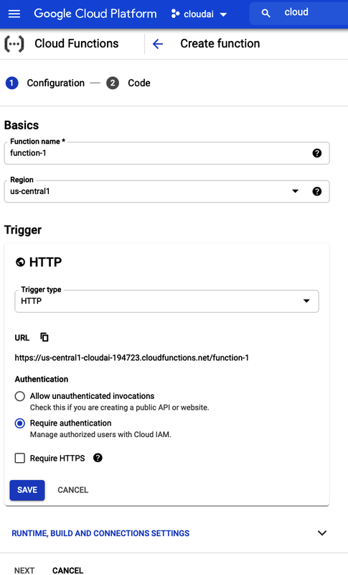

###### **Figure 9-14. Google Cloud Function**

To invoke via the gcloud command line do the following:

gcloud functions call changemachine --data '{"amount":"1.34"}'

To invoke via the curl command, you can use the following.

curl -d '{

"amount":"1.34"

}' -H "Content-Type: application/json" -X POST <trigger>/function-3

Another approach is to build a command line tool to invoke your endpoint:

#!/usr/bin/env python

import click

import requests

@click.group()

@click.version_option("1.0")

def cli():

"""Invoker"""

@cli.command("http")

@click.option("--amount", default=1.34, help="Change to Make")

@click.option(

"--host",

default="https://us-central1-cloudai-194723.cloudfunctions.net/change722",

help="Host to invoke",

)

def mkrequest(amount, host):

"""Asks a web service to make change"""

click.echo(

click.style(

f"Querying host {host} with amount: {amount}", bg="green", fg="white"

)

)

payload = {"amount": amount}

result = requests.post(url=host, json=payload)

click.echo(click.style(f"result: {result.text}", bg="red", fg="white"))

if __name__ == "__main__":

cli()

Finally, one more approach is to either upload your ML model to Vertex AI or call an existing API endpoint that performs computer vision, NLP, or another ML-related task. You can [find the complete example on GitHub](https://oreil.ly/P7JsE). In the following example, let’s use a preexisting NLP API. You will also need to add two third-party libraries by editing the requirements.txt file included in the Google Cloud scaffolding (see [Figure 9-15](https://learning.oreilly.com/library/view/practical-mlops/9781098103002/ch09.html#Figure-9-6)).

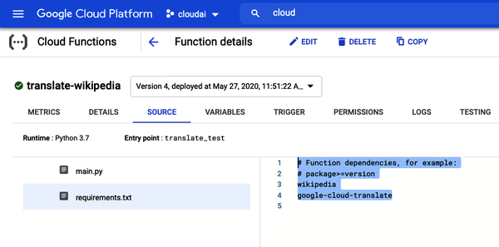

###### **Figure 9-15. Add requirements**

Paste this code into the main.py function in the Google Cloud Shell Console:

import wikipedia

from google.cloud import translate

def sample_translate_text(

text="YOUR_TEXT_TO_TRANSLATE", project_id="YOUR_PROJECT_ID", language="fr"

):

"""Translating Text."""

client = translate.TranslationServiceClient()

parent = client.location_path(project_id, "global")

# Detail on supported types can be found here:

# https://cloud.google.com/translate/docs/supported-formats

response = client.translate_text(

parent=parent,

contents=[text],

mime_type="text/plain", # mime types: text/plain, text/html

source_language_code="en-US",

target_language_code=language,

)

print(f"You passed in this language {language}")

# Display the translation for each input text provided

for translation in response.translations:

print("Translated text: {}".format(translation.translated_text))

return "Translated text: {}".format(translation.translated_text)

def translate_test(request):

"""Takes JSON Payload {"entity": "google"}"""

request_json = request.get_json()

print(f"This is my payload: {request_json}")

if request_json and "entity" in request_json:

entity = request_json["entity"]

language = request_json["language"]

sentences = request_json["sentences"]

print(entity)

res = wikipedia.summary(entity, sentences=sentences)

trans = sample_translate_text(

text=res, project_id="cloudai-194723", language=language

)

return trans

else:

return f"No Payload"

To invoke the function, you can call it from the Google Cloud Shell:

gcloud functions call translate-wikipedia --data\

'{"entity":"facebook", "sentences": "20", "language":"ru"}'

You can see the output of the Russian translation in the Google Cloud Shell terminal in [Figure 9-16](https://learning.oreilly.com/library/view/practical-mlops/9781098103002/ch09.html#Figure-9-7).

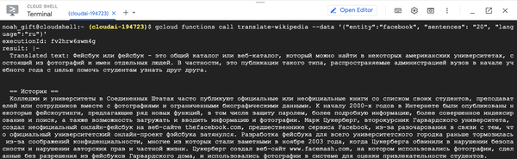

###### **Figure 9-16. Translate**

For prototyping data engineering workflows, there is no quicker method than serverless technology like Google Cloud Functions. My recommendation is to solve an initial data engineering workflow using serverless technology and move to more complex tools if necessary.

An important note is that the Vertex AI platform adds many additional data engineering and ML engineering components that enhance larger projects. In particular, the ability to use Explainable AI, track the quality of a model, and use a Feature Store are valuable components of a comprehensive MLOps solution. Let’s dive into these options next.

# Operationalizing ML Models

Every major cloud platform nows has an MLOps platform. On GCP, the platform is Vertex AI and integrates many individual services it has developed over the years, including AutoML technology. In particular, some of the essential components of MLOps platforms include Feature Stores, Explainable AI, and tracking model quality. If starting an MLOps project at a larger company, the first place to start on GCP would be its Vertex AI platform, just like SageMaker on AWS or Azure ML Studio on Azure.

Another option is to use components as standalone solutions to operationalize ML models on the GCP platform. One service to use is the [prediction service](https://oreil.ly/7cWEV) to deploy models and then accept requests.

For example, you could test a local sklearn model using a command similar to the following:

gcloud ai-platform local predict --model-dir\

LOCAL_OR_CLOUD_STORAGE_PATH_TO_MODEL_DIRECTORY/ \

--json-instances LOCAL_PATH_TO_PREDICTION_INPUT.JSON \

--framework NAME_OF_FRAMEWORK

Later, you could create an endpoint and then call this endpoint from an example shown earlier in the chapter, say Google Cloud Functions, Google Cloud Run, or Google App Engine.

Let’s walk through an example of how a Google App Engine project looks on the GCP cloud using [this repo as a starting point](https://oreil.ly/2vC8t). To start with, notice the core architecture of continuous delivery on GCP. To get started, create a new Google App Engine project as shown in the “light” MLOps workflow in [Figure 9-17](https://learning.oreilly.com/library/view/practical-mlops/9781098103002/ch09.html#Figure-9-8).

###### NOTE

Notice that this lightweight workflow allows for a transparent and straightforward way to deploy an ML model, but a “heavy” flow could add tremendous value if the features shown, like Explainable AI, are required for a project.

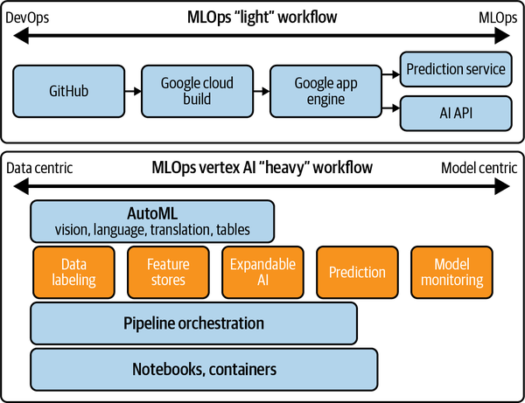

###### **Figure 9-17. MLOps light versus heavy workflows**

Next, enable the Cloud Build API as shown in [Figure 9-18](https://learning.oreilly.com/library/view/practical-mlops/9781098103002/ch09.html#Figure-9-9).

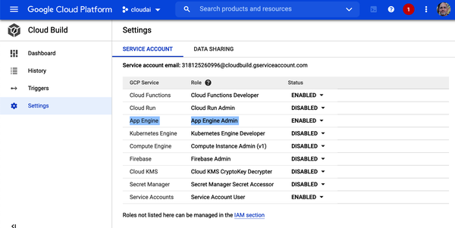

###### **Figure 9-18. Cloud build**

The cloudbuild.yml file needs only a deploy command:

steps:

- name: "gcr.io/cloud-builders/gcloud"

args: ["app", "deploy"]

timeout: "1600s"

The only other requirements are app.yaml, requirements.txt, and main.py, all found in this [example repository](https://oreil.ly/YAy6c). A final step to make this application do any form of machine learning is to call an ML/AI API or use the AI Platform endpoint hosting.

The advantage of the simple approach is that it is easy to set up an entire MLOps pipeline in an hour or two at most. You could also pick and choose from AI APIs, prediction services, and an AutoML endpoint.

There are both “light” and “heavy” approaches to doing MLOps on GCP. This example explored the “light” approach, but there is merit to using the platform technology Vertex AI since it includes advanced features many enterprises desire.

Let’s wrap up the chapter and discuss the next steps for using the GCP for MLOps.

# Conclusion

One final takeaway on MLOps technologies like Vertex AI is they solve a complicated problem better than most organizations can do themselves. I remember talking to someone at a research lab, and they bragged about how the cloud was overrated since they had a ton of GPUs. A ton of GPUs doesn’t give you platform services like these platforms. This statement is a fundamental misunderstanding of how enterprise software and startups work. Comparative advantage is critical for both early-stage startups and Fortune 500 companies. Don’t build something worse than what you can buy for a trivial cost.

I recommend taking everything from this chapter and applying it to a final machine learning project that consists of building a cloud native ML application on the GCP. This project should give you the ability to create realistic, working solutions designed with modern techniques.

Before you begin, make sure you read the Sculley et al. (2015) paper to consider [technical debt in machine-learning (ML) systems](https://oreil.ly/d8jrl). Your project may benefit from using public data from Google BigQuery datasets. Alternately, if using AutoML, data can be tutorial data or custom data.

The main idea is to create a portfolio project demonstrating your ability to do ML engineering on the Google Cloud. Here are the suggested project requirements to think through:

* Source code stored in GitHub
* Continuous deployment from CircleCI
* Data stored in GCP (BigQuery, Google Cloud Storage, etc.)
* ML predictions created and served out (AutoML, BigQuery, AI Platform, etc.)
* Cloud native monitoring
* Google App Engine serves out HTTP requests via REST API with a JSON payload
* Deployed into GCP environment using Google Cloud Build

Here are some items to add to a final project requirements checklist:

* Does the application make ML inference?
* Are there separate environments?
* Is there comprehensive monitoring and alerts?
* Is the correct datastore used?
* Does the principle of least security apply?
* Is data encrypted in transit?

You can see some recent student and top data science projects in the [official code repository](https://oreil.ly/hJkDx). These projects provide a frame of reference for what you can build, and you are welcome to submit a pull request in the future to get your project added.

* [Jason Adams: FastAPI Sentiment Analysis with Kubernetes](https://oreil.ly/5Omf3)
* [James Salafatinos: Tensorflow.js real-time image classification](https://oreil.ly/rs4QQ)
* [Nikhil Bhargava: Sneaker Price Predict](https://oreil.ly/MjU7H)
* [Covid Predictor](https://oreil.ly/Wm8UF)
* [Absenteeism at Work](https://oreil.ly/Rrh6S)

The next chapter discusses machine learning interoperability and how it uniquely solves MLOps problems that crop up from different platforms, technologies, and model formats.

# Exercises

* Using Google Cloud Shell Editor, create a new GitHub repository with necessary Python scaffolding using a Makefile, linting, and testing. Add steps such as code formatting in your Makefile.
* Create a “hello world” pipeline to Google Cloud that calls into a Python-based Google App Engine (GAE) project and returns “hello world” as a JavaScript Object Notation (JSON) response.
* Create an ingest to ETL pipeline using CSV files and Google BigQuery. Schedule a reoccurring cron job to batch update the data.
* Train a multiclass classification model on Google AutoML vision and deploy to an edge device.
* Create a production and development environment and deploy a project to both environments using Google Cloud Build.

# Critical Thinking Discussion Questions

* What problems does a CI system solve, and why is a CI system an essential part of SaaS software?
* Why are cloud platforms the ideal target for analytics applications, and how does deep learning benefit from the cloud?
* What are the advantages of managed services like Google BigQuery, and how does Google BigQuery differ from a traditional SQL?
* How does ML prediction directly from BigQuery add value to the Google platform, and what advantages could this have for analytics application engineering?
* How does AutoML have a lower total cost of ownership (TCO), and how could it have a higher TCO?

Semi-supervised algorithms in action

We've discussed what semi-supervised learning is, why we want to engage in it, and what some of the general realities of employing semi-supervised algorithms are. We've gone about as far as we can with general descriptions. Over the next few pages, we'll move from this general understanding to develop an ability to use a semi-supervised application effectively.

**Self-training**

Self-training is the simplest semi-supervised learning method and can also be the fastest. Self-training algorithms see an application in multiple contexts, including NLP and computer vision; as we'll see, they can present both substantial value and significant risks.

The objective of self-training is to combine information from unlabeled cases with that of labeled cases to iteratively identify labels for the dataset's unlabeled examples. On each iteration, the labeled training set is enlarged until the entire dataset is labeled.

The self-training algorithm is typically applied as a wrapper to a base model. In this chapter, we'll be using an SVM as the base for our self-training model. The self-training algorithm is quite simple and contains very few steps, as follows:

1. A set of labeled data is used to predict labels for a set of unlabeled data. (This may be all unlabeled data or part of it.)
2. Confidence is calculated for all newly labeled cases.
3. Cases are selected from the newly labeled data to be kept for the next iteration.
4. The model trains on all labeled cases, including cases selected in previous iterations.
5. The model iterates through steps 1 to 4 until it successfully converges.

Presented graphically, this process looks as follows:

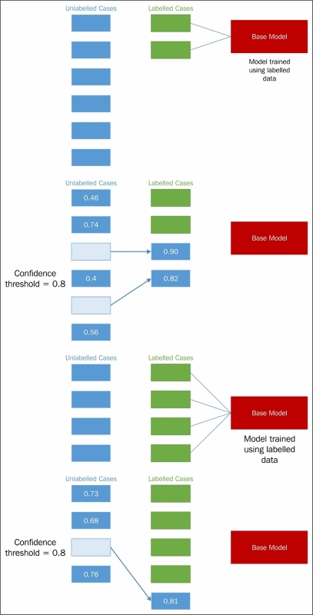

Upon completing training, the self-trained model would be tested and validated. This may be done via cross-validation or even using held-out, labeled data, should this exist.

Self-training provides real power and time saving, but is also a risky process. In order to understand what to look out for and how to apply self-training to your own classification algorithms, let's look in more detail at how the algorithm works.

To support this discussion, we're going to work with code from the semisup-learn GitHub repository. In order to use this code, we'll need to clone the relevant GitHub repository. Instructions for this are located in [Appendix A](https://learning.oreilly.com/library/view/advanced-machine-learning/9781784398637/apa.html).

**Implementing self-training**

The first step in each iteration of self-training is one in which class labels are generated for unlabeled cases. This is achieved by first creating a SelfLearningModel class, which takes a base supervised model (basemodel) and an iteration limit as arguments. As we'll see later in this chapter, an iteration limit can be explicitly specified or provided as a function of classification accuracy (that is, convergence). The prob_threshold parameter provides a minimum quality bar for label acceptance; any projected label that scores at less than this level will be rejected. Again, we'll see in later examples that there are alternatives to providing a hardcoded threshold value.

class SelfLearningModel(BaseEstimator):

def __init__(self, basemodel, max_iter = 200, prob_threshold = 0.8):

self.model = basemodel

self.max_iter = max_iter

self.prob_threshold = prob_threshold

Having defined the shell of the SelfLearningModel class, the next step is to define functions for the process of semi-supervised model fitting:

def fit(self, X, y):

unlabeledX = X[y==-1, :]

labeledX = X[y!=-1, :]

labeledy = y[y!=-1]

self.model.fit(labeledX, labeledy)

unlabeledy = self.predict(unlabeledX)

unlabeledprob = self.predict_proba(unlabeledX)

unlabeledy_old = []

i = 0

The X parameter is a matrix of input data, whose shape is equivalent to [n_samples, n_features]. X is used to create a matrix of [n_samples, n_samples] size. The y parameter, meanwhile, is an array of labels. Unlabeled points are marked as -1 in y. From X, the unlabeledX and labeledX parameters are created quite simply by operations over X that select elements in X whose position corresponds to a -1 label in y. The labeledy parameter performs a similar selection over y. (Naturally, we're not that interested in the unlabeled samples of y as a variable, but we need the labels that do exist for classification attempts!)

The actual process of label prediction is achieved, first, using sklearn's predict operation. The unlabeledy parameter is generated using sklearn's predict method, while the predict_proba method is used to calculate probabilities for each projected label. These probabilities are stored in unlabeledprob.

**NOTE**

Scikit-learn's predict and predict_proba methods work to predict class labels and the probability of class labeling being correct, respectively. As we'll be applying both of these methods within several of our semi-supervised algorithms, it's informative to understand how they actually work.

The predict method produces class predictions for input data. It does so via a set of binary classifiers (that is, classifiers that attempt to differentiate only two classes). A full model with n-many classes contains a set of binary classifiers as follows:

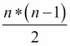

In order to make a prediction for a given case, all classifiers whose scores exceed zero, vote for a class label to apply to that case. The class with the most votes (and not, say, the highest sum classifier score) is identified. This is referred to as a one-versus-one prediction method and is a fairly common approach.

Meanwhile, predict_proba works by invoking **Platt calibration**, a technique that allows the outputs of a classification model to be transformed into a probability distribution over the classes. This involves first training the base model in question, fitting a regression model to the classifier's scores:

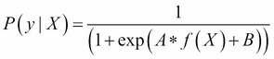

This model can then be optimized (through scalar parameters *A* and *B*) using a maximum likelihood method. In the case of our self-training model, predict_proba allows us to fit a regression model to the classifier's scores and thus calculate probabilities for each class label. This is extremely helpful!

Next, we need a loop for iteration. The following code describes a while loop that executes until there are no cases left in unlabeledy_old (a copy of unlabeledy) or until the max iteration count is reached. On each iteration, a labeling attempt is made for each case that does not have a label whose probability exceeds the probability threshold (prob_threshold):

while (len(unlabeledy_old) == 0 or

numpy.any(unlabeledy!=unlabeledy_old)) and i < self.max_iter:

unlabeledy_old = numpy.copy(unlabeledy)

uidx = numpy.where((unlabeledprob[:, 0] > self.prob_threshold)

| (unlabeledprob[:, 1] > self.prob_threshold))[0]

The self.model.fit method then attempts to fit a model to the unlabeled data. This unlabeled data is presented in a matrix of size [n_samples, n_samples] (as referred to earlier in this chapter). This matrix is created by appending (with vstack and hstack) the unlabeled cases:

self.model.fit(numpy.vstack((labeledX, unlabeledX[uidx, :])),

numpy.hstack((labeledy, unlabeledy_old[uidx])))

Finally, the iteration performs label predictions, followed by probability predictions for those labels.

unlabeledy = self.predict(unlabeledX)

unlabeledprob = self.predict_proba(unlabeledX)

i += 1

On the next iteration, the model will perform the same process, this time taking the newly labeled data whose probability predictions exceeded the threshold as part of the dataset used in the model.fit step.

If one's model does not already include a classification method that can generate label predictions (like the predict_proba method available in sklearn's SVM implementation), it is possible to introduce one. The following code checks for the predict_proba method and introduces Platt scaling of generated labels if this method is not found:

if not getattr(self.model, "predict_proba", None):

self.plattlr = LR()

preds = self.model.predict(labeledX)

self.plattlr.fit( preds.reshape( -1, 1 ), labeledy )

return self

def predict_proba(self, X):

if getattr(self.model, "predict_proba", None):

return self.model.predict_proba(X)

else:

preds = self.model.predict(X)

return self.plattlr.predict_proba(preds.reshape( -1, 1 ))

Once we have this much in place, we can begin applying our self-training architecture. To do so, let's grab a dataset and start working!

For this example, we'll use a simple linear regression classifier, with **Stochastic Gradient Descent** (**SGD**) as our learning component as our base model (basemodel). The input dataset will be the statlog heart dataset, obtained from [www.mldata.org](http://www.mldata.org/). This dataset is provided in the GitHub repository accompanying this chapter.

The heart dataset is a two-class dataset, where the classes are the absence or presence of a heart disease. There are no missing values across the 270 cases for any of its 13 features. This data is unlabeled and many of the variables needed are usually captured via expensive and sometimes inconvenient tests. The variables are as follows:

* age
* sex
* chest pain type (4 values)
* resting blood pressure
* serum cholestoral in mg/dl
* fasting blood sugar > 120 mg/dl
* resting electrocardiographic results (values 0,1,2)
* maximum heart rate achieved
* exercise induced angina
* 10. oldpeak = ST depression induced by exercise relative to rest
* the slope of the peak exercise ST segment
* number of major vessels (0-3) colored by flourosopy
* thal: 3 = normal; 6 = fixed defect; 7 = reversable defect

Lets get started with the Heart dataset by loading in the data, then fitting a model to it:

heart = fetch_mldata("heart")

X = heart.data

ytrue = np.copy(heart.target)

ytrue[ytrue==-1]=0

labeled_N = 2

ys = np.array([-1]*len(ytrue)) # -1 denotes unlabeled point

random_labeled_points = random.sample(np.where(ytrue == 0)[0], labeled_N/2)+\random.sample(np.where(ytrue == 1)[0], labeled_N/2)

ys[random_labeled_points] = ytrue[random_labeled_points]

basemodel = SGDClassifier(loss='log', penalty='l1')

basemodel.fit(X[random_labeled_points, :], ys[random_labeled_points])

print "supervised log.reg. score", basemodel.score(X, ytrue)

ssmodel = SelfLearningModel(basemodel)

ssmodel.fit(X, ys)

print "self-learning log.reg. score", ssmodel.score(X, ytrue)

Attempting this yields moderate, but not excellent, results:

**self-learning log.reg. score 0.470347**

However, over 1,000 trials, we find that the quality of our outputs is quite variant:

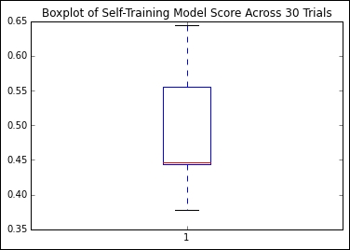

Given that we're looking at classification accuracy scores for sets of real-world and unlabeled data, this isn't a terrible result, but I don't think we should be satisfied with it. We're still labeling more than half of our cases incorrectly!

We need to understand the problem a little better; right now, it isn't clear what's going wrong or how we can improve on our results. Let's figure this out by returning to the theory around self-training to understand how we can diagnose and improve our implementation.

**Finessing your self-training implementation**

In the previous section, we discussed the creation of self-training algorithms and tried out an implementation. However, what we saw during our first trial was that our results, while demonstrating the potential of self-training, left room for growth. Both the accuracy and variance of our results were questionable.

Self-training can be a fragile process. If an element of the algorithm is ill-configured or the input data contains peculiarities, it is very likely that the iterative process will fail once and continue to compound that error by reintroducing incorrectly labeled data to future labeling steps. As the self-training algorithm iteratively feeds itself, garbage in, garbage out is a very real concern.

There are several quite common flavors of risk that should be called out. In some cases, labeled data may not add more useful information. This is particularly common in the first few iterations, and understandably so! In general, unlabeled cases that are most easily labeled are the ones that are most similar to existing labeled cases. However, while it's easy to generate high-probability labels for these cases, there's no guarantee that their addition to the labeled set will make it easier to label during subsequent iterations.

Unfortunately, this can sometimes lead to a situation in which cases are being added that have no real effect on classification while classification accuracy in general deteriorates. Even worse, adding cases that are similar to pre-existing cases in enough respects to make them easy to label, but that actually misguide the classifier's decision boundary, can introduce misclassification increases.

Diagnosing what went wrong with a self-training model can sometimes be difficult, but as always, a few well-chosen plots add a lot of clarity to the situation. As this type of error occurs particularly often within the first few iterations, simply adding an element to the label prediction loop that writes the current classification accuracy allows us to understand how accuracy trended during early iterations.

Once the issue has been identified, there are a few possible solutions. If enough labeled data exists, a simple solution is to attempt to use a more diverse set of labeled data to kick-start the process.

While the impulse might be to use all of the labeled data, we'll see later in this chapter that self-training models are vulnerable to overfitting—a risk that forces us to hold on to some data for validation purposes. A promising option is to use multiple subsets of our dataset to train multiple self-training model instances. Doing so, particularly over several trials, can help us understand the impact of our input data on our self-training models performance.

In [Chapter 8](https://learning.oreilly.com/library/view/advanced-machine-learning/9781784398637/ch08.html), *Ensemble Methods*, we'll explore some options around ensembles that will enable us to use multiple self-training models together to yield predictions. When ensembling is accessible to us, we can even consider applying multiple sampling techniques in parallel.

If we don't want to solve this problem with quantity, though, perhaps we can solve it by improving quality. One solution is to create an appropriately diverse subset of the labeled data through selection. There isn't a hard limit on the number of labeled cases that works well as a minimum amount to start up a self-training implementation. While you could hypothetically start working with even one labeled case per class (as we did in our preceding training example), it'll quickly become obvious that training against a more diverse and overlapping set of classes benefits from more labeled data.

Another class of error that a self-training model is particularly vulnerable to is biased selection. Our naïve assumption is that the selection of data during each iteration is, at worst, only slightly biased (favoring one class only slightly more than others). The reality is that this is not a safe assumption. There are several factors that can influence the likelihood of biased selection, with the most likely culprit being disproportionate sampling from one class.

If the dataset as a whole, or the labeled subsets used, are biased toward one class, then the risk increases that your self-training classifier will overfit. This only compounds the problem as the cases provided for the next iteration are liable to be insufficiently diverse to solve the problem; whatever incorrect decision boundary was set up by the self-training algorithm will be set where it is—overfit to a subset of the data. Numerical disparity between each class' count of cases is the main symptom here, but the more usual methods to spot overfitting can also be helpful in diagnosing problems around selection bias.

**NOTE**

This reference to the usual methods of spotting overfitting is worth expanding on because techniques to identify overfitting are highly valuable! These techniques are typically referred to as validation techniques. The fundamental concept underpinning validation techniques is that one has two sets of data—one that is used to build a model, and the other is used to test it.

The most effective validation technique is independent validation, the simplest form of which involves waiting to determine whether predictions are accurate. This obviously isn't always (or even, often) possible!

Given that it may not be possible to perform independent validation, the best bet is to hold out a subset of your sample. This is referred to as sample splitting and is the foundation of modern validation techniques. Most machine learning implementations refer to training, test, and validation datasets; this is a case of multilayered validation in action.

A third and critical validation tool is resampling, where subsets of the data are iteratively used to repeatedly validate the dataset. In [Chapter 1](https://learning.oreilly.com/library/view/advanced-machine-learning/9781784398637/ch01.html), *Unsupervised Machine Learning*, we saw the use of v-fold cross-validation; cross-validation techniques are perhaps the best examples of resampling in action.

Beyond applicable techniques, it's a good idea to be mindful of the needed sample size required for the effective modeling of your data. There are no universal principles here, but I always rather liked the following rule of thumb:

If *m* points are required to determine a univariate regression line with sufficient precision, then it will take at least *mn* observations and perhaps *n!mn* observations to appropriately characterize and evaluate a regression model with *n* variables.

Note that there is some tension between the suggested solutions to this problem (resampling, sample splitting, and validation techniques including cross-validation) and the preceding one. Namely, overfitting requires a more restrained use of subsets of the labeled training data, while bad starts are less likely to occur using more training data. For each specific problem, depending on the complexity of the data under analysis, there will be an appropriate balance to strike. By monitoring for signs of either type of problem, the appropriate action (whether that is an increase or decrease in the amount of labeled data used simultaneously in an iteration) can be taken at the right time.

A further class of risk introduced by self-training is that the introduction of unlabeled data almost always introduces noise. If dealing with datasets where part or all of the unlabeled cases are highly noisy, the amount of noise introduced may be sufficient to degrade classification accuracy.

**NOTE**

The idea of using data complexity and noise measures to understand the degree of noise in one's dataset is not new. Fortunately for us, quite a lot of good estimators already exist that we can take advantage of.

There are two main groups of relative complexity measures. Some attempt to measure the overlap of values of different classes, or separability; measures in this group attempt to describe the degree of ambiguity of each class relative to the other classes. One good measure for such cases is the maximum **Fisher's discriminant ratio**, though maximum individual feature efficiency is also effective.

Alternatively (and sometimes more simply), one can use the error function of a linear classifier to understand how separable the dataset's classes are from one another. By attempting to train a simple linear classifier on your dataset and observing the training error, one can immediately get a good understanding as to how linearly separable the classes are. Furthermore, measures related to this classifier (such as the fraction of points in the class boundary or the ratio of average intra/inter class nearest neighbor distance) can also be extremely helpful.

There are other data complexity measures that specifically measure the density or geometry of the dataset. One good example is the fraction of maximum covering spheres. Again, helpful measures can be accessed by applying a linear classifier and including the nonlinearity of that classifier.

**Improving the selection process**

The key to the self-training algorithm working correctly is the accurate calculation of confidence for each label projection. Confidence calculation is the key to successful self-training.

During our first explanation of self-training, we used some simplistic values for certain parameters, including a parameter closely tied to confidence calculation. In selecting our labeled cases, we used a fixed confidence level for comparison against predicted probabilities, where we could've adopted any one of several different strategies:

* Adding all of the projected labels to the set of labeled data
* Using a confidence threshold to select only the few most confident labels to the set
* Adding all the projected labels to the labeled dataset and weighing each label by confidence

All in all, we've seen that self-training implementations present quite a lot of risk. They're prone to a number of training failures and are also subject to overfitting. To make matters worse, as the amount of unlabeled data increases, the accuracy of a self-training classifier becomes increasingly at risk.

Our next step will be to look at a very different self-training implementation. While conceptually similar to the algorithm that we worked with earlier in this chapter, the next technique we'll be looking at operates under different assumptions to yield very different results.

**Contrastive Pessimistic Likelihood Estimation**

In our preceding discovery and application of self-training techniques, we found self-training to be a powerful technique with significant risks. Particularly, we found a need for multiple diagnostic tools and some quite restrictive dataset conditions. While we can work around these problems by subsetting, identifying optimal labeled data, and attentively tracking performance for some datasets, some of these actions continue to be impossible for the very data that self-training would bring the most benefit to—data where labeling requires expensive tests, be those medical or scientific, with specialist knowledge and equipment.

In some cases, we end up with some self-training classifiers that are outperformed by their supervised counterparts, which is a pretty terrible state of affairs. Even worse, while a supervised classifier with labeled data will tend to improve in accuracy with additional cases, semi-supervised classifier performance can degrade as the dataset size increases. What we need, then, is a less naïve approach to semi-supervised learning. Our goal should be to find an approach that harnesses the benefits of semi-supervised learning while maintaining performance at least comparable with that of the same classifier under a supervised approach.

A very recent (May 2015) approach to self-supervised learning, CPLE, provides a more general way to perform semi-supervised parameter estimation. CPLE provides a rather remarkable advantage: it produces label predictions that have been demonstrated to consistently outperform those created by equivalent semi-supervised classifiers or by supervised classifiers working from the labeled data! In other words, when performing a linear discriminant analysis, for instance, it is advised that you perform a CPLE-based, semi-supervised analysis instead of a supervised one, as you will always obtain at least equivalent performance.

This is a pretty big claim and it needs substantiating. Let's start by building an understanding of how CPLE works before moving on to demonstrate its superior performance in real cases.

CPLE uses the familiar measure of maximized log-likelihood for parameter optimization. This can be thought of as the success condition; the model we'll develop is intended to optimize the maximized log-likelihood of our model's parameters. It is the specific guarantees and assumptions that CPLE incorporates that make the technique effective.

In order to create a better semi-supervised learner—one that improves on it's supervised alternative—CPLE takes the supervised estimates into account explicitly, using the loss incurred between the semi-supervised and supervised models as a training performance measure:

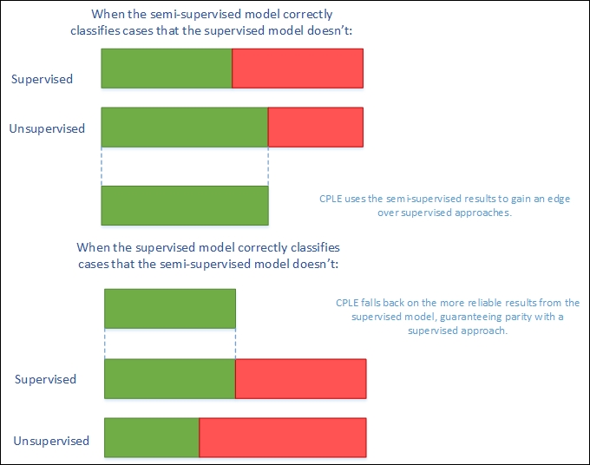

CPLE calculates the relative improvement of any semi-supervised estimate over the supervised solution. Where the supervised solution outperforms the semi-supervised estimate, the loss function shows this and the model can train to adjust the semi-supervised model to reduce this loss. Where the semi-supervised solution outperforms the supervised solution, the model can learn from the semi-supervised model by adjusting model parameters.

However, while this sounds excellent so far, there is a flaw in the theory that has to be addressed. The fact that data labels don't exist for a semi-supervised solution means that the posterior distribution (that CPLE would use to calculate loss) is inaccessible. CPLE's solution to this is to be pessimistic. The CPLE algorithm takes the **Cartesian product** of all label/prediction combinations and then selects the posterior distribution that minimizes the gain in likelihood.

In real-world machine learning contexts, this is a very safe approach. It delivers the classification accuracy of a supervised approach with semi-supervised performance improvement derived via conservative assumptions. In real applications, these conservative assumptions enable high performance under testing. Even better, CPLE can deliver particular performance improvements on some of the most challenging unsupervised learning cases, where the labeled data is a poor representation of the unlabeled data (by virtue of poor sampling from one or more classes or just because of a shortage of unlabeled cases).

In order to understand how much more effective CPLE can be than semi-supervised or supervised approaches, let's apply the technique to a practical problem. We'll once again work with the semisup-learn library, a specialist Python library, focused on semi-supervised learning, which extends scikit-learn to provide CPLE across any scikit-learn-provided classifier. We begin with a CPLE class:

class CPLELearningModel(BaseEstimator):

def __init__(self, basemodel, pessimistic=True, predict_from_probabilities = False, use_sample_weighting = True, max_iter=3000, verbose = 1):

self.model = basemodel

self.pessimistic = pessimistic

self.predict_from_probabilities = predict_from_probabilities

self.use_sample_weighting = use_sample_weighting

self.max_iter = max_iter

self.verbose = verbose

We're already familiar with the concept of basemodel. Earlier in this chapter, we employed S3VMs and semi-supervised LDE's. In this situation, we'll again use an LDE; the goal of this first assay will be to try and exceed the results obtained by the semi-supervised LDE from earlier in this chapter. In fact, we're going to blow those results out of the water!

Before we do so, however, let's review the other parameter options. The pessimistic argument gives us an opportunity to use a non-pessimistic (optimistic) model. Instead of following the pessimistic method of minimizing the loss between unlabeled and labeled discriminative likelihood, an optimistic model aims to maximize likelihood. This can yield better results (mostly during training), but is significantly more risky. Here, we'll be working with pessimistic models.

The predict_from_probabilities parameter enables optimization by allowing a prediction to be generated from the probabilities of multiple data points at once. If we set this as true, our CPLE will set the prediction as 1 if the probability we're using for prediction is greater than the mean, or 0 otherwise. The alternative is to use the base model probabilities, which is generally preferable for performance reasons, unless we'll be calling predict across a number of cases.

We also have the option to use_sample_weighting, otherwise known as **soft labels** (but most familiar to us as posterior probabilities). We would normally take this opportunity, as soft labels enable greater flexibility than hard labels and are generally preferred (unless the model only supports hard class labels).

The first few parameters provide a means of stopping CPLE training, either at maximum iterations or after log-likelihood stops improving (typically because of convergence). The bestdl provides the best discriminative likelihood value and corresponding soft labels; these values are updated on each training iteration:

self.it = 0

self.noimprovementsince = 0

self.maxnoimprovementsince = 3

self.buffersize = 200

self.lastdls = [0]*self.buffersize

self.bestdl = numpy.infty

self.bestlbls = []

self.id = str(unichr(numpy.random.randint(26)+97))+str(unichr(numpy.random.randint(26)+97))

The discriminative_likelihood function calculates the likelihood (for discriminative models—that is, models that aim to maximize the probability of a target—*y = 1*, conditional on the input, *X*) of an input.

**NOTE**

In this case, it's worth drawing your attention to the distinction between generative and discriminative models. While this isn't a basic concept, it can be fundamental in understanding why many classifiers have the goals that they do.

A classification model takes input data and attempts to classify cases, assigning each case a label. There is more than one way to do this.

One approach is to take the cases and attempt to draw a decision boundary between them. Then we can take each new case as it appears and identify which side of the boundary it falls on. This is a **discriminative** learning approach.

Another approach is to attempt to model the distribution of each class individually. Once a model has been generated, the algorithm can use Bayes' rule to calculate the posterior distribution on the labels given input data. This approach is **generative** and is a very powerful approach with significant weaknesses (most of which tie into the question of how well we can model our classes). Generative approaches include Gaussian discriminant models (yes, that is a slightly confusing name) and a broad range of Bayesian models. More information, including some excellent recommended reading, is provided in the *Further reading* section of this chapter.

In this case, the function will be used on each iteration to calculate the likelihood of the predicted labels:

def discriminative_likelihood(self, model, labeledData, labeledy = None, unlabeledData = None, unlabeledWeights = None, unlabeledlambda = 1, gradient=[], alpha = 0.01):

unlabeledy = (unlabeledWeights[:, 0]<0.5)*1

uweights = numpy.copy(unlabeledWeights[:, 0])

uweights[unlabeledy==1] = 1-uweights[unlabeledy==1]

weights = numpy.hstack((numpy.ones(len(labeledy)), uweights))

labels = numpy.hstack((labeledy, unlabeledy))

Having defined this much of our CPLE, we also need to define the fitting process for our supervised model. This uses familiar components, namely, model.fit and model.predict_proba, for probability prediction:

if self.use_sample_weighting:

model.fit(numpy.vstack((labeledData, unlabeledData)), labels, sample_weight=weights)

else:

model.fit(numpy.vstack((labeledData, unlabeledData)), labels)

P = model.predict_proba(labeledData)

In order to perform pessimistic CPLE, we need to derive both the labeled and unlabeled discriminative log likelihood. In order, we then perform predict_proba on both the labeled and unlabeled data:

try:

labeledDL = -sklearn.metrics.log_loss(labeledy, P)

except Exception, e:

print e

P = model.predict_proba(labeledData)

unlabeledP = model.predict_proba(unlabeledData)

try:

eps = 1e-15

unlabeledP = numpy.clip(unlabeledP, eps, 1 - eps)

unlabeledDL = numpy.average((unlabeledWeights*numpy.vstack((1-unlabeledy, unlabeledy)).T*numpy.log(unlabeledP)).sum(axis=1))

except Exception, e:

print e

unlabeledP = model.predict_proba(unlabeledData)

Once we're able to calculate the discriminative log likelihood for both the labeled and unlabeled classification attempts, we can set an objective via the discriminative_likelihood_objective function. The goal here is to use the pessimistic (or optimistic, by choice) methodology to calculate dl on each iteration until the model converges or the maximum iteration count is hit.

On each iteration, a t-test is performed to determine whether the likelihoods have changed. Likelihoods should continue to change on each iteration preconvergence. Sharp-eyed readers may have noticed earlier in the chapter that three consecutive t-tests showing no change will cause the iteration to stop (this is configurable via the maxnoimprovementsince parameter):

if self.pessimistic:

dl = unlabeledlambda * unlabeledDL - labeledDL

else:

dl = - unlabeledlambda * unlabeledDL - labeledDL

return dl

def discriminative_likelihood_objective(self, model, labeledData, labeledy = None, unlabeledData = None, unlabeledWeights = None, unlabeledlambda = 1, gradient=[], alpha = 0.01):

if self.it == 0:

self.lastdls = [0]*self.buffersize

dl = self.discriminative_likelihood(model, labeledData, labeledy, unlabeledData, unlabeledWeights, unlabeledlambda, gradient, alpha)

self.it += 1

self.lastdls[numpy.mod(self.it, len(self.lastdls))] = dl

if numpy.mod(self.it, self.buffersize) == 0: # or True:

improvement = numpy.mean((self.lastdls[(len(self.lastdls)/2):])) - numpy.mean((self.lastdls[:(len(self.lastdls)/2)]))

_, prob = scipy.stats.ttest_ind(self.lastdls[(len(self.lastdls)/2):], self.lastdls[:(len(self.lastdls)/2)])

noimprovement = prob > 0.1 and numpy.mean(self.lastdls[(len(self.lastdls)/2):]) < numpy.mean(self.lastdls[:(len(self.lastdls)/2)])

if noimprovement:

self.noimprovementsince += 1

if self.noimprovementsince >= self.maxnoimprovementsince:

self.noimprovementsince = 0

raise Exception(" converged.")

else:

self.noimprovementsince = 0

On each iteration, the algorithm saves the best discriminative likelihood and the best weight set for use in the next iteration:

if dl < self.bestdl:

self.bestdl = dl

self.bestlbls = numpy.copy(unlabeledWeights[:, 0])

return dl

One more element worth discussing is how the soft labels are created. We've discussed these earlier in the chapter. This is how they look in code:

f = lambda softlabels, grad=[]: self.discriminative_likelihood_objective(self.model, labeledX, labeledy=labeledy, unlabeledData=unlabeledX, unlabeledWeights=numpy.vstack((softlabels, 1-softlabels)).T, gradient=grad)

lblinit = numpy.random.random(len(unlabeledy))

In a nutshell, softlabels provide a probabilistic version of the discriminative likelihood calculation. In other words, they act as weights rather than hard, binary class labels. Soft labels are calculable using the optimize method:

try:

self.it = 0

opt = nlopt.opt(nlopt.GN_DIRECT_L_RAND, M)

opt.set_lower_bounds(numpy.zeros(M))

opt.set_upper_bounds(numpy.ones(M))

opt.set_min_objective(f)

opt.set_maxeval(self.max_iter)

self.bestsoftlbl = opt.optimize(lblinit)

print " max_iter exceeded."

except Exception, e:

print e

self.bestsoftlbl = self.bestlbls

if numpy.any(self.bestsoftlbl != self.bestlbls):

self.bestsoftlbl = self.bestlbls

ll = f(self.bestsoftlbl)

unlabeledy = (self.bestsoftlbl<0.5)*1

uweights = numpy.copy(self.bestsoftlbl)

uweights[unlabeledy==1] = 1-uweights[unlabeledy==1]

weights = numpy.hstack((numpy.ones(len(labeledy)), uweights))

labels = numpy.hstack((labeledy, unlabeledy))

**NOTE**

For interested readers, optimize uses the **Newton conjugate gradient** method of calculating gradient descent to find optimal weight values. A reference to Newton conjugate gradient is provided in the Further reading section at the end of this chapter.

Once we understand how this works, the rest of the calculation is a straightforward comparison of the best supervised labels and soft labels, setting the bestsoftlabel parameter as the best label set. Following this, the discriminative likelihood is computed against the best label set and a fit function is calculated:

if self.use_sample_weighting:

self.model.fit(numpy.vstack((labeledX, unlabeledX)), labels, sample_weight=weights)

else:

self.model.fit(numpy.vstack((labeledX, unlabeledX)), labels)

if self.verbose > 1:

print "number of non-one soft labels: ", numpy.sum(self.bestsoftlbl != 1), ", balance:", numpy.sum(self.bestsoftlbl<0.5), " / ", len(self.bestsoftlbl)

print "current likelihood: ", ll

Now that we've had a chance to understand the implementation of CPLE, let's get hands-on with an interesting dataset of our own! This time, we'll change things up by working with the University of Columbia's Million Song Dataset.

The central feature of this algorithm is feature analysis and metadata for one million songs. The data is preprepared and made up of natural and derived features. Available features include things such as the artist's name and ID, duration, loudness, time signature, and tempo of each song, as well as other measures including a crowd-rated danceability score and tags associated with the audio.

This dataset is generally labeled (via tags), but our objective in this case will be to generate genre labels for different songs based on the data provided. As the full million song dataset is a rather forbidding 300 GB, let's work with a 1% (1.8 GB) subset of 10,000 records. Furthermore, we don't particularly need this data as it currently exists; it's in an unhelpful format and a lot of the fields are going to be of little use to us.

The 10000_songs dataset residing in the [Chapter 6](https://learning.oreilly.com/library/view/advanced-machine-learning/9781784398637/ch06.html), *Text Feature Engineering* folder of our *Mastering Python Machine Learning* repository is a cleaned, prepared (and also rather large) subset of music data from multiple genres. In this analysis, we'll be attempting to predict genre from the genre tags provided as targets. We'll take a subset of tags as the labeled data used to kick-start our learning and will attempt to generate tags for unlabelled data.

In this iteration, we're going to raise our game as follows:

* Using more labeled data. This time, we'll use 1% of the total dataset size (100 songs), taken at random, as labeled data.
* Using an SVM with a linear kernel as our classifier, rather than the simple linear discriminant analysis we used with our naïve self-training implementation earlier in this chapter.

So, let's get started:

import sklearn.svm

import numpy as np

import random

from frameworks.CPLELearning import CPLELearningModel

from methods import scikitTSVM

from examples.plotutils import evaluate_and_plot

kernel = "linear"

songs = fetch_mldata("10000_songs")

X = songs.data

ytrue = np.copy(songs.target)

ytrue[ytrue==-1]=0

labeled_N = 20

ys = np.array([-1]*len(ytrue))

random_labeled_points = random.sample(np.where(ytrue == 0)[0], labeled_N/2)+\

random.sample(np.where(ytrue == 1)[0], labeled_N/2)

ys[random_labeled_points] = ytrue[random_labeled_points]

For comparison, we'll run a supervised SVM alongside our CPLE implementation. We'll also run the naïve self-supervised implementation, which we saw earlier in this chapter, for comparison:

basemodel = SGDClassifier(loss='log', penalty='l1') # scikit logistic regression

basemodel.fit(X[random_labeled_points, :], ys[random_labeled_points])

print "supervised log.reg. score", basemodel.score(X, ytrue)

ssmodel = SelfLearningModel(basemodel)

ssmodel.fit(X, ys)

print "self-learning log.reg. score", ssmodel.score(X, ytrue)

ssmodel = CPLELearningModel(basemodel)

ssmodel.fit(X, ys)

print "CPLE semi-supervised log.reg. score", ssmodel.score(X, ytrue)

The results that we obtain on this iteration are very strong:

**# supervised log.reg. score 0.698**

**# self-learning log.reg. score 0.825**

**# CPLE semi-supervised log.reg. score 0.833**

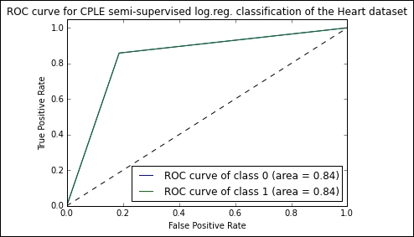

The CPLE semi-supervised model succeeds in classifying with 84% accuracy, a score comparable to human estimation and over 10% higher than the naïve semi-supervised implementation. Notably, it also outperforms the supervised SVM.

Using models in dynamic applications

We've spent this chapter discussing the use of techniques to manage model performance under conditions that might be seen as ideal; specifically, conditions in which all of the data is available ahead of time so that a model can be trained on all data. These assumptions are frequently valid in research contexts or when dealing with one-time problems, but in many contexts they are unsafe assumptions. The range of unsafe contexts goes beyond the cases where the data is simply unavailable, such as data science contests where a held-out dataset is used to establish the final leaderboard.

Returning to a subject from earlier in this chapter, you'll recall the Pragmatic Chaos algorithm, which won the Netflix prize? By the time Netflix came to assessing the algorithm for implementation, both the business context and requirements had shifted so dramatically that the minimal accuracy gains provided by that algorithm didn't justify implementation costs. The $1M algorithm was redundant and was never implemented in production! The point to take from this example is that in commercial contexts, it is critical for our models to have as much adaptability as we can provide.

The really challenging applications of machine learning algorithms, in which our existing run once methodologies become less valuable, are ones where real data changes occur across time (or other dimensions). In these contexts, one knows that a substantial data change will occur and that existing models cannot be easily trained to adapt to this data change. At that point, new techniques are needed as well as new information.

To adapt and gather this information, we need to become better able to predict the ways in which data change is liable to occur. With this information, our model building and the content of our ensembles can start to change in order to cover the most likely data change scenarios that we see ahead. This adaptation lets us pre-empt data change and reduce the adjustment time required. As we'll see later in this chapter, in real-world applications any reduction in the time it takes us to pivot based on data change is valuable.

In the next section, we'll be looking at tools that we can use to make our models more robust to changing data. We'll discuss the means by which we can maintain a broad set of model options, simultaneously accommodating one or multiple data change scenarios, without reducing the performance of our models.

**Understanding model robustness**

It's important to understand exactly what the problem is here and how and when it is presented. This involves defining two things; the first being robustness as it applies to machine learning algorithms. The second, of course, is data change. Some of the content in the first part of this section is at an introductory level, but experienced data scientists may still find value in reviewing the section!

In academic terms, the robustness of a machine learning algorithm is the property that characterizes how effective your algorithm is while being applied to a dataset other than the dataset on which it was trained.

Robustness testing is a core part of machine learning methodology in any context. The importance of validation techniques such as k-fold cross-validation and the use of tests when developing models for even the simplest contexts is a consequence of machine learning algorithm vulnerability to data change.

Most datasets contain both a signal and noise. Noise may be predictable (and thus more easily managed) or it may be stochastic and difficult to treat. A dataset may contain more or less noise. Typically, datasets with more or less predictable noise are harder to train and test against the same datasets with this noise removed (which can be easily tested).

When one has trained a model on a given dataset, it is almost inevitable that this model has learned based on both the signal and noise. The concept of overfitting is generally used to describe a model that has fit so well to a given dataset that it has learned to predict based on both the signal and noise, rendering it less powerful against other samples than a model with a less exact fit.

Part of the goal of training a model is to reduce the impact of any local noise on learning as much as possible. The purpose of validation techniques that hold out a set of data to test is to ensure that any learning of noise during training happens only on noise that is local to the training set. The difference between training and test error can be used to understand the degree of overfitting between model implementations.

We've applied cross-validation in [Chapter 1](https://learning.oreilly.com/library/view/advanced-machine-learning/9781784398637/ch01.html), *Unsupervised Machine Learning*. Another useful means of testing models for the overfitting is to directly add random noise in the form of jitter to the training dataset. This technique was introduced via a Kaggle notebook in October 2015 by Alexander Minushkin and offers a very interesting test. The concept is simple; by adding jitter and looking at the accuracy of prediction on the training data, we can distinguish an overfitted model (whose training error will increase more quickly as we add jitter) from a well- or poorly-fitted model:

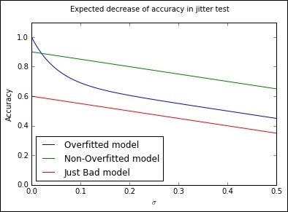

In this case, we're able to plot the results of a jitter test to easily identify whether a model has overfit. From a very strong initial position, an overfit model will typically rapidly decline in performance as small amounts of jitter are added. For better-fitting models, the loss in performance with added jitter is much reduced, with the degree of overfitting in a model being particularly obvious at low levels of added jitter (where a well-fit model will tend to outperform an overfit counterpart).

Let's look at how we implement a jitter test for overfitting. We use a familiar score, accuracy_score, defined as the proportion of class labels predicted correctly, as the basis for test scoring. Jitter is defined by simply adding random noise to the data (using np.random.normal) with the amount of noise defined by the configurable scale parameter:

from sklearn.metrics import accuracy_score

def jitter(X, scale):

if scale > 0:

return X + np.random.normal(0, scale, X.shape)

return X

def jitter_test(classifier, X, y, metric_FUNC = accuracy_score, sigmas = np.linspace(0, 0.5, 30), averaging_N = 5):

out = []

for s in sigmas:

averageAccuracy = 0.0

for x in range(averaging_N):

averageAccuracy += metric_FUNC( y, classifier.predict(jitter(X, s)))

out.append( averageAccuracy/averaging_N)

return (out, sigmas, np.trapz(out, sigmas))

allJT = {}

The jitter_test itself is defined as a wrapper to normal sklearn classification, given a classifier, training data, and a set of target labels. The classifier is then called to predict against a version of the data that first has the jitter operation called against it.

At this point, we'll begin creating a number of datasets to run our jitter test over. We'll use sklearn's make_moons dataset, commonly used as a dataset to visualize clustering and classification algorithm performance. This dataset is comprised of two classes whose data points create interleaving half-circles. By adding varying amounts of noise to make_moons and using differing amounts of samples, we can create a range of example cases to run our jitter test against:

import sklearn

import sklearn.datasets

import warnings

warnings.filterwarnings("ignore", category=DeprecationWarning)

Xs = []

ys = []

#low noise, plenty of samples, should be easy

X0, y0 = sklearn.datasets.make_moons(n_samples=1000, noise=.05)

Xs.append(X0)

ys.append(y0)

#more noise, plenty of samples

X1, y1 = sklearn.datasets.make_moons(n_samples=1000, noise=.3)

Xs.append(X1)

ys.append(y1)

#less noise, few samples

X2, y2 = sklearn.datasets.make_moons(n_samples=200, noise=.05)

Xs.append(X2)

ys.append(y2)

#more noise, less samples, should be hard

X3, y3 = sklearn.datasets.make_moons(n_samples=200, noise=.3)

Xs.append(X3)

ys.append(y3)

This done, we then create a plotter object that we'll use to show our models' performance directly against the input data:

def plotter(model, X, Y, ax, npts=5000):

xs = []

ys = []

cs = []

for _ in range(npts):

x0spr = max(X[:,0])-min(X[:,0])

x1spr = max(X[:,1])-min(X[:,1])

x = np.random.rand()*x0spr + min(X[:,0])

y = np.random.rand()*x1spr + min(X[:,1])

xs.append(x)

ys.append(y)

cs.append(model.predict([x,y]))

ax.scatter(xs,ys,c=list(map(lambda x:'lightgrey' if x==0 else 'black', cs)), alpha=.35)

ax.hold(True)

ax.scatter(X[:,0],X[:,1],

c=list(map(lambda x:'r' if x else 'lime',Y)),

linewidth=0,s=25,alpha=1)

ax.set_xlim([min(X[:,0]), max(X[:,0])])

ax.set_ylim([min(X[:,1]), max(X[:,1])])

return

We'll use an SVM classifier as the base model for our jitter tests:

import sklearn.svm

classifier = sklearn.svm.SVC()

allJT[str(classifier)] = list()

fig, axes = plt.subplots(nrows=2, ncols=2, figsize=(11,13))

i=0

for X,y in zip(Xs,ys):

classifier.fit(X,y)

plotter(classifier,X,y,ax=axes[i//2,i%2])

allJT[str(classifier)].append (jitter_test(classifier, X, y))

i += 1

plt.show()

The jitter test provides an effective means of assessing model overfitting and performs comparably to cross-validation; indeed, Minushkin provides evidence that it can outperform cross-validation as a tool to measure model fit quality.

Both of these tools to mitigate the overfitting work well in contexts where your algorithm is either run over data on a one-off basis or where underlying trends don't vary substantially. This is true for the majority of single-dataset problems (such as most academic or web repository datasets) or data problems where the underlying trends change slowly.

However, there are many contexts where the data involved in modeling might change over time in one or several dimensions. This can occur because of change in the methods by which data is captured, usually because new instruments or techniques come into use. For instance, video data captured by commonly-available devices has improved substantially in resolution over the decade since 2005 and the quality (and size!) of such data has increased. Whether you're using the video frames themselves or instead the file size as a parameter, you'll observe noticeable shifts in the nature, quality, and distributions of features.

Alternatively, changes in dataset variables might be caused by differences in underlying trends. The classic data schema concept of measures and dimensions comes back into play here, as we can better understand how data change is affected by considering what dimensions influence our measurement.

The key example is time. Depending on context, many variables are subject to day-of-week, month-of-year, or seasonal variations. In many cases, a helpful option might be to parameterize these variables, (as we discussed in the preceding chapter, techniques such as one-hot encoding can help our algorithms learn to parse such trends) particularly if we're dealing with periodic trends that are easily predicted (for example, the impact of month-of-year on scarf sales in a given location) and easily modeled.

A more problematic type of time series trend is non-periodic change. As in the preceding video camera example, some types of time series trends change irrevocably and in ways that might not be trivial to predict. Telemetry from software tends to be influenced by the quality and functionality of the software build live at the time the telemetry was emitted. As builds change over time, the values sent in telemetry and the variables created from those values can change radically overnight in hard-to-predict ways.

Human behavior, a hugely important factor in many datasets, helpfully changes both periodically and non-periodically. People shop more around seasonal holidays, but also change their shopping habits permanently based on new societal or technological developments.

Some of the added complexity here comes not just from the fact that single variables and their distributions are affected by time series trends, but also from how relationships between relevant factors and their associated variables will change. The relationships between variables may change in quantifiable terms. One example is how, for humans, height and weight are two variables whose relationship varies between times and locations. The BMI feature, which we might use to track this relationship, shows differing distributions when sampled across periods of time or between locations.

Furthermore, variables can change in another serious way; namely, their importance to a performant modeling algorithm may vary over time! Some variables whose values are highly relevant in some periods of time will be less relevant in others. As an example, consider how climate and weather variables affect agriculture markets. For some crops and the companies dealing in them, these variables are fairly unimportant for much of the year. At the time of crop growth and harvest, however, they become fundamentally important. To make this more complex, the strength of these factors' importance is also tied to location (and local climate).

The challenge for modeling is clear. For models that are trained once and run again on new data, managing data change can present serious challenges. For models that are dynamically recomputed based on new input data, data change can still create problems as variable distributions and relationships change and available variables become more or less valuable in generating an effective solution.

Part of the key to successfully managing data change in your application of ML is to recognize the dimensions (and there are common culprits) where change is probable and liable to affect the distributions of your features, relationships, and feature importance, which a model will attempt to pick up on.

Once you have an understanding as to what the factors in your data are that are likely to influence overfitting, you're better positioned to develop a solution that manages these factors effectively.

This said, it will still seem hugely challenging to build a single model that can resolve any potential issues. The simple response to this is that if one faces serious data change issues, the solution probably isn't to try to solve for them with a single model! In the next section, we'll be looking at ensemble methods to provide a better answer.

**Identifying modeling risk factors**

While it is in many cases quite straightforward to identify which elements present a risk to your model over time, it can help to employ a structured process for identification. This section briefly describes some of the heuristics and techniques you can employ to screen your models for the risk of data change.

Most data scientists keep a data dictionary for datasets that are intended for general use or automated applications. This is especially likely to happen if the data or applications are complex, but keeping a data dictionary is generally good practice. Some of the most effective work you can do in identifying risk factors is to run through these features and tag them based on different risk types.

Some of the tags that I tend to use include the following:

* **Longitudinally variant**: Is this parameter liable to change over a long time due to longitudinal trends that many not be fully visible in the span of the training data that you have available? The most obvious example is the ecological seasons, which affect many areas of human behavior as well as the many things that depend on some more fundamental climatic variables. Other longitudinal trends include the financial year and the working month, but extend to include many other longitudinal trends relevant to your area of investigation. The life cycle of new iPhone models or the population flux of voles might be an important longitudinal factor depending on the nature of your work.
* **Slowly changing**: Is this categorical parameter likely to gain new values over time? This concept is borrowed from data warehousing best practices. A slowly changing dimension in the classical sense will gain new parameter codes (for example, as a new store opens or a new case is identified). These can throw your model entirely if not managed properly or if they appear in sufficient number. Another impact of slowly changing data, which can be more problematic to handle, is that it can begin to affect the distribution of your features. This can have a substantial impact on the effectiveness of your model.
* **Key parameter**: A combination of data value monitoring and recalculation of decision boundaries/regression equations will often handle a certain amount of slowly changing data and seasonal variance well, but consider taking action should you see an unexpectedly large amount of new cases or case types, especially when they affect variables depended on heavily by your model. For this reason, also make sure that you know which variables are most relied upon by your solution!

The process of tagging in this way is helpful (not least as an export of your own memory) mostly because it helps you to do the following:

* Organize your expectations and develop a kind of checklist for your development of monitoring readiness. If you aren't able to keep track of at least your longitudinally variant and slowly changing parameter change, you are effectively blind to any output from your model besides changes in the parameters that it favors when recomputed and its (likely slowly declining) performance measure.
* Investigate mitigation (for example, improved normalization or extra parameters that codify those dimensions in which your data is variant). In many ways, mitigation and the addition of parameters is the best solution you can tap to handle data change.
* Set up robustness testing using constructed datasets, where your risk features are deliberately varied to simulate data change. Stress-test your model under these conditions and find out exactly how much variance it'll tolerate. With this information, you can easily set yourself up to use your monitoring values as an early alert system; once data change exceeds a certain safe threshold, you know how much degradation to expect in the model performance.

**Strategies to managing model robustness**

We've discussed a number of effective ensemble techniques that allow us to balance the twin needs for performant and robust models. However, throughout our exposition and use of these techniques, we had to decide how and when we would reduce our model's performance to improve robustness.

Indeed, a common theme in this chapter has been how to balance the conflicting objectives of creating an effective, performant model, without making this model too inflexible to respond to data change. Many of the solutions that we've seen so far have required that we trade-off one outcome against the other, which is less than ideal.

At this point, it's worth our taking a slightly wider view of our options and drawing from complimentary techniques. The need for robust, performant statistical models within evolving business landscapes is neither new nor untreated; fields such as credit risk modeling have a long history of applied statistical modeling in changing domains and have developed effective decision management methodologies in order to succeed. Data scientists can turn some of these established techniques to our own benefit via using them to help organize our own models.

One effective methodology is **Champion/Challenger**, a test-centric approach that involves running multiple, parallel model configurations. In addition to the model whose outputs are applied (to direct business activities or inform reporting), champion/challenger approaches training one or more alternative model configurations.

By maintaining and monitoring multiple models, one can arrange to substitute the current model as and when an alternative outperforms it. This is usually done by maintaining a performance scoring process for all models and observing the results so that a manual decision call can be made about whether and when to switch to a challenger.

While the simplest implementation may involve switching to a challenger as soon as it outperforms the main model, this is rarely done as there are risks around specific challenger models being exposed to local minima (for example, the day-of-week or month-of-year local trends). It is normal to spend a significant period assessing a challenger model, particularly ahead of sensitive applications. In complex real cases, one may even want to do additional testing by providing a sample of treatment cases to a promising challenger to determine whether it generates significant lift over the champion.

There is scope for some creativity beyond simple, "replace the challenger" succession rules. Voting-based approaches are quite common, where a top subset of the trained ensembles provides scores on a case-by-case basis and those scores treated as (weighted or unweighted) votes. Another approach involves using a **Borda count**, a voting system where each voter ranks the candidate solutions in order of preference. In the context of ensembling, one would typically assign each individual model's prediction a point value equal to its inverse rank (keeping each model separate!). Then one can combine these votes (usually experimenting with a range of different weightings) to generate a result.

Voting can perform fairly well with a larger number of models but is dependent on the specific modeling context and factors like the similarity of the different voters. As we discussed earlier in this chapter, it's critical to use tests such as Pearson's correlation coefficient to ensure that your model set is both performant and uncorrelated.

One may find that particular classes of input data (users, say, with specific segmentation tags) are more effectively treated by a given challenger and may implement a case routing system where multiple champions deal with different user subgroups. This approach overlaps somewhat with the benefits of boosting ensembles, but can help in production circumstances by separating concerns. However, maintaining multiple champions will increase the monitoring and oversight burden for your data team, so this option is best avoided if not entirely necessary.

A major concern to address is how we go about scoring our models, not least because there are immediate practical challenges. In particular, it is hard to compare multiple models in real contexts, given that class labels (to guide correctness) typically aren't available. In predictive contexts, this problem is compounded by the fact that the champion model's predictions are typically used to take actions that alter predicted events. This activity makes it very difficult to make assertions about how a challenger model's predictions would've performed; by taking action based on our champion's predictions, we're unable to confirm the results of our models!

The most common implementation process is to provide each challenger model with a statistically viable sample of the input data and then compare the lift from each approach. This approach inherently limits the number of challengers that one can support for some modeling problems. Another option is to leave just one statistically viable sample out of any treatment activity and use it to create a single regression test. This test is applied to the entire set of champion and challenger models, providing a meaningful basis for comparison.

The downside to this approach is that the change to a more effective model will always trail the data change by however long it takes to generate correct class labels for the test cases. While in many cases this isn't crippling (the champion model remains in place for the period it takes to generate accurate models), it can present problems in contexts where underlying conditions change rapidly compared to the training time for models.

**NOTE**

It's worth making one brief comment on the relationship between model training time and data change frequency. It isn't always clearly stated as such, but the typical goal in applied machine learning contexts is to reduce the factor of training time to data change frequency to the smallest value possible. To take the worst case, if the length of time it takes to train a model is longer than the length of time that model will be accurate for (and the ratio is equal to or greater than one), your model will never generate current results that can directly drive current actions. In general, a high ratio should prompt review and adjustment activities (either an investigation into whether faster score delivery at lower confidence delivers more value or adjustment to the rate at which controllable environment variables change).

The smaller this ratio becomes, the more leeway your team has to apply your model's outputs to drive actions and generate value. Depending on how variant and quantifiable this ratio is for your modeling context, it can be a useful concept to promote within your organization as a health measure for your automated modeling solution.

These alternative models may simply be the next best-performing ensemble configurations; they may be older models, kept around for observation. In sophisticated operations, some challengers are configured to handle different *what-if* scenarios (for example, *what if the temperature in this region is 2 C below expectations* or *what if sales are significantly below expectations*). These models may have been trained on the same data as the main model or on deliberately skewed or prepared data that simulates the what-if scenario.

More challengers tend to be better (providing improved robustness and performance), provided that the challengers are not all minute variations on the same theme. Challenger models also provide a safe venue for innovation and testing, while observing effective challengers can provide useful insights into how robust your champion ensemble is likely to be to a range of possible environmental changes.

The techniques that you've learned to apply in this section have provided us with the tools to apply our existing toolkit of models to real applications in evolving environments. This chapter also discussed complications that can arise when applying ML models to production; data change, between samples or across dimensions, will cause our models to become increasingly ineffective. By thoroughly unpacking the concept of data change, we became better able to characterize this risk and recognize where and how it might present itself.

The remainder of the chapter was dedicated to techniques that provide improved model robustness. We discussed how to identify model degradation risk by looking at the underlying data and discussed some helpful heuristics to this end. We drew from existing decision management methods to learn about and use Champion/Challenger, a well-regarded process with a long history in contexts including applied machine learning. Champion/Challenger helps us organize and test multiple models in healthy competition. In conjunction with effective performance monitoring, a proactive tactical plan for model substitution will give you faster and more controllable management of the model life cycle and quality, all the while providing a wealth of valuable operational insights.